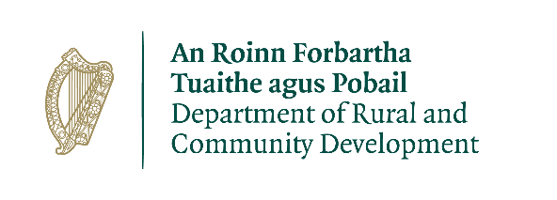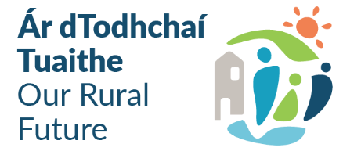

Community Recognition Fund 2023
Expression of Interest
Closing Date: 1st March 2023 at 5:00pm
Name of Group/Organisation
Contact Name
Address

Townlands

Email
Telephone No.
Details of the requirement for funding
Outline gaps in community facilities/infrastructure in your area
Village/Town Name | Requirement for funding  Detail any gaps in community facilities/infrastructure

Project Details
Village/Town Name | Project Elements | Total Costs | Detail position re. the required consents/ permissions /ownership | Estimated Completion Date
 | Please list all elements of the proposed project. |  | Appropriate assessment, planning, land ownership etc. if not in place please specify and specify the est. timeline | 60% of the proposed project must be complete in 2023
 | 1. | €
 | 2.
 | 3.

Outline of how the proposed project will deliver tangible benefits to the community:
Has any element of this proposal previously been approved under a Government Departments’ scheme:
If so, please outline

Use of Data
The information on this form will be used by Cavan County Council for the purposes of processing the application. Further information may be sought by Cavan County Council to clarify aspects of the project proposal. The form may be shared with other Government Departments for assessment purposes.

The Applicant and the Department are subject to the data protection and privacy laws of Ireland and the EU, in particular the Data Protection Act 2018 and Regulation (EU) 2016/679, known as the EU General Data Protection Regulation (“GDPR”). Any personal information which you provide as part of the application process will be obtained and processed in compliance with Data Protection legislation.

Cavan County Council retains the right to disclose for the purposes of a request under the Freedom of Information Act 2014 or otherwise, in connection with the funded project(s) –
- any information supplied by the Applicant to the Department, and
- any relevant data gathered by the Department in administering grant aid to the project, except where the information is considered to be personal or commercially sensitive.

Declaration by Lead Applicant
This declaration must be signed by an authorised person i.e. chairperson, secretary.

I confirm that I have read and understood this document and declare that the particulars supplied in this funding proposal are true and correct and that –
- The costings are accurate and reasonable.
- All necessary permissions are in place e.g. planning consent etc.
- All relevant ecological survey work (if applicable) has been undertaken or will be undertaken e.g. Appropriate Assessment screen.
- There is evidence of ownership (if applicable) or the consent of the landowner.
- The project will comply with Public Procurement Guidelines.
- The project conforms to the LECP and other local or regional plans.
- No funding has been allocated for the same works from any other sources.

Proof of the above is not required at the time of application but must be available to the Cavan County Council, the Department, or its agents on request.

I acknowledge the information regarding the use of data set out above and give consent to the Cavan County Council for the sharing of all information, personal or otherwise, contained in this funding proposal and any attachments accompanying it, in accordance with the uses of the data and information provided above.

Local Community Group __________________________

Signature _______________________________

Name in Block Capitals_____________________

Position_________________________________

Date___________________________________

