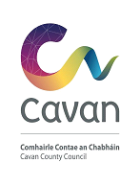

TVRS - Streetscape Enhancement Scheme 2021
Terms and Conditions
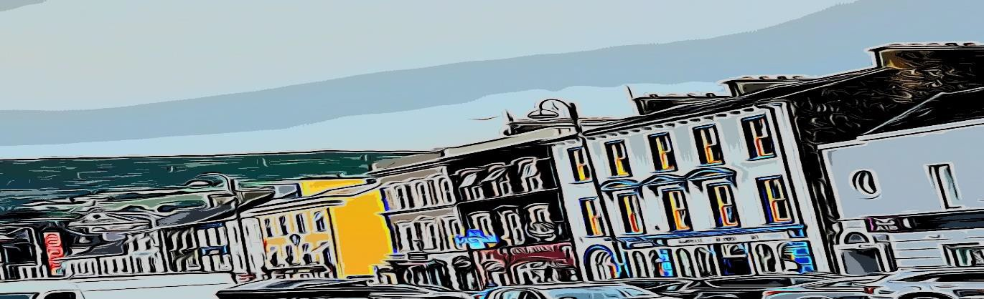

Introduction

Our Rural Future is the Government’s five-year strategy to revitalise rural Ireland and includes a commitment to upgrade and enhance shopfronts and street facades in our rural towns and villages.

This activity will be funded by the Department of Rural & Community Development (DRCD) through this 2021 Streetscape Enhancement Measure. This is an additional Measure introduced as part of the Town & Village Renewal Scheme. €7 million is being made available under this Measure in 2021

Improving the visual appearance of our urban streetscapes increases pride and confidence in our hometowns and villages, making them more attractive places to live, work and do business.

This Measure will support activity such as painting (including murals), signage replacement, shopfront improvement, lighting, and canopies.

Streetscape Enhancement Measure 2021

Focus of Measure

The focus of this measure is to support the upgrade and enhancement of shopfronts and street facades of defined areas within selected rural town/village centres.
Each Local Authority has been provided with a grant allocation which they can use to deliver this Measure through their own scheme developed and delivered locally.

Eligible Towns/Villages

The Measure is targeted at the following towns in County Cavan in 2021:
- Ballyjamesduff (Granard Street, Chapel Street, Market Street, Main Street, Dublin Street, Stradone Street)
- Belturbet (Main Street, Butler Street, Bridge Street (Upper & Lower)
- Cootehill (Market Street and Bridge Street)

Eligible Premises

Commercial, residential or unoccupied buildings in town/village centre locations as defined in Section 2.2.

Eligible Works

Eligible works include painting, signage replacement, shopfront improvement, scaffolding, materials, lighting and planting – see Appendix 1 for list of eligible works.

Grant Rates

Grant funding will be provided at the following rates:
      - 70% for individual premises – matched funding of 30%
      - 80% for joint applications (groups of 3 or more adjacent premises) – matched funding of 20%
      - 100% - Where painting is undertaken by direct labour by applicant

Timeline for Delivery

Projects must be completed and all funding requests and supporting documentation submitted to Cavan County Council by 5th November 2021.

Quotations

The following procurement rules apply, as a minimum, to the individual projects funded:
    - 2 x Contractor quotations;
    - 1 x Materials quotation;

(Note: 3 written quotations for contracts above €5,000 as per National Procurement Guidelines)

Publicity

Cavan County Council and/or the Department of Rural and Community Development may seek to use the details of the works funded in each town or village in the broader promotion of its policies, including through the use of the photographs which are required to be submitted to the Local Authority at claim drawdown stage.

Planning Requirements
The majority of the actions eligible under the scheme may not require planning permission. However, where a proposal involves a material alteration to the structure, planning permission will be required at payment stage.
Applicants are therefore advised to contact Cavan County Council in advance of making an application to discuss individual proposals which involve alterations to or replacement of existing shopfronts. Any such alterations must be consistent with the guidance laid out in the Draft County Development Plan (available on Cavan County Councils website). Guidance will be provided by Cavan County Council upon request to individual applicants.

Monitoring of Funding

Cavan County Council and/or the Department may carry out on-the-spot pre- or post-payment checks on a minimum 5% of project payment claims to verify compliance with funding conditions, project delivery and the reality of expenditure where appropriate. Payment claims will be selected on both a risk and random basis.
The checks will include an examination of any relevant documentation identified during the course of the on-the-spot check.

Appendix 1: Eligible Works

WORKS
Green enhancement of entrances/ terraces with planting | €500
Painting of building/shopfront in carefully selected colours which will complement the host building and streetscape.  Mural (agreed in advance with Local Authority) | €1,500
Decluttering and repair of shopfronts. (Decluttering can include such works as removing unnecessary signs, flagpoles, wiring etc.) | €2,000
Careful illumination and lighting of architectural features of buildings. | €4,000
Improvements to shopfront window displays and staging.
Replacement of signage with traditional wooden fascia with wooden/hand painted lettering OR contemporary design
Canopies/Awnings complementary to the materials of the shopfront and building (including street furniture).
Replacement of existing shopfront with traditional painted wooden shopfront OR contemporary design
Maximum per building | €8,000

