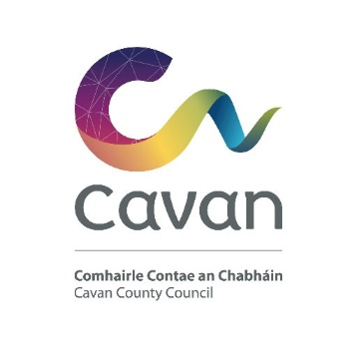
Taking in Charge - Application Form
CAVAN COUNTY COUNCIL
RESIDENTS ASSOCIATION APPLICATION FORM
Application to have Development taken in charge by Cavan County Council
Spokesperson: ______________________________________________________________
Spokespersons Address: _______________________________________________________
Contact No.: ___________________________________________________________________
Estate Name:_____________________________________________________________
Estate Location:___________________________________________________________
Planning Permission Reference Numbers:____________________________________________
No. of Houses: _________________________________________________________________
No. of Apartments:_______________________________________________________________
Items Submitted with this Application Form: (Tick where appropriate)
Signed owners declaration sheet
• As Constructed Drawings .
• CCTV survey & Executive Summary Report .
• Copies of Way leaves .
1. ROADS AND FOOTPATHS
Length of Roadway (m) ___________________________
Width of Roadway (m) ____________________________
Length of Footpath (m) ____________________________
Width of Footpath (m) _____________________________
2. FOUL SEWERS
No of FS manholes ___________________________
Is sewage disposal to the public sewer - Yes / No
Pumping station Yes / No __________
3. Watermains
Does the scheme have a water supply booster pump - Yes / No
4. Surface Water
Number of S.W.S. Manholes: _______
Number of Road Gullies: _____
5. Public Lighting
No of Public Lights: __________
No of Public Lights working: _________
6. Open Spaces
Area(s) ______M2

FOR OFFICE USE ONLY_________________________________________________________
Date application received ______________________
Date further information requested ________________________
Date further information received__________________________
Date application validated _______________________________
Development Contribution Paid:____________________________________________________

Certificate no. 2
For the benefit of Cavan County Council, this is to certify that the roads and footpaths
comply with the requirements of Cavan County Councils “Taking in Charge Policy for
Private Housing Developments” document.
Signed: _______________________________ Date: __________________

Certificate No. 3
For the benefit of Cavan County Council, this is to certify that the development
complies with all conditions of the Planning Permission granted and Building
Regulations (esp. Parts B & M).
Signed: _________________________________ Date: ____________________

Owners Declaration

WE THE UNDERSIGNED DO HEREBY AGREE TO HAVE CAVAN COUNTY COUNCIL TAKE OUR ESTATE IN CHARGE.
House No | Name (Block Capitals) | Owner | Signature

