COMHAIRLE CONTAE AN CHABHÁIN

CAVAN COUNTY COUNCIL

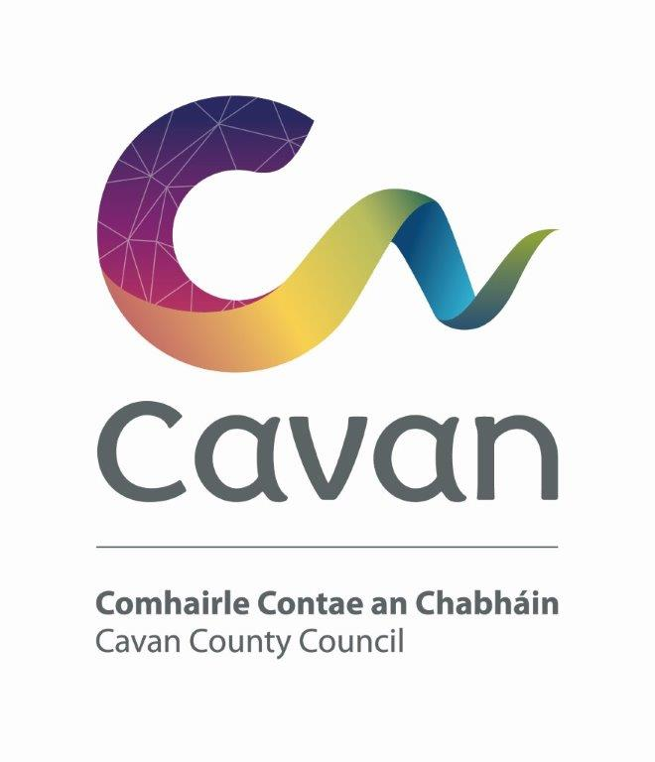

DRAFT

Strategic Policy Committees Scheme

2019-2024

DATE AUGUST 2019

Background
The statutory basis for Strategic Policy Committees (SPCs) is set out in the Local Government Act, 2001, as amended by the Local Government Reform Act 2014. Each Local Authority is required to establish SPCs in accordance with guidelines published by the Department of Environment, Heritage and Local Government: “Strategic Policy Committees – Guidelines for Establishment and Operation issued in June 2014”. The rationale for setting up SPCs is to provide forums where Local Authority Members and relevant sectoral interests with specific expertise can work together and advise and assist the Council in the formulation and development of policy. Ultimately the Council remains the decision making authority.

SPCs meet regularly to deal with policy issues of the Council. Recommendations are, in the main, reached by consensus and presented to the full Council for approval. Each SPC is facilitated by a Director of Service.

The SPC system is intended to give Elected Members and relevant sectoral interests an opportunity for full involvement in the policy making process from the early stages when policy options are being considered. The SPC system allows much of the preliminary and background work to be completed at SPC level before final consideration and ratification by the Council.

Following the local elections 2019, each Local Authority is required to review its SPC scheme and approve a new scheme to operate for the lifetime of the Council.

Role of Corporate Policy Group and Strategic Policy Committees
The Corporate Policy Group (CPG) links the work of the different SPCs and provides a forum where policy positions affecting the whole Council can be agreed for submission to the full Council. The CPG comprises the Cathaoirleach of the Council and the Chairs of the SPCs. It is supported by the Chief Executive and Directors of Services.

The role of SPCs is to assist and advise the Council in relation to functions of a strategic statutory nature. They also have a function in other non-statutory policy areas such as policy related to the development of work programmes and the establishment of priorities for particular services. SPCs will be involved from the preliminary phase of preparation of a policy and assist in the setting of overall parameters, identification of issues to be addressed and approaches to be taken etc.

Meetings
Meetings will be conducted in accordance with Cavan County Council’s Standing Orders and subject to law or amendments made by Cavan County Council. Within this framework, each SPC may regulate its own business and proceedings (including the fixing of days and times of its meetings). SPCs will be required to meet four times annually and more frequently if necessary. Meetings will be held at a suitable time for the SPC members.

SPC Framework
Having regard to Cavan County Council’s organisational structures, the areas of responsibility assigned to each SPC are as follows:-
1. Economic Development, Enterprise and Planning
2. Climate Change and Environment
3. Transportation, Infrastructure and Emergency Services
4. Housing, Social Inclusion & Corporate Services
5. Cultural Development, Irish Language and Sport

Each Member of the Council will have an opportunity to serve on one SPC. Cavan County Council’s representation shall be six Members on each of the committees. This is in order to achieve a balance between Elected Members and sectoral interests on each SPC. Therefore, twelve Elected Members shall serve on two SPCs.

Sectoral representation on each committee is set out in Appendix 1. The membership of each committee shall be determined by the Council after closing date for receipt of notification to participate in the nominating process.

Sectoral Representatives
At a minimum six and where appropriate seven sectors should be represented in each SPC configuration. External representatives may be nominated by the following sectors:
- Agriculture/Farming
- Environment/Conservation
- Development/Construction
- Business/Commercial
- Trade Union
- Community/voluntary
- Social Inclusion

Nominations to the SPCs from the agricultural/farming, business/commercial, development/construction and trade union sectors will be organised by the designated contact person from the relevant National Pillars.

The environmental/conservation sector will be facilitated by the environmental pillar and the associated Environmental College under the Public participation Network (PPN)
The community/voluntary and social inclusion sectors will be determined on the basis of the local nomination process through the PPN.

Nominees will be expected to have a specific interest in the areas under the remit of the particular SPC.
The Sectors shall achieve a 40% gender balance in the making of appointments as well as the need to foster social inclusiveness and equality when selecting their representatives.

The assignment of sectoral interests for each S.P.C. is as follows:

Sector | Number of SPC places  (5 SPCs)
Agriculture/Farming/Rural Water | 3
Trade Union | 1
Development/Construction | 3
Business/Commercial | 4
Environmental/Conservation | 2
Social Inclusion | 2
Community/Voluntary | 5
Total | 20

The areas of responsibility relevant to each of the five Strategic Policy Committees are set out in Appendix 2.

General
- The Chairs of the SPC’s have been appointed by the full Council from among the Councillor appointees to the SPCs. SPC Chairs will hold office for a minimum period of three years.
- It is desirable that sectoral nominees retain membership of the SPC for the life of the Council. Where a casual vacancy occurs, it should be filled by the relevant sector.
- The relevant Director of Services will attend meetings and provide support to the SPC. The Director will, subject to the Chief Executive’s overall responsibility for staffing matters, work closely with the Committee and be entitled to speak and participate at meetings.
- S.P.C. membership for Councillors will be for the lifetime of the Council.

Conclusion
This scheme will be considered by the Elected Members of Cavan County Council at its meeting on 14th October 2019.

Appendix 1 Strategic Policy Committees 2014-2019 Membership

6 Elected Members per SPC
Total Sectoral Interests = 20

 | Housing, Social Inclusion & Corporate Services | Climate Change & Environment | Transportation, Infrastructure  & Emergency Services | Economic,  Development,  Enterprise & Planning | Cultural Development, Irish Language & Sport
Chairperson | 1 | 1 | 1 | 1 | 1
Elected Members | 6 | 6 | 6 | 6 | 6
Agriculture and Farming | - | 1 | 1 | 1
Trade Unions | 1 | - | - | -
Development & Construction | 1 | - | 1 | 1
Business & Commercial | - | 1 | 1 | 1 | 1
Environment / Conservation | - | 1 | - | - | 1
Social Inclusion | 1 | 0 | - | - | 1
Community / Voluntary | 1 | 1 | 1 | 1 | 1
 | 10 | 10 | 10 | 10 | 10

Appendix 2 Indicative Areas of Responsibility

Housing, Social Inclusion & Corporate Services
- Housing Capital Programme
- Social Housing
- Voluntary Housing
- Social Inclusion
- Corporate Services
- Preparation and Implementation of (Community elements) of the Local Economic and Community Plan (LECP)

Climate Change & Environment
- Climate Change
- Waste Management Planning
- Environmental Protection/Awareness
- Water Services Strategic Planning

Transportation and Infrastructure
- Road Maintenance & Improvement
- Road Safety
- Public Transport
- Car Parking
- Traffic Management
- Emergency Services
- Playgrounds
- Greenways
Economic Development, Enterprise & Planning
- Economic Development & Promotion
- Urban & Village Renewal
- Preparation and implementation of (economic elements) of the Local Economic and Community Plan (LECP)
- Local Enterprise Office functions
- Planning & Development Services
- Development Contribution Schemes
- Heritage & Conservation issues
- National & Regional Spatial Planning
- Tourism
- Brexit
- Food Strategy
- Community Grants Scheme

Cultural Development, Irish Language and Sport
- Culture
- Theatre & Arts
- Library services
- Museum
- Irish Language
- Sports Development
- Sports Partnership

Made under Official Seal of the County Council of the County of Cavan
this Day of 2019.

Present when the Official Seal of the Council was affixed:

___________________________

Cathaoirleach,

SEAL
Cavan County Council

__________________________
Tommy Ryan
Chief Executive,
Cavan County Council

