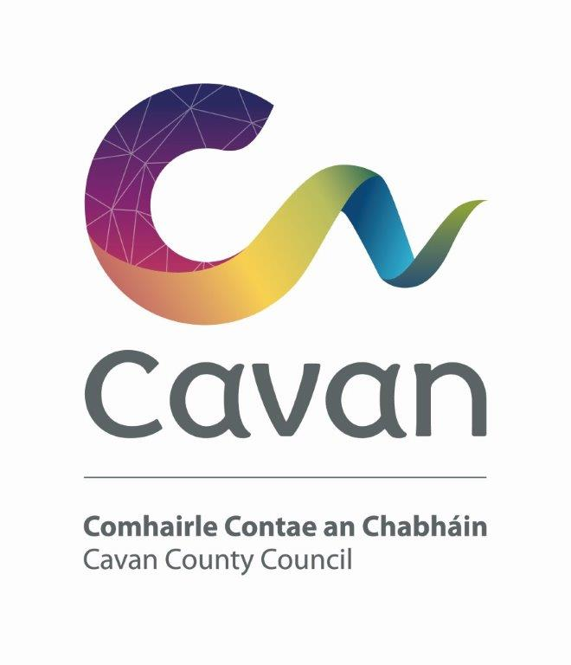
Protected Disclosures Act 2014
Annual Report 2021

The Protected Disclosures Act 2014 became operational on the 15th July 2014. In accordance with Section 22 of that Act, Cavan County Council has an obligation to report on the number of protected disclosures made to the Council in the preceding year.

Section 22 states that:
- Every public body shall prepare and publish not later than 30 June in each year a report in relation to the immediately preceding year in a form which does not enable the identification of the persons involved containing information relating to the matters specified in subsection (2).

- Those matters are -

- the number of protected disclosures made to the public body,
- the action (if any) taken in response to those protected disclosures, and
- such other information relating to those protected disclosures and the action taken as may be requested by the Minister from time to time.

In accordance with Section 22 of the Protected Disclosures Act 2014, Cavan County Council reports that it received one protected disclosure in the period 1st January 2021 to 31st December 2021. This protected disclosure has been closed.

