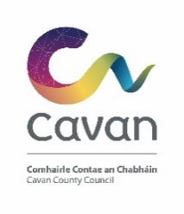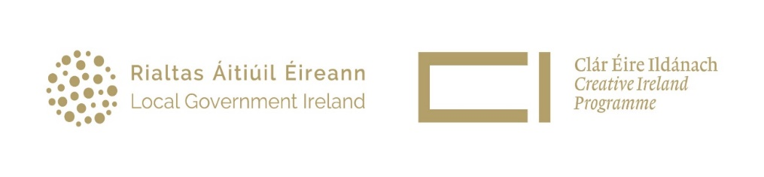
Creative Cavan 2023
Open Call Grant Application

Applicant Details

Name of Applicant / Organisation

Address

Website & Social Media Details (if applicable)

Details of the contact person dealing with the application:

Title: ___________________________________________

Name: ___________________________________________

Email: ___________________________________ Telephone no.: _____________________

Bank Account Details: please state the name listed on the bank account for payment purposes.

Details of Proposed Project/Event

Title of Project/Event:

Summary of Project Proposal:
Provide a brief description of the project/event for publication on the Creative Ireland website (Max 150 words).
Please use short sentences, plain English, and jargon-free language.

Type of initiative? Select one initiative from the list below:

Arts Project | Conference | Festival |  | Research
Award/ Grants scheme | Conservation | Film production/ screening |  | Strategic Policy Development
Climate Change | Cultural Project | Outreach Project |  | Talks/ storytelling
Commemoration | Data collection & recording | Performance Show |  | Touring
Commission | Digitisation / Archival | Programme of events |  | Training & Skills
Concert | Exhibition | Publication |  | Workshop
Select the target audience from the list below:

Artists / Creatives | Children / Young People | Disability Groups |  | General Public
Older Audience | Specific Groups | Not applicable
Main Genre: Select the main genre of the project/event from the list below:

Archaeology | Creative / Cultural Development | History |  | Storytelling/ Oral heritage
Architecture / Architectural Heritage | Dance | Irish language |  | Street Art/ Spectacle
Biodiversity / Natural Heritage | Design, Science, Technology, Engineering, Maths | Literature/ Poetry |  | Tangible/ Intangible heritage
Community / Social | Film/ Screen, Animation | Multidisciplinary |  | Theatre, Drama, or Comedy
Crafts/artisan/gastronomy | Folklore/ Archives | Music/ Spoken Word |  | Visual Art
Capacity to deliver.
Does your group (or its members) have experience in successfully running a project like this? If so, please give details. Max 500 words

Project/Event Description

Creative Ireland Pillars
Please select the Creative Ireland pillar that this project/event supports (more than one pillar may be selected but must include Pillar 2: Creative Communities).

- Creative Youth

- Creative Communities

- Creative Industries

- Creative Health and Wellbeing

- Creative Climate Action and Sustainability

Project/Event Description
Briefly describe the initiative and how it addresses the key priorities outlined in the Cavan Culture and Creativity Strategy 2023 - 2027. Please use short sentences, plain English, and jargon-free language. (Max 500 words)

What will be the community benefit of this project/event? (max 250 words)

Promotion, Dates, and Venue

How will the project/event be promoted?
An acknowledgment of the support of Creative Ireland and Cavan County Council in all promotional material is essential.

Start Date: |  | End Date:  (Deadline for completion is Friday 13th October 2023)
Start and End time (if relevant)

Total running time (hours/minutes/days as appropriate)

How will the participants register for the initiative?

If the initiative is an event, how will it be ticketed? |  |  | Free
 |  |  | Free, but booking required
 |  |  | Ticketed
 |  |  | N/A
Venue (full address & Eircode)

Project Costs

Please provide a breakdown of the proposed costs for the project. Provide quotes where possible.

Total Cost of Project (Including VAT where applicable).

What is the total amount sought from Creative Cavan?

Have you received or applied for other sources of public funding?

If yes, please give details:

Source: |  |  |  |  | Amount:
Source: |  |  |  |  | Amount
Please submit paid receipts on completion of the project/event for audit purposes.

Images

Please provide at least one high quality image for use by Creative Ireland and Creative Cavan to promote project/event on associated websites and social media accounts. Images should be landscape, 700x450 pixels, and in JPEG or PNG format.

Please indicate that the Creative Ireland Office and Cavan County Council have full permission to use this image.  If yes, please provide the name of the Photographer: _________________________________ |  |  |  |  |  | Yes  No
If the image provided contain individuals who are identifiable, then in line with GDPR legislation please provide the corresponding image consent form for everyone to ensure consent has been obtained for Creative Ireland and Creative Cavan to collect and use the images.

I/We have read and understood the information and criteria applicable to the fund and agree to comply in full therewith. I/we certify that all information provided in this application, and all information given in any documentation submitted in support of the application is truthful and accurate and that I have not applied to any other Local Authority for funding for this event/project.

A signed version of the application may be scanned and emailed (with the appropriate organiser’s signatures) to creativecavan@cavancoco.ie Accompanying additional documentation can be included as appropriate.

Name (block capitals) _________________________ Signed: _________________________________
Date: ______________________
On behalf of: (organisation name) ___________________________________

To be eligible for funding the project/event:
- Must take place in County Cavan and in the calendar year in which the funding is granted.
- Applicants must be 18 years or older.
- Be organised by an individual/community/voluntary group based in Cavan
- Encourage or benefit participation in the Creative Ireland programme and enhance the awareness of creativity or culture in the County.
- Be in keeping with at least one of the five pillars of the Creative Ireland Programme, especially Pillar 2: Creative Communities.
- Recipients of grant assistance for projects involving children or young people must show evidence that a current child protection policy and up to date Garda Vetting are in place.
- Cavan County Council and Creative Ireland logos should appear on all printed material, and be acknowledged on all video/film, event websites, and social media.
- It is the responsibility of the grant recipient to follow public health recommendations and guidelines in relation to COVID 19
- Details of all projects will be advertised on the Creative Ireland website.
- Funding shall not be given for commercial activities.
- Be designed on a realistic financial basis and provide good value for money.
- The deadline for project delivery is Friday 13th of October 2023. This deadline is to facilitate Cavan County Council’s funding drawdown from the Creative Ireland Programme and is non-negotiable.
- Payment of the award will be made on completion of the project/event and the submission to the Creative Ireland office of an evaluation report, photographs, and receipts of money spent.

Items that are excluded from the fund include:
- Capital projects.
- Purchase of equipment.
- Fuel Costs.
- Spends on alcoholic beverages, food, fines, legal costs, penalty payments, and prizes.
- Wages and salaries relating to administrative costs.
- Generally, the cost of items for resale is ineligible.
- Items of expenditure incurred prior to the approval of grant funding are not eligible for recoupment.

Assessment Process:
- All applications will be assessed by an independent panel.
- Funding will be allocated based on the recommendations of this panel.
- All applicants will be advised of the decision by email.
- Successful applicants will receive a letter of offer and a funding agreement document that details terms and conditions. This document must be signed and returned by the date specified on the letter of offer. Failure to do so may result in funding being withdrawn and reallocated to another project.
- Due to resource constraints, it may not be possible to allocate funding to all projects, and eligibility and compliance with these criteria do not guarantee a letter of offer.

Policies and Guidelines

Applications must be received by Wednesday 31st May 2023 at 12pm.

If I am successful how do I draw down the Fund? Payment will be made following adjudication and notification of success. An initial payment of 50% of the requested funding will be paid following approval and signing of a Creative Cavan Funding Agreement. The final 50% will be paid when the project is completed and a report is submitted (as per the criteria in the Funding Agreement) to the Creative Cavan Office.
Note: Payment will be made to the community group named on the application form, and not to individuals.
Payment will be by Electronic Funds Transfer only. A Supplier Set Up Form and Bank details must be submitted to facilitate the transfer.

Acknowledgment- Successful applicants must ensure that their project is promoted as part of the Creative Ireland initiative. Appropriate guidelines to support this will be included in the Creative Cavan Funding Agreement.

Disclaimer – Please read carefully It will be a condition of any application for funding under the terms and conditions of the Cavan Creative Ireland Grant Fund that the applicant has read, understood, and accepted the following:
Cavan County Council and Creative Ireland shall not be liable to the applicant or any other party, in respect of any loss, damage, or costs of any nature arising directly or indirectly from:

- The application or the subject matter of the application.
- The rejection for any reason of any application. Cavan County Council & Creative Ireland shall not be held responsible or liable, at any time in any circumstances, in relation to any matter whatsoever arising in connection with the administration of activities.
- By submitting an application, applicants agree to the processing and disclosure of the applicant’s information by Cavan County Council, Creative Ireland, and to other third parties if required, for fund administration, reporting, evaluation, and audit purposes; and successful applicants further consent to the disclosure of this information (e.g. name of the successful applicant, amount of award, etc.) by these parties in connection with the marketing or promotion.
- Cavan County Council and Creative Ireland agree to employ appropriate measures to keep applicants’ data safe and secure, to prevent its unauthorised or accidental disclosure, access, or alteration; and to ensure that personal data will be processed only in accordance with the relevant provisions of the Data Protection regulations.

Freedom of Information:

Applicants completing this Form should note that information provided to the Cavan Creative Ireland programme of Cavan County Council may be disclosed in response to a request made under The Freedom of Information Act (1997 and 2003). Every effort will be made to protect Client confidentiality.

