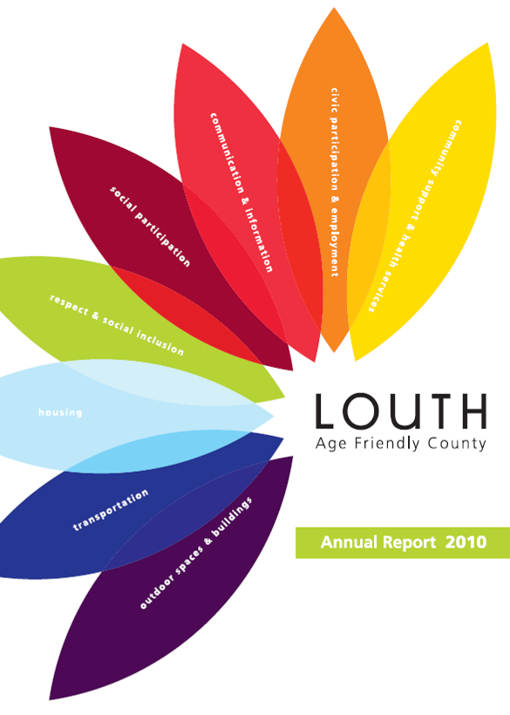
CAVAN
Age Friendly County
Annual Report 2013

Cavan Age- Friendly Report 2013

Foreword
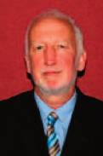
The Cavan Age Friendly Alliance is proud to present its first report on the Cavan Age Friendly County Strategy. This report reviews the exemplary work of the various agencies and organisations that comprise the Cavan Age Friendly Alliance which aim to make Cavan a great county for everyone to live in, whatever age they are. We particularly want to ensure that the voices of older people are prominent in decision-making about services and developments that affect them.
The Cavan Age Friendly Alliance was established formally in early 2012. It is made up of senior personnel in public sector agencies like Cavan County Council, The Gardaí, The Netwell Centre, The Ageing Well Network, The Health Service Executive, The Gaelic Athletics Association, Cavan and Monaghan Education and Training Board with representatives from the Cavan Older Peoples Forum. These organisations and more work together to promote a positive approach to ageing. The main goal of the Alliance is to make Cavan a great place to live and grow old in. The Age Friendly Strategy was written with realistic achievable goals. The strategy is expected to be completed in three years. Many goals have been achieved even though barely a year has passed.
The Alliance is focussed on operating within existing structures by exploring how resources can be aligned and used with maximum efficiency and effectiveness. We know from statistics the people are living longer as they have lived healthier lives. There will be a higher demand for services and we in Cavan intend to be prepared for these demands. We also acknowledge that older people today have higher expectations to be involved at community level, to be engaged with service providers and to be heard. To this end the Cavan Older Persons Forum was set up and has been active since April of 2013; an executive committee has been set up with members meeting regularly in an attempt to accomplish as many goals within the strategy as possible. Informative briefing sessions and training have been held. Students have been taken on to research into issues affecting older people including: loneliness and Isolation, safety and security in the home and health issues. Findings are due in a few months. A river walkway has been developed in Cavan town, including a boardwalk. Legislation is in place which prohibits drinking and smoking in playgrounds and responsible dog ownership.
The Cavan Older People’s Forum nominates representatives from its Executive Committee onto the Cavan Age Friendly Alliance so there is a direct link between older adults within the local community and the service provider agencies. The report is designed to reflect the Cavan Age Friendly County Strategy and correspondingly reports on performance under the eight objectives of the WHO Age Friendly Communities Programme. One of our most significant achievements since our strategy was launched in 2013 has been the formation of Cavan Older People’s Forum. This Forum is a representative structure for older people throughout Cavan, and its Executive Committee meets on a monthly basis to work on elements of the strategy. In the past months, the Forum has been involved in briefing and information sessions, Information Technology training and Age Friendly concessions at events.
I look forward to continuing this important work in the coming years and to transforming our local communities to ensure they are fully inclusive of all ages. We look to 2014 as a crucial year in moving the process forward.

Jack Keyes
County Manager

Contents

Forward from Jack Keyes, County Manager............................................... 3

Contents ......................................................................................................... 5

Introduction .................................................................................................... 8

Theme 1 Outdoor Spaces and Buildings................................ 10
Action 1.1 Age Friendly Buildings and Public Spaces................................ 10
Action 1.2 Recreation and Amenity Areas.................................................. 11
Action 1.3 Age Friendly Local Communities............................................... 12

Theme 2 Transportation........................................................... 13
Action 2.1 Improved transport facilities countywide .................................... 13

Theme 3 Housing ...................................................................... 14
Action 3.1 Enhanced Links with An Garda Síochána ................................. 14
Action 3.2 Research on safety and security at home ................................. 15
Action 3.3 Greater access to home support information ............................ 16

Contents

Theme 4 Social Inclusion ......................................................... 17
Action 4.1 Creation of the Cavan Older People’s Forum ............................ 17
Action 4.2 Delivery of the GAA Social Initiative in Cavan ........................... 18
Action 4.3 Raise awareness across the public sector................................ 18
Action 4.4 Development of Men’s Sheds in County Cavan ........................ 19
Action 4.5 Research on loneliness and isolation ........................................ 19

Theme 5 Social Participation ................................................... 20
Action 5.1 Opportunities to learn Information Technology skills................. 20
Action 5.2 Interactions at community level ................................................. 21
Action 5.3 Participation in social, cultural and community activities........... 21

Theme 6 Communication & Information ................................. 23
Action 6.1 Awareness raising about the Age Friendly approach ................ 23
Action 6.2 Information supports for older people at home.......................... 23
Action 6.3 Citizens Information Programme............................................... 23

Contents

Theme 7 Civic Participation..................................................... 24
Action 7.1 Garda Schools Programme ....................................................... 24
Action 7.2 Participation of retired staff........................................................ 24
Action 7.3 Engagement with private sector ................................................ 25
Action 7.4 Development of an Age Friendly Business Forum.................... 25

Theme 8 Community Support and Health .............................. 26
Action 8.1 Research on the Doctor on Call Service ................................... 26
Action 8.2 Implement national programmes to improve health outcomes... 26
Action 8.3 Increased focus on preventative care ....................................... 26
Action 8.4 Review of acute care pathways and outpatient referrals .......... 27
Action 8.5 Targeted health promotion activities......................................... 27
Action 8.6 Telecare and telehealth initiatives............................................ 28

Conclusion .................................................................................................... 29

Useful Numbers ............................................................................................. 30

Introduction

This is the End of Year Report for 2013 of the Age Friendly Strategy for County Cavan. The strategy commits to improving key areas of infrastructure, services, information and our overall social response to older people’s issues in Cavan.

The strategy has been developed by the Cavan Age Friendly Alliance in consultation and co-operation with older people in Cavan. The Alliance was established formally in early 2012. It is made up of senior personnel in public sector agencies, older people’s representatives and other organisations that promote a positive approach to ageing. Members of the Alliance are from the following agencies:

- Cavan County Council
- An Garda Síochána
- Cavan County Development Board
- The Netwell Centre, Dundalk Institute of Technology
- Ageing Well Network
- Health Service Executive (HSE)
- Gaelic Athletics Association (GAA) Cavan County Board
- Cavan and Monaghan Education and Training Board (ETB)
- Cavan Older Person’s Forum

The Cavan Age Friendly Alliance is tasked with the overall implementation of the Cavan Age Friendly County Strategy and forming strategic alliances to ensure its implementation. Each of the Alliance members has given commitments in this strategy that will significantly help to improve the quality of life of older people in Cavan in the coming years. An Age Friendly County has been described by the Ageing Well Network as a county that recognises the great diversity among older people and promotes their inclusion in all areas of community life. It is a county that respects their decisions and lifestyle choices and anticipates and responds related needs and preferences.

This report is presented along the 8 themes developed by the World Health Organization through its ‘Age Friendly Cities and Communities’ programme. This programme is part of an international effort to address environmental and social factors that contribute to active and healthy ageing. The themes are:
- Outdoor Spaces and Buildings
- Transportation
- Housing
- Social Inclusion
- Social Participation
- Communication and Information
- Civic Participation
- Community Support and Health

It is our vision that Cavan will be a great county to live and grow old in. To this end we signed up to Ireland’s Age Friendly Counties Programme. In Cavan this was initiated through liaison and consultation with the 15 organisations factoring in the feedback received directly from members of the community. We identified realistic goals and have set out to achieve them within a 3 year period. This report shows that work commenced on several of the actions set out in the strategy and many have been completed. It would appear that things are progressing quite well as we are not yet a third of the way through the timeframe set out in the strategy. The strategy is outcome based with specific bodies taking the lead while receiving support from related bodies.
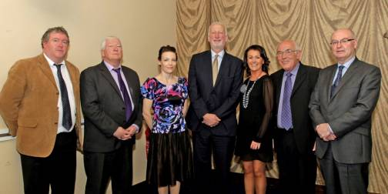
Members of Cavan Age Friendly Alliance

Theme 1 Outdoor Spaces and Buildings

Action 1.1: Age Friendly Buildings and Public Spaces
Lead partner: Cavan County Council
Steps taken & progress:
Council circular to personnel in relation to including Older Person’s Forum on the list for Part 8 consultations
Initiating a discussion with Men’s Shed and Town Council regarding the provision of additional seating as per universal design guidelines
Initial communication with The Ageing Well Network regarding disseminating lessons from graduate planners has taken place. Cavan County Council may host a regional workshop for planners.
Local authority signage policy is in place countywide regarding accessible streetscapes e.g. removal of sandwich boards, signage, and hoardings
The new Belturbet library is due for completion in early 2014.
Options around providing Age Friendly seating and shelters at bus stops were explored. LEADER and the local authority engineer explored options around seating at bus stops but unfortunately LEADER funding is closed. It may be a suitable avenue in the future but this is unfortunately on hold. The Roads Design Department will map current stops and explore suitability of sites.

Action 1.2: Recreation and amenity areas
Lead partner: Cavan County Council
Steps taken & progress:
Research is being undertaken to prepare a funding application for the next phase of development of Castle Saunderson as a landmark intergenerational public facility.
Development of Green Lough Park was completed in 2012.
Development of a river walkway in Cavan town, including a boardwalk, was completed in 2013.
Some funding has been secured for the creation of bowling greens with a hope to complete in 2014.
There is hope of funding for an outdoor gym at Halton’s site in Cootehill with a view to complete in 2014 if secured.
Phase 1 funding approved for a sculpture project at Halton’s Site with the Arts Council Northern Ireland.
Cavan Town Council adopted by-laws for Cavan Urban area playgrounds in 2012. This prohibits drinking and smoking in playgrounds and while quite specific, could be expanded to all public parks.
Cavan Town Council consultation paper on Responsible Dog Ownership was published in August 2012.
Cavan Alzheimer’s Association were approved funding from the Alzheimer’s Society of Ireland to develop a “Reminiscent & Sensory Park’ in Con Smith Park. Development will commence in early 2014.
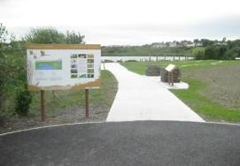
Green Lake Eco Park in Cavan Town which has been developed with accessibility features
Action 1.3: Age Friendly Local Communities
Lead partner: Cavan 050 Network
Steps taken & progress:
The Ageing Well Network has met with the 050 to discuss Cavan as an Age Friendly Town. They are hoping to explore opportunities for using a National Recognition Symbol for Age Friendly services.
Cavan Chamber of Commerce has agreed to take part in the Age Friendly Business Recognition Scheme delivered by the Ageing Well Network. Businesses will be invited to take part in a training workshop on how to become more age-friendly in 2014. Following consultation with their customers, they will be implementing a number of practical changes to the business. This will be jointly supported by the Council’s Tourism Officer and Social Inclusion Unit.

Theme 2 Transportation

Action 2.1: Improved transport facilities countywide
Lead partner: Transport Working Group of Cavan and Monaghan Age Friendly Alliances
Steps taken & progress:
Cavan & Monaghan Transport Working Group established with a meeting organised in January 2014 in relation to terms of reference for the group
Rural Transport Schemes to be restructured. New Local Transport Offices to be established under local authorities.
Chair of Transport Working Group met Cavan County Manager in relation to mapping routes. Cavan Geographical Information Systems Officer is supporting mapping.
A research need was identified for mapping community based transport. This exercise will be undertaken in 2014.
Bus Eireann has introduced changes to services including re-routing the Cavan Monaghan service via Cavan Hospital.
Theme 3 Housing

Action 3.1: Enhanced Links with An Garda Síochána
Lead partner: An Garda Síochána
Steps taken & progress:
An Older Person’s Register has been completed in respect of Cavan and Bailieboro Districts which cover County Cavan. These District Registers are subject to regular review to ensure the information is accurate and up to date.
Community Policing Clinics / meetings are held on an on-going basis with local Community Garda and the Divisional Crime Prevention Officer.
Garda talks on keeping safe at home occur on an on-going basis in conjunction with Community Alert Meetings for older peoples groups.
Crime Prevention Programme piloted in Cavan, Monaghan and Meath in 2013. Eleven volunteers from Cavan participated as Crime Prevention Ambassadors. Up to 50 visits were completed in total. Surveys were completed by the ambassadors and a review on the initiative will be completed by An Garda Síochána. An Accreditation Ceremony was held for volunteers in Clones on the 10th of December 2013.

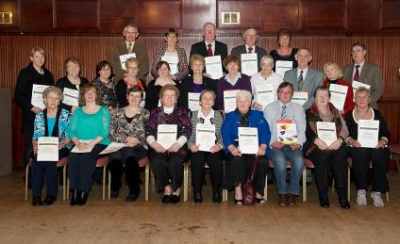
Crime Prevention Ambassadors from the pilot programme at the accreditation ceremony in December 2013.
Action 3.2: Research on safety and security at home
Lead partner: Cavan and Monaghan County Councils and The Netwell Centre
Steps taken & progress:
Anita Murphy commenced her research through Dundalk Institute of Technology on safety and security at home and the fear of crime in 2013. Her literature review has been completed. Her target of 300 collected surveys has been exceeded with the findings due in April 2014.

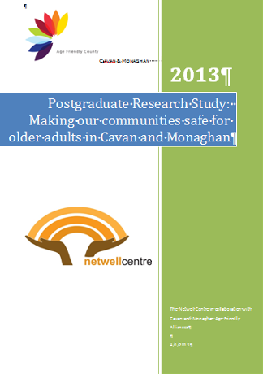

Action 3.3: Greater access to home support information
Lead partner: Cavan Older Person’s Forum
Steps taken & progress:
New bimonthly newsletter, ‘Age Conscious Times’, has been published and in circulation since September 2013. There was an article in Issue 1 on Cavan & Monaghan Community Area Service (CAMCAS), with reference to Telecare and Telehealth items like personal alarms which are on display in their Technology Show House in Ballyconnell. Contact information for national help lines and local support services are listed in Issue 2.
Seasonal Safety Tips from the Garda website and Fire Safety in the home at Christmas were circulated in December 2013.

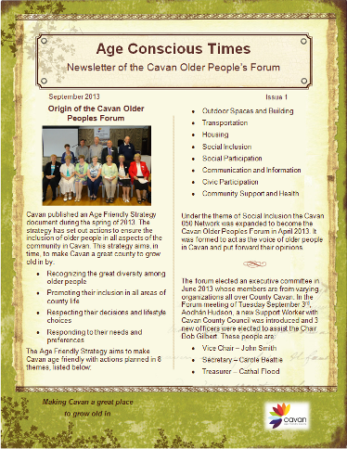
The new ‘Age Conscious Times’ newsletter produced by the Cavan Older Person’s Forum
Theme 4 Social Inclusion

Action 4.1: Creation of the Cavan Older People’s Forum
Lead partner: Cavan 050 Network
Steps taken & progress:
Cavan Older People’s Forum was established in May 2013. The group now has an executive committee which meets every month.
Age Friendly County Website under development

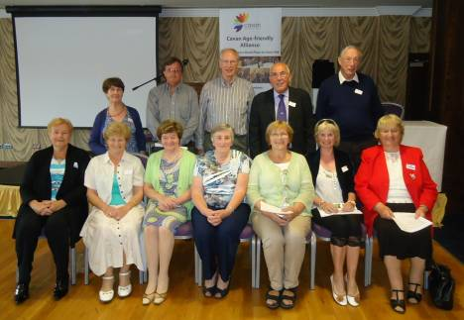
Members of the Cavan Older Person’s Forum at their election day in May 2013

Action 4.2: Delivery of the GAA Social Initiative in Cavan
Lead partner: GAA
Steps taken & progress:
There was an age friendly discount provided at drama ‘The Quare Land’ during Aussie Rules Weekend
Christmas party in December 2013
Activity is expected to increase when the season restarts in February 2014

Action 4.3: Raise awareness across the public sector
Lead partner: Cavan Age Friendly Alliance
Steps taken & progress:
A formal training programme on Age Friendly Awareness has yet to commence but all agencies involved in the Alliance are actively promoting the Age Friendly agenda within their organisations.

Action 4.4: Development of Men’s Sheds in County Cavan
Lead partner: Cavan & Monaghan ETB
Steps taken & progress:
Cavan & Monaghan ETB has held regular meetings and a number of men’s sheds are being set up:
Cavan Town Men’s Shed (Tar Isteach) at Cana House
Belturbet Men’s Shed at Old Railway Station
Corlough Men’s Shed
Bailieborough Men’s Shed
Groups are also interested in Bawnboy, Virginia and West Cavan.

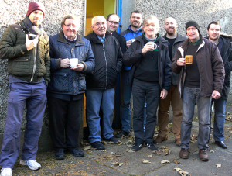
Members of the Cavan Town Men’s Shed: - ‘Tar Isteach’ at its opening

Action 4.5: Research on loneliness and isolation
Lead partner: Cavan and Monaghan County Councils and The Netwell Centre
Steps taken & progress:
Toyosi Ayoade commenced her research through Dundalk Institute of Technology on loneliness and isolation in 2013. Literature review has been completed and interviews will be conducted with service providers. Application for ethical approval submitted in Nov. She has met with befriending services. The findings are due in April 2014.
Theme 5 Social Participation

Action 5.1: Opportunities to learn Information Technology skills
Lead partner: Cavan Monaghan ETB
Steps taken & progress:
Free internet training took place in 3 locations during October & November 2013 – Digitise the Nation. More expected to run in Spring of 2014.
St Patrick’s College, Young Social Innovators Group have run 3 training courses for older people in digital technologies.
Cavan & Monaghan ETB are running Beginners Internet & E-mail courses as well as workshops to the Over 55’s. The first round of classes started in November 2013. Thirteen volunteers were recruited to deliver the training & two full days of training provided to them.
Classes are being delivered in the following locations:
Cootehill Youth Café 1 class 6 learners
Ballyjamesduff Adult Learning Centre 1 class 6 learners
Virginia Virginia College 1 class 6 learners
Cavan Unit 5, Church View Square 7 classes 42 learners
60 learners, spread over the 10 classes, completed their courses in December 2013.

Workshops
Cavan & Monaghan ETB have participants to fill 8 Digital Photography Workshops (48 learners), 3 Skype Workshops (21 learners), 2 Mobile Phone Workshops (12 learners) & 4 Facebook Workshops (24 learners). The total on waiting list is 105 so far.
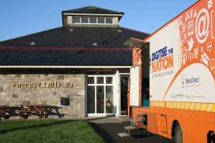
The Digitise the Nation mobile training facility delivered free internet classes at St Killian’s Heritage Centre (Mullagh) and also in Bailieborough and Belturbet in October 2013.
Action 5.2: Interactions at community level
Lead partner: Breffni Integrated Limited
Steps taken & progress:
This action has yet to commence.

Action 5.3: Participation in social, cultural and community activities
Lead partner: Cavan County Council and Community Forum
Steps taken & progress:
Bealtaine Arts Festival ran in May 2013
County Museum programming for older people is ongoing. The Museum hosts visits from social services groups. Discount rates apply for older people and group booking rates. In 2013 they hosted visits from older people from Bailieboro, Milltown and Kingscourt, as well as further afield such as Dublin and Northern Ireland.
The ‘100 Books’ initiative was launched by Cavan Library Service in 2013. It relates to equality across the 9 grounds protected by Irish equality legislation.
NCBI coffee morning takes place monthly for people with a visual impairment.
Age Friendly Library resources are available. Tax Forms and Relief Forms are available at the libraries.

Allotments & Community Gardens are being sustained in:

CAMCAS Ballyconnell
Fairgreen, Cavan Town
Bailieborough
Drumlane

In 2013 the Cavan Sports Inclusion Officer delivered:

3 programmes of Aqua Aerobics
Gentle Aerobics Classes held in Stradone and Drumlane
Active Adults SportsFest
New Age Kurling Day
Pitch and Putt Taster Sessions
Go For Life Games Workshop
Walk Active Programme in Ballinagh
Physical Activity Leader Training Course (PALS)
Gentle Yoga Classes in Ballymachugh
Line Dancing in Cavan Town

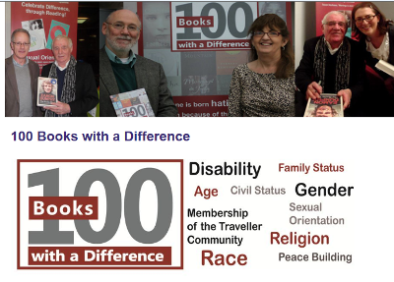
The ‘100 Books with a Difference’ initiative launched by
Cavan Library Service in 2013 which encourages people to think
differently about diverse communities including older people.

Theme 6 Communication & Information

Action 6.1: Awareness raising about the Age Friendly approach
Lead partner: Cavan 050 and Cavan Community Forum
Steps taken & progress:
Cavan Age Friendly display at Ageing Well Network conference in 2013
Older Person’s Forum Display at Virginia Show 2012
Age Friendly Audits were carried out in Gowna and Ballinagh (and previously in Cavan Town, Kilnaleck and Killeshandra).

Action 6.2: Information supports for older people at home
Lead partner: Cavan County Council
Steps taken & progress:
Septic tank leaflets were distributed in December 2013
SEAI booklets on keeping well and warm were distributed in December 2013
Information Session on septic tanks, fuel efficiency and grants were held in 2013 in 4 locations around the county.
The Older People’s Forum was created to improve communication. With this in mind a contact list has been established to provide members of the Forum with information.

Action 6.3: Citizens Information Programme
Lead partner: Citizens Information Service
Steps taken & progress:
This action has yet to commence.

Theme 7 Civic Participation

Action 7.1: Garda Schools Programme
Lead partner: An Garda Síochána
Steps taken & progress:
Action group for Cavan and Monaghan has been set up and comprises:
Sergeant Regina McArdle, Monaghan
Ms. Carol Lambe, Monaghan County Council
Ms. Majella Beggan, Principal of St Tiernach’s National School Clones
The group are currently examining the proposal to develop a 45 minute training module on Age Friendliness aimed at students in Primary and Secondary Schools. The module will covers issues around respect and stereotypes and will be organised by the Garda Community Officer. Work is on-going in this regard to prepare a draft proposal for the consideration of Assistant Commissioner Jack Nolan.

Action 7.2: Participation of retired staff
Lead partner: Cavan County Council
Steps taken & progress:
Retired staff are involved in the CRAIC Advisory Group (disability) and in the IDEAL Network (diversity).

Action 7.3: Engagement with private sector
Lead partner: Ageing Well Network and Cavan Age Friendly Alliance
Steps taken & progress:
Initial meetings have taken place between Ageing Well Network and Cavan County Council staff in relation to establishing Cavan Town as an age friendly business town. The Older Person’s Forum has also discussed this action and is willing to be involved.

Action 7.4: Development of an Age Friendly Business Forum
Lead partner: Older Person’s Forum and Cavan County Council
Steps taken & progress:
Discussions about an Age Friendly Business Forum have taken place but the Business Forum not been established yet.

Theme 8 Community Support and Health

Action 8.1: Research on the Doctor on Call Service
Lead partner: The Netwell Centre
Steps taken & progress:
Suzanne Smith commenced her research through Dundalk Institute of Technology on the health issues of older people in 2013 with specific focus on the North East Doctor on Call service. The findings are due in April 2014.

Action 8.2: Implement national programmes to improve health outcomes
Lead partner: Health Service Executive
Steps taken & progress:
A service manager for Older Persons was appointed in March 2013 and will provide strategic oversight to residential, community and social supports for older people in Cavan and Monaghan.
The HSE are working on an integrated plan called ‘Service Without Walls” which will ensure a seamless service for older people.
HSE have assisted with the funding for Men’s Sheds in Cavan and Monaghan.

Action 8.3: Increased focus on preventative care
Lead partner: Health Service Executive
Steps taken & progress:
HSE are planning for the implementation of rapid access clinics for older people who require rapid access to a consultant but do not require referral to and A&E Department.

Action 8.4: Review of acute care pathways and outpatient referrals
Lead partner: Health Service Executive
Steps taken & progress:
The opening of the medical assessment unit in Cavan Hospital has improved access for older people and has reduced the numbers of older people presenting to A&E.
The short stay unit in Cavan allows older people to be transferred from acute medical & surgical units while they wait e.g. funding for Nursing Home or Home Support package to be put in place.
Rehabilitation Beds in Monaghan Hospital allow people to be transferred from Cavan Hospital who can then avail of physiotherapy, occupational therapy etc. while in a non acute setting.

Action 8.5: Targeted health promotion activities
Lead partner: Health Service Executive
Steps taken & progress:
Service Manager for Older People has met with all voluntary groups in Cavan who have availed of funding from section 38/39 grants. Work will continue in 2014 to review the model of service provided by these groups and review sustainability.
In 2014 the Manager of Service for Older Persons will arrange a ‘Train the Trainers’ programme for these voluntary groups who will then deliver health promotion initiatives to the older people who attend.

Action 8.6: Telecare and Telehealth Initiatives
Lead partner: Health Service Executive
Steps taken & progress:
Plans are well underway for the recruitment of a Clinical Nurse Specialist for Older People who will work across the acute and community services focusing on hospital avoidance and maintaining older people at home.
Meetings have been held with staff in Dundalk Institute of Technology to review the Teaglacht Model of Care with a view to exploring the option of replicating this in Cavan and Monaghan.
HSE have been involved with a CAWT project which involved the installation of Telecare packages in the homes of 60 older people in Cavan and Monaghan.

Conclusion

The Cavan Age Friendly Alliance is satisfied that significant progress has been made in delivering the county strategy over the first 10 months of its operation. We will continue to focus our energies on the realisation of the ambition of Cavan as an age friendly county and look forward to reporting on further successes at the end of 2014.

Useful Numbers

Emergency requiring immediate assistance 999 / 112
North East Doctor on Call 1850 777 911
Cavan Garda Station 049 436 8800
Senior Helpline 1850 440 444
Citizen’s Information 076 1075 200
Alzheimer's Society – Cavan Branch 087 224 0963
Irish Wheelchair Association 049 437 1212
Health Service Executive Info 1850 24 1850
Cavan General Hospital 049 437 6183
Women’s Aid 1800 341 900
1 Life 1800 247 100
CUAN (Cancer Support and Wellness Group) 086 223 2877
The Samaritans 1850 609 090
Garda Confidential 1800 666 111
Good Morning Positive Age 049 437 2838
National Association of Widows 01 872 8814
SOSAD (suicide prevention) 083 423 9090
CONSOLE (Support for those bereaved by suicide) 1800 201 890
Cavan Older Person’s Forum (Secretariat) 049 437 8584

Notes

________________________________________________________________________________________________________________________________________________________________________________________________________________________________________________________________________________________________________________________________________________________________________________________________________________________________________________________________________________________________________________________________________________________________________________________________________________________________________________________________________________________________________________________________________________________________________________________________________________________________________________________________________________________________________________________________________________________________________________________________________________________________________________________________________________________________________________________________________________________________________________________________________________________________________________________________________________________________________________________________________________________________________________________________________________________________________________________________________________________________________________________________________________________________________________________________________________________________________________________________________________________________________________________________________________________________________________________________________________________________________________________________________________________________________________________________________________________________________________________________________________________________________________________________________________________________________________________________________________________________________________________________________________________________________________________________________________________________________________________________________________________________________________________________________________________________
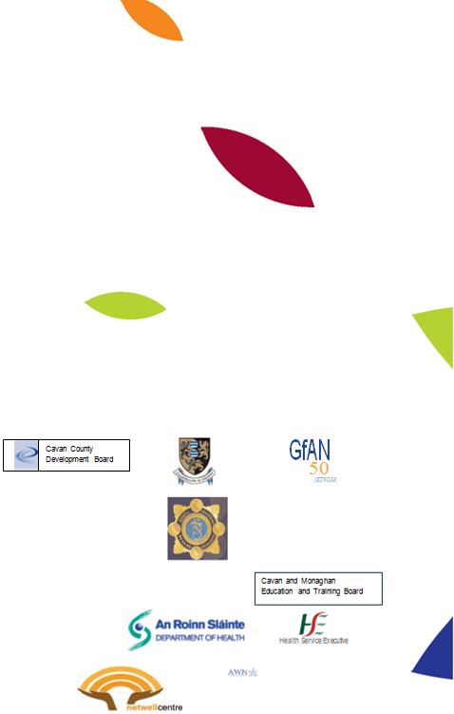
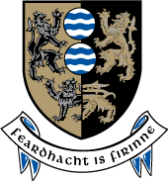




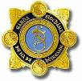

Cavan and Monaghan Education and Training Board
