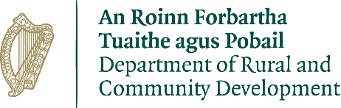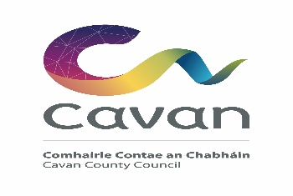

CLÁR Funding 2020 Project Application for
Measure 1: Support for Schools/Community Safety Measures

Local Authority Information ( Office Use Only)

Project Name:
Project Description: (Less than 50 words)
Indicative Priority given by LA (1- 10):
Contact Person:
Correspondence Address:
Correspondence Email:
Correspondence Telephone No.:
Project implementation directly by the Local Development Company (LDC) (Yes/No)
Please provide contact details, if applicable:

Local School/Community Group Information

School/Community Group Name:
Contact Person and position held:
Correspondence Address:
Correspondence Email:
Correspondence Telephone No.:

Project Information

School/Community Facility Name:
Location of proposed works, if different from above:
Are these works part of a larger project Y/N
If yes, please provide details:
Outline the nature and scope of the works:
Outline of the need and rationale for the works:

Was an application in respect of this facility approved under CLÁR in the past 3 years (Y/N)
If yes, please provide details.
Has an application for funding for this project been submitted to any other scheme or programme in the past (Y/N)
If yes, please provide details.

Please indicate the intervention(s) being applied for:

Type of Intervention |  | Possible Funding be allocated | to | Amount Sought | of | Funding
Purchase and replacement of  Flashing Amber Safety Lights. |  | Max €7,000 per set
Purchase of Child safety signs |  | Max €1000 per sign
Purchase of Digital Speed safety  signs, indicating that cars are entering a particular zone. |  | Max €14,000 per set
Upgrade Road markings approach roads  Schools/community facilities. | on to | Max €1,000
Erect pedestrian crossings in small towns and villages at  schools/community facilities. |  | Max €22,000
Construction and upgrading of access footpaths next to schools or  community facilities. |  | Max €30,000
Car Parking facilities to access  schools or community facilities. |  | Max €30,000
Provision of Bus Shelters |  | Max €25,000
Provision of Public Lighting |  | Max €30,000

COVID-19 safety related project (need and rationale must be demonstrated in the Project  Information section). | Max €50,000
Overall max per project if there are a number of elements above included in applications for a single  location | Max €50,000

Detailed Costings for Proposed Project:
Please provide detailed breakdown of all elements of the proposed works including any administration/other fees/costs:
Element 1, 2, etc.
Total Cost | €
Funding amount sought:  (Maximum 90% of total cost up to €50,000) | €
Match Funding:  (Minimum 10% of total cost) | €
Amount of Cash Contribution: (Minimum of 5% of total cost)  Supplied by(LA/LDC/Community/School/Philanthropic body): | €
Any other relevant information:

I confirm that the particulars of this application are correct and that

- The project is based in a CLÁR area
- Match funding is available and ringfenced for the project
- All necessary permissions are in place
- Evidence of ownership/lease is available (if applicable)
- The project conforms to the LECP and/or other local or regional plans, and
- No funding has been allocated for the same project from any other sources.

Signed on behalf of the Group:____________________________________

Date:______________________________

Proof of the above must be available to the Department or its agents on request.

Signed:
Local Authority Director of Services

Date:

