County Cavan Community and Sports Facilities Survey 2016

Compiled by: Cavan Social Inclusion Unit, Cavan County Council on behalf of the Cavan Local Community Development Committee

January 2017

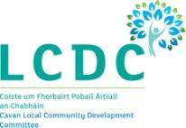

Acknowledgements

Thank you to all those who took part in this survey by taking the time to complete and return the questionnaires.

Gratitude is also extended to those who helped identify community and sporting premises within the county and piloted the initial questionnaire:

- Una Traynor, Breffni Integrated
- Sandy Holland, Breffni Integrated
- Angie Mc Kenna, Killeshandra Focus FRC
- Bernie Brady, Tullacmongan FRC
- Bob Gilbert / Daniel Downey, Public Partnership Network
- Nadine Mc Cormilla, Cavan Sports Partnership

Executive Summary

In November 2016, Cavan County Council commenced on completing an audit of indoor community and sports facilities within County Cavan. This was in response to a specific action contained within the Local Economic and Community Plan (LECP) 2016
- 2021, developed by the Local Community Development Committee (LCDC).

After widespread consultations125 community groups/organisations in ownership of a community or sports facility responded to the audit. This report sets out the findings from the audit. It examines in detail the extent of facilities available geographically but also inspects the overall management, usage and facility conditions.

While this report acknowledges that this would not be a representative figure of all the community and sports facilities within the county, it provides us with a good benchmark from which to work from and draw conclusions from. The following recommendations have been put forward from the findings received:

Key findings & recommendations

  - The ‘Community and Sports Facility Registration Form’, (please see Appendix 14 for a sample copy), should be used on an ongoing basis to develop a comprehensive database of all such facilities within County Cavan. New and existing facilities not already captured through this audit should be encouraged to complete the form in order to register their facility. Any facility applying for funding under any of the various funding programmes available within the county should also be asked to complete this form as part of the application process.
  - Distribution of community and sporting facilities and populations trends.
    - According to the findings there is a deficit of sporting facilities available within the West Cavan area as no sporting facilities were identified beyond Swanlinbar.
    - In terms of population growth, certain areas which have increased in population are lagging behind in terms of having suitable community and sports facilities to meet their growing needs. Particular areas of concern would include the areas surrounding the following large towns Kingscourt,

Ballyjamesduff, Mullagh and Virginia. These areas have all experienced significant population growth over the past few years.
    - There is a lack of facilities within Cavan Town to cater for the large number of sporting organisations operating there.
    - It is recommended that intensive support is provided for community and sporting groups within these identified areas in particular to support them to tap into funding opportunities available under Sports Capital and the newly launched ‘Realising Our Potential: An Action Plan for Rural Development’.
  - As in many rural areas, the GAA has a large presence within the county and sporting groups are relatively well catered for under this sport. However data collected from this audit suggests there is a deficit of non GAA sporting facilities within County Cavan, specifically around sporting activities such as soccer and athletics. The Local Economic and Community Plan (LECP) identified that we have a growing youth population which will result in increased pressure to provide an outlet for our young people through sport and the appropriate facilities. A specific action within the plan states that Cavan County Council is to ‘Develop a multi-purpose sports facility for the county’ and the findings from this report add weight for such a need.
  - Only 20 facilities are lined marked for sporting activities such as badminton, basketball, indoor soccer etc, only 36 facilities have an outdoor pitch available and only 10 facilities have an ‘All Weather Pitch’. These are very poor results reflecting the lack of sporting facilities available within the county. Given the adverse weather conditions that often occur in Ireland the availability of an all weather pitch and indoor sporting facilities are important for sporting and community organisations to have available locally. The management groups over these existing facilities should be supported to enhance the levels of sporting activities/facilities made available within their centres. The issue of health and well being is becoming an increasingly important aspect for our society and one which should be encouraged. It is recommended that Cavan Sports Partnership and other supporting organisations provide support to these
groups on how to develop sporting activities and facilities. This could be done by producing information packs and resources in hard-copy and electronic versions to distribute to groups in order to support and inform them on the process. This will provide more opportunities for people to engage in various sporting activities.

  - Due to the rural makeup of County Cavan many of the facilities are located within rural areas with limited access to public transport which prohibits people accessing them, particularly the marginalised or elderly. The Cavan Monaghan Transport Co-ordination Unit (CMTCU) has a ‘Once off Community Transport Fund’ which should be promoted to management groups over the facilities to avail of. The CMRTU have also given a commitment through the new Cavan Age Friendly Strategy 2017-2010 to explore the possibility of developing a Community Voluntary Car Scheme which could support people’s access to these facilities on more sustainable basis.
  - Only 50 facilities have access to broadband. The provision of broadband is an issue across the county and would be an important aspect of running any modern facility. There is currently a new Digital Strategy being developed for County Cavan, this along with the roll out of the National Broadband Plan and other Government Initiatives will enable communities across the county, particularly in rural areas to avail of high speed broadband.
  - There is a large reliance on voluntary staff members or the various community employment schemes to run the facilities, which would be expected. However to support this and perhaps improve the reliability and sustainability of obtaining dedicated committed volunteers for the facilities, the services of the newly established Volunteer Information Service should be availed of.
  - Almost all of the facilities (97%) have ‘Public Liability’ insurance, but few had cover for other important areas such as ‘Burglary Cover’, ‘Property Damage Cover’ or ‘Member to Member Liability’. Group insurance schemes may be an option for facilities to explore further, possibly assisted by the Cavan Public Participation Network (PPN).
  - Up to 69% of funding received by the facilities was reported as being self- generated through fundraising activities suggesting that the facilities are largely self-sufficient. However very few facilities replied that they apply for grant aid as a means to generate funds. If facilities are to develop and grow, rather than merely maintain current operations, investment in grant schemes is needed.
  - The facilities are doing reasonably well in terms of having the appropriate Health & Safety procedures in place for their premises. However there is room for improvement. For example, only 71% of facilities reported that they have a Fire Certificate for their premises, this is a necessary requirement for any facility to have once operating as a public building.

  - Up to 90 facilities reported that they would like to participate in Community Development Training. The delivery of this training is a specific action within the LECP, with Breffni Integrated leading out on it. Such training should specifically target these groups identified.
  - Only 12 facilities reported that they had a computer suite which can be used for training purposes. Equipping community centres with up to date information technology hardware and software is essential in reducing the digital divide and again could be something which can be addressed through the County Digital Strategy.
  - Space can be an issue for many of the facilities based within urban areas, with many having limited availability to meet the demands for their use, or in other cases, facilities do not have the sufficient room size available to cater for larger groups. As identified within the LECP there is a need for a new community hub to be developed within walking distance of Cavan Town, this presents itself as a reoccurring issue under various local consultations carried out. Other urban areas highlighted through this audit would include Ballyconnell and Ballyjamesduff.
  - Many facilities would have been newly built between 2001 and 2016 (33%), followed by 25% of the facilities being built pre-1900. However the majority of these older facilities would have had refurbishments works carried out. As a result of the high number of new builds and newly refurbished premises, the majority of facilities (86%) report that they were in either excellent or good condition.
  - The majority of facilities are open to the ‘general community’ to use. However more support needs to be provided to management groups over the facilities to advice on the development of equal usage policies and how to monitor the diversity of people using their facility. Active promotion within this area would help to ensure increased usage of the facilities by the young, unemployed, ethnic minorities, LGBT, disabled people etc. Also being able to demonstrate usage of their facilities by such target groups would also benefit the facilities in applying for funding support as supporting socially excluded groups is a funding requirement under many of the current funding sources currently available.
  - 85% of the facilities reported that they were wheelchair accessible. To strengthen this area further

    - The Age Friendly Business Programme, an action contained within the new Cavan Age Friendly Strategy, should also be made available for community & sporting facilities to participate on.
    - Cavan County Council’s Access Officer would also be able to provide advice and assistance to facilities on how to improve accessibility and this should be looked at in conjunction with the Walkability Audits which will be conducted through the Town Teams Initiative.
    - The Disabled Go Access Audit should also include community & sporting facilities.

Contents Page No.

Section 1: Introduction 1
Section 2: Baseline Population Data 3
Section 3: Methodology 7
Section 4: Spatial Analysis of Data 10
Section 5: Sectoral Analysis 16
Section 6: Conclusions & Recommendations 30

Appendices:

Appendix 1: Distribution of Community Facilities from the 2009 Audit Appendix 2: List of Survey Respondents
Appendix 3: Copy of the Community & Sports Questionnaire Appendix 4: ‘Other’ Type of Facility. (Question 2.1)
Appendix 5: ‘Other’ line markings for sporting activities (Question 2.2) Appendix 6: ‘Other’ Types of Outdoor Leisure/Sporting Facilities (Question 2.3) Appendix 7: ‘Other’ Indoor Facilities. (Question 2.4)
Appendix 8: ‘Other’ Ownership of the Facility (Question 3.2) Appendix 9: ´Other’ Types of Managements Structures (Question 3.1) Appendix 10: Income Generation (Question 3.5)
Appendix 11: ‘Other’ rooms available within the Facility (Question 4.1) Appendix 12: Estimated Budgets (Question 4.6)
Appendix 13: ‘Other’ users of the facilities (Question 5.1)
Appendix 14: Sample ‘Community and Sports Facility Registration Form’

Section 1: Introduction

The Social Inclusion Unit within the Community and Enterprise Section of Cavan County Council were assigned the task of conducting the “Survey of Community and Sports Facilities” within County Cavan. The completion of the survey was one of the key actions contained within the County’s Local Economic and Community Plan (LECP) 2016 – 2021 developed by the Local Community Development Committee (LCDC).
The need to either provide community and sports facilities or to make improvements to existing centres was a common theme across the various consultation sessions carried out for the LECP. The plan stated that in order to enable progress in this area, information must first be captured on groups currently operating and the facilities available in each local area. This audit of community and sports infrastructure will help to identify what is currently available at the local level within County Cavan. The analysis will enable identification of where new facilities are needed, or where facilities require upgrading, which will enable investment to be directed to communities on a priority basis.
The overall objectives of this survey were to:
- establish the current level of provision, management and usage of facilities.

- Inform future investment in community and sports facilities based on the outcome of the survey, having regard to identified local needs.

The survey also set out to update an audit of community and sporting facilities which was previously carried out by Cavan County Council in 2009 in response to a request from the then Department of Environment, Heritage and Local Government. The need for a comprehensive national audit was identified at the time through the consultation process undertaken by the Taskforce on Active Citizenship which had identified the lack of community facilities in which community activity could take place
as a major obstacle to community development. Therefore the Report of the Taskforce on Active Citizenship (2007) recommended that an audit of all community and sporting facilities be undertaken by Local Authorities to establish a detailed county - wide database collected at a local level. A copy of the map showing the distribution of all the

community facilities identified during this audit is included in Appendix 1 for reference purposes.
Problems exist in identifying and defining a true population of community and sporting facilities but none the less the survey was successful in capturing and authenticating the location of 125 indoor facilities. Please see Appendix 2, for all a full listing of all those who responded to the survey.

Section 2: Baseline Population Data

Cavan is divided into three Municipal Districts, illustrated in Figure 1 below. These are Bailieborough/Cootehill; Cavan/Belturbet; and Ballyjamesduff.

Figure 1 – Municipal Districts of Cavan

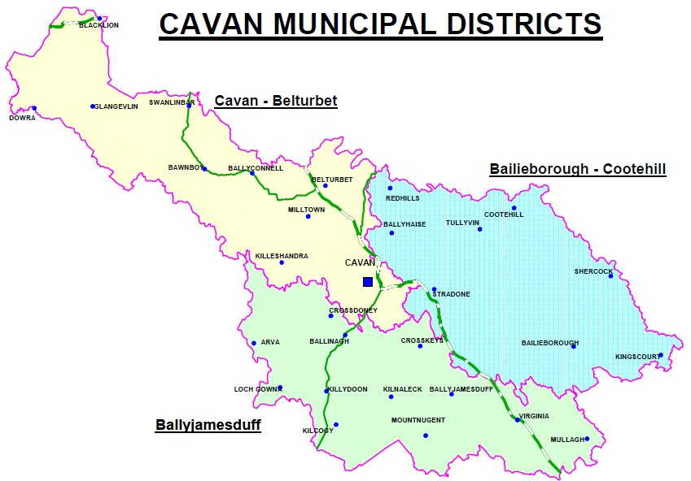

Cavan is a predominately rural county with 70% of the population living in
rural areas and very small settlements. This is in stark contrast to the State, where the majority of people (62%) live in urban areas. Nationally the proportion of people living in urban areas increased by 11% between 2006 and 2011.
As well as having a relatively high proportion of our population living in rural areas, Cavan‘s population density is also relatively low. The population density of County Cavan in 2011 was 39.43 persons per square kilometre, having increased from 34.48 in 2006. The national average in 2011 was 67 persons per square kilometre.
Census 2011 data shows varying geographical trends throughout the county. The population of the east of the county continues to grow at a faster rate than that of the

west. Some areas close to larger towns in the east have experienced a significant rise in population. For example, the Mullagh Electoral Division (ED) experienced a 40.6% and Ballyjamesduff ED a 39.9% growth in population from the 2006 to 2011 censuses. Other more remote and economically weaker areas have experienced population decline, for example in west Cavan near Dowra and Glangevlin, the Derrylahan ED had a population decrease of 20% and Teebane ED 17.1%.
Figure 2: Total Population in Cavan Electoral Divisions 2011
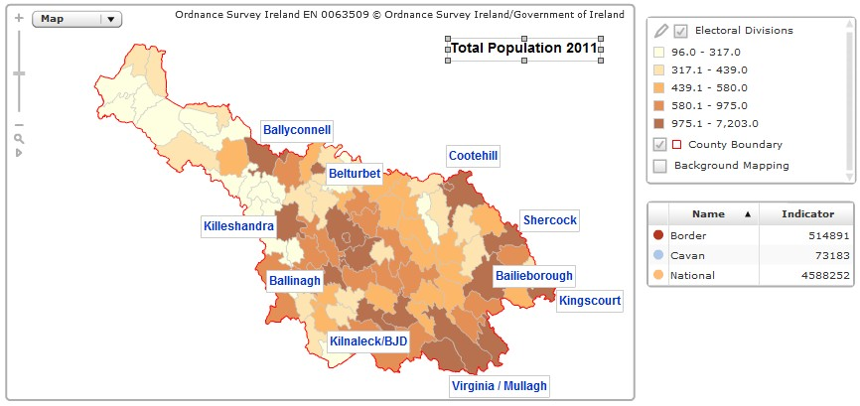
Source: AIRO Maynooth

Table 1 illustrates the hierarchy of settlements in the County Cavan according the Cavan County Council’s County Development Plan 2014 -2020.

Table1: Hierarchy of Settlements in County Cavan

Status | Name | Population
Tier Six  (Small Villages) | Bawnboy Dowra Kilcogy Stradone Redhills Mountnugent Crossdoney  Crosskeys | No census data
Tier Five (Villages) | Loch Gowna Swanlinbar Blacklion  Butlersbridge | Under 300
Tier Four (Small Towns) | Killeshandra, Arva Kilnaleck Shercock Ballyhaise  Ballinagh | Under 1,000
Tier Three  (Medium Towns) | Mullagh, Belturbet, Ballyconnell | Over 1,000
Tier Two  (Large Towns) | Bailieborough, Ballyjamesduff,  Cootehill, Kingscourt, Virginia | Over 2,000
Tier One  (Principle Town) | Cavan | 10,000

Population distribution and density is an important element in considering the provision of community and sporting facilities in County Cavan. Services should follow population growth and change.

Population Changes

The population of the county grew by 14.3 per cent between 2006 and 2011, nearly twice the growth rate for the State at 8.2 per cent. The population of the Border Region grew by 9.9 per cent in the same period.

Figure 3 shows the percentage population changes in Cavan Electoral Division between 2006 and 2011. It is clearly evident that the population of the East of the County continues to grow at a much faster rate than that of the West. One of the biggest challenges we face is continuing to recognise and support the rural nature of the county while at the same time supporting the continued development of our towns and villages.

Figure 3: Percentage population change in County Cavan 2006-2011
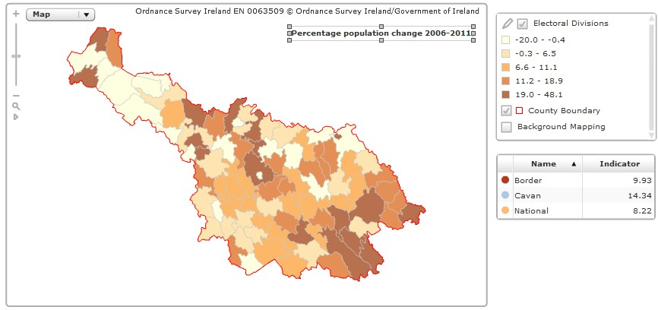
Source: AIRO Maynooth

Section 3: Methodology

Definition of a Community Facility

It is easier to identify a sporting facility but an indoor facility can be harder to define. For the purpose of this survey the following definition is used to define a community facility, as stipulated in the 2009 Community Facility Audit by the then Department of Environment, Heritage and Local Government.
A ‘community facility’ is any indoor building or part thereof, which allows individuals to engage in active citizenship and where people gather to engage in voluntary activities of a civic or recreational nature with a view to creating a sense of community’.
The remit of this survey was widened from the last community survey in that sports facilities and any public building available for community groups to use were also included within this survey. The following requirements were used to determine the types of facilities to include in the survey.
  - They must be built indoor facilities (not necessarily purpose built)
  - They must be run on a ‘not for profit’ basis therefore excluding pubs, hotels, etc

Various other facilities were excluded from the survey such as schools, health centres, outdoor amenities, hospitals etc.
Identifying Community & Sporting Facilities

The first step was to use the databases from the previous communities and sports audit conducted in 2009 to identify community and sporting facilities within the county. To update this audit in-house consultation were carried out with personnel of Cavan County Council including the arts section, sports and community and enterprise sections. The local development company Breffni Integrated Ltd, the two Family Resource Centres and the Public Participation Network were also consulted. Once the survey commenced widespread public advertisement was used to encourage a good response rate and encourage those community groups in ownership of facilities not already identified to come forward for inclusion.

Research Method

The main method adopted for the survey was a ‘Survey Questionnaire’. The survey questionnaire dealt with size, location, facilities available, condition and management of facilities. A copy of the questionnaire drafted is attached in Appendix 3. The survey was posted out to the pre-identified database of community & sports facilities with a pre-paid, stamped addressed envelope enclosed for completed questionnaires to be returned. The survey was also uploaded onto Survey Monkey and respondents had the option of completing the form through this means also.

Data analysis

Data was inputted into Survey Monkey and MapInfo database for analysis. Outputs included charts, tables, maps and statistics.

Report writing

The report was drafted and published by the Social Inclusion Unit within Cavan County Council.

Data received was analysed both spatially and sectorally.
- Spatially - it was necessary to determine where community and voluntary infrastructure is located around the county and to determine how spatially accessible it is to concentrations of the populations in different towns and areas.
- Sectorally - it was essential to examine how accessible this infrastructure is for a number of key sectors of the population and how well their needs are being met.

Approach

In consultation with the Community and Voluntary Sector Cavan County Council drafted a research methodology aimed at maximising questionnaire returns. This was facilitated through:

- Liaising with personnel of Breffni Integrated Ltd, the two Family Resource Centres and the Public Participation Network.
- Circulating a press release in the local newspaper.

- An advertisement and copy of the questionnaire was placed on the following local websites: Cavan County Council, the PPN and westcavan.ie. Also using social media sources to promote the survey.
- One hundred and sixty questionnaires were directly issued to groups identified as having ownership over community and sporting facilities within the county. A pre-paid stamped addressed envelope was enclosed for easy return of completed forms.
- Survey Monkey was also used and advertised as a method for questionnaire completion.
- For all unreturned questionnaires, follow up telephone calls were made with some telephone interviews being carried out where necessary.

Section 4: Spatial Analysis of Data

In this section the information collected is visualized spatially using GIS. Analyzing access to and distribution of facilities is key to ensuring that all communities have adequate facilities. As such this audit analyses the data gathered on facilities spatially using mapinfo programme. Mapinfo is a GIS programme used for the mapping of data.

For the purpose of analysing data spatially three maps have been generated:
- Geographic location of facilities
- Demographic movement
- Sports Groups in Cavan Town & Current Sporting Facilities Available Geographic Location
Figure 4 displays the current level of provision of facilities within the county broken down by the type of facility. The map displays the location of the identified 125 facilities by facility type. So there are 76 ‘Community’ facilities, 26 ‘Sports’ facilities and 23 ‘Community & Sports’ facilities plotted on the map.

The map demonstrates a fairly even distribution of facilities throughout the county; however it can be seen that there is a lack of community and especially sporting facilities in particular to the west of the county when compared to the central and east areas.

County Cavan Community & Sports Facilities Survey 2016

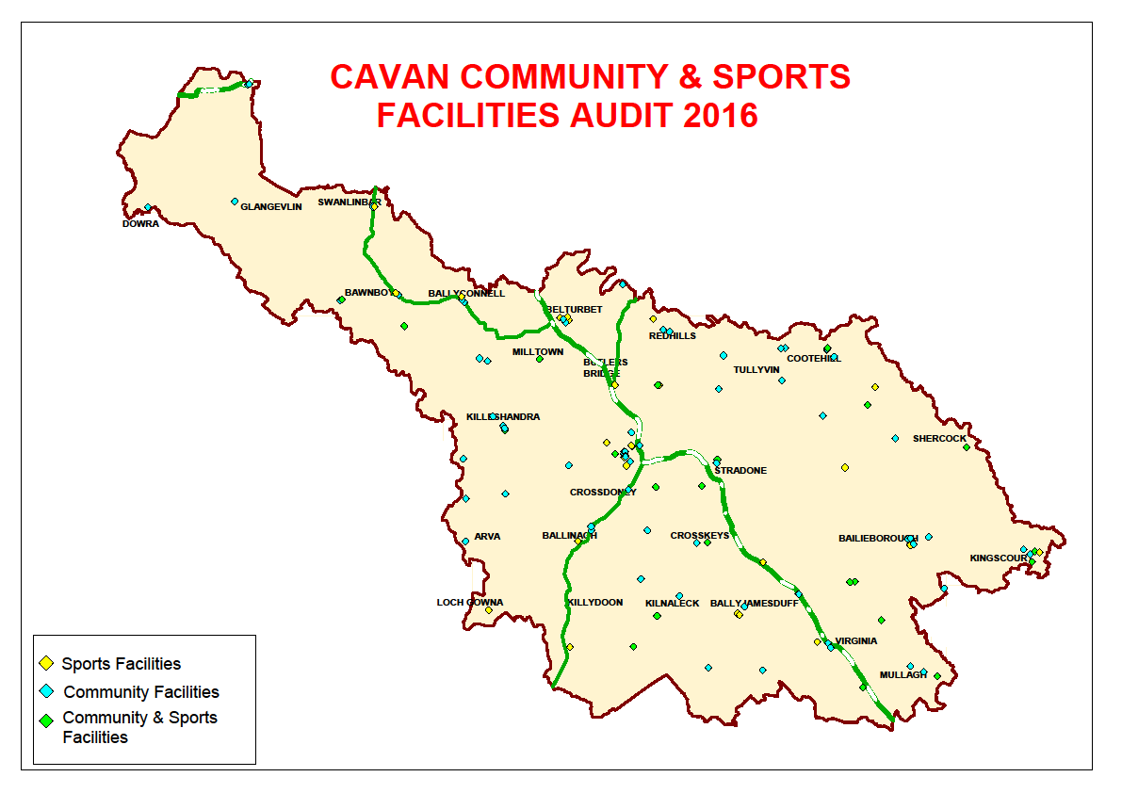
Figure 4: Geographic distribution of the facilities

11

County Cavan Community & Sports Facilities Survey 2016

Demographic Movement

Figure 6 demonstrates the population changes within the county over the last census period 2006 to 2011. It highlights that certain areas of the county are falling behind in terms of meeting the need for new facilities to match their growing population levels. Particular areas where this is very obvious are those located along the southern eastern border of the county where there has been a significant increase in the population levels. The electoral divisions of Enniskeen, Lisagoan and Taghart (surrounding the Kingscourt electoral division) all show large increases in population but are not serviced by any facilities. Munterconnaught also had no reported facilities. The town of Ballyjamesduff has also experienced a large increase in its population however it still has, according to the findings of the survey, only one community centre to cater for the needs of this area.

12

County Cavan Community & Sports Facilities Survey 2016

Figure 6: Population changes
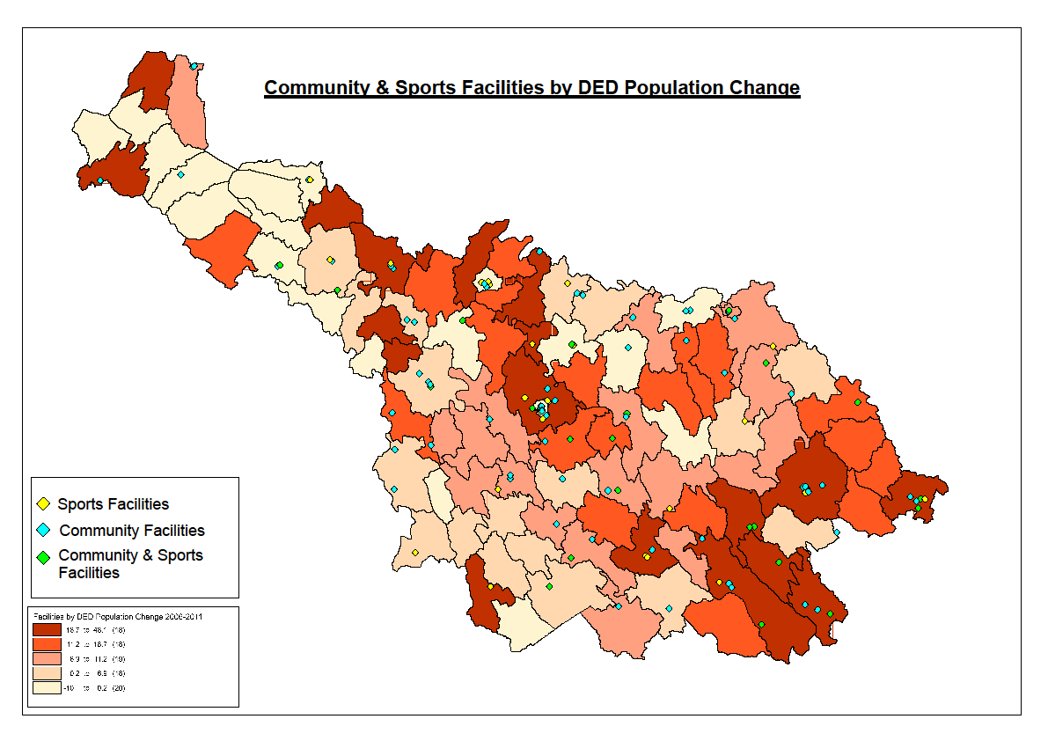

13

Distribution of Sporting Group/Organisations within the Cavan Town Boundary and Sporting Facilities Available

It was decided to carry out a more in depth analysis into the Cavan Town area as it would have one of the largest concentrations of sporting groups/organisations within the County. As of January 2016 Cavan Sports Partnership had 26 sporting groups based in Cavan town registered with them. These groups are displayed on Map 5 against those facilities within Cavan Town which identified themselves as sporting facilities, 6 in total. As the map demonstrates there is clearly a lack of sporting facilities available within and around the town to meet the needs of all the sporting groups based there. Also many of those sporting facilities that are available only cater for one type of sport only, with the exception of the Cavan Sport and Leisure CLG (Cavan Leisure Centre).

Figure 5: Sports Groups in Cavan Town & Current Sporting Facilities Available

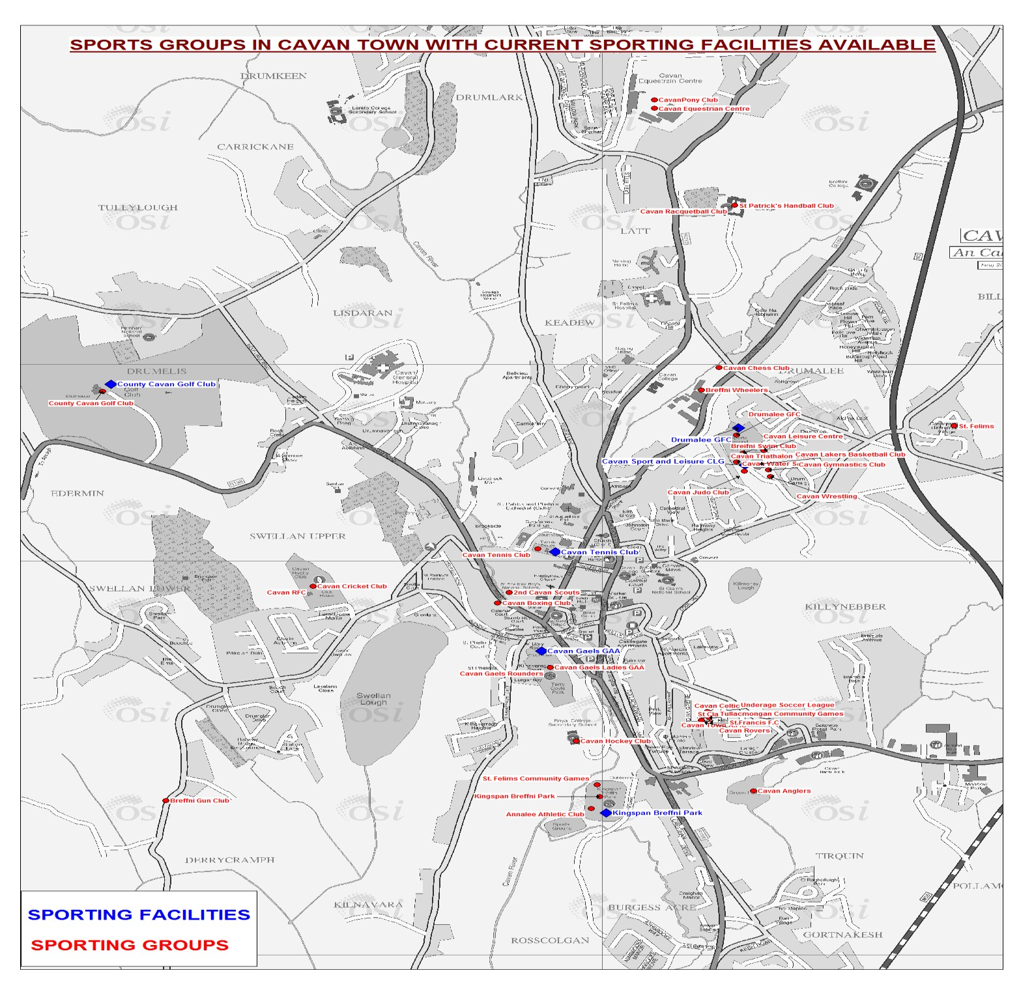

Section 5: Sectoral Analysis

The aim of this section of the report is to outline the physical community resources available across the county for activities, sports and recreational events, social interaction and meeting spaces.

It will examine in detail the findings from the survey questionnaire used under the headings:
- Facilities provided
- Ownership / Management
- Size and Condition of the Facility
- Facility Users

Facilities Provided

This will examine what types of facilities responded to the survey and what they had available for communities to use.

The majority of those who responded to the survey described their facility as a ‘community facility’ 43%, 21% were ‘community and sport facilities’ and 19% were ‘sports facilities’. Thirteen percent of facilities described themselves as ‘other, and these included public libraries, heritage centres etc. A full listing of the other types of facilities can be found in Appendix 4.

Figure 7: Type of Facility
Type of Facility
Community facility Sports facility Community & sport facility Childcare facility
Social Enterprise facility Other (please specify)
2% 2%
13%
43%
21%
19%

Of those facilities which indicated they were line marked for sporting activities the majority were line marked for badminton, followed by indoor soccer, basketball or handball, as displayed in Figure 8. A list of ‘Other’ responses can be found in Appendix 5.

Figure 8: Facilities lined marked for activities
Hall Markings for Sporting Activities
80.0%
70.0%
60.0%
50.0%
40.0%
30.0%
20.0%
10.0%
0.0%
Basketball
Indoor Soccer
Badminton
Handball

Outdoor Activities
30% (36) of facilities have an outdoor pitch. Of these the majority are GAA pitches (32).

Figure 9: Type of Pitch
Type of Pitch
Soccer Rugby GAA

20%
7%
73%

Almost all of those facilities which indicated they have an outdoor pitch also have a spectator’s stand (33) and floodlighting (31).

Table 2: Type of Outdoor Facility

Type of Outdoor Facility | Number | Percentage
‘All Weather Pitch’ | 10 | 10%
Spectator’s Stand | 33 | 33%
Floodlighting | 31 | 30%
Walking/Running Track | 26 | 25%

Respondents were asked what other type of leisure or sporting facilities were available at their premises. The most common response received was playgrounds, followed by handball alley and tennis court, as illustrated in Figure 10. Respondents were invited to indicate ‘other’ outside facilities available and those put forward included, training pitch areas, recreation/gardening areas, outdoor gyms etc. A full listing can be found the Appendix 6.

Figure 10: ‘Other’ outdoor leisure/sporting facilities
Other outdoor leisure/sporting
facilities available
Playground Tennis Court Handball Alley
22%
17%
61%

Indoor Facilities
Almost all of the facilities (97%) have toilets available, followed by a kitchen 81% and furniture, 78%. For a listing of ‘Other’ indoor facilities given please see Appendix 7.

Figure 11: Types of facilities available within the premises
Does the facility have access to the following?
120.0%
100.0%
80.0%
60.0%
40.0%
20.0%
0.0%

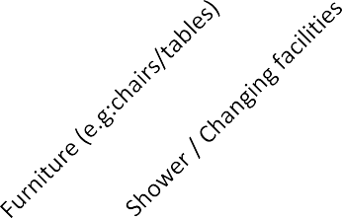71% (87) of facilities responded that they can provide catering if requested.

Car Parking & Transport
The majority of facilities 31%, (38) had between 11 to 50 car parking spaces available for people using their facility. The full response to this question can be seen in Figure 12.

Figure 12: No. of car parking spaces
Number of parking spaces provided at the facility
0-10 11-50 51-99 100+
18%
26%
25%
31%

58% (69) facilities have bus parking available.

28% (34) are serviced by public transport. Only 2 facilities had their own bus.

Broadband
Under half, 41% or 50 facilities, have access to broadband and of these 42 make it available for users to access through Wi-Fi.

Ownership / Management

This section of the survey looked at the issue of who has ownership of the facilities and who manages them. It also enquired into the operations of the facility and health and safety procedures followed.

The most common form of ownership of the facilities was in the form of a community organisation (31%), followed by the parish/church (28%). A listing of the ‘other’ types of ownership can be found in Appendix 8.

Figure 13: Ownership of the facility
Ownership of the facility
Community Organisation Sports Club
Parish/Church Owned
Local Authority
Other (please specify)
7%
13%
31%
28%
21%

Figure 14 displays how facilities are managed. The majority (39%) responded that they are managed by a ‘club or association’, followed by 29% of facilities being managed by a ‘company Ltd. by guarantee’. While many of the facilities may be actually owned by the church/parish as the previous findings suggest only 18% of them stated that in terms of management they were ‘vested in the parish’. This indicates that many of the facilities while being owned by the church/parish are actually run independently by a

local community or voluntary committee who may not be necessarily affiliated to the local parish committee or church. The ‘other’ types of management structures described can be seen in Appendix 9.

Figure 14: Management Structure
Management Structure
Company Ltd. By Guarantee Club or Association
Club Vested In Parish
Other (please specify)
13%
30%
18%
39%

Staffing Levels
The majority of facilities (41%) have voluntary staff, with only 11% having full-time paid staff members.

Figure 15: Staffing Arrangments
Staffing Arrangements
Full-Time Staff Part-Time Staff Voluntary Staff
Work Experience Scheme Staff (e.g. Tus, CE)

11%
32%
16%
41%

Opening Times
The majority of facilities indicated that they are open to the public 30+ hours per week (53%).

Figure 16: Hours opened to the public
Hours per week the facility is opened
to the public
0 - 10 10 - 20 20 - 30 30+
19%
53%
17%
12%

The facilities are opened at varied times with the majority stating that they mostly open during the evenings (29%) and weekend (25%).

Figure 17: Times the facility is opened
Times the facility is opened
Mornings
Afternoons
Evenings/Nights
Weekends
25%
23%
29%
23%

Insurance
The questionnaire asked respondents to specify the types of insurance policies they held on their premises. All those who responded stated they had some form if insurance policy with almost all having ‘Public Liability’ 97%, followed by ‘Property Damage Cover’ (41%) being the most common types of insurance policies held. Table 3 provides a full breakdown of the various types of policies held by the facilities.

Table: 3: Types of Insurances

Type of Insurance | Number | Percentage
Public Liability | 117 | 97%
Employer Liability | 36 | 30%
Burglary Cover | 22 | 18%
Money Cover | 13 | 11%
Property Damage Cover | 49 | 41%
Product Liability | 5 | 4%
Member to Member Liability | 6 | 5%
Business Interruption | 2 | 2%

Income Generation
In terms of generating an income for the ongoing maintenance and upkeep of the premises the majority of facilities obtain this from a mix of self-generated sources. Fundraising activities would be the most common method used with 69% of facilities carrying out such activities, followed by room rental charges (54%). Only 13 facilities replied that they apply for grant aid under ‘other’ sources of income described. For a full list of ‘other’ sources of income please refer to Appendix 10.

Figure18: Types of income generated
Types of income generated for the facilities
80.0%
70.0%
60.0%
50.0%
40.0%
30.0%
20.0%
10.0%
0.0%
Room rental Catering charges Facilities use
Fundraising Other (please
activities specify)

Health & Safety
Almost all of the facilities (80%) have an exit strategy in case of a fire. The majority of facilities had a Health & Safety Policy (76%).

Figure 19: Health & Safety Procedures
Health and Safety Procedures
90.0%
80.0%
70.0%
60.0%
50.0%
40.0%
30.0%
20.0%
10.0%
0.0%
Health & Safety Designated H&S Fire Certificate Fire Safety Policy Exit strategy in
Policy Officer the case of fire

Ninety or 74% of the facilities said they would be interested in participating in Community Development training if it were offered locally.

Size & Condition of Facilities

This section of the survey sought to obtain information on the condition of the facilities, if they had any plans to develop further or refurbish and gain a rough estimate as to their capacity.

The majority of facilities have a kitchen (85%). Only 11% have a computer suite available for members of the public to use for training purposes. For a listing of ‘Other’ rooms available within the facilities please see Appendix 11.

Figure 20: Types of rooms available
Rooms available within facilities
100.0%
90.0%
80.0%
70.0%
60.0%
50.0%
40.0%
30.0%
20.0%
10.0%
0.0%
Computer suite
for training
Kitchen
Sports/Function
Hall
Office
Storage

Almost all of the facilities would have a meeting room available for use with 86% (103) of facilities replying positively to this.

An analysis was made into when the facilities were built and 33% (40) were built between 2001 and 2016, followed by 25% (31) of facilities reported as being built pre- 1900. So the majority of facilities are either newly built or are quite old. The full list of responses can be seen in Figure 21.

Figure 21: Construction period
Construction Period
Before 1900 1901 – 1920 1921 – 1940 1941 – 1960
1961 – 1980 1981 – 2000 2001 – 2016
33%
25%
5%
21%
5%
9% 2%

The questionnaire asked if any refurbishment works have taken place on the facilities and 35% of the respondents indicated that their facilities have been refurbished within the last 5 years.

Figure 22: Year refurbishment
Year of Refurbishment
Last 20 years
Last 15 years
Last 10 years
Last 5 years
35%
25%
17%
23%

When asked about the condition of the facilities the majority (45%) were deemed to be in ‘good’ condition’, with only 4 facilities reported as being ‘in need of significant repair’.

Figure 23: Condition of facilities
Condition of facilities
Excellent
Good
In need of repair
3%
In need of significant repair
11%
41%
45%

49% (59) of the facilities indicated that they have plans to develop their facility in the near future. 45 facilities stated the nature of these works, with 24 saying they plan to carry out refurbishment works and 21 saying they’d wish to extend.

Thirty three facilities provided an estimate of the budget needed to carry out these works. Please refer to Appendix 12 to read see a full listing of the replies received ranging from €20,000 to €250,000.

Facilities Users

This section of the survey sought to identify who within the local community uses the facilities and investigate the diversity/equality policies and procedures the facilities adhere to. It also assessed how accessible the facilities are for those with disabilities.

Figure 24 displays the primary target groups of the facilities. The vast majority (78%) make their premises available to the general community for use. 13% of the respondents replied ‘other’ to this question. These related to those premises which provide a particular service to a targeted community, such as for example, the disability sector or particular sporting group members. In other cases they were only available to particular religious communities, such as the Protestant or Presbyterian community. For a full listing of ‘other’ users of the facilities please refer to Appendix 13.

Figure 24: Primary Target Groups
Primary Target Groups
General Community
Older People
Other (please specify)
Young People
Only service users of your organisation
5%
13%
2%
2%
78%

Diversity/Equality
The Equal Status Act 2000 takes the concept of equality identified in the Employment Equality Act 1998 beyond discrimination in the workplace and into the public arena where people buy goods, use services, obtain accommodation and attend educational

establishments. These acts prohibit discrimination on nine grounds: Gender, Marital Status, Family Status, Sexual Orientation, Religious Belief, Age, Disability, Race, and Membership of the Traveller Community.
In relation to community and sports facilities this would impact by refusing membership, terminating membership or providing alternative terms of membership. The questionnaire sought to determine what provisions the facilities had to the above.
Forty nine percent of respondents monitor the diversity of people using their facilities. 27% have an equal usage policy. 57% offer special discounts for disadvantaged groups or low income groups.

Table 4: Diversity/Equality Procedures

Diversity/Equality Procedures | Number | Percentage
Monitor the diversity of people | 59 | 49%
Equal usage policy | 33 | 27%
Offer special discounts | 66 | 57%

Accessibility
To determine how accessible the facilities audited were, the questionnaire requested information on whether they made reasonable provision for people with disabilities.
The majority of the facilities positively responded, with 85% stating that their facility is wheelchair accessible. These facilities were asked to describe further the type of accessible features available at their premises and the results received can be read in Table 5 below.

Table 5: Accessibility

Accessibility Features | Number | Percentage
Designated parking spaces | 55 | 51%
An accessible route (car park to entrance) | 105 | 93%
Primary front door accessible | 98 | 86%
At least one accessible toilet | 97 | 87%
An induction loop | 5 | 4%

In order to get an idea of the catchment area served by the facilities they were asked to choose an appropriate geographical level. The catchment area for the majority of facilities is local, at the Parish boundary 33%.

Figure 25: Catchment area of facilities
Catchment area of facilities
Parish boundary Village and environs
Town and environs County Wide Regions within the county Regional or National
2%
10%
33%
17%
23%
16%

Section 6: Conclusions & Recommendations

This report aimed to provide an audit of existing, community and sports facilities serving the County of Cavan. As previously acknowledged within this report this would not be a definitive listing of all the community and sports facilities within the county as not all facilities replied to the survey. However the data collected from the survey, along with local knowledge and other data sources available can be used to draw conclusions and put forward recommendations on the supports and development needs of the community and sports facilities sector within the county.

In order to develop a comprehensive database on all the community and sports facilities within the county on an ongoing basis, one of the first recommendations this report would put forward is that a ‘Community & Sports Facilities Database Registration Form’ is produced. Any new facility and those not already included within this latest audit should be encouraged to complete this form. Facilities may be more willing to complete a short one page form rather than respond to a lengthy survey so this will enable the identification of such facilities to be made more easily. This form should be made readily available by all the relevant organisations within the county for distribution such as Cavan County Council, Breffni Integrated, PPN, Sports Partnership, Leader etc. Cavan County Council would be responsible for maintaining and updating the database.

Distribution of the Community Facilities / Geographic Analysis

The west of Cavan is lacking in community facilities once compared to other parts of the county. However it can be said that the west of the county would not be as highly populated and therefore this would not serve as a particular disadvantage to the local communities in terms of accessibility to a community facility. What would be of concern however is that there are very few sporting facilities located in the west of the county. No sporting facilities were identified beyond Swanlinbar from the audit.

When the distribution of community and sports facilities are considered against the background of population changes over the last inter-censual period it can be seen that certain areas which have increased in population are lagging behind in terms of

having suitable community and sports facilities to meet their growing needs. Ballyjamesduff is an area of particular concern along. From the audit only two sports facilities (both GAA and based a few miles outside the town) and one community facility was identified, which is the County Museum. The museum would not in be available exclusively for community use. Although they didn’t respond to this survey it is known that there are two other small community facilities within the town also.
However the population of Ballyjamesduff has grown substantially over the last census period and these findings would suggest that there are not enough facilities to cater for and meet this growing demand. The electoral divisions of Enniskeen, Lisagoan, Taghart are also areas of concern, as according to the audit neither of these divisions have a community or sports facility at all, despite showing significant increases within their populations. While the town of Mullagh itself appears to be well catered for, the hinterlands and neighbouring ED Munterconnaught with very few facilities available and increasing population levels. These emerging areas of need should been considered under the newly launched ‘Realising Our Potential: An Action Plan for Rural Development’.

Facilities Provided

The majority of facilities identified themselves as community facilities (43%), followed by a community and sport facility (21%) and only 19% of facilities identified themselves as a sports facility and the majority of these sporting facilities identified were found to be under the ownership of the GAA. The data collected from the audit backs up local knowledge that would suggest there is a deficit of non GAA sporting facilities within County Cavan, specifically around sporting activities such as soccer and athletics. The Local Economic and Community Plan (LECP) identified that we have a growing youth population which will result in increased pressure to provide an outlet for our young people through sport and the appropriate facilities. It specifically states as an action within the plan that Cavan County Council is to ‘Develop a multi-purpose sports facility for the county’ and the findings from this report should add weight for such a need.

Only 20 facilities responded that they were lined marked for sporting activities such as badminton, basketball, indoor soccer etc, only 36 facilities have an outdoor pitch available and only 10 facilities have an ‘All Weather Pitch’. These are very poor results to reflect the sporting facilities available within the facilities. Given the adverse weather

conditions that often occur in Ireland the availability of an all weather pitch and indoor sporting facilities are important for sporting and community organisations. More supports for facilities to improve their level of provision of sporting facilities and activities within the county are needed. The area of health and well being is becoming an increasingly important aspect for our society and one which should be encouraged. It is recommended that Cavan Sports Partnership and other supporting organisations provide support to community organisations on how to develop sporting activities and facilities. This could be done by producing information packs and resources in hard- copy and electronic versions to distribute to community organisations in order to support and inform them on the process.

Car parking is provided by the majority of facilities and this is adequately catered for with 31% of the facilities having between 11 to 50 car parking spaces and 25% having between 51 to 99 spaces. However 26% of facilities replied that they had limited availability, if any at all, and these would have been facilities located mainly within urban areas. Only 28% of facilities are serviced by public transport and just 2 facilities have their own bus. With so many of the facilities being based within rural locations the lack of public transport options could potentially prohibit groups such as the elderly and the young from accessing them. The Cavan Monaghan Transport Co-ordination Unit operates a ‘Once Off Community Transport Fund’. This fund is open for community groups to apply for on a once off basis but could only be useful for large scale events being held within the facilities. Car Pooling Schemes could be explored by older people’s groups such as the Older People’s Council under the remit of the Age Friendly Alliance to tackle this issue on a more sustainable basis.

The facilities audited seem to be well furnished with equipment and other such facilities such as access to toilets, kitchen facilities, furniture etc. However, only 50 premises stated that they had access to broadband. The provision of broadband is an issue across the county and would be an important aspect of running any modern facility. There is currently a new Digital Strategy being developed for County Cavan. This along with the roll out of the National Broadband Plan and other Government Initiatives will enable communities across the County, particularly in rural areas to avail of high speed broadband.

Ownership /Management

The majority of facilities are managed by a ‘club or association’ (39%) followed by a ‘company Ltd. by guarantee’. The high level of facilities managed by a ‘club or association’ would indicate a large percentage of voluntary contribution. The low percentage of facilities (18%) ‘vested in the parish’ would suggest a move away from the more traditional management structure.

In terms of staffing arrangements for the facilities, the majority are staffed either voluntarily or by staff members who are on work experience schemes such as TÚS, the CE scheme or the Rural Social Scheme. This demonstrates the importance of these schemes to voluntary projects on the grounds however they would not be sustainable in the long term as these schemes can only take on someone over a limited time period. In situations were facilities are finding it difficult to access volunteers they should register with the newly established County Cavan Volunteer Information Service. This service would be able to provide assistance to those facilities looking for volunteers.

Over half of those who responded (53%) indicated that their facilities were opened 30
+ hours per week. This suggests that the facilities are being well utilised by the local populations.

The types of insurances taken out for the facilities would largely depend on the nature of their activities. However there is a minimum requirement of public liability for facilities which almost all the facilities have (97%). However the facilities were less likely to have other types of insurance policies which would also provide important cover, such as Burglary Cover (18%), Property Damage Cover (41%). The rising cost of insurance can be an issue for some community groups and there is some anecdotal evidence to suggest that in some cases insurance companies have been known to decline to cover. Group insurance schemes may be a good option for facilities facing such problems to explore further, with assistance from the Public Participation Network (PPN).

Up to 69% of funding received by the facilities was reported as being self- generated through fundraising activities; this suggests that the facilities are largely self-sufficient.

However only 13 facilities reported that they would apply for grant aid to generate funds. If the facilities are to develop and grow, rather than merely maintain current operations, investment in grant schemes for rural and urban regeneration projects such as sporting and social amenities, and skills training is needed. There is currently a significant amount of grant aid available for projects. While this is encouraging, the application process for many of these funding streams has become increasingly complex along with the subsequent funding administration procedures required to be maintained by the successful applicants. In order to support the management groups over these facilities to access these funds training and advice should be provided to equip them with these necessary skills to successfully access these funds. It should also be born in mind however that while an increase in the amount of funding being made available can provide an amenities boost to local areas, sustainability must be the key if any progress is to be maintained.

In terms of health and safety procedures, having an ‘Exit strategy in the case of fire’ was the most commonly implemented procedure with 80% of premises having this, followed by 76% of facilities having a ‘Health & Safety Policy’. There is room for improvement within this area, only 71% of the facilities said they have a ‘Fire Certificate’ for their premises and this would be a basic requirement for all public buildings to have. The Building Control Regulations 1997 to 2013 provide, among other things, for a system of Fire Safety Certificates to show that building designs comply with fire safety requirements. If a facility is operating without a certificate it leaves itself open to prosecution under building control legislation. All the facilities should have these relevant health and safety requirements and procedure in place from the start if they are operating as public buildings.

Up to 90 respondents indicated that the committee running their facility would be interested in participating in Community Development Training. The delivery of this training is a specific action within the LECP, with Breffni Integrated leading out on this.

The local development company should target their training programmes towards these community groups or indeed develop specific training programmes to meet their needs.

Size & Condition of Facilities

Only 12 facilities had a computer suite which can be used for training purposes. Equipping community centres with up to date information technology hardware and software is essential in reducing the digital divide. Pilot initiatives in community centres could be undertaken.

Almost all of the facilities (86%) reported that they had at least one meeting room available for their local communities to use. This is an important resource to the long term sustainability of community facilities. They can often generate much needed extra income. However many of the facilities located within urban areas would be limited in the number of people they could cater for and if there was a large scale event to take place, space may serve to be a particular problem. This is particularly evident in Cavan Town where this need was also identified during consultations carried out for the Local Economic and Community Plan (LECP). The LECP has a specific action which identified the need for a particular community venue to be located within walking distance of the town which would be large enough to accommodate different groups and type of uses.

Many facilities would have been newly built between 2001 and 2016 (33%), followed by 25% of the facilities being built pre-1900. However many of these older facilities would have had refurbishments works carried out. As a result of the high number of new builds and newly refurbished premises, the majority of facilities (86%) report that they were in either excellent or good condition. This would suggest that the community and voluntary sector has been successful to date in leveraging both funding and support from relevant bodies such as Departments, State Agencies, Local Development Bodies and Cavan County Council, i.e. Dormant Accounts, LEADER, Local Authority Grants, PEACE funding etc.

Facility Users

The majority of the facilities (78%) surveyed stated that they are primarily available to the ‘General Community’ to use. However greater emphasis must be placed on the adoption of equal usage policies by facilities, as only 27% (33) facilities had this in place, while only 49% (59) monitor the diversity of people using their facility. Active

promotion of equal usage encourages participation for students, unemployed, ethnic minorities etc.

Accessibility is a necessary prerequisite to building better communities therefore it was decided to look at how accessible the facilities were for people with a disability. It was found that the majority of facilities were wheelchair accessible (85%). However there are opportunities to make further improvements within this area.
- The management groups over the facilities should consider participating on the Age Friendly Business Recognition Programme. This is a national programme developed by Age Friendly Ireland and while it has been primarily targeted at businesses, it would also be relevant for anyone operating a community facility to participate on. The programme looks at how access to facilities can be improved for older people and it also raises awareness in general around the needs of older people. With society’s ageing demographics, particularly in rural areas, this would represent a large proportion of people who use the facilities.
- Cavan County Council’s Cavan County Council’s Access Officer would also be able to provide advice and assistance to facilities on how to improve accessibility and this could be looked at in conjunction with the Walkability/Access Audits which are to be conducted through the Town Teams Initiative.
- The Disabled Go Access Initiative which Cavan County Council has signed up to should be extended to include community & sporting facilities also within the county. Through this initiative detailed surveys are conducted by experienced access surveyors to assess the overall accessibility of premises. This information is then put up on a public website for the public to view and avail of.

Appendices

Appendix 1: Distribution of Community Facilities in County Cavan from the 2009 Audit

Appendix 2: Survey Respondents

ID | Name of Facility
1 | Ashfield Parochial Hall
2 | Bailieborough Arts and Cultural Centre
3 | Bailieborough Business Centre
4 | Bailieborough Community Centre
5 | Bailieborough Community Resource House
6 | Bailieborough Leisure Centre
7 | Bailieborough Library
8 | Ballinagh Community Centre
9 | Ballyhaise Celtic Park
10 | Ballyhaise Community Centre
11 | Ballymachugh GAA Club
12 | Bawnboy Workhouse Ltd.
13 | Beckscourt Resource House
14 | Bellasis Church Hall
15 | Belturbet GAA Club
16 | Belturbet Library
17 | Belturbet Parish Snooker and Table Tennis Club
18 | Belturbet Railway Staion
19 | Belturbet Rowing Boat Club
20 | Belturbet Town Hall Civic Centre
21 | Billyhill/Knocknalosset Orange Hall
22 | Blacklion Market House
23 | Brackey Hall
24 | Bridge Street Centre Cavan
25 | Bunnoe Community Centre
26 | Burrowes Hall
27 | Butlersbridge GAA Club
28 | CAMCAS Ballyconnell
29 | Castlemanor Community Centre
30 | Castlerahan Community Centre
31 | Castlerahan GAA Club
32 | Castlesaunderson International Scout Centre
33 | Cavan Box Park (Ballyjamesduff AFC)
34 | Cavan County Museum
35 | Cavan Gaels GAA
36 | Cavan Presbyterian Church Hall
37 | Cavan Public Participation Network Cana House
38 | Cavan Regional Health Sport and Leisure CLG
39 | Cavan Tennis Club
40 | Church Street Centre
41 | Cootehill Community Childcare
42 | Cootehill Library
43 | Corlisbrattan Methodist Old School Hall
44 | Corlough Community Centre
45 | Corlough GAA Club

46 | Corwillis Mission Hall
47 | County Cavan Golf Club
48 | County Cavan Rugby Club
49 | Crosserlough Community Centre
50 | Crossreagh Community Centre
51 | Denn Resource Centre
52 | Dowra Resource centre
53 | Drumalee GFC
54 | Drumavaddy Community Centre
55 | Drumcor Community Centre
56 | Drumgoon Eire Og
57 | Drumkeeran Church Hall
58 | Drumkilly Hall
59 | Drumlane Community Centre
60 | Drumlin House Training Centre
61 | Drummartin Hall
62 | Drung Parish Hall
63 | Events Space Johnston Central Library
64 | Focus Family Resource Center
65 | Gallonray House
66 | Gowna GAA Club
67 | Irish Wheelchair Association
68 | Kildallan Community Hall
69 | Kildallon GAA Club
70 | Kildallon Sunday School
71 | Killeshandra (Croghan) Church Hall
72 | Killeshandra Community Council Resource Centre
73 | Killeshandra GAA Club
74 | Killinkere Leisure centre
75 | Killinkere Parish Hall (Church of Ireland)
76 | Killoughter Hall
77 | Killygarry GAA Club
78 | Kilmore Docesan Pastoral Centre
79 | Kilmore Parish Hall
80 | Kilnaleck Community Hall
81 | Kingscourt Community Centre
82 | Kingscourt Harps AFC
83 | Kingscourt Stars
84 | Kingspan Breffni Park
85 | Knockbride GAA Club
86 | Lacken Celtic GAA Club
87 | Laragh Community Centre
88 | Lavey Community Centre
89 | Lavey GAA Club
90 | Mac Nean Community Resources Ltd.
91 | Maghera McFinns GAA Club
92 | Martin Memorial Hall

93 | Matt Talbot Hall
94 | Mountnugent Community Centre
95 | Mullagh Hall
96 | Mullagh Sports Centre
97 | Mullahoran GAA Club
98 | O'Raghilly Hall
99 | Portlongfield Orange Hall
100 | Realtog Centre
101 | Redhills GAA Club
102 | SOSAD
103 | St.Bridget's Community Centre (Gowna Community Hall)
104 | St.Kilian's Heritage Centre
105 | St.Mary's Brass and Reed Band
106 | St.Mary's Hall
107 | St.Matthews Park
108 | St.Michael's Hall
109 | St.Patrick's Community Centre Glangevlin
110 | St.Patricks Hall-Shercoco
111 | St.Patrick's Hall-Arvagh
112 | Stonepark Hall
113 | Stradone Community Centre
114 | Swanlinbar Community Centre (Trivia House)
115 | Swanlinbar St. Marys GAA Club
116 | Templeport Community Centre
117 | Templeport St. Aidens GAA Club
118 | The Billis Meeting Hall
119 | The Ozanam Centre
120 | Belturbet Town Hall Civic Centre
121 | Tullacmongan Resource Centre
122 | Tullyvin Community Centre
123 | Virginia Church of Ireland Hall
124 | Virginia Rugby Football Club
125 | Virginia Show Centre

Appendix 3: Community & Sports Questionnaire

County Cavan Community & Sports Facilities Survey 2016

This survey is designed to collect information on all facilities which are available for communities to use within the county. To be included in this survey such facilities are to be run on a ‘not for profit’ basis only. Privately run facilities such as hotels or pubs will not be included within the survey. For the purpose of this survey, we will not be including schools either.

Please complete and return this questionnaire by Wednesday 9th November, 5pm. The questionnaire can be completed and returned in the pre-paid stamped addressed envelope. Alternatively you can complete this survey on survey monkey at www.surveymonkey.com/r/Community-Sports-Survey-Cavan or email gboyle@cavancoco.ie. to receive a softcopy. All questionnaires returned by the deadline will be entered into a draw for €250.
Return to: Gráinne Boyle
Community and Enterprise, Cavan County Council, Farnham Centre,
Farnham St. Cavan
Co. Cavan

Section 1: Contact Details

  - Name of facility

  - Address of facility

  - Townland the facility is located in

  - Eircode

  - Telephone:

  - Mobile:

  - Email:

  - Website:

  - Name & address of contact person for the facility:

1.10. Would you like for your details to be placed on a public database?

Yes □ No □

SECTION 2: Facilities Provided
  - Is the facility a:Community Facility □ Community & Sport Facility □ Sports Facility □ Social Enterprise Facility □ Childcare Facility □ Multi-Purpose □ Other, please specify:

  - Is your facility line marked for the following sporting activities?

Basket Ball □ Badminton □

Indoor Soccer □ Handball □

Other, please specify:

  - Outdoor Facilities

- Has your facility an outdoor pitch? Yes □ No □

If Yes, how many?

- What type of pitches are they?

Soccer □ Rugby □ GAA □

- Have you an ‘all weather’ pitch? Yes □ No □

- Has your pitch a spectator’s facility? Yes □ No □

- Is there floodlighting? Yes □ No □

- Is there a walking/running track around the pitch? Yes □ No □

- Please indicate other outdoor leisure/sporting facilities available: Playground □ Tennis Court □ Handball Alley □ Other, please specify:

  - Does the facility have access to the following?

Toilets □ Accessible Toilet □

Kitchen □ Furniture (e.g: chairs/tables) □

Gym □ Shower/ changing facilities □

Stage □ Bar □

Other, please specify:

  - Can the facility provide catering if needed? Yes □ No □

  - Car Parking & Transport

(a) Number of parking spaces provided at the facility?

0 - 10 |  | □ 51 - 99 |  |  | □
11 - 50 |  | □ 100+ |  |  | □
(b) | Is bus parking provided? |  | Yes | □ No | □
(c) | Is your facility serviced by public transport? |  | Yes | □ No | □
(d) | Does your facility have its own bus? |  | Yes | □ No | □
2.7 | Does your facility have access to broadband? If yes, is Wifi available? |  | Yes Yes | - No  - No | □  □

SECTION 3: Ownership / Management

3.1 What type of management structure runs the facility? Company Ltd. by Guarantee □
Club or Association □

Club Vested In Parish □

Other, please specify:

3.2 | Who owns the facility?
 | Commercial  Community Organisation Parish/Church Owned | - Local Authority  - Sports Club  □ | □  □

Other, please specify:

  - Operations

    - Does the facility have any of the following?

Full -Time Staff □

Part -Time Staff □

Voluntary Staff □

Work experience Scheme Staff (e.g, Tus, CE) □

    - How many hours per week is the facility opened to the public?

0 - 10 □ 20 - 30 □

10 - 20 □ 30 + □

    - Is the facility open during the following times?

Mornings □ Evenings/Nights □

Afternoons □ Weekends □

  - Which of the following types of insurance do you have?

Public Liability □ Employer Liability □

Burglary Cover □ Money Cover □ Property Damage Cover □ Product Liability □ Member-To-Member Liability □ Business Interruption □

  - How do you generate income for your facility?

Room rental costs □ Facilities use □

Catering charges □ Fundraising □

Other, please specify:

  - In relation to health and safety would you have the following?

Health & Safety Policy □ Designated H&S Officer □ Fire Certificate □ Fire Safety Policy □ Exit strategy in the case of fire □

  - Would your group/organisation be interested in participating in Community Development Training? Yes □ No □

SECTION 4: Size & Condition of the Facility

  - What rooms are available within your facility?
Computer suite for training □ Kitchen □
Changing Rooms □ Sports Hall □
Office □ Storage □
Other, please specify:

  - Has the facility a meeting room? Yes □ No □

If Yes, how many meeting rooms?

Please specify the capacity of the biggest room:

Up to 20 people approx . □ Up to 50 people approx. □

If over 50 people, please specify:

4.3 | When was the facility | built?
 | Before 1900 | □ 1961 – 1980 | □
 | 1901 – 1920  1921 – 1940 | □ 1981 – 2000  □ 2001 – 2016 | □  □
 | 1941 – 1960 | □

4.4 | If the facility has been | refurbished, when did this happen?
 | Last 20 years □ | Last 10 years | □
4.5 | Last 15 years □  What would you state | Last 5 years  the facility’s condition to be in? | □
 | Excellent | □ In need of repair | □
 | Good | □ In need of significant repair | □

4.6 Have you any plans to develop the facility in the near future?

Yes □ No □

If Yes, please indicate the nature of the works to be undertaken. Refurbish □ Extend □

Other, please specify: Have you an estimated budget for the works?

SECTION 5: Facility Users

5.1 Please indicate which target group your facility is primarily available to: General Community □
Young People □

Older People □

Only service users of your organisation □
5.2  (a) | Other, please specify:  Diversity/Equality  Do you monitor the diversity of people using the facility?
(b) | Yes □ No  Do you have an equal usage policy displayed in the facility? |  |  |  | □
 | Yes □ No |  |  |  | □
(c). Do you offer special discounts for disadvantaged groups or low i  Yes □ |  |  |  | ncome g  No | roups?  □
Is the facility wheelchair accessible? Yes |  | □ | No | □

  - Accessibility

If Yes, please specify:
- Are there designated parking spaces for people with disabilities? Yes □ No □

- Is there an accessible route (i.e free from steps) from car park to the entrance of the facility? Yes □ No □
- Is the primary/front door entrance accessible, (i.e. level access)?
Yes □ No □

- Is there at least one accessible toilet available? Yes □ No □

- Is there an induction loop installed in the meeting room to assist people with a hearing impairment? Yes □ No □

  - What is the catchment area of your facility?

Parish boundary | □ County Wide | □
Village and environs | □ Regions within the county | □
Town and environs | □ Regional or National | □

Thank you for your time, your feedback is important.

Appendix 4: ‘Other’ Type of Facility. (Question 2.1)
    - Heritage Centre (x2)
    - Training Centre for People with intellectual disabilities
    - Library Building (x6)
    - Museum
    - Multi-purpose - exhibition arena also
    - Orange gospel hall
    - Band Rooms
    - Scouting Facility
    - Charity Based Organisation

Appendix 5: ‘Other’ line markings for sporting activities (Question 2.2)
    - Golf
    - Rugby football
    - Bowling (x2)
    - darts, juke box, table tennis
    - Additional Sports Facilitated
    - Table tennis
    - Volleyball
    - Football
    - air hockey, table tennis, softball
    - GAA games
    - Handball, GAA sports

Appendix 6: ‘Other’ types of outdoor leisure/sporting facilities (Question 2.3)
    - Training Pitch
    - Sand area which can be used for all weather training
    - Baseball and cricket
    - Walking & Gardening Facilities
    - Outdoor Bowling Green
    - Handball Wall & Hurling Wall
    - Recreation Garden & Outdoor Adults Gym
    - Astro-Turf
    - Outdoor Gym

Appendix 7: ‘Other’ Indoor Facilities. (Question 2.4)

    - Coffee shop
    - Soundproof studio
    - Moveable Stage
    - Stage Lighting/Sound
    - Shop/tourist information office
    - Reception, office & 3 counselling rooms & drop in area
    - Gallery
    - Computer suite & pool table

Appendix 8: ‘Other’ Ownership of the Facility (Question 3.2)
- Members Club
- Trustees (x2)
- Privately owned
- Private Lease in place
- Scouting Ireland
- Commercial
- Charity
- Belturbet Orange Order
- leased

Appendix 9: ´Other’ Types of Managements Structures (Question 3.1)

  - Cavan County Council (x5)
  - Co-operative Society (x2)
  - Ltd Company (x2)
  - Charitable Organisation (x3)
  - Diocesan Institution Board of Management

Appendix 10: Income Generation (Question 3.5)
  - Membership Subscriptions (x4)
  - Apply for grants (x13)
  - club lotto (x2)
  - Church offerings
  - Admission Charges
  - sponsorship, gate receipts
  - Funded by Dept &a Local Authority
  - Church funds (collections)
  - Weekly Bingo
  - gospel services
  - Voluntary submissions
  - meter box
  - The library does not generate any income generally but does charge for some events

Appendix 11: ‘Other’ rooms available within the Facility (Question 4.1)
  - One room with small kitchen and toilet
  - Men’s shed room
  - Event Space
  - gym, bar, hall
  - Therapy Rooms/Community House consisting of sitting room, recreational rooms, wetroom
  - cafe area, large arena
  - After School Club
  - Main bandroom, classrooms, music library
  - Counselling and drop in room
  - gym & cyrospa
  - Audio visual room, exhibition room
  - Youth cafe space with games, also meeting rooms
  - Gallery

  - Boardroom, multi-purpose space
  - Community childcare rooms

Appendix 12: Estimated Budgets (Question 4.6)
- €65,000
- €50,000
- €185,000
- €20,000 (x4)
- €100,000 (x2)
- €42,903, walking track, €53,859 bandstand, €31,000 medical room
- €70,000
- €250,000
- €500,000
- €130,000
- €150,000 (x2)
- €30,000 (x2)
- €200,000
- €250,000 (x2)
- €60 - €250,000
- €90,000
- €35,000
- €120,000
- €80,000

Appendix13: ‘Other’ Users of the Facility (Question 5.1)
  - Golfers
  - GAA Club Members (X3)
  - Presbyterian Community
  - Protestant Community
  - Disabilities Sector

Appendix 14: Sample ‘Community and Sports Facility Registration Form’
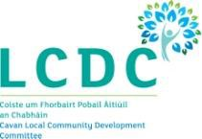

Community & Sports Facilities Registration Form

Name of Facility:
Organisation/Community Group who manages the Facility:
Address of the Facility:
Eircode:
Phone Number for the Facility (if available):
Contact Person for the Facility:
Contact Number:
Email Address:

Please tick this box if you do not wish these details to be openly available within Cavan County Council’s Community & Sports Facilities Public Database. This database is shared with relevant third parties.
Please return completed form to Gráinne Boyle: Via Email: gboyle@cavancoco.ie
Via Post: Cavan County Council, Community & Enterprise, Farnham Centre, Farnham St., Cavan, Co. Cavan

