Department of Rural and Community Development
2nd round of COVID-19 Emergency Fund

NOTE: Closing Date 19th February 2021

FOR OFFICE USE ONLY

Date Received:

Reference Number:

LCDC recommendation:

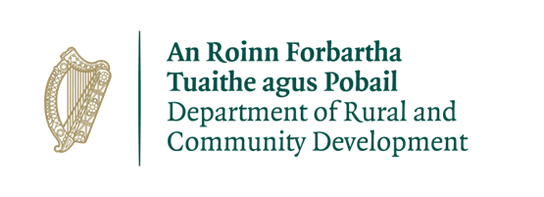

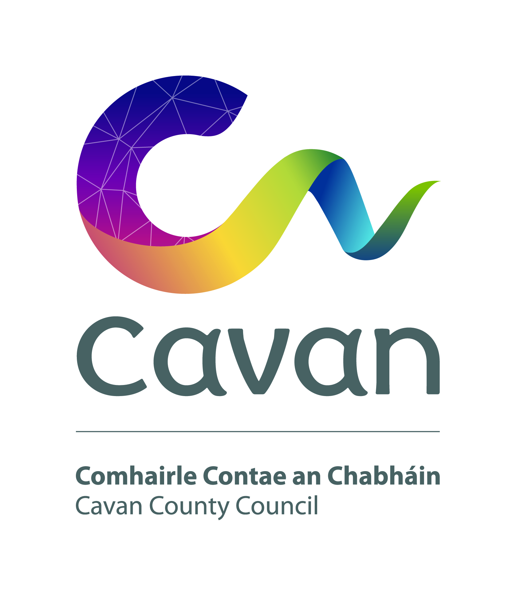
Cavan County Council

GROUP /ORGANISATION NAME:

ALL APPLICATIONS ARE TO BE RETURNED TO:

Siobhan Mulligan
Via Email
smulligan@cavancoco.ie

By Friday 19th February 2021
CLOSING DATE WILL BE STRICTLY ADHERED TO.

Please read the Application Guidelines for the ‘2nd round of the COVID-19 Emergency Fund’ before completing this form.

Department of Rural and Community Development
2nd round of COVID-19 Emergency Fund

The Department of Rural and Community Development (“the Department”) funds the COVID-19 Emergency Fund. It is administered by Local Community Development Committees (LCDCs) in each Local Authority area.

2nd round of COVID-19 Emergency Fund
The Department put in place the first round of the COVID-19 Emergency fund in April 2020 to provide grants to community groups involved in the Community Call response.

The Department is now launching the 2nd round of the COVID-19 Emergency fund with funding of €1.7m. It will provide grants to groups to assist them:

- to adapt their services and operations to fit the new COVID-19 reality. Examples of measures supported could be adapting premises to allow for social distancing; offering on-line activities; providing social supports and friendly calls by phone etc.
- to become more involved in the Government's 'Keep Well' campaign. The grants are aimed at assisting participation in the campaign, in particular with the three themes: staying connected, switching off and being creative, and minding your mood.
The grants may also be provided to support groups including those involved in the community call.

Note : Applications from Groups who applied under Round 1 will be accepted only if they meet all conditions and have drawn down all funding approved under round 1 as of that closing date of 31st December 2020.

It is intended that 30% of the funding allocated to each Local Authority area will be ring-fenced for grants of €1,000 or less.

TERMS AND CONDITIONS

- Under the 2nd round of the COVID-19 Emergency Fund grants will be provided to community groups as outlined above.
- The information supplied by the applicant group /organisation must be accurate and complete.
- Misinformation may lead to disqualification and/or the repayment of any grant made.
- All information provided in respect of the application for a grant will be held electronically. The Department reserves the right to publish a list of all grants awarded on its website.
- The Freedom of Information Act applies to all records held by the Department and Local Authorities.
- The application must be signed by the Chairperson, Secretary or Treasurer of the organisation making the submission.
- It is the responsibility of each organisation to ensure that it has proper procedures and policies in place, including appropriate insurance, where relevant.
- Evidence of expenditure, receipts /invoices must be retained and provided to the LCDC or their representative if requested.
- Grant monies must be expended and drawn down from the LCDC by end of August 2021. Photographic evidence may be required to facilitate draw down of grants.
- The Department’s contribution must be publicly acknowledged in all materials associated with the purpose of the grant.
- Generally no third party or intermediary applications will be considered.
- Late applications will not be considered.
- Applications by email not later than the closing date of Friday 19th February 2021
- Breaches of the terms and conditions of the grants scheme may result in sanctions including disbarment from future grant applications.
- Please ensure the application form is completed in full. Incomplete applications will not be considered for funding.
- In order to process your application it may be necessary for Cavan County Council to collect personal data from you. Such information will be processed in line with the Local Authority’s privacy statement which is available to view on www.cavancoco.ie

All questions on this form must be answered. Please write your answers clearly in block letters.

SECTION 1 – YOUR ORGANISATION

Name of Group / Organisation

Address

Eircode

Contact name

Role in Group/Organisation

Telephone number

E-mail

Website

Alternative Contact name

Alternative Telephone number

Alternative E-mail

Please provide a brief organisational description of your group / organisation e.g. committee structure, meeting schedule etc.

Has your Organisation / Group registered with the relevant local Public Participation Network (PPN)?
YES ☐ NO ☐

If NO, then perhaps you would consider joining the PPN.

Year established
What is the purpose of group / organisation

Successful applications for funding under this programme will only be paid to the applicant organisation’s Bank Account. Please ensure you have your Bank Account details to hand if your application is successful.

Have you received funding under any grants schemes from 2018 to current date- i.e. grants from Government Departments, Local Authority or LEADER?

YES ☐ NO ☐
If YES please give details below
Name of scheme | Funding organisation | Amount received | Date received

If any of the above funding was paid through the Local Authority, have you submitted your Bank Account Details previously?

YES ☐ NO ☐

Do you receive funding from any other organisation?

YES ☐ NO ☐

If YES please give details below:
Funding organisation | Amount received | Date received

Is your organisation affiliated or connected to any relevant local regional or national body?

YES ☐ NO ☐

If YES please give details below:
Name of organisation(s):

How does your organisation link in with other organisations in your area?

Charitable Status Number (if applicable)

Tax Reference Number (if applicable)

Tax Clearance Access Number (if applicable)

SECTION 2 – Project Details

How much funding are you applying for? Tick one of the below options.

☐ Small scale grant of €1,000 or less

☐ Grant in excess of €1,000

PURPOSE OF GRANT

What will the funding be used for?

When will your work begin?

When will your work be completed?

Are all relevant permissions in place (e.g. planning, written consent from landowner/property owner if your project involves the development of a property)?

Not applicable ☐ YES ☐ NO ☐

Is this part of a phased development and/or linked with (or funded by) other schemes operated by Government Departments or the Local Authority?

YES ☐ NO ☐

If YES please provide the details below:

FUNDING
€
Amount being applied for under this fund:
Is this amount a partial or total project cost?  € | ☐Partial | ☐Total
If partial, give the estimated total project cost:

Important note: Please include supporting documentation. If needed, please contact the smulligan@cavancoco.ie for information on the required supporting documentation.

To be eligible for funding under this programme you must state where you will source any shortfall of funding. Please provide these details below.

Source | Amount

Has your organisation availed of funding under the 2018 CEP, or the 2018 Men’s Shed fund, or the 2019 CEP, or the 2019 Men’s and Women’s Shed fund or the 1st round of the COVID-19 Emergency Fund or either of the CEP funds ran in 2020?
YES ☐ NO ☐

If YES, please give details of the project which received funded in 2018 and/or 2019 and/or 2020:

Please state how your group proposes to publicly acknowledge the Department and LA or LCDC

SECTION 3 - DECLARATION

- I declare that the information given on this form is accurate and correct.

- I confirm I have read and fully understand the Terms and Conditions of the ‘2nd round of the COVID-19 Emergency Fund’ (see page 2 of this form).

- I confirm that I have read the Application Guidelines for the ‘2nd round of the COVID-19 Emergency Fund’ prior to completing this form.

- I confirm that this grant application is submitted in acceptance of and compliance with the Terms and Conditions.

- I confirm that the applicant group/organisation does not have the funding to undertake the work (or make payment) without this grant aid or alternatively that the grant will facilitate a larger project or more work which they would otherwise be unable to afford.

- I confirm that the applicant group/organisation is tax compliant (if tax registered).

Name in block capitals (on behalf of group / organisation):

Signature:

Position held in group / organisation (block capitals):
Date:

This is consistent with an action assigned to our Department under the Resilience and Recovery 2020-2021: Plan for Living with COVID-19.

