COMMUNITY ENHANCEMENT PROGRAMME 2019

Applications under the ring-fenced fund for Men’s and Women’s Sheds

NOTE: Closing Date Friday 30th August 2019

FOR OFFICE USE ONLY

Date Received:

Reference Number:

LCDC recommendation:

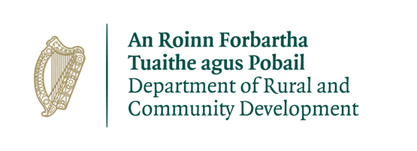

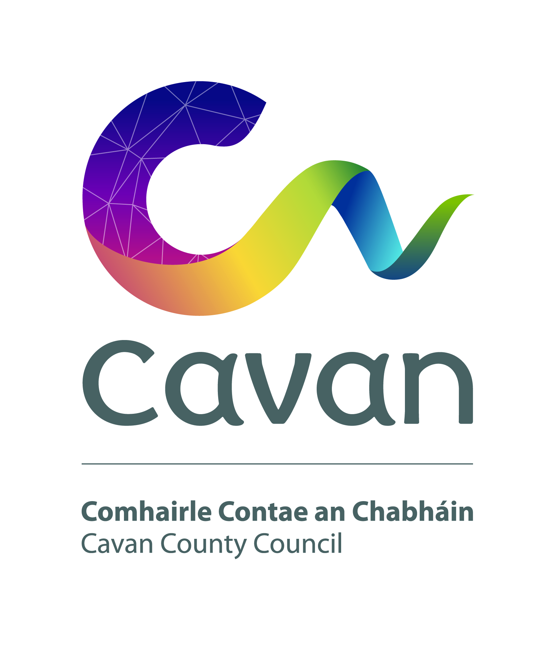

Shed Name:

ALL APPLICATIONS ARE TO BE RETURNED TO:

John Donohoe C/o Chief Officer Cavan LCDC
C/o Community and Enterprise Section
Cavan County Council
Johnston Library
Cavan

By Friday 30th August 2019
CLOSING DATE WILL BE STRICTLY ADHERED TO.

Department of Rural and Community Development
Community Enhancement Programme – Ring-fenced fund for Men’s and Women’s Sheds

Following discussion with the Irish Men’s Shed Association, the Department of Rural and Community Development (“the Department”) has decided to allocate €0.5m to fund capital equipment or minor capital works in Men’s Sheds. The fund is also open to Women’s Sheds.

This is a ring-fenced fund under the existing Community Enhancement Programme. The application process is being administered by Local Community Development Committees (LCDCs).

Applications for this funding can be made on this application form. All Men’s Sheds in Ireland that are affiliated with the Irish Men’s Shed Association are eligible to apply. Women’s Sheds are also eligible to apply.

It envisaged that this funding would, in general, be allocated in a relatively equal manner across Sheds that submit valid applications. To provide guidance on what this equates to, the total of €0.5m is approximately €1,300 per existing Men’s Shed. This should be used for guidance only, as not all Men’s Sheds might apply, or some might apply for an amount less than the €1,300, or some might apply for funding for an unsuitable project, or some Women’s Sheds may apply.

TERMS AND CONDITIONS

- Under this part of the Community Enhancement Programme, grants will be provided to Sheds towards small scale capital costs. The scheme does not provide funding for operating costs (e.g. the employment of staff, electricity costs, heating costs, etc.).
- The information supplied by the applicant Shed must be accurate and complete.
- Misinformation may lead to disqualification and/or the repayment of any grant made.
- All information provided in respect of the application for a grant will be held electronically. The Department reserves the right to publish a list of all grants awarded on its website.
- The Freedom of Information Act applies to all records held by the Department and Local Authorities.
- The application must be signed by the Chairperson, Secretary or Treasurer of the Shed.
- It is the responsibility of each organisation to ensure that it has proper procedures and policies in place including appropriate insurance where relevant.
- Applications must be on the 2019 form.
- Evidence of expenditure, receipts /invoices must be retained and provided to the LCDC or their representative if requested.
- Grant monies must be expended and drawn down from the LCDC by end of year 2019. Photographic evidence may be required to facilitate draw down of grants.
- The Department’s contribution must be publicly acknowledged in all materials associated with the purpose of the grant.
- Generally no third party or intermediary applications will be considered.
- Late applications will not be considered.
- Applications by post should use the correct value of postage stamps and allow sufficient time to ensure delivery not later than the closing date of to be chosen by the LCDC but no later than 30 August 2019.
- Claims that any application form has been lost or delayed in the post will not be considered, unless applicants have a Post Office Certificate of Posting in support of such claims.
- Breaches of the terms and conditions of the grants scheme may result in sanctions including disbarment from future grant applications.
- Please ensure the application form is completed in full. Incomplete applications will not be considered for funding.
- In order to process your application it may be necessary for Cavan to collect personal data from you. Such information will be processed in line with the Local Authority’s privacy statement which is available to view on www.cavancoco.ie

SECTION 1 – YOUR ORGANISATION

Name of Shed

Address

Eircode

Contact name

Role in Group

Telephone number

E-mail

Website

Alternative Contact name

Alternative Telephone number

Alternative E-mail

Successful applications for funding under this programme will only be paid to the applicant organisation’s Bank Account. Please ensure you have your Bank Account details to hand if your application is successful.

Charitable Status Number (if applicable): ___________________________________________

Tax Reference Number (if applicable): _____________________________________________

Tax Clearance Access Number (if applicable): _______________________________________

Section 2

If your group is a Men’s Shed, please complete Section 2a below.

If your group is a Women’s Shed, please complete Section 2b below.

Section 2a: Questions for Men’s Sheds:

Is your Men’s Shed affiliated with Irish Men's Sheds Association?

YES ☐ NO ☐

Year the Men’s Shed was established ________

Section 2b: Questions for Women’s Sheds

This funding is ring-fenced for Sheds. Therefore, it is expected that your Women’s Shed would not be affiliated with any other parent organisation. Is your Shed affiliated with any other parent organisation?

YES ☐ NO ☐

If yes, please provide detail how your organisation is also considered to be a Women’s Shed group.

Please provide a description of your Women’s shed, including information on the number of members, the organisational structure of your Shed, whether there is any criteria for membership, the main focus of the activities of your Shed, etc.

SECTION 3 – Project Details

What will the funding be used for?

When will the purchase be made? ________________

Amount being applied for: | €
Is this amount the partial or total cost: | ☐Partial | ☐Total
If partial, please give the estimated total cost: | €

Important note: Please include supporting documentation. If your total project cost is less than €5,000 and is not related to building/landscaping/construction works, then please include estimates/quotes from a minimum of two different independent suppliers with this form. For all other cases, please contact the ttierney@cavancoco.ie and/or 049 4378587 for information on the required supporting documentation.

Please state how your Shed proposes to acknowledge the Department, LA or LCDC.

Note: Depending on the amount being applied for, this could be as simple as including an acknowledgement on equipment labels, or on notices/signs, or in any newsletters that are being produced locally.

SECTION 4 - DECLARATION

- I declare that the information given in this form is correct.

- I confirm I have read and fully understand the Terms and Conditions of this Programme (see page 2-3 of this form).

- I confirm that this grant application is submitted in acceptance of and compliance with the Terms and Conditions.

- I confirm that the Shed does not have the funding to undertake the work/project without this grant aid or alternatively that with the grant the Shed will now undertake a larger project which they otherwise would not be able to afford.
- I confirm that the applicant Shed is tax compliant (if tax registered).

Name in block capitals (on behalf of Shed):

Signature:

Position held (block capitals):
Date:

The Department operates the Community Enhancement Programme through the Local Community Development Committees (LCDCs). It is a capital grant programme that provides funding to enhance facilities in disadvantaged areas. The Department previously committed to funding of €4.5m for this programme. The €0.5m fund which is ring-fenced for Sheds is in addition to the €4.5m.

