COMMUNITY ENHANCEMENT PROGRAMME 2021
Funded by the Department of Rural and Community Development

NOTE: Closing Date is 5pm 16th July 2021

FOR OFFICE USE ONLY

Date Received:

Reference Number:

LCDC recommendation:

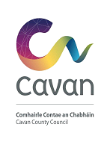
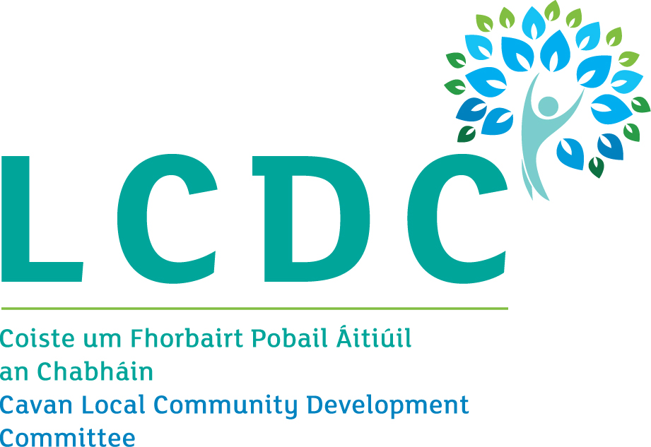

[Insert logo of relevant local authority here]

GROUP /ORGANISATION NAME:

ALL APPLICATIONS ARE TO BE RETURNED TO:

smulligan@cavancoco.ie

By 5pm on Friday 16th July 2021

CLOSING DATE WILL BE STRICTLY ADHERED TO.

Please read the CEP Application Guidelines before completing this form.
Please read the CEP Application Guidelines before completing this form.

Department of Rural and Community Development
Community Enhancement Programme

The Department of Rural and Community Development (“the Department”) operates a grant programme through the Local Community Development Committees (LCDCs). This grant programme provides funding to enhance facilities in disadvantaged communities. Applications should relate to one or more key priority areas identified in the LCDC Local Economic and Community Plan (LECP) in order to be eligible for consideration.

TERMS AND CONDITIONS

- Under the Community Enhancement Programme (CEP), which is funded by the Department, grants will be provided towards projects to enhance facilities in disadvantaged areas. The scheme does not provide funding for the employment of staff.
- The activity or project must benefit the local community and relate to the key priority areas identified in the LECP.
- The information supplied by the applicant group /organisation must be accurate and complete.
- Misinformation may lead to disqualification and/or the repayment of any grant made.
- All information provided in respect of the application for a grant will be held electronically. The Department reserves the right to publish a list of all grants awarded on its website.
- The Freedom of Information Act applies to all records held by the Department and Local Authorities.
- The application must be signed by the Chairperson, Secretary or Treasurer of the organisation making the submission.
- It is the responsibility of each organisation to ensure that it has proper procedures and policies in place including appropriate insurance where relevant.
- Applications must be on the 2021 form.
- Evidence of expenditure, receipts /invoices must be retained and provided to the Cavan LCDC or their representative if requested.
- Grant monies must be expended and drawn down from the Cavan LCDC by end of year 2021. Photographic evidence may be required to facilitate draw down of grants.
- The Department’s contribution must be publicly acknowledged in all materials associated with the purpose of the grant.
- Generally no third party or intermediary applications will be considered.
- Late applications will not be considered.
- Applications by post should use the correct value of postage stamps and allow sufficient time to ensure delivery not later than the closing date of by 5pm on 16th July 2021. Claims that any application form has been lost or delayed in the post will not be considered, unless applicants have a Post Office Certificate of Posting in support of such claims.
- Breaches of the terms and conditions of the grants scheme may result in sanctions including disbarment from future grant applications.
- Please ensure the application form is completed in full. Incomplete applications will not be considered for funding.
- In order to process your application it may be necessary for Cavan County Council to collect personal data from you. Such information will be processed in line with the Local Authority’s privacy statement which is available to view on Cavan County Council.

- Please note that all works must be completed by 31st December 2021.

All questions on this form must be answered. Please write your answers clearly in block letters.

SECTION 1 – YOUR ORGANISATION

Name of Group / Organisation

Address

Eircode

Contact name

Role in Group/Organisation

Telephone number

E-mail

Website

Alternative Contact name

Alternative Telephone number

Alternative E-mail

Please provide a brief organisational description of your group / organisation e.g. committee structure, meeting schedule etc.

Has your Organisation / Group registered with the relevant local Public Participation Network (PPN)?
YES ☐ NO ☐

If NO, then perhaps you would consider joining the PPN.

Year established
What is the purpose of group / organisation
Successful applications for funding under this programme will only be paid to the applicant organisation’s Bank Account. Please ensure you have your Bank Account details to hand if your application is successful.

Have you received funding under any grants schemes from 2018 to current date- i.e. grants from Government Departments, Local Authority or LEADER?

YES ☐ NO ☐
If YES please give details below
Name of scheme | Funding organisation | Amount received | Date received

If any of the above funding was paid through the Local Authority, have you submitted your Bank Account Details previously?

YES ☐ NO ☐

Do you receive funding from any other organisation?

YES ☐ NO ☐

If YES please give details below:
Funding organisation | Amount received | Date received

Is your organisation affiliated or connected to any relevant local regional or national body?

YES ☐ NO ☐

If YES please give details below:
Name of organisation(s):

How does your organisation link in with other organisations in your area?

Charitable Status Number (if applicable)

Tax Reference Number (if applicable)

Tax Clearance Access Number (if applicable)

SECTION 2 – Project Details

How much funding are you applying for? Tick one of the below options.

☐ Small scale capital grant of €1,000 or less

☐ Capital grant in excess of €1,000 up to Maximum of € 10,000

☐

PURPOSE OF GRANT

What will the funding be used for?
Note: This list is not exhaustive, but gives examples of types of expenditure. In general, upgrades to facilities, equipment or grants towards reopening are eligible.

☐ IT Equipment ☐ Sports Equipment ☐ Training Equipment
☐ Safety Equipment ☐ Machinery & Equipment ☐ Renovation of building
☐ Construction works ☐ Energy efficient upgrade
☐ Development of community facility ☐ Grant towards reopening (Give details)
☐ Other (Give details)

What is the purpose of the grant? (Outline details of the work).

Please input exact location (X-Y co-ordinates) of where the proposed project will based.
Y ITM
X ITM

This information is required in ITM format. The simple guide we have provided with this form will show you how to find these on https://irish.gridreferencefinder.com/ .

If this is for a specific project, when will your project begin?

If this is for a specific project, when will your project be completed?

Are all relevant permissions in place (e.g. planning, written consent from landowner/property owner if your project involves the development of a property)?

Not applicable ☐ YES ☐ NO ☐

Is this part of a phased development and/or linked with (or funded by) other schemes operated by Government Departments or the Local Authority?

YES ☐ NO ☐

If YES please provide the details below:

FUNDING
€
Amount being applied for under the CEP:

If this amount is for equipment or the upgrade of facilities, please provide details for A and B and C below. If it is for a reopening cost that is not for equipment or the upgrade of facilities, please provide details for D below.

A. Is this amount a partial or total project cost?  €  B. If partial, give the estimated total project cost: | ☐Partial | ☐Total
C. Important note: Please include supporting documentation outlined below for your project. The Local Authority may also request specific documentation to support the application e.g. Bank statement to confirm available funds.

If your total project cost is less than €5,000 and is not related to building/landscaping/construction works, then please include estimates/quotes from a minimum of three different independent suppliers with this form. For all other cases, please contact the smulligan@cavancoco.ie .for information on the required supporting documentation.

To be eligible for funding under this programme you must state where you will source any shortfall of funding. Please provide these details below.

Source | Amount

D. If your application is related to a reopening cost that is not for equipment or the upgrade of facilities, please provide supporting documentation below. This could include utility bills that fall due for payment in 2021. If you are unclear about what to provide, please contact the smulligan@cavancoco.ie for information on the required supporting documentation.

The Local Authority may also at a later stage request specific documentation to support the application e.g. Bank statement to confirm available funds.

E. Has your organisation availed of funding under the 2018 CEP, or the 2018 Men’s Shed fund, or the 2019 CEP, or the 2019 Men’s and Women’s Shed fund, or the 2020 CEP, or any rounds of the 2020 COVID-19 Emergency Fund?
YES ☐ NO ☐

If YES, please give details of the project which received funded in 2018 and/or 2019 and/or 2020:

Please state how your group proposes to publicly acknowledge the Department, LA or LCDC

The Cavan LCDC will check to ensure that this application works towards addressing priorities within its Local Economic and Community Plan (LECP) which you can access on your local authorities’ website. If your application is for an amount greater than €1,000, please complete the below table to state which key priority area(s) in the LECP this grant application relates to and the estimated number of people to benefit.
For further information on the LECP refer to www.cavancoco.ie for details.

If your application is for a small scale grant of €1,000 or less, then you may wish to complete the below table, but you are not required to do so.

Key priority area of LECP | No. of beneficiaries | Tick area(s) applicable
Supporting the development of safe, active and empowered communities
Capital Projects to support physical fitness and promote healthy lifestyles
Supporting crime prevention and safety initiatives
Developing an integrated response to the needs of young people
Supporting opportunities for sporting and recreational life within the county
Reducing levels of drug and alcohol use among adults and young people

Reducing the isolation and marginalisation of socially excluded groups
Responding to the needs of older people
Supporting green and sustainable communities
Community Based Arts Activities

SECTION 3 - DECLARATION

- I declare that the information given in this form is correct.

- I confirm I have read and fully understand the Terms and Conditions of the Community Enhancement Programme (see page 2 of this form).

- I confirm that I have read the Community Enhancement Programme Application Guidelines prior to completing this form.

- I confirm that this grant application is submitted in acceptance of and compliance with the Terms and Conditions.

- I confirm that the applicant group/organisation does not have the funding to undertake the work/project without this grant aid or alternatively that the grant will facilitate a larger project which they would otherwise be unable to afford.
- I confirm that the applicant group/organisation is tax compliant (if tax registered).
- I agree to the following statement :
In accordance with current data protection legislation the personal data supplied by me/us to Cavan County Council shall only be used for the purpose of application for Community Enhancement Programme 2021. I understand that the data shall be stored securely for only as long as is necessary & will not be shared with any third parties without my consent.

Queries relating to your personal data in this form can be forwarded to dpo@cavancoco.ie.”

Name in block capitals (on behalf of group / organisation):

Signature:

Position held in group / organisation (block capitals):
Date:

