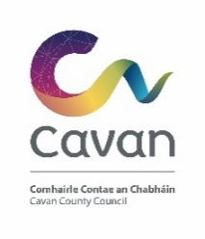
Cavan Calling 2020 Grant Scheme
Application Form (Please use additional pages if required)
Community Group Name & Address
Contact Person
Contact Number
Email
Where will your event take place?
Tell us about your group

Tell us about your event (Please provide an estimate of the expected number of Diaspora attending)
Is the event a new initiative or an add-on to an existing event?
Please provide details of any other funding received or applied for in relation to this event.

Tell us what you will use the funding for  (Please submit evidence of costs/ quotes where possible) | Description of costs Amount  Total
Total Amount requested | €
Is your organisation registered for VAT? | Yes   No     Organisation tax number:
Grants are paid retrospectively: | Please provide a Bank /Credit Union statement with this application
Bank Name and Address:
Account Name:
IBAN
BIC
Is your group registered with Cavan Public Participation Network? Yes    No 
If not, consider if you would like to join by contacting cavanppn@gmail.com

I declare the information provided on this form to be true and accurate.

SIGNED: ____________________________________
TITLE: ______________________________________
DATE:__________________________________

For Queries please contact

Theresa Tierney, Community and Enterprise Section on 049 4378587 or by Email: ttierney@cavancoco.ie

Completed application forms should be returned to:

Mr John Donohoe
Senior Executive Officer
Community and Enterprise & Tourism
Cavan County Council
Cavan
Closing Date Friday 28th February 2020

Late Applications will not be accepted

