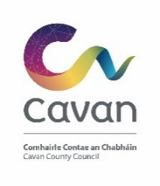
Christmas Lights Grant Scheme 2020
Application Form (Please use additional pages if required)
Community Group Name & Address
Contact Person
Contact Number
Email
What work / actions do you propose to undertake?
Where will the work/ actions above be located?
What do you hope to achieve with this project

Tell us what you will use the funding for  (Please submit evidence of costs/ quotes where possible) | Description of costs Amount  Total
Total Amount requested | €
Is your organisation registered for VAT? | Yes   No     Organisation tax number:
Grants are paid retrospectively: | Please provide a Bank /Credit Union statement with this application
Bank Name and Address:
Account Name:
IBAN
BIC

I declare the information provided on this form to be true and accurate.
SIGNED: ____________________________________
TITLE: ______________________________________
DATE:__________________________________
For Queries please contact

Donna Macklin, Community and Enterprise Section on 049 4378545 or by Email: dmacklin@cavancoco.ie

Completed application forms should be returned by email only to Donna Macklin at dmacklin@cavancoco.ie

Closing Date Tuesday 1st December 2020
Late Applications will not be accepted

