

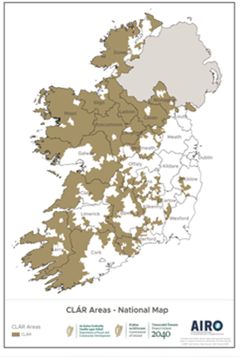

**CLÁR 2021 Scheme Outline**

**Community Wellbeing Support**

**Measure 3(b) Mobility and Cancer Care Transport**

**Background**

CLÁR (Ceantair Laga Árd-Riachtanais) is a targeted investment programme for rural areas that aims to provide funding for small infrastructural projects in rural areas that have experienced significant levels of de-population. The funding works in conjunction with local/Agency and other Departmental funding programmes and on the basis of locally identified priorities.

**2021 Mobility and Cancer Care Transport Funding**

Recognising the critical role that volunteer organisations play in the provision of vital services to vulnerable sectors of the community; and the level of interest in this particular funding stream, CLÁR 2021 once again sees the allocation of funding for Mobility and Cancer Care Transportsupport**.**

This measure will be operated directly by the Department of Rural and Community Development and is open to established organisations/groups that operate entirely on a voluntary basis and provide:

* transport to/from day care/other medical/therapy/respite services for those with significant mobility issues including requiring specialised wheelchair accessible vehicles or
* transport to/from designated cancer treatment hospitals/centres under the National Cancer Care Programme.

**Eligible Costs**

The scheme will cover the cost of a vehicle and/or the fit out of a vehicle where necessary. Applicants should provide full details regarding the costs associated with the purchase and/or fit out of proposed vehicles as follows;

1. Any vehicle funded must be in good condition and not more than 5 years old.
2. Any vehicle(s) funded is used solely for the activities outlined and not for any commercial transport routes and
3. The Department must be acknowledged in signage on the vehicle.
4. Only one vehicle per ‘Branch’ of regional/National organisation will be considered.

The scheme will not cover any ongoing running costs such as insurance, maintenance, fuel etc. Applicant organisations will be required to outline how they will manage the ongoing operation of the vehicle.

**Eligible Applicants**

The measure is open to **established, voluntary organisations/groups** that operate **on a voluntary basis,** and are involved in the provision of transport services, **free of charge**, to persons requiring wheelchair accessible vehicles to access day care/other medical/therapy/respite services and/or those requiring transport to/from hospitals for treatments under the National Cancer Care Programme (list of designated hospitals/centres attached in Appendix 2).

Support will be made available to applicant groups/organisations that are **formally established** e.g. registered charity or not for profit etc. Support will **not** be made available to individuals or ad hoc groups. It will be necessary to provide:

* information/certification regarding the formal establishment of the group/organisation e.g. Memoranda and Articles of Association, and
* letter(s) in support of the application from, e.g. HSE/GP/ Public Health Nurse or other service provider.

**Eligible CLÁR Area**

In general, CLÁR eligibility is based on being physically located within a designated CLÁR DED. However, given the possible need to travel considerable distances to hospitals and other specialist facilities located in non-CLÁR areas; eligibility for this Measure will be based on the ‘catchment area’ being served by the vehicles.

It will be necessary for applicants to demonstrate that the majority (over 80%) of their normal clientele reside within CLÁR DED’s. A listing of eligible CLÁR DED’s is available on the Department’s website and from [CLÁR@DRCD.gov.ie](mailto:CLÁR@DRCD.gov.ie).

Evidence of the organisation’s meeting this requirement at the time of application should be retained on file for a period of six years, where approved.

**Rate of Aid**

* The scheme will provide up to 90% of the total cost of a vehicle/fit out subject to a maximum grant of;
  + €50,000 for a wheelchair accessible vehicle and
  + €100,000 for a bus
* A match funding contribution of at least 10% is required. Philanthropic contributions may be accepted as full or part of match funding costs.

**Timelines**

|  |  |
| --- | --- |
| **Scheme launch** | Monday, 15th March 2021 |
| **Applications due** | Friday, 7th May 2021 |
| **Funding awarded** | Early August 2021 |
| **Projects completed and drawdown** | 31st March 2022 |

**Assessment Criteria**

It should be noted that, in assessing the applications received, a number of factors will be considered including the indicated order of priority (where applicable); the range, mix, quality and impact of proposed projects; previous funding provided and other relevant considerations.

The applicant must ensure that the application form is fully completed and complies with the 2021 Scheme Outline.

**Procurement Requirement**

For the purposes of this application groups must source **at least one written detailed quotation from a supplier in respect of the supply and/or fit out of a vehicle.**

As this grant involves the spending of public funds, it is essential that good value for money is derived from it. **If successful,** applicants are then required to comply with relevant [public procurement guidelines](https://ogp.gov.ie/public-procurement-guidelines-for-goods-and-services/). Purchases in excess of €25,000 must be sourced using the [www.etenders.gov.ie](http://www.etenders.gov.ie)process. This must be submitted to the Department with the application form.

Guidance on this is available from the Office of Government Procurement (website: www.OGP.gov.ie; email: [support@OGP.gov.ie](mailto:support@OGP.gov.ie) phone: 076 100 8000).

**Application Process**

Applications must be submitted on the “Measure 3(b) Community Wellbeing Support - Mobility and Cancer Care Transport” application form.

* Applications should include supporting information requested in the application form including a detailed breakdown of all costs including detailed quotations as previously outlined
* The application form must clearly set out what the funding will be used for, the need for same, and be accompanied by all supporting documentation, including evidence of match funding.

**Grant Payment Arrangements**

Groups should note that the payment of the grant will be in arrears on the basis of invoices marked as paid, i.e. after the group has purchased the vehicle. Groups may need to arrange bridging funding to cover the amount of the grant while awaiting this payment from the Department. However, it should be noted that the Department generally finalises this payment within a matter of days where the drawdown request is in order. **The vehicle must not be purchased/paid for prior to the announcement of successful applicants**.

**Appendix 1: Funding Conditions for Rural Schemes funded under the Department of Rural and Community Development**

All expenditure registered through the Department’s Rural Schemes i.e. Town and Village Renewal Scheme, CLÁR, Outdoor Recreation and Infrastructure Scheme (ORIS) will be subject to the terms of the Public Spending Code which can be found at <http://publicspendingcode.per.gov.ie/>.

In addition to this, the requirements outlined below will apply to all funding approved through those schemes. The need for adherence to all of the requirements will be reflected in the contractual agreement between the Department of Rural and Community Development and the grantee approved for funding under the scheme.

|  |  |
| --- | --- |
| **1** | Projects will be expected to commence and be completed in line with the timelines set out in the relevant Scheme Outline. |
| **2** | The Department may de-commit funding allocated to projects under the Scheme where the project is not completed within the time specified, and where the express agreement of the Department to extend the funding arrangement has not been agreed in advance. |
| **3** | Not Applicable |
| **4** | Not Applicable |
| **5** | A cash contribution as set out in the relevant Scheme Outline is required. The grantee will be required to provide confirmation that the cash contribution is in place and retain a record of the source of the cash contribution. |
| **6** | Projects must be completed in full in order to drawdown the full grant amount. Where it is established that a project has not been completed, the Department may request the grantee to repay any funding received on the project. Any changes to the proposed project must be advised and agreed with the Department in advance of the change being implemented. |
| **7** | Where an element of the approved project is not carried out as per the project application, grant funding may be reduced to reflect the amended project. |
| **8** | If the project involves works on buildings or lands that are not in the ownership of the grantee, a minimum 5 year lease must be in place from date of project completion. |
| **9** | In the case of funding allocated to enterprises or facilities (i.e. community centre, hubs, vehicles under CLÁR etc.), it is a requirement that they must operate as funded for a minimum of 5 years following release of the final stage of funding, otherwise funding may have to be repaid. Where they do not operate as funded this must be advised and agreed with the Department in advance. |
| **10** | All appropriate financial, Public Procurement and accounting rules and regulations must be complied with and each grantee will fully account for the funding received in a timely manner. |
| **11** | Full and accurate documentation to support all expenditure should be maintained and accessible by Department officials for audit purposes at all times and for a period of six years from the date of completion of the project. |
| **12** | Grantees will acknowledge the support of Project 2040 / Department of Rural and Community Development/ Government of Ireland, and any other applicable sources of funding (as identified in the relevant Funding Agreement) in all public announcements, advertising and signage, as appropriate, relating to the project. In addition, the Department may seek to use the project in the broader promotion of its policies. |
| **13** | Grantees will provide any reports and information relating to the project as may reasonably be requested by the Department of Rural and Community Development from time to time. |
| **14** | On-going monitoring and evaluation of the project outputs and outcomes should take place in the context of assessing the impact of the project. Grantees will be expected to collect appropriate data to facilitate this learning on an on-going basis. On request, a brief report (1-2 pages) on the outputs and outcomes of the project funded should be completed and made available to the Department. |
| **15** | Each grantee, will provide a contact point/points to the Department to facilitate payment and information requests. The Department should be updated on any changes to contact personnel in a timely manner. |
| **16** | A checklist confirming compliance with funding conditions relating to the grant aid will be required upon project completion. |

**Non-Compliance with the conditions as outlined or any additional stipulations agreed during contract negotiations may result in the requirement to refund part or all of the grant aid awarded.**

**Applications should be submitted directly to the Department at** [**CLAR@DRCD.gov.ie**](mailto:CLAR@DRCD.gov.ie) **by the 7th May 2021.**

The Department may not be in a position to follow up regarding missing documentation or incomplete application forms. Incomplete application forms may not be considered.

If you do not receive acknowledgment of receipt of your application within 10 working days, please contact the Department at the email address below.

**Queries**

**Any queries should be submitted to** [**CLAR@DRCD.gov.ie**](mailto:CLAR@DRCD.gov.ie)**.**

**Appendix 2**

**Regional Cancer Services**

The NCCP is responsible for overseeing national services for the treatment of cancer.  These treatments include surgery, radiotherapy and systemic anti-cancer therapy (SACT).

Eight hospitals were designated as cancer centres (with a satellite unit in Letterkenny General Hospital).  In 2013 the [Department of Health](http://health.gov.ie/blog/publications/the-establishment-of-hospital-groups-as-a-transition-to-independent-hospital-trusts/) announced the formation of six Hospital Groups. Each of the Hospital Groups has at least one designated cancer centre.  The NCCP has also progressed various initiatives to develop radiotherapy and SACT services across Ireland.

A further 18 public hospitals provide systemic anti-cancer therapy (chemotherapy, immunotherapy etc.). Details of these are available on the map below. An additional two centres provide radiotherapy services.

The map below shows the location of the designated cancer centres and other public hospitals where cancer services are provided.

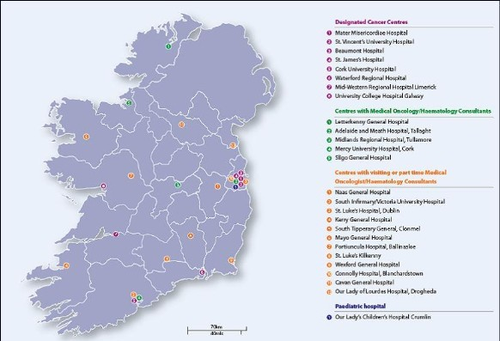

[Download the Map of cancer service locations.jpg (size 54.5 KB)](https://www.hse.ie/eng/services/list/5/cancer/about/services/map.jpg)

Ireland's eight Designated Cancer Centres are aligned with the Hospital Group structure.

The table below shows the designated cancer centre in each Hospital Group and the former HSE administrative area for each.

|  |  |  |
| --- | --- | --- |
| **Hospital Group** | **Cancer Centre** | **HSE Region** |
| RCSI | [**Beaumont University Hospital**](https://www.hse.ie/eng/services/list/3/acutehospitals/hospitals/beaumont/) | HSE Dublin – North East |
| Ireland East | [**Mater University Hospital**](https://www.hse.ie/eng/services/list/3/acutehospitals/hospitals/mater/) | HSE Dublin – North East |
|  | [**St Vincent’s University Hospital**](https://www.hse.ie/eng/services/list/3/acutehospitals/hospitals/svuh/) | HSE Dublin – Mid Leinster |
| Dublin Midlands | [**St James’s University Hospital**](https://www.hse.ie/eng/services/list/3/acutehospitals/hospitals/james/) | HSE Dublin – Mid Leinster |
| South/Southwest | [**Cork University Hospital**](http://www.cuh.hse.ie/) | HSE South |
|  | [**Waterford Regional Hospital**](https://www.hse.ie/eng/services/list/3/acutehospitals/hospitals/waterford/) | HSE South |
| Saolta University | [**Galway University Hospital**](https://www.hse.ie/eng/services/list/3/acutehospitals/hospitals/guh/)  (satellite: Letterkenny General Hospital) | HSE West |
| Midwest | [**University Hospital Limerick**](https://www.hse.ie/eng/services/list/3/acutehospitals/hospitals/ulh/hospitals/uhl/) | HSE West |

The services provided in the designated cancer centres are summarised in the table below:

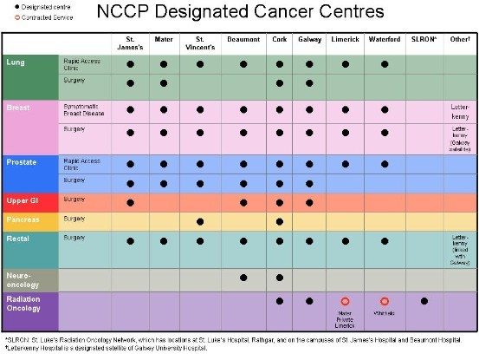

The table above is also available at the following link: <https://www.hse.ie/eng/services/list/5/cancer/about/services/cancercentres.jpg>