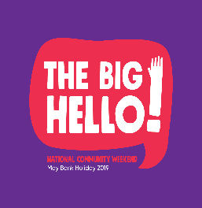
National Community Event “ The Big Hello”
Application Form
Community Group Name & Address
Contact Person
Contact Number
Email
Which Municipal District will your project be located in? | Cavan Ballyjamesduff  Bailieboro/Cootehill
Tell us about your group

Tell us about your event

Tell us what you will use the funding for  (Please submit evidence of costs/ quotes where possible) | Description of costs Amount  Total
Amount requested | €
Is your organisation registered for VAT? | Yes   No     Organisation tax number:
Is your group registered with Cavan Public Participation Network? Yes    No 
If not, consider if you would like to join by contacting cavanppn@gmail.com

I declare the information provided on this form to be true and accurate.

SIGNED: ____________________________________
TITLE: ______________________________________
DATE:__________________________________
For Queries please contact Community and Enterprise Section on 049 4378587

Completed application forms should be returned to:

Mr John Donohoe
Senior Executive Officer
Community and Enterprise
Cavan County Council
Cavan

Closing Date: 12noon, Tuesday 23rd April 2019

