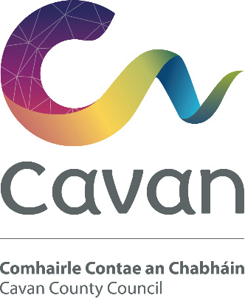
Cavan County Council

Municipal Districts Discretionary Allocation Grant Scheme 2022

Application Form

The scheme has been created by the members of Cavan County Council for the purpose of supporting community groups in delivering and promoting projects in their areas.

Please read the guidelines for this scheme before completing an application. Cavan County Council will only consider projects that meet the criteria of the scheme. Incomplete or late applications will not be considered.

This scheme complements the existing Community & Voluntary Organisation Grant scheme and is designed for larger scale, infrastructural and capital projects. The minimum grant aid payable will be €3,000.

Final payment of the grant will not be paid until all invoices, bank statements and evidence such as before and after photos (where applicable) are provided.

Work must be completed within the allocated time frame in 2022

- Name and address of group/organisation:

- Name and address of contact person:

Telephone number and email address
of contact person

3. Details of Constitution/governing rules of group/organisation.

4. Number of members:

5. Is membership open to everyone? Yes No

6. Date of your last Annual General Meeting?

Details of membership fees
(if applicable):

7. What work do you propose to undertake? (Please give a full description so that we can assess the project)

8. What do you hope to achieve through these actions?

9. Proposed Start date of project/event:
10. Is planning permission required: Yes PP No: No:

12. Total estimated cost of Project:
€

13. Estimated cost for this phase of project
€
(relevant to this application):

14. Details of any other grants applied for or approved (in respect of this project phase):

15. Have you been funded by Cavan County Council within the last 3 years?

Yes No

If yes, amount received: Years:

List Projects/Events Funded:

16. Details of Bank or Financial Institution where grant will be paid:
(Enclose up to date bank/credit union Statement on official headed paper for payment under EFT )
Name and Address of Bank/Financial Institution*
__________________________________________________________
Account Name _____________________________________________
IBAN _____________________________________________________
BIC _____________________________________________________
*Grants will only be paid into a Bank, Credit Union or Post Office Account

17. Present financial situation of Organisation/Group:

18. Details of insurance policies held by the group/organisation (it is a condition of the scheme that specific indemnity is provided to Cavan County Council on your public liability policy, Copy of Insurance Policy must be submitted with application)

The application form must be accompanied by the following:

- A copy of minutes of a meeting held by the applicant body within the past six months (A committee/group must be formally constituted).
- A copy of the constitution, rules etc.
- A child protection policy (where activities include children and young people under 18).
4. A detailed estimate of the cost of the proposed works (it is important that cost estimates should be as accurate and realistic as possible)
5. Three quotations
6. Insurance Policy valid for 2020.

Declaration

I agree to the following statement:
In accordance with current data protection legislation the personal data supplied by me/us to Cavan County Council shall only be used for the purpose of application for Municipal District Discretionary Allocation Scheme. I understand that the data shall be stored securely for only as long as is necessary & will not be shared with any third parties without my consent.
Queries relating to your personal data in this form can be forwarded to dpo@cavancoco.ie.”

I have read the terms and conditions and I certify that the information supplied here is accurate and true to the best of my knowledge.

Signed:

Position
(Chairperson, Secretary)

Date:

For all queries and to send your completed application form together with all required documentation please email into dmacklin@cavancoco.ie
Please put MD Grant and Group Name in the subject line
The closing date for completed applications is Wednesday 16th March 2022 at 5pm.
Late applications will not be accepted

