**Very Disadvantaged and Disadvantaged Urban Areas in County Cavan based on the Haase 2016 Index.**

**Legend**

|  |  |
| --- | --- |
| Very Disadvantaged | |
|  | |
| Disadvantaged |
|  |

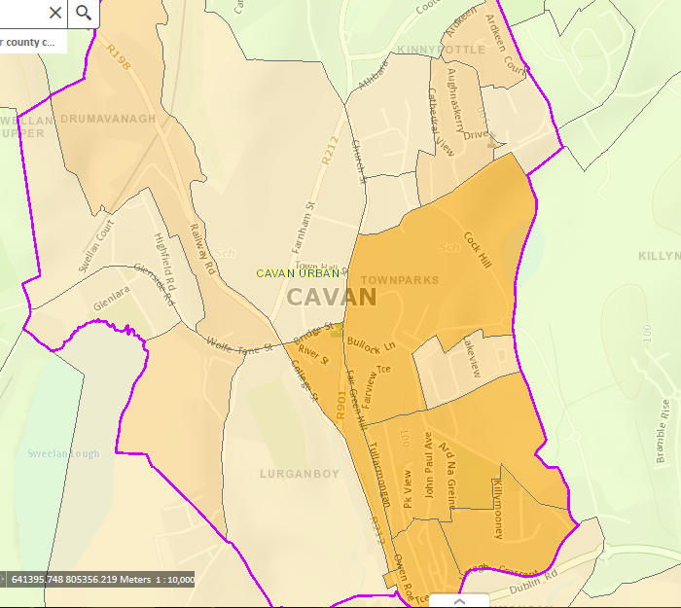

**Cavan**

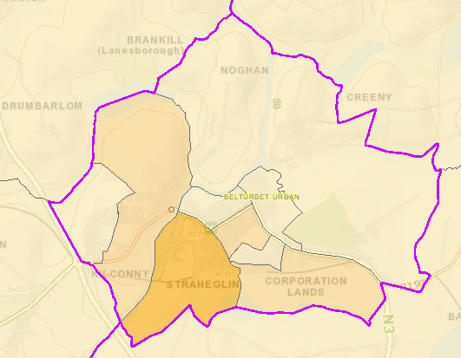

**Belturbet**

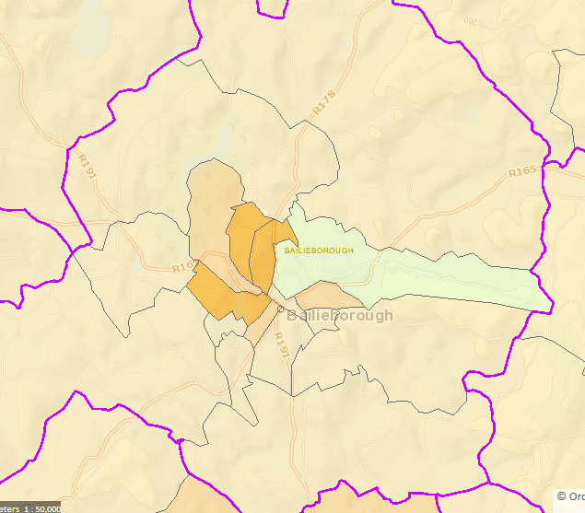

**Bailieborough**

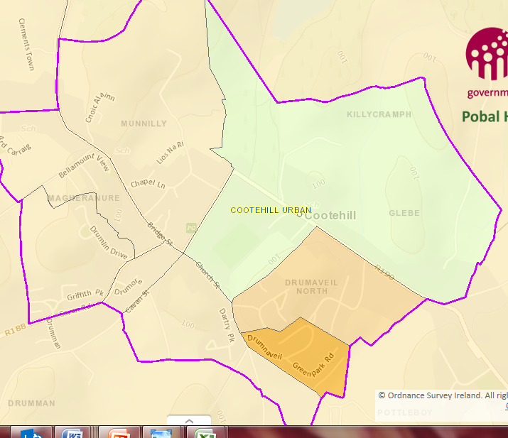

**Cootehill**

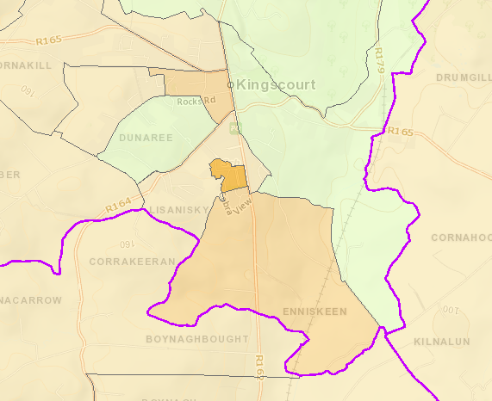

**Kingscourt**

**Disadvantaged Areas Urban Areas and Provincial Towns in County Cavan**

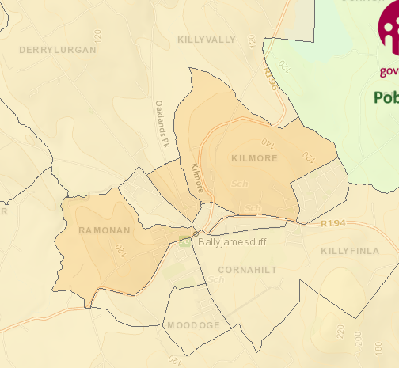

**Ballyjamesduff**

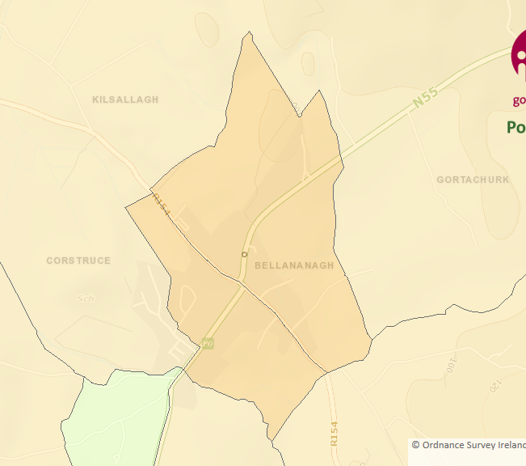

**Ballinagh**

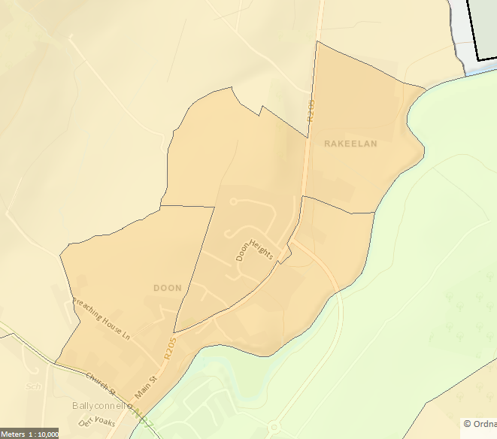

**Ballyconnell**

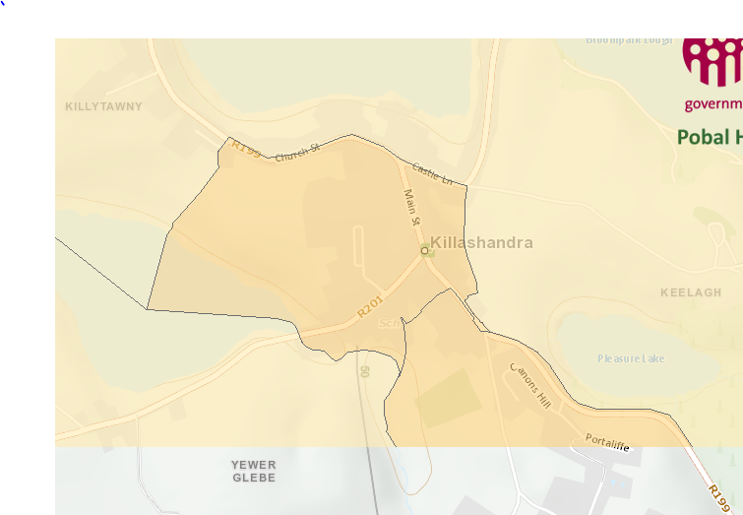

**Killeshandra**

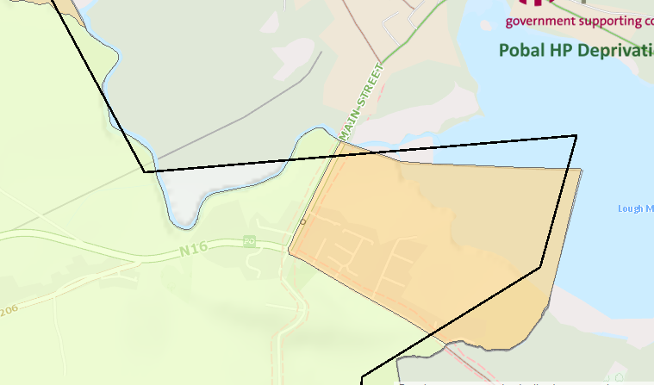

**Blacklion**

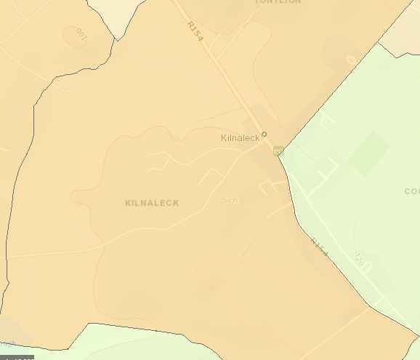

**Kilnaleck**

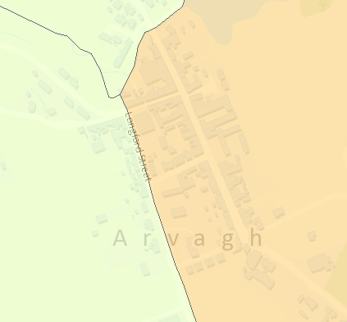

**Arvagh**