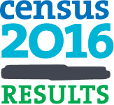
Census 2016
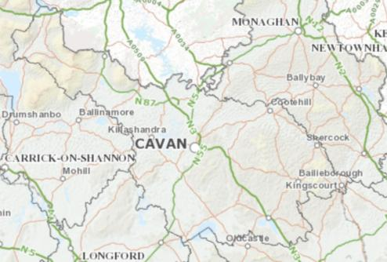
Results and Analysis for County Cavan

Draft 1

Cavan County Council  Social Inclusion Unit  September 2017 |  | 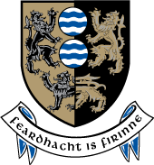

Contents
Summary 1
Population, Gender and Age 4
Marital Status 10
Nationality, Ethnicity and Languages 11
Religion 14
Irish Speakers 16
Educational Attainment 17
Family Units 20
Housing 22
Household Composition 26
Type of Household 27
Water, Heating, Sewerage 28
Economic Status and Social Class 30
Commuting 34
People with Disability and Carers 37
Health 39
Car ownership 39
Personal computer and broadband 40

Source: All statistical information taken from www.cso.ie

Tables
Table 1 Population of County Cavan since 1841 7
Table 2 Speakers of foreign languages by language spoken 13
Table 3 Speakers of foreign languages by ability to speak English 13
Table 4 Population aged 3 years and over by ability to speak Irish 16
Table 5 Irish speakers aged 3 years and over by frequency of speaking Irish 16
Table 21 Population aged 15 years and over by age education ceased 17
Table 22 Population aged 15 years and over by field of study 18
Table 23 Population aged 15 years and over by sex and highest level of education completed Error! Bookmark not defined.
Table 6 Family units with children by type of family and age of children 20
Table 7 Family units with children by type of family and age of children 20
Table 8 Females aged 20 years or over by number of children born 21
Figure 9 New house registrations by year in County Cavan 24
Table 10 Private households by type 26
Table 11 Private households by size 26
Table 12 Private households by type of accommodation 27
Table 13 Permanent private households by type of occupancy 28
Table 14 Permanent private households by central heating 28
Table 15 Permanent private households by water supply 29
Table 16 Permanent private households by sewerage facility 29
Table 17 Number of communal establishments and persons in communal establishments 30
Table 18 Population aged 15 years and over by principal economic status and sex 30
Table 19 Population by sex and social class 32
Table 20 Persons in private households by socio-economic group of reference person 32
Table 24 Population aged 5 years and over by means of travel to work school or college 34
Table 25 Population aged 5 years and over by time leaving home to travel to work, school or college 34
Table 26 Population aged 5 years and over by journey time to work school or college 35
Table 27 Persons with a disability by sex 38
Table 28 Carers by sex 38
Table 29 Population by general health and sex 39

Introduction
This report sets out the key statistics from Census 2016 as they relate to County Cavan.
The Census of Ireland is carried out every five years. In 2016, Census day was on Sunday 24th April. Over two million dwellings were visited nationally by Census enumerators. Preliminary results were available in July 2016 and the main data reports became available in mid 2017.
This document provides comparative data for 2011 Census figures in many instances to demonstrate changing trends in County Cavan. State averages are also provided for comparison purposes in some instances.

Summary
- The population of County Cavan increased by 4% between 2011 and 2016.
- There has been almost a continuous positive trend in population increase in the county since the 1970s.
- 7.5% of the population are aged 0-4 years (5,725 children).
- 29% of the population are aged 0-18 years.
- There are 10,464 people aged 65 and over. There are 2,755 people aged 65 years and over living alone in County Cavan.
- There are 9,508 people with disability in County Cavan.
- There are 4,725 carers (people who provide regular unpaid personal help for a friend or family member with a long-term illness, health problem or disability).
- The majority of people (all ages) in County Cavan are single (52%) while 39% of the population are married (including same sex civil partnership).
- 87% of Cavan residents are of Irish nationality.
- There are 2,189 Polish nationals and 1,433 Lithuanian nationals living in the county.
- In terms of ethnicity, the population is 83% White Irish; while ‘Other White’ people make up ten per cent of the population. There are 1,073 Asian/Asian Irish and 831 Black/Black Irish in Cavan.
- The Census records 477 people from the Traveller community living in Cavan. This community has not increased substantially since 2011.
- Polish (2,363) and Lithuanian (1,387) followed by French (582) are the most commonly spoken foreign languages.
- Almost two thousand (1,984) speakers of foreign languages who live in Cavan cannot speak English well or at all.
- 82% of people in the county are Catholic; 11.38% are other stated religions.
- Five per cent of people indicated ‘no religion’. This proportion of the population is increasing at every Census.
- 35% can speak Irish. Most people who speak Irish on a daily basis are within the education system. 339 people who are outside of the education system speak Irish on a daily basis. 1,280 people speak Irish outside of the education system on a weekly basis.
- Almost 17% of people who have completed their education have no formal or primary education only (8,264 people). A growing proportion of the population is educated to degree level or higher (19.27% or 9,504 people).
- A significant proportion of the population left school before they were 15 years of age (4,326 or 8.77% of those aged 15 years and over).
- Social Science, Business and Law (4,916) is the most common area of qualification followed by Engineering, Manufacturing and Construction (4,679). Health and Welfare is the third most common qualification area (3,764).
- There are 2,603 mothers parenting alone and 451 fathers parenting alone. There are 5,022 children living in one parent family units in the county.
- There are 26,899 households in County Cavan with 75,285 people living in them.
- There are 50 communal establishments in the county with 1,717 people living in them.
- There are 6,162 vacant houses in the county (a rate of 18.2% of housing stock). This rate has declined from 21.6% in the 2011 Census.
- Most accommodation in County Cavan is a house/bungalow (94%) with only 4% being flats/apartments.
- The most common form of household structure was ‘married couple with children’ (9,242) followed by ‘one person’ (6,683) and ‘married couple’ (4,219).
- The largest proportion of households are owner occupied with no mortgage (39%), followed by owner occupied with mortgage (32%).
- Over two thousand (2,169) units are rented from the local authority and 133 are rented from a voluntary body.
- The majority of households in Cavan (69%) are heated with oil central heating. There are similar proportions using coal (7%) and natural gas (7%) as their heating source.
- Less than half of houses in County Cavan are supplied with water from the public mains (45.14%). 28.75% are supplied by a group scheme. Over six thousand households are supplied by a private source.
- 54% of households have either an individual septic tank or an alternative treatment source, with only 42% being on the public sewerage scheme.
- 30,509 people were at work in Cavan in 2016, and 5,413 were unemployed. There were 6,014 students and 5,545 people looking after home/family. 2,390 people were unable to work due to permanent sickness or disability.
- There are 8,796 people living in farming households in the county.
- The largest industry sector was Professional Services (6,419) followed by Commerce and Trade (5,993) and Manufacturing (5,081). The next largest industry sector was Agriculture, Forestry and Fishing with 11.32% of people at work in this sector (3,455 people).
- In County Cavan, most commuters travel by car either as a driver (19,919) or passenger (10,243).
- The majority of households (86%) have at least one car. Over three thousand households have no car.
- 64.49% of households have a personal computer. One third have no computer (8,761 households or 32.68%). This is higher than the proportion of households in the State that have no computer (28.19%).
- 87.44% people report their health as being ‘very good’ or ‘good’.

Population, Gender and Age
The population of County Cavan increased by 4 per cent between 2011 and 2016. In 2011, the population was 73,183. By 2016 it had increased to 76,176.
The State’s population in 2016 was 4,761,865, having increased by 3.78%.
In 2016, County Cavan had 5,725 children aged 0-4 (comprising 7.52% of its population). The State average for this statistic was 6.96%.
There were 21,999 young people aged 0-18 in the county (29% of the population).
Older people aged 65 and over made up 13.73% of the population (10,464 people). This proportion of older people increased from 12.1% in 2011. Both nationally and internationally there is evidence of population ageing, meaning that the proportion of older people in the population is increasing over time. This presents issues for planning and delivery of service. ‘Age Friendly’ programmes seek to prepare society for population ageing.
The gender breakdown in Cavan was 50.3% male and 49.7% female in 2016.

Age Group | Male | Female | Total
0 | 539 | 553 | 1,092
1 | 540 | 530 | 1,070
2 | 566 | 578 | 1,144
3 | 636 | 555 | 1,191
4 | 608 | 620 | 1,228
5 | 671 | 614 | 1,285
6 | 635 | 603 | 1,238
7 | 680 | 606 | 1,286
8 | 643 | 623 | 1,266
9 | 610 | 616 | 1,226
10 | 579 | 508 | 1,087
11 | 570 | 581 | 1,151
12 | 579 | 560 | 1,139
13 | 591 | 544 | 1,135
14 | 546 | 538 | 1,084
15 | 559 | 552 | 1,111
16 | 568 | 559 | 1,127
17 | 554 | 609 | 1,163
18 | 514 | 462 | 976
19 | 448 | 390 | 838
20-24 | 1,837 | 1,688 | 3,525
25-29 | 1,956 | 2,033 | 3,989
30-34 | 2,599 | 2,821 | 5,420
35-39 | 2,829 | 2,984 | 5,813
40-44 | 2,776 | 2,717 | 5,493
45-49 | 2,682 | 2,609 | 5,291
50-54 | 2,548 | 2,415 | 4,963
55-59 | 2,286 | 2,182 | 4,468
60-64 | 2,024 | 1,889 | 3,913
65-69 | 1,796 | 1,649 | 3,445
70-74 | 1,345 | 1,226 | 2,571
75-79 | 923 | 895 | 1,818
80-84 | 644 | 755 | 1,399
85+ | 449 | 782 | 1,231
Total | 38,330 | 37,846 | 76,176

Table 1 Population aged 0-19 by sex and year of age and population aged 20+ by sex and age group
The distribution of the population is illustrated in the table below, with higher concentrations living in the south of the county and around the main urban centres, and a more dispersed population living in West Cavan.
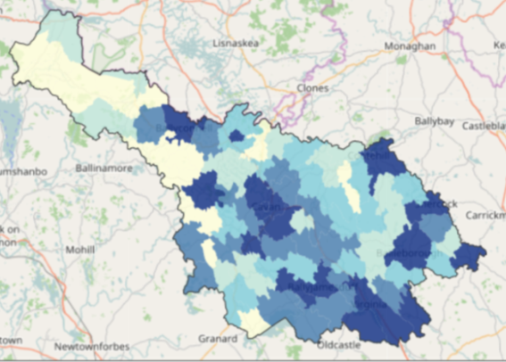
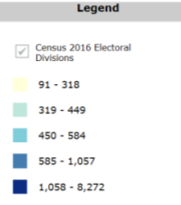
The following graph shows County Cavan’s population by age. Rural counties such as Cavan share similar features, with fewer young adults and proportionally more older people.
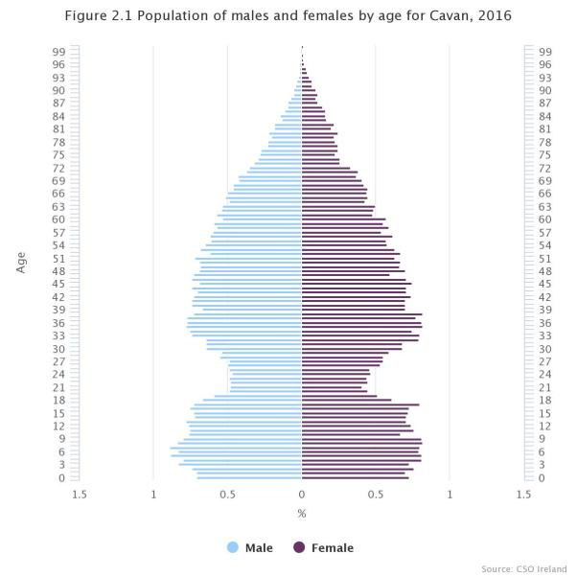

The average age of the national population in 2016 was 37.4, up from 36.1 in 2011, a rise of 1.3 years. The average age in Cavan was 37.2 in 2016, having increased from 36 in 2011.

Cavan’s population has gone through dramatic change over the past 175 years. In 1841, the population of the county was almost a quarter of a million (243,158 people). This declined sharply after the Great Famine and continued to decline until it hit its lowest point of 52,618 in 1971.
Population increase was registered in the 1979 Census and since then there has generally been an increase at every Census (with the exception of 1991).
1841 | 1851 | 1861 | 1871 | 1881 | 1891 | 1901 | 1911 | 1926 | 1936 | 1946
243158 | 174071 | 153906 | 140735 | 129476 | 111917 | 97541 | 91173 | 82452 | 76670 | 70355

1951 | 1956 | 1961 | 1966 | 1971 | 1979 | 1981 | 1986 | 1991 | 1996 | 2002 | 2011 | 2016
66377 | 61740 | 56594 | 54022 | 52618 | 53720 | 53855 | 53965 | 52796 | 52944 | 56,546 | 64,003 | 76,176
Table 1 Population of County Cavan since 1841

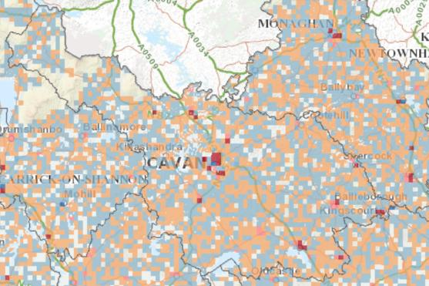
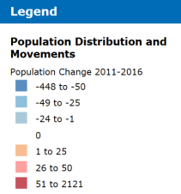
Figure 2 Map 1.2 Change in population by 1km2 grid, 2011- 2016

There are 2,755 people aged 65 years and over living alone in County Cavan. Of these, 395 are aged 85 years and over. Independent living is a positive feature of ageing but older people living alone are likely to require additional supports as they age.
Persons living alone (Number)  2016 | All ages | 65 years and over | 70 years and over | 75 years and over | 80 years and over | 85 years and over
Both sexes | 6,683 | 2,755 | 2,071 | 1,476 | 911 | 395
Male | 3,711 | 1,244 | 872 | 551 | 298 | 116
Female | 2,972 | 1,511 | 1,199 | 925 | 613 | 279
Table 2 Population Aged 65 years and Over Living Alone in County Cavan, 2016

Marital Status
The majority of people (all ages) in County Cavan are single (52%) while 39% of the population are married (including same sex civil partnership). Over three thousand people are widowed. Similar numbers are either separated (1,758) or divorced (1,652).
Marital Status | Male | Female | Total | Total %
Single | 21,004 | 18,461 | 39,465 | 51.81
Married (incl. same sex civil partnership) | 15,044 | 14,966 | 30,010 | 39.40
Separated | 802 | 956 | 1,758 | 2.31
Divorced | 731 | 921 | 1,652 | 2.17
Widowed | 749 | 2542 | 3,291 | 4.32
Total | 38,330 | 37,846 | 76,176
Table 3 Population by sex and marital status

Nationally, 4,226 people indicated that they were in a registered same-sex civil partnership. The majority of these were male (2,526 people or 59.8%). This was the first time this category was recorded on an Irish census.

Table 4 Population of County Cavan by sex and marital status

Nationality, Ethnicity and Languages
Eight-seven per cent of County Cavan’s population are of Irish nationality. There are significant populations of other nationalities, with 2,189 Polish nationals living here, and 1,433 Lithuanian nationals.
62,173 people were born in Ireland but there are 65,609 Irish nationals in the county, presumably this includes Irish people born abroad who have moved to Cavan and people of other nationalities who have become Irish citizens.
 | Birthplace | Nationality (Number) | Nationality  %
Ireland | 62,173 | 65,609 | 87.11
UK | 5,414 | 2,041 | 2.71
Poland | 2,009 | 2,189 | 2.91
Lithuania | 1,301 | 1,433 | 1.90
Other EU 28 | 1,717 | 1,755 | 2.33
Rest of World | 2,706 | 1,396 | 1.85
Not stated | 0 | 897 | 1.19
Total | 75,320 | 75,320 | 100
Table 5 Usually resident population by place of birth and nationality

In terms of ethnicity, County Cavan’s usually resident population is predominantly White Irish (83%). People of ‘Other White’ ethnicity make up ten per cent of the population. The ‘White Irish Traveller’ community is less than one percent of the county population (477 people). The population of Travellers has not increased significantly in Cavan since 2011 when there were 452 Travellers in the county, however it is estimated that there is some underreporting among this community. Only 1% of Irish Travellers in County Cavan live in caravans or mobile homes.
Cavan | 2011 | 2016
Irish Travellers (Number) | 452 | 477
Irish Travellers per 1,000 total population (Number) | 6.2 | 6.3
Table 6 Irish Travellers Usually Resident and Present in the State as a proportion of the Total Population 2011 and 2016
There are 1,073 people of Asian or Asian Irish ethnicity or and 831 of Black of Black Irish ethnicity living in County Cavan.
Ethnic or Cultural Background | Persons | %
White Irish | 63,191 | 83.90
White Irish Traveller | 477 | 0.63
Other White | 7,493 | 9.95
Black or Black Irish | 831 | 1.10
Asian or Asian Irish | 1,073 | 1.42
Other | 887 | 1.18
Not stated | 1,368 | 1.82
Total | 75,320
Table 7 Usually resident population by ethnic or cultural background

Figure 3 Usually resident population by ethnic or cultural background

Over 9,000 people in County Cavan speak foreign languages at home. Three quarters of this group speak English very well or well.

The most commonly spoken foreign languages in County Cavan are Polish (2,363) and Lithuanian (1,387) followed by French (582). This information, combined with data on ability to speak English, is important in terms of informing service providers about languages to choose when translating literature for the community.

There are almost two thousand speakers of foreign languages (1,984) who cannot speak English well or at all living in County Cavan.
Translation and literacy supports are important for this segment of the population.

Language | Persons
Polish | 2,363
French | 582
Lithuanian | 1,387
Other | 4,698
Total | 9,030
Table 4 Speakers of foreign languages by language spoken

Ability to speak English | Persons
Very well | 3,953
Well | 2,826
Not well | 1,633
Not at all | 351
Not stated | 267
Total | 9,030
Table 5 Speakers of foreign languages by ability to speak English

Religion
Over eighty per cent of the population stated they were Catholic, while 11.38% stated they were of other stated religions. Five per cent listed themselves as ‘No religion’. The corresponding proportion stating they had no religion in 2011 was 3.11%.
This question on the Census is not about frequency of attendance at church or other place or worship. People were asked to answer the question based on how they feel about their religious beliefs, if any.
Religion | Persons | %
Catholic | 62,392 | 81.91
Other stated religion | 8671 | 11.38
No religion | 3904 | 5.12
Not stated | 1209 | 1.59
Total | 76176
Table 8 Population of County Cavan by religion

There has been a significant change in the number of people stating they have no religion which figure increased by 71.5% between 2011 and 2016.
In 2011 there were 2,276 people with no religion in the county; this increased to 3,904 in 2016.
2016 Cavan | Population (Number) | Actual change since previous census  (Number) | Percentage change since previous census (%)
All religions | 76,176 | 2993 | 4.1
Roman Catholic | 62,392 | 197 | 0.3
Church of Ireland (incl. Protestant) | 4,292 | 62 | 1.5
Presbyterian | 935 | 25 | 2.7
Methodist, Wesleyan | 123 | 3 | 2.5
Jewish | 11 | -6 | -35.3
Other stated religion (nec) | 3,310 | 823 | 33.1
No religion | 3,904 | 1628 | 71.5
Not stated | 1,209 | 261 | 27.5
Table 9 Population of County Cavan by religion

Year | 1946 | 1961 | 1971 | 1981 | 1991 | 2002 | 2006 | 2011 | 2016
Population | 0 | 2 | 23 | 170 | 291 | 847 | 1,458 | 2,276 | 3,904
Table 10 Population of County Cavan categorised as having no religion, 1946-2016
Up until 1946 the Census did not record any people with no religion. Since the 1961 Census the numbers of people in Cavan categorising themselves as having no religion have increased.

Irish Speakers
Thirty five per cent of the population aged over 3 stated they could speak Irish, but the majority of people (63%) stated they cannot speak Irish.
Ability to speak Irish | Persons | %
Yes | 25,210 | 34.60
No | 46,003 | 63.13
Not stated | 1,657 | 2.27
Total | 72,870
Table 6 Population aged 3 years and over by ability to speak Irish

Of the 25,201 people aged over three who can speak Irish, the majority of those who speak Irish on a daily basis are within the education system (9,386) while 339 people speak Irish on a daily basis outside the education system. 1,280 speak Irish outside of the education system on a weekly basis.

Frequency of speaking Irish | Male | Female | Total
Speaks Irish daily only within the education system | 4,168 | 5,218 | 9,386
Speaks Irish daily within and daily outside the education system | 47 | 84 | 131
Speaks Irish daily within and weekly outside the education system | 42 | 58 | 100
Speaks Irish daily within and less often outside the education system | 34 | 51 | 85
Speaks Irish daily within and never outside the education system | 24 | 21 | 45
Speaks Irish daily only outside the education system | 156 | 183 | 339
Speaks Irish weekly only outside the education system | 580 | 700 | 1280
Speaks Irish less often only outside the education system | 3,265 | 4,289 | 7,554
Never speaks Irish | 2,736 | 3,358 | 6,094
Not stated | 100 | 96 | 196
All Irish speakers | 11,152 | 14,058 | 25,210
Table 7 Irish speakers aged 3 years and over by frequency of speaking Irish

Educational Attainment
Almost 17% of the population have no formal or primary education only (8,264 people). A further 17% had Lower Secondary Education only (8,266 people).
A growing proportion (9,504 people) are educated to degree level or higher (19.27%). In 2011, the proportion educated to degree level or higher was 16.68%.

Education Level | Males | Females | Total | %
No Formal Education | 675 | 507 | 1,182 | 2.40
Primary Education | 4,143 | 2,939 | 7,082 | 14.36
Lower Secondary | 4,904 | 3,362 | 8,266 | 16.76
Upper Secondary | 4,090 | 4,720 | 8,810 | 17.86
Technical or Vocational qualification | 2,547 | 3,075 | 5,622 | 11.40
Advanced Certificate/Completed Apprenticeship | 2,344 | 1,196 | 3,540 | 7.18
Higher Certificate | 986 | 1,542 | 2,528 | 5.13
Ordinary Bachelor Degree or National Diploma | 1,352 | 1,820 | 3,172 | 6.43
Honours Bachelor Degree Professional qualification or both | 1,361 | 2,279 | 3,640 | 7.38
Postgraduate Diploma or Degree | 908 | 1,647 | 2,555 | 5.18
Doctorate(Ph.D) or higher | 79 | 58 | 137 | 0.28
Not stated | 1,390 | 1,391 | 2,781 | 5.64
Total | 24,779 | 24,536 | 49,315
Table 11 Population aged 15 years and over by sex and highest level of education completed

A significant proportion of the population left school before they were 15 years of age (4,326 or 8.77% of those aged 15 years and over)
There are 6,014 people in the county who are currently at school or college.
Age | Males | Females | Total
Under 15 years | 2,648 | 1,678 | 4,326
15 | 1,411 | 909 | 2,320
16 | 2,593 | 1,795 | 4,388
17 | 1,811 | 1,729 | 3,540
18 | 2,720 | 3,058 | 5,778
19 | 998 | 1,340 | 2,338
20 | 1,046 | 1,247 | 2,293
21 and over | 3,906 | 5,263 | 9,169
Not stated | 7,646 | 7,517 | 15,163
Total | 24,779 | 24,536 | 49,315
Table 8 Population aged 15 years and over by age education ceased
In terms of qualification area, significantly more women than men are qualified in the education sector and teacher training (1,605 women and 322 men). Significantly more women than men are qualified in Social Science, Business and Law (3,565 women compared to 1351 men).
The Engineering, Manufacturing and Construction qualification sector has more males (4,312 males compared to 367 females) as has Agriculture and Veterinary (2,065 males versus 273 females).

Qualification | Males | Females | Total
Education and teacher training | 322 | 1,605 | 1,927
Arts | 304 | 308 | 612
Humanities | 238 | 292 | 530
Social Sciences Business and Law | 1,351 | 3,565 | 4,916
Science Mathematics and Computing | 754 | 710 | 1,464
Engineering Manufacturing and Construction | 4,312 | 367 | 4,679
Agriculture and Veterinary | 2,065 | 273 | 2,338
Health and Welfare | 432 | 3,332 | 3,764
Services | 814 | 1,586 | 2,400
Other subjects | 19 | 25 | 44
Not Stated (incl. unknown) | 14,168 | 12,473 | 26,641
Total | 24,779 | 24,536 | 49,315
Table 9 Population aged 15 years and over by field of study

The diagram below illustrates that approximately half of the county’s population are educated only to secondary level. The remaining half have higher levels of education (degree level or higher).

Figure 10 Highest level of education completed in County Cavan, 2016

Family Units
There are 14,122 family units with children, comprised of 11,068 couples with children, 2,603 mothers with children and 451 fathers with children. This means that of the total 14,122 family units with children, 18.43 per cent are lone mothers and 3.19 per cent are lone fathers.
People parenting on their own can include people who never married and those who are separated, divorced or widowed.
Age of children | Couples with children | Mothers with children | Fathers with children
All children under 15 | 5,480 | 1,002 | 87
All children 15 and over | 3,586 | 1,267 | 332
Children both under and over 15 | 2,002 | 334 | 32
Total | 11,068 | 2,603 | 451
Table 11 Family units with children by type of family and age of children

There are 5,022 children living in lone parent family units in the county.
Number of children | Couples with children | Mothers with children | Fathers with children
All children under 15 | 11,616 | 1,572 | 1,27
All children 15 and over | 6,053 | 1,767 | 459
Children both under and over 15 | 6,421 | 1,002 | 95
Total | 24,090 | 4,341 | 681
Table 12 Family units with children by type of family and age of children

In County Cavan, 23% of women aged 20 and over gave birth to four or more children. Eighteen per cent had three children and 22 per cent had 2 children.
Nationally, only 18% of women had four children or more, 17% had three children and 22% had 2 children.

Number of children born | Number of females
0 | 6,345
1 | 3,149
2 | 5,592
3 | 4,701
4 or more | 5,807
Total | 25,594
Table 13 Females aged 20 years or over by number of children born

Donegal, Cavan and Monaghan had the largest families with 2.19 children per family on average.

Figure 14 Number of children born to females in County Cavan aged 20 years and over

Housing
There are 33,585 housing units in County Cavan in 2016. Given that the total housing stock in 1991 was 18,111, this meant there was an 85% increase in housing stock in the county in a 25 year period.
 | 1991 | 1996 | 2002 | 2006 | 2011 | 2016
Total housing stock (Number) | 18,111 | 18,591 | 21,165 | 28,250 | 33,711 | 33,585
Vacant (Number) | 2,170 | 2,081 | 2,720 | 5,997 | 7,277 | 5,875
Vacancy rate (%) | 12 | 11.2 | 12.9 | 21.2 | 21.6 | 17.5
Figure 15 Housing Stock and Vacancy Rate 1991 to 2016 in County Cavan
Among the 5,875 vacant housing units, 1,046 were unoccupied holiday homes and 4,829 were other vacant dwellings. This gives a vacancy rate of 17.5 in 2016, which had decreased from 21.6 in 2011.
Given the housing crisis and the numbers on waiting lists for social housing, it is a positive trend to see a decline in the number of vacant houses.

Occupancy Status | Permanent Dwellings
Occupied | 26,925
Temporarily absent | 785
Unoccupied holiday homes | 1,046
Other vacant dwellings | 4,829
Total | 33,585
Figure 16 Occupancy status of permanent dwellings on Census night
Nationally, there were 289,451 vacant dwellings in 2011. The 2016 census results show that the number of vacant dwellings has fallen by 29,889 (-13.8%) and now stands at 259,562. The vacancy rate has also fallen to 12.8 per cent. Within this the number of holiday homes has increased marginally between 2011 and 2016, from 59,395 to 61,204.
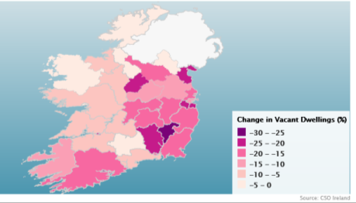
Figure 17 Map of change in housing vacancy rate, 2011-2016

Census data also show that there were 93 temporary private households in County Cavan in 2016 with 141 people residing in them.
At individual town level, Blacklion (46.4%) in Cavan had the highest vacancy rate, excluding holiday homes in 2016 followed by Keshcarrigan (45.6%) in Leitrim and Kilgarvan (43.1%) in Kerry.
Town | County | Vacancy rate
Blacklion | Cavan | 46.4
Keshcarrigan | Leitrim | 45.6
Kilgarvan | Kerry | 43.1
Drumkeeran | Leitrim | 38.4
Swanlinbar | Cavan | 37.8
Tullaghan | Leitrim | 37.3
Ballinlough | Roscommon | 36.8
Table 12 Top 7 highest vacancy rate in towns, 2016
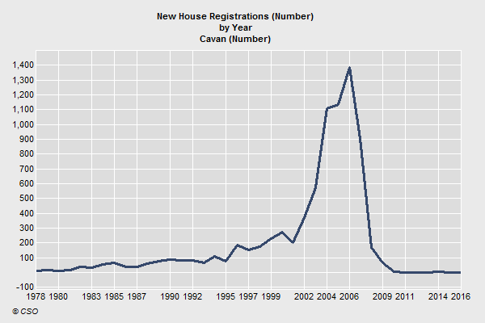
Figure 18 New house registrations by year in County Cavan (Source: CSO)

The diagram above illustrates the peak of the housing boom in County Cavan in 2006 followed by a sharp decline in the number of new houses registered every year.
The Central Statistics Office also provides figures for average rents. In County Cavan in 2016, the average monthly rent paid on all property types was €511.23. In contrast the average monthly rent in Dublin 1 in 2016 was €1,284.
Property Type | 2016
Detached house | 544.55
Semi detached house | 538.6
Terrace house | 524.04
Apartment | 461.94
Other flats | 356.25
All property types | 511.23
Table 13 RTB Average Monthly Rent Report (Euro) in County Cavan, 2016

Nationally, 497,111 households in Ireland were renting on Census night 2016. This is an increase of 22,323 since Census 2011 when 474,788 households were renting. The biggest increases in the number of renters were in Cavan (up 12.8%) and Kilkenny (up 11.2%).

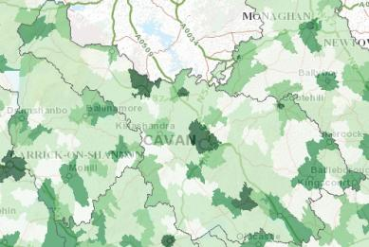 | 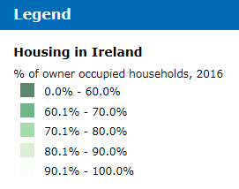

The map above shows the rate of owner occupied housing in Cavan, with the darker shaded areas having lower rates of owner occupied housing.

Household Composition
The most common form of household structure was ‘married couple with children’ (9,242) followed by ‘one person’ (6,683) and ‘married couple’ (4,219).
Type of Household | Households | Persons
One person | 6,683 | 6,683
Married couple | 4,219 | 8,438
Cohabiting couple | 844 | 1,688
Married couple and children | 9,242 | 39,039
Cohabiting couple and children | 1,175 | 4,587
Father and children | 387 | 969
Mother and children | 2,202 | 5,968
Couple and others | 217 | 724
Couple children and others | 484 | 2,575
Father children and others | 50 | 194
Mother children and others | 213 | 789
Two or more family units | 257 | 1,431
Non-family households and relations | 529 | 1,200
Two or more non-related persons | 397 | 1,000
Total | 26,899 | 75,285
Table 19 Private households by type

In terms of household size, over half (13,910) were comprised of 1-2 people. 445 households had seven or more people. Sixteen per cent had three people, and 16% had four people.
Size of household | Households | Persons
1 person | 6,683 | 6,683
2 persons | 7,227 | 14,454
3 persons | 4,327 | 12,981
4 persons | 4,358 | 17,432
5 persons | 2,768 | 13,840
6 persons | 1,091 | 6,546
7 persons | 295 | 2,065
8 or more persons | 150 | 1,284
Total | 26,899 | 75,285
Table 20 Private households by size

Type of Household
The vast majority of accommodation in County Cavan is made up of houses/bungalows (94%) with only 4 per cent of units being flats/apartments. There are only 22 bedsits and 93 caravans/mobile homes in the county.

Type of accommodation | Households | % of households
House/Bungalow | 25,335 | 94.19
Flat/Apartment | 1,110 | 4.13
Bed-sit | 22 | 0.08
Caravan/Mobile Home | 93 | 0.35
Not stated | 339 | 1.26
Total | 26,899
Table 21 Private households by type of accommodation

Of the 26,806 households, the largest proportion are owner occupied with no mortgage, followed by owner occupied with mortgage.
Over two thousand (2,169) units are rented from the local authority and 133 are rented from a voluntary body.

Type of occupancy | Households | Persons
Owner occupied with mortgage | 8,507 | 30,082
Owner occupied no mortgage | 10,657 | 25,080
Rented from Private Landlord | 4,171 | 11,625
Rented from Local Authority | 2,169 | 5,593
Rented from Voluntary Body | 133 | 229
Occupied free of rent | 511 | 946
Not stated | 658 | 1,589
Total | 26,806 | 75,144
Table 22 Permanent private households by type of occupancy

Water, Heating, Sewerage
The bulk of households in County Cavan are heated with oil central heating (18,698), coal was the next most common heating source (2,002 households) and electricity was the third most common heat source (1,146).
273 households stated they had no central heating system.

Central heating | Households
No central heating | 273
Oil | 18,698
Natural Gas | 2,000
Electricity | 1,146
Coal (incl. Anthracite) | 2,002
Peat (incl. turf) | 899
Liquid Petroleum Gas (LPG) | 269
Wood (incl. wood pellets) | 890
Other | 182
Not stated | 447
Total | 26,806
Table 23 Permanent private households by central heating

Less than half of houses in County Cavan are supplied with water from the public mains (45.14%). 28.75% are supplied by a group scheme. Over six thousand households are supplied by a private source.
54 houses stated they had no water supply. The number of households stating they have no piped water supply has decreased from 2011 when 74 households in Cavan indicated this was the case.
Type of water supply | Households
Public main | 12,099
Group scheme with public source | 4,961
Group scheme with private source | 2,746
Other private source | 6,056
None | 54
Not stated | 890
Total | 26,806
Table 24 Permanent private households by water supply

There are over twelve thousand households in the county with an individual septic tank and a further two thousand with other individual treatment for sewerage (combined these figures represent 54% of households). There are 59 households listed with no sewerage facility. This figure has decreased significantly from 2011 when there were 98 households with no sewerage facility.

Type of sewerage facility | Households
Public scheme | 11,132
Individual septic tank | 12,319
Other individual treatment | 2,117
Other | 166
No sewerage facility | 59
Not stated | 1,013
Total | 26,806
Table 25 Permanent private households by sewerage facility

There are fifty communal establishments in the county with 1,717 people living in them (an average of 34 people per establishment). These establishments include places like nursing homes and the prison.

Communal Establishments | Total
Number of establishments | 50
Number of persons | 1,717
Table 26 Number of communal establishments and persons in communal establishments, County Cavan

Economic Status and Social Class
Over thirty thousand people were at work in Cavan in 2016, and 5,413 were unemployed. There were 6,014 students and 5,545 people looking after home/family.
2,390 people were unable to work due to permanent sickness or disability.
Principal Economic Status | Male | Female | Total
At work | 17,112 | 13,397 | 30,509
Looking for first regular job | 314 | 289 | 603
Unemployed having lost or given up previous job | 2,728 | 2,082 | 4,810
Student | 2,909 | 3,105 | 6,014
Looking after home/family | 401 | 5,144 | 5,545
Retired | 4,508 | 3,956 | 8,464
Unable to work due to permanent sickness or disability | 1,228 | 1,162 | 2,390
Other | 137 | 82 | 219
Total | 29,337 | 29,217 | 58,554
Table 27 Population aged 15 years and over by principal economic status and sex
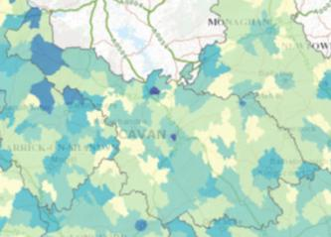 | 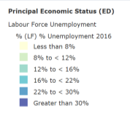
Table 14 Map of labour force unemployment, 2016
Cavan is listed as having two unemployment blackspots in Census 2016, which is defined as an area where there unemployment is in excess of 27%. From the above map, these appear to be Cavan Town and Belturbet.
Nationally the monthly unemployment rate was listed as 6.4% in July 2017.
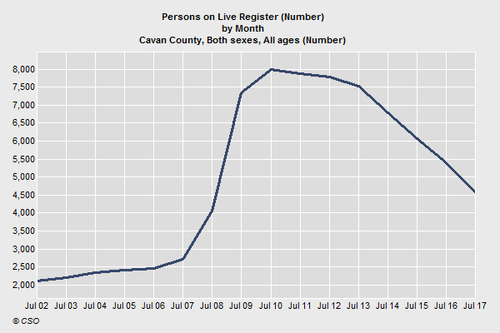
Source: Central Statistics Office, Live Register Data.

Social Class | Male | Female | Total
Professional workers | 2,346 | 1,869 | 4,215
Managerial and technical | 8,350 | 9,866 | 18,216
Non-manual | 5,500 | 8,167 | 13,667
Skilled manual | 8,911 | 4,866 | 13,777
Semi-skilled | 5,104 | 4,567 | 9,671
Unskilled | 1,862 | 1,406 | 3,268
All others gainfully occupied and unknown | 6,257 | 7,105 | 13,362
Total | 38,330 | 37,846 | 76,176
Table 28 Population by sex and social class

In County Cavan, 5.53 per cent of the population are in the ‘Professional worker’ social class category and 24 per cent are ‘Managerial and technical’. Seventeen per cent of the population are in ‘Semi-skilled’ or ‘Unskilled’ social classes.
Nationally, significant differences existed in the distribution of social class across the country with Dún Laoghaire-Rathdown (55.9%) containing the highest proportion of people classified to the combined classes of 1 and 2 while Longford (27.7%), Monaghan (29.3%) and Cavan (29.4%) had the lowest rates.

The socio-economic group of the reference person was ‘farmer’ in 3,211 households in County Cavan, while there were 8,796 people living in farming households in the county.
Socio-economic group of reference person | Households | Persons
A Employers and managers | 2,893 | 9,063
B Higher professional | 1,048 | 3,205
C Lower professional | 2,374 | 6,773
D Non-manual | 4,122 | 11,294
E Manual skilled | 3,084 | 9,357
F Semi-skilled | 2,540 | 7,439
G Unskilled | 1,066 | 2,856
H Own account workers | 1,482 | 4,558
I Farmers | 3,211 | 8,796
J Agricultural workers | 301 | 825
Z All others gainfully occupied and unknown | 4,778 | 11,119
Total | 26,899 | 75,285
Table 29 Persons in private households by socio-economic group of reference person
The largest industry sector in County Cavan is Professional Services (6,419) followed by Commerce and Trade (5,993) and Manufacturing (5,081). The next largest industry sector is Agriculture, Forestry and Fishing with 11.32% of people at work in this sector.

Industry | Male | Female | Total | %
Agriculture forestry and fishing | 3,030 | 425 | 3,455 | 11.32
Building and construction | 1,988 | 144 | 2,132 | 6.99
Manufacturing industries | 3,773 | 1,308 | 5,081 | 16.65
Commerce and trade | 3,040 | 2,953 | 5,993 | 19.64
Transport and communications | 1,129 | 332 | 1,461 | 4.79
Public administration | 658 | 792 | 1,450 | 4.75
Professional services | 1,383 | 5,036 | 6,419 | 21.04
Other | 2,111 | 2,407 | 4,518 | 14.81
Total | 17,112 | 13,397 | 30,509
Table 15 Persons at work by industry and sex in County Cavan, 2016

Commuting
In County Cavan, most commuters travel by car either as a driver (19,919) or passenger (10,243).
Almost two thousand people work from home (1,961); 5,576 use a bus/coach; 4,201 travel on foot; and 239 cycle to work, school or college.
The proportion opting for cycling as a mode of commuting in Cavan is 0.49 per cent compared to 2.7 per cent nationally.
Means of Travel | Work | School or College | Total
On foot | 1,851 | 2,350 | 4,201
Bicycle | 141 | 98 | 239
Bus minibus or coach | 425 | 5,151 | 5,576
Train DART or LUAS | 55 | 37 | 92
Motorcycle or scooter | 27 | 3 | 30
Car driver | 19,247 | 672 | 19,919
Car passenger | 1,422 | 8,821 | 10,243
Van | 3,299 | 56 | 3,355
Other (incl. lorry) | 348 | 11 | 359
Work mainly at or from home | 1,940 | 21 | 1,961
Not stated | 1,288 | 601 | 1,889
Total | 30,043 | 17,821 | 47,864
Table 30 Population aged 5 years and over by means of travel to work school or college

Almost half (47%) of commuters leave home after 8.30am to travel to work, school or college. 6,741 people leave home before 7 o’clock in the morning to commute to their destination.
Time leaving home | Persons | %
Before 06:30 | 3,860 | 8.41
06:30-07:00 | 2,881 | 6.28
07:01-07:30 | 3,293 | 7.17
07:31-08:00 | 6,368 | 13.87
08:01-08:30 | 7,864 | 17.13
08:31-09:00 | 11,022 | 24.01
09:01-09:30 | 5,709 | 12.44
After 09:30 | 2,735 | 5.96
Not stated | 2,171 | 4.73
Total | 45,903
Table 31 Population aged 5 years and over by time leaving home to travel to work, school or college
The majority of people (65%) have a journey time of under half an hour. However, almost two thousand people have a journey time of 1.5 hours or longer.
Journey time | Persons | %
Under 15 mins | 17,924 | 39.05
1/4 hour - under 1/2 hour | 11,915 | 25.96
1/2 hour - under 3/4 hour | 6,311 | 13.75
3/4 hour - under 1 hour | 1,812 | 3.95
1 hour - under 1 1/2 hours | 2,502 | 5.45
1 1/2 hours and over | 1,989 | 4.33
Not stated | 3,450 | 7.52
Total | 45,903
Table 32 Population aged 5 years and over by journey time to work school or college

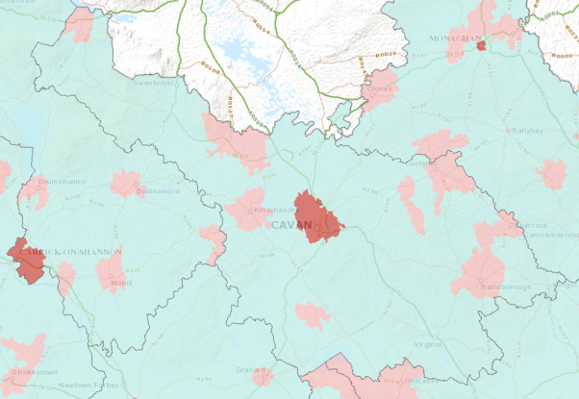
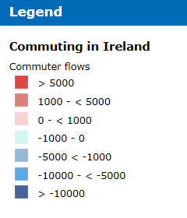
Commuter flows – inward commuters less outward, 2016

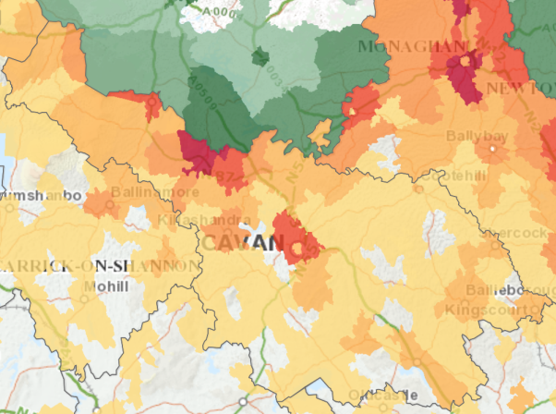
Persons commuting from Ireland to Northern Ireland for work or study by electoral division/ward, 2016
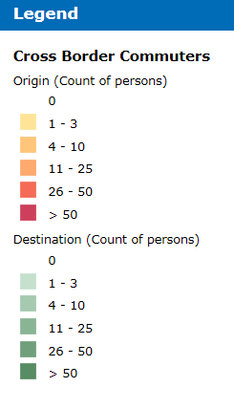

People with Disability and Carers
There are 9,508 people with disability in County Cavan, 50.3 per cent female and 49.7 per cent male.
Disability | Male | Female | Total
Total | 4,725 | 4,783 | 9,508
Table 33 Persons with a disability by sex

There are over three thousand carers in the county, 59.6 per cent female and 40.4 per cent male.
Carers | Male | Female | Total
Total | 1,265 | 1,866 | 3,131
Table 34 Carers by sex

Health
A large majority of people in the county report their health as being ‘very good’ or ‘good’ – combined the proportion is 87.44 per cent.
Fewer than a thousand people reported ‘bad’ health and 210 people said they had ‘very bad’ health. In general there were no major gender differences in people’s self-reported health, although a greater proportion of men had very bad health.
General Health | Male | Female | Total | Total %
Very good | 23,173 | 22,992 | 46,165 | 60.60
Good | 10,382 | 10,064 | 20,446 | 26.84
Fair | 3,234 | 3,245 | 6,479 | 8.51
Bad | 466 | 488 | 954 | 1.25
Very bad | 125 | 85 | 210 | 0.28
Not stated | 950 | 972 | 1,922 | 2.52
Total | 38,330 | 37,846 | 76,176
Table 35 Population by general health and sex

Car ownership
The majority of households (86%) have at least one car. A significant percentage (36%) report having two cars.
Over three thousand households in county Cavan have no car. This is likely to be a disadvantage given the rural nature of the county and limitations in the transport infrastructure.
Motor cars | Households | %
No motor car | 3,111 | 11.61
One motor car | 11,117 | 41.47
Two motor cars | 9,700 | 36.19
Three motor cars | 1,677 | 6.26
Four or more motor cars | 614 | 2.29
Not stated | 587 | 2.19
Total | 26,806
Table 16 Number of households with cars

Personal computer and broadband
Almost two thirds (64.49%) of households have a personal computer. One third have no computer (8,761 households).
Nationally, 68% of households have a personal computer and 28% have no computer. Cavan lags behind the state average for computer ownership but only by a few percentage points.

Personal Computer | Cavan Households | Cavan  % | State Households | State  %
Yes | 17,286 | 64.49 | 1,160,603 | 68.36
No | 8,761 | 32.68 | 478,487 | 28.19
Not stated | 759 | 2.83 | 58,575 | 3.45
Total | 26,806 |  | 1,697,665
Table 17 Number of households with a personal computer, Co Cavan and State

Among households with internet access, 17,061 have a broadband connection for their internet access. 2,693 said they had ‘other’ connection.
Internet Access | Households
Broadband | 17061 | 63.65
Other | 2698 | 10.06
No | 6318 | 23.57
Not stated | 729 | 2.72
Total | 26806
Table 18 Number of households with internet access

Appendix I Population of Electoral Divisions in County Cavan
Electoral Division | Age 0-18 | Age 19 | Age 20-24 | Age 25-29 | Age 30-34 | Age 35-39 | Age 40-44 | Age 45-49 | Age 50-54 | Age 55-59 | Age 60-64 | Age 65-69 | Age 70-74 | Age 75-79 | Age 80-84 | Age 85+ | Total Pop
Cavan Urban | 1004 | 41 | 249 | 315 | 353 | 307 | 236 | 212 | 204 | 213 | 208 | 159 | 93 | 61 | 65 | 50 | 3,770
Bailieborough | 1193 | 39 | 206 | 230 | 293 | 294 | 289 | 269 | 246 | 206 | 186 | 179 | 146 | 91 | 85 | 53 | 4,005
Carnagarve | 146 | 6 | 42 | 29 | 28 | 33 | 51 | 51 | 38 | 34 | 39 | 24 | 23 | 11 | 7 | 7 | 569
Crossbane | 203 | 8 | 25 | 21 | 36 | 57 | 43 | 53 | 38 | 28 | 25 | 26 | 20 | 17 | 9 | 5 | 614
Drumanespick | 167 | 3 | 11 | 15 | 24 | 31 | 25 | 41 | 21 | 42 | 17 | 17 | 12 | 7 | 9 | 5 | 447
Enniskeen | 140 | 6 | 22 | 27 | 27 | 22 | 37 | 39 | 42 | 35 | 20 | 13 | 9 | 4 | 8 | 6 | 457
Killinkere | 123 | 3 | 30 | 18 | 22 | 20 | 33 | 31 | 31 | 32 | 30 | 27 | 11 | 7 | 15 | 12 | 445
Kingscourt | 1043 | 43 | 152 | 212 | 308 | 294 | 229 | 230 | 184 | 157 | 153 | 107 | 87 | 59 | 45 | 32 | 3,335
Lisagoan | 123 | 4 | 17 | 18 | 38 | 33 | 16 | 31 | 29 | 19 | 30 | 16 | 16 | 7 | 4 | 2 | 403
Mullagh | 787 | 25 | 74 | 112 | 172 | 195 | 183 | 182 | 110 | 84 | 87 | 75 | 69 | 35 | 21 | 10 | 2,221
Shercock | 362 | 15 | 71 | 79 | 100 | 101 | 93 | 80 | 81 | 72 | 55 | 47 | 32 | 39 | 21 | 14 | 1,262
Skeagh | 127 | 5 | 22 | 13 | 15 | 18 | 29 | 32 | 24 | 28 | 26 | 25 | 17 | 8 | 9 | 8 | 406
Taghart | 172 | 10 | 39 | 32 | 47 | 35 | 41 | 45 | 38 | 45 | 38 | 24 | 23 | 19 | 4 | 6 | 618
Termon | 143 | 8 | 26 | 36 | 26 | 39 | 42 | 32 | 35 | 29 | 35 | 36 | 24 | 9 | 7 | 9 | 536
Ballyconnell | 440 | 17 | 52 | 82 | 168 | 159 | 120 | 85 | 73 | 74 | 92 | 61 | 47 | 28 | 23 | 32 | 1,553
Ballymagauran | 55 | 5 | 6 | 7 | 12 | 10 | 18 | 21 | 20 | 23 | 12 | 22 | 7 | 10 | 11 | 6 | 245
Bawnboy | 150 | 4 | 28 | 25 | 42 | 35 | 38 | 48 | 43 | 37 | 30 | 28 | 35 | 12 | 18 | 14 | 587
Bilberry | 39 | 3 | 8 | 6 | 6 | 15 | 14 | 12 | 5 | 12 | 14 | 10 | 9 | 6 | 3 | 3 | 165
Carn | 50 | 1 | 13 | 6 | 5 | 13 | 14 | 20 | 20 | 22 | 12 | 13 | 9 | 6 | 3 | 4 | 211
Diamond | 33 | 1 | 5 | 4 | 8 | 12 | 13 | 8 | 9 | 3 | 6 | 13 | 6 | 4 | 3 | 2 | 130
Doogary | 33 | 2 | 5 | 11 | 7 | 3 | 12 | 11 | 14 | 9 | 10 | 10 | 3 | 4 | 1 | 7 | 142
Kinawley | 30 | 1 | 8 | 3 | 5 | 11 | 5 | 3 | 12 | 6 | 8 | 8 | 5 | 2 | 2 | 2 | 111
Lissanover | 85 | 3 | 13 | 6 | 17 | 23 | 20 | 20 | 26 | 19 | 16 | 15 | 9 | 6 | 7 | 6 | 291
Pedara Vohers / Tircahan | 42 | 2 | 9 | 5 | 9 | 11 | 10 | 8 | 12 | 20 | 9 | 19 | 9 | 10 | 6 | 4 | 185
Swanlinbar | 92 | 3 | 17 | 17 | 20 | 24 | 25 | 28 | 37 | 23 | 23 | 26 | 13 | 11 | 10 | 6 | 375
Templeport / Benbrack | 55 | 2 | 18 | 21 | 20 | 16 | 19 | 21 | 29 | 24 | 23 | 27 | 23 | 18 | 10 | 6 | 332
Ballyjamesduff | 1068 | 49 | 158 | 184 | 256 | 317 | 249 | 225 | 183 | 156 | 123 | 95 | 64 | 58 | 32 | 21 | 3,238
Castlerahan | 265 | 10 | 51 | 29 | 36 | 60 | 73 | 82 | 72 | 40 | 47 | 45 | 35 | 27 | 19 | 10 | 901
Kilbride | 283 | 8 | 33 | 30 | 55 | 74 | 81 | 63 | 79 | 52 | 52 | 46 | 29 | 28 | 24 | 33 | 970
Lurgan | 170 | 6 | 27 | 20 | 28 | 35 | 35 | 69 | 50 | 30 | 37 | 20 | 27 | 19 | 24 | 34 | 631
Munterconnaught | 361 | 15 | 51 | 42 | 61 | 71 | 76 | 108 | 98 | 63 | 54 | 36 | 42 | 21 | 17 | 13 | 1,129
Virginia | 1334 | 57 | 178 | 247 | 335 | 331 | 341 | 335 | 284 | 237 | 197 | 167 | 126 | 113 | 67 | 51 | 4,400
Ardue | 221 | 9 | 21 | 25 | 69 | 53 | 63 | 59 | 78 | 80 | 71 | 51 | 29 | 22 | 12 | 3 | 866
Arvagh | 263 | 7 | 34 | 42 | 64 | 65 | 60 | 73 | 56 | 54 | 65 | 52 | 37 | 39 | 28 | 20 | 959
Ashfield | 101 | 5 | 16 | 16 | 16 | 20 | 24 | 28 | 18 | 28 | 19 | 17 | 15 | 15 | 13 | 7 | 358
Ballintemple | 112 | 7 | 30 | 29 | 23 | 18 | 36 | 24 | 36 | 37 | 27 | 18 | 15 | 8 | 5 | 9 | 434
Ballyhaise | 306 | 13 | 55 | 59 | 65 | 81 | 73 | 68 | 77 | 53 | 57 | 41 | 34 | 24 | 32 | 18 | 1,056
Ballymachugh | 225 | 10 | 37 | 29 | 45 | 64 | 56 | 69 | 62 | 51 | 36 | 45 | 32 | 40 | 18 | 9 | 828
Bellananagh | 475 | 19 | 75 | 94 | 148 | 110 | 104 | 97 | 88 | 85 | 74 | 56 | 42 | 25 | 16 | 21 | 1,529
Belturbet Urban | 362 | 15 | 97 | 95 | 119 | 110 | 98 | 83 | 75 | 104 | 98 | 93 | 72 | 40 | 27 | 16 | 1,504
Bruce Hall | 66 | 4 | 8 | 3 | 6 | 16 | 15 | 19 | 17 | 9 | 6 | 16 | 7 | 7 | 9 | 4 | 212
Butler's Bridge | 138 | 1 | 14 | 14 | 33 | 37 | 47 | 34 | 36 | 32 | 27 | 12 | 13 | 17 | 7 | 8 | 470
Canningstown | 133 | 4 | 22 | 28 | 27 | 26 | 35 | 33 | 49 | 41 | 39 | 19 | 22 | 18 | 12 | 24 | 532
Carrafin | 128 | 3 | 11 | 14 | 16 | 27 | 29 | 29 | 35 | 28 | 20 | 20 | 11 | 15 | 7 | 7 | 400
Castlesaunderson | 85 | 5 | 13 | 17 | 18 | 19 | 25 | 15 | 18 | 20 | 21 | 14 | 10 | 9 | 7 | 4 | 300
Cavan Rural | 2507 | 68 | 326 | 491 | 789 | 821 | 694 | 460 | 410 | 358 | 290 | 299 | 234 | 171 | 141 | 214 | 8,273
Clonervy | 249 | 12 | 58 | 38 | 43 | 51 | 59 | 94 | 64 | 55 | 41 | 36 | 28 | 9 | 10 | 6 | 853
Cootehill Rural | 307 | 15 | 61 | 64 | 63 | 84 | 78 | 66 | 82 | 68 | 62 | 48 | 44 | 10 | 19 | 16 | 1,087
Cootehill Urban | 388 | 12 | 78 | 121 | 134 | 135 | 94 | 111 | 100 | 106 | 83 | 75 | 62 | 47 | 33 | 19 | 1,598
Corr | 78 | 3 | 11 | 10 | 10 | 21 | 14 | 19 | 14 | 17 | 17 | 19 | 14 | 5 | 8 | 7 | 267
Corraneary | 108 | 4 | 24 | 16 | 32 | 29 | 23 | 37 | 29 | 32 | 28 | 29 | 17 | 15 | 14 | 6 | 443
Crossdoney | 156 | 9 | 30 | 24 | 26 | 42 | 36 | 49 | 35 | 26 | 26 | 31 | 18 | 14 | 13 | 6 | 541
Crosskeys | 194 | 8 | 40 | 28 | 37 | 39 | 51 | 54 | 56 | 61 | 33 | 34 | 26 | 10 | 7 | 19 | 697
Cuttragh | 130 | 11 | 22 | 14 | 20 | 29 | 32 | 27 | 22 | 18 | 16 | 18 | 6 | 15 | 7 | 6 | 393
Denn | 213 | 5 | 31 | 32 | 35 | 48 | 50 | 58 | 45 | 46 | 29 | 48 | 25 | 18 | 13 | 9 | 705
Derrin | 119 | 8 | 17 | 19 | 20 | 34 | 38 | 20 | 31 | 24 | 29 | 33 | 18 | 11 | 9 | 3 | 433
Drumcarban | 176 | 9 | 14 | 28 | 39 | 47 | 36 | 45 | 27 | 42 | 44 | 30 | 30 | 19 | 13 | 13 | 612
Drumcarn | 139 | 10 | 25 | 24 | 24 | 34 | 35 | 33 | 27 | 47 | 37 | 45 | 19 | 20 | 6 | 3 | 528
Drung | 157 | 2 | 18 | 22 | 28 | 41 | 32 | 34 | 48 | 32 | 37 | 30 | 15 | 7 | 14 | 7 | 524
Graddum | 153 | 7 | 34 | 22 | 27 | 34 | 34 | 45 | 39 | 46 | 33 | 24 | 24 | 18 | 4 | 6 | 550
Grilly | 122 | 6 | 11 | 22 | 20 | 25 | 31 | 28 | 31 | 37 | 26 | 32 | 18 | 19 | 16 | 41 | 485
Kilconny | 178 | 4 | 20 | 18 | 29 | 45 | 42 | 47 | 34 | 40 | 28 | 33 | 15 | 7 | 2 | 4 | 546
Kill | 108 | 3 | 11 | 26 | 20 | 20 | 23 | 27 | 26 | 30 | 19 | 18 | 12 | 10 | 7 | 5 | 365
Killashandra | 274 | 11 | 63 | 65 | 58 | 56 | 86 | 64 | 99 | 100 | 65 | 68 | 53 | 42 | 25 | 24 | 1,153
Killykeen | 184 | 3 | 16 | 21 | 30 | 45 | 53 | 36 | 36 | 37 | 42 | 42 | 25 | 17 | 8 | 7 | 602
Kilnaleck | 323 | 12 | 38 | 51 | 85 | 92 | 111 | 85 | 76 | 54 | 57 | 45 | 38 | 29 | 13 | 9 | 1,118
Knappagh | 127 | 6 | 28 | 22 | 24 | 37 | 28 | 32 | 40 | 23 | 37 | 19 | 22 | 8 | 9 | 2 | 464
Larah North | 140 | 2 | 26 | 18 | 29 | 17 | 32 | 39 | 43 | 30 | 24 | 27 | 21 | 12 | 6 | 6 | 472
Larah South | 126 | 8 | 25 | 34 | 35 | 32 | 35 | 24 | 39 | 28 | 30 | 22 | 12 | 23 | 13 | 8 | 494
Milltown | 86 | 4 | 5 | 13 | 16 | 16 | 30 | 30 | 29 | 28 | 26 | 29 | 20 | 9 | 6 | 4 | 351
Moynehall | 544 | 24 | 86 | 74 | 118 | 121 | 131 | 123 | 123 | 121 | 90 | 69 | 50 | 28 | 26 | 16 | 1,744
Rakenny | 98 | 8 | 24 | 17 | 26 | 32 | 28 | 22 | 36 | 28 | 29 | 21 | 17 | 12 | 10 | 13 | 421
Redhill | 121 | 5 | 17 | 26 | 26 | 29 | 26 | 32 | 32 | 27 | 39 | 22 | 21 | 12 | 7 | 5 | 447
Springfield | 34 | 1 | 7 | 5 | 5 | 10 | 10 | 14 | 16 | 10 | 9 | 18 | 7 | 7 | 9 | 3 | 165
Stradone | 224 | 3 | 41 | 31 | 42 | 60 | 45 | 51 | 56 | 47 | 49 | 39 | 35 | 17 | 11 | 15 | 766
Tullyvin East | 126 | 3 | 12 | 19 | 42 | 34 | 23 | 27 | 28 | 24 | 31 | 22 | 28 | 25 | 12 | 6 | 462
Tullyvin West | 69 | 0 | 17 | 19 | 18 | 24 | 20 | 8 | 24 | 17 | 13 | 15 | 19 | 5 | 6 | 3 | 277
Waterloo | 200 | 8 | 39 | 27 | 41 | 50 | 46 | 67 | 59 | 67 | 37 | 26 | 26 | 15 | 26 | 23 | 757
Derrylahan | 17 | 0 | 4 | 3 | 4 | 2 | 1 | 7 | 11 | 10 | 4 | 5 | 4 | 8 | 4 | 1 | 85
Dowra | 26 | 1 | 7 | 15 | 5 | 6 | 10 | 7 | 18 | 19 | 12 | 9 | 4 | 4 | 2 | 9 | 154
Dunmakeever / Derrynananta | 31 | 3 | 10 | 3 | 3 | 11 | 5 | 12 | 12 | 11 | 10 | 6 | 11 | 6 | 5 | 3 | 142
Eskey | 64 | 1 | 21 | 24 | 29 | 23 | 24 | 30 | 24 | 22 | 16 | 14 | 10 | 4 | 7 | 6 | 319
Killinagh / Teebane | 38 | 0 | 5 | 5 | 4 | 10 | 5 | 12 | 16 | 8 | 6 | 6 | 7 | 8 | 3 | 4 | 137
Tuam | 64 | 3 | 11 | 16 | 22 | 14 | 26 | 20 | 26 | 38 | 22 | 31 | 13 | 5 | 9 | 11 | 331
Drumlumman | 197 | 7 | 22 | 23 | 37 | 54 | 33 | 45 | 30 | 29 | 30 | 29 | 19 | 14 | 10 | 7 | 586
Kilcogy | 130 | 6 | 20 | 15 | 23 | 32 | 33 | 22 | 30 | 23 | 23 | 23 | 20 | 11 | 10 | 6 | 427
Kilgolagh | 83 | 5 | 18 | 14 | 14 | 24 | 24 | 24 | 34 | 25 | 16 | 14 | 9 | 6 | 8 | 5 | 323
Loughdawan | 92 | 1 | 10 | 11 | 23 | 26 | 21 | 26 | 18 | 20 | 19 | 19 | 16 | 9 | 18 | 9 | 338
Scrabby | 166 | 10 | 23 | 32 | 37 | 32 | 30 | 52 | 56 | 41 | 25 | 33 | 20 | 21 | 18 | 13 | 609
Total | 21999 | 838 | 3525 | 3989 | 5420 | 5813 | 5493 | 5291 | 4963 | 4468 | 3913 | 3445 | 2571 | 1818 | 1399 | 1231 | 76,176

Properties can be vacant for a variety of reasons Census enumerators endeavoured to speak to neighbours to determine the status of vacant dwellings. They recorded why a dwelling might be vacant, for example, for sale, if the owner moved to a nursing home or was deceased, property for tent, renovation, new build, emigrated, boarded up, owner in hospital, abandoned.

