CLÁR 2018 M4 Scheme Outline

Mobility and Cancer Care Transport Measure

Background
CLÁR (Ceantair Laga Árd-Riachtanais) is a targeted investment programme for rural areas that aims to provide funding for small infrastructural projects in areas that experience disadvantage. The aim of CLÁR is to support the sustainable development of identified CLÁR areas with the aim of attracting people to live and work there. The funding works in conjunction with local/Agency and other Departmental funding programmes and on the basis of locally identified priorities.

Recognising the critical role that volunteer organisations play in the provision of vital services to vulnerable sectors of the community; the Department of Rural and Community Development, through the CLÁR Programme, will provide funding to qualifying, voluntary, organisations that provide;
- transport to/from day care/other medical/therapy/respite services for those with significant mobility issues including, requiring specialised wheelchair accessible vehicles or
- transport to/from designated cancer treatment hospitals/centres under the National Cancer Care Programme.
Funding Allocation for 2018
There is an allocation of €1.5M available to eligible organisations under the CLÁR 2018 programme for the Wheelchair Access and Cancer Care Support Measure which will be operated directly by the Department of Rural and Community Development.

Eligible Applicants
The measure is open to established, voluntary organisations/groups that operate on a voluntary basis, and are involved in the provision of transport services, free of charge, to persons requiring wheelchair accessible vehicles to access day care/other medical/therapy/respite services and/or those requiring transport to/from hospitals for treatments under the National Cancer Care Programme (list of designated hospitals/centres attached).

Support will be made available to applicant groups/organisations that are formally established e.g. registered charity or not for profit etc. Support will not be made available to individuals.

In that regard it will be necessary to provide information/certification regarding the formal establishment of the group/organisation e.g. Memoranda and Articles of Association and letters in support of application, from for example, the HSE/other service provider.

Eligible CLÁR Area
In the normal course, CLÁR eligibility is based on being physically located within a designated CLÁR DED. Given the need to travel considerable distances, in some cases, to hospitals and other specialist facilities located in non CLÁR areas; eligibility in this instance will be based on the ‘catchment area’ being served by the vehicles and by demonstrating that the majority (at least 80%) of the need can be attributed to CLÁR DED’s.

It will be necessary for applicants to demonstrate that the majority of their normally clientele reside within CLÁR DED’s. A listing of eligible CLÁR DED’s is available at clar@drcd.gov.ie .

Eligible Costs
The scheme will cover the cost of a vehicle and/or the fit out of a vehicle where necessary. Applicants should provide full details regarding the costs associated with the purchase and/or fit out of proposed vehicles.

Please note: The scheme will not cover any ongoing running costs such as insurance, maintenance, fuel etc. Applicant organisations will be required to outline how they will manage the ongoing operation of the vehicle.

Rate of Aid
The scheme will provide up to 85% of the total cost of a vehicle/fit out subject to a maximum grant, per applicant, of;
- €50,000 for a wheelchair accessible vehicle and
- €100,000 for a bus.
A match funding contribution of at least 15% is required.

Grant Payment arrangements
Grant payment arrangements will be in arrears and the detailed arrangements will be agreed with the successful grant recipients directly.

Application Process
Applications should include supporting information requested in the application form including a detailed breakdown of all costs including detailed quotations. As outlined above Applicants are required to comply with relevant public procurement guidelines.

Documentation should provide a clear evidence base for the assistance being requested and should be submitted directly to the Department at clar@drcd.gov.ie, by the 28th of August and on the attached application form. Queries in relation to this scheme should be submitted to the Department via clar@drcd.gov.ie also.

Timelines

Scheme launch | 8th August
Applications to be received by the Department | By August 31st
Assessment and decisions, contracts | By September 7th
Project Completion/Drawdown | October /November 2018

Appendix 1
Regional Cancer Services

The NCCP is responsible for overseeing national services for the treatment of cancer. These treatments include surgery, radiotherapy and systemic anti-cancer therapy (SACT).
Eight hospitals were designated as cancer centres (with a satellite unit in Letterkenny General Hospital). In 2013 the Department of Health announced the formation of six Hospital Groups. Each of the Hospital Groups has at least one designated cancer centre. The NCCP has also progressed various initiatives to develop radiotherapy and SACT services across Ireland.
There eight designated cancer centres. A further 18 public hospitals provide systemic anti-cancer therapy (chemotherapy, immunotherapy etc.). Details of these are available on the map below. An additional two centres provide radiotherapy services.
The map below shows the location of the designated cancer centres and other public hospitals where cancer services are provided.
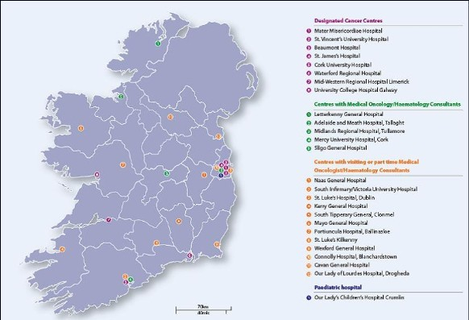
Download the Map of cancer service locations.jpg (size 54.5 KB)
Ireland's eight Designated Cancer Centres are aligned with the Hospital Group structure.
The table below shows the designated cancer centre in each Hospital Group and the former HSE administrative area for each.
Hospital Group | Cancer Centre | HSE Region
RCSI | Beaumont University Hospital | HSE Dublin – North East
Ireland East | Mater University Hospital | HSE Dublin – North East
 | St Vincent’s University Hospital | HSE Dublin – Mid Leinster
Dublin Midlands | St James’s University Hospital | HSE Dublin – Mid Leinster
South/Southwest | Cork University Hospital | HSE South
 | Waterford Regional Hospital | HSE South
Saolta University | Galway University Hospital  (satellite: Letterkenny General Hospital) | HSE West
Midwest | University Hospital Limerick | HSE West
The services provided in the designated cancer centres are summarised in the table below:

Download the diagram: Designated Cancer Centres.jpg (size 62.6 KB)

