Report from the Consultation on a Regional Response to Drugs and Alcohol Issues in Cavan 30 November 2015
Contents
1 Introduction 2
2 Key Issues 2
2.1 A lack of transport to connect people to existing services 2
2.2 A lack of residential treatment options 2
2.3 A lack of knowledge of service pathways / consistent interagency working 2
2.4 Supports needed for the 16 – 25 year old group out of work and education 2
2.5 Supports for parents 3
2.6 Additional out of hours activities needed for the 10 – 15 age group 3
2.7 Issues in relation to accessing crisis services 3
2.8 Referral to alcohol/drug education programmes through the courts 3
3 A New Alcohol and Drugs Forum 4
4 Draft Terms of Reference for the Cavan Alcohol and Drugs Forum 6
4.1 Aim 6
4.2 Values 6
4.3 Membership 6
4.4 How the Forum runs 7
4.5 Key roles 7
4.6 Secretariat duties 8
4.7 Other considerations 8
5 Strategic Goals 9
5.1 Transport 9
5.2 Housing 9
5.3 Residential 9
5.4 Service mapping 9
5.5 16 – 25 age group out of education and employment 9
5.6 Supports to parents 10
5.7 Activities for youth (10 – 16 age group) 10
5.8 Access to crisis supports 10
6 Appendix: Resources to Support Research 11
6.1 Summary Findings from the Drug and Alcohol Evidence Review in Relation to Prevention Programmes 11
6.2 Introduction 11
6.3 Key Messages for Practitioner Groups 11
6.4 UN report on evidence based family interventions 13
6.5 Appendix II List of groups that attended the facilitated session 13

Report developed by:

Introduction
This consultation between local groups working with people at risk or problematically using alcohol and/or drugs was organised by the Cavan County Council. The Council are currently working on a new local development plan and as part of the local consultations residents have raised issues and concerns in relation to the problematic use of drug and alcohol within the area. The purpose of the session was to explore whether there was agreement on responses needed in relation to this issue. Of note was that this meeting engaged a number of professionals from the spectrum of local statutory and community voluntary services, which made for dynamic and informed discussions.
This report outlines how a drugs and alcohol forum would operate in the area, the core issues in relation to the issue, and the strategic actions that the forum will progress in order to address these.

Key Issues
Groups identified a range of issues affecting the local area; from this key issues emerged, which included the following:

A lack of transport to connect people to existing services
Transport was seen as a significant issue affecting the ability of people to access a number of existing services, including although not limited to:
- Attendance at appointments
- Attendance in rehabilitation programmes, it was noted that CE payments did not cover additional transport costs associated with attendance at programmes.
- Youth engagement in positive social activities

A lack of residential treatment options
There are no residential options for any age group within the area. This was seen as a significant barrier for people wishing to address problematic alcohol and drug use.

A lack of knowledge of service pathways / consistent interagency working
While professionals were clear that there were examples of good interagency working this was compromised by a number of factors, including:
- Lack of knowledge of the range of available services from professionals
- Referral criteria that means people fall though gaps in between services
- Different service understandings of problems and client needs resulting in challenges for people to receive joined up services
- A lack of clear pathways for specific target group or presenting issues

Supports needed for the 16 – 25 year old group out of work and education
- While there are a number of courses for this age group, many youth do not avail of these
- The progression pathways into employment from courses or programmes such as Job Bridge are unclear and often unsupported, which results in youth drop out and in some cases a feeling of being taken advantage of.

Supports for parents
There is a need for a range of programmes that support parents to engage with young people, it was noted that these should be targeted at high risk families as well as the more general population and that higher risk families may require more supported to engage with programmes.

Additional out of hours activities needed for the 10 – 15 age group
There is a lack of after hours activities for teenagers, especially for those who do not wish to engage in sporting activities. Issues in relation transportation to access to existing activities were also noted.

Issues in relation to accessing crisis services
One of the key issues raised in the consultations was a lack of access to mental health supports for people with concurrent alcohol and drug issues. A very common experience was having vulnerable individuals in need of mental health supports but unable to access these due to alcohol or drug use. The option of attending A&E was generally unsuitable, as this requires getting a vulnerable person to A&E, waiting for numerous hours and a high likelihood that this would not result in a service due to dual diagnosis. Also most professional services do not have after hours capacity for these supports.

Referral to alcohol/drug education programmes through the courts
Currently there are no options for the courts to refer people with drug and alcohol related crimes to programmes. While the drug courts exist within Dublin there are no formal alternatives to incarceration for people with drug and alcohol related crimes who are interested in rehabilitation.

A New Alcohol and Drugs Forum
It was agreed that the development of an alcohol and drugs forum was necessary in order to progress responses to the identified issues.
Key agreements in relation to the forum were:
- The group will be established for an initial period of two years. The focus over this time will be the achievement of a number of strategic actions. Members will be asked to commit to a two year membership period. After two years all forum will be reviewed to see if it has been effective and if there is sufficient need for it to continue. Members at this point decide whether they wish to continue.
- The forum meets quarterly
- At least half the meetings would involve working groups undertaking actions, i.e. proposal and report development, research synthesis, letter writing as well as planning
- Strong chairing is be crucial to ensuring that time is used productively
- Ideally decision makers within organisations will attend the forum
- The network would be linked with wider regional strategies through the attendance of two people on the two working groups of the NERD&ATF.
- The work of the group would be directed by a strategic plan or work plan and would be undertaken by working groups
- The local council would provide secretariat support including:
  - Organising meetings
  - Minute taking
  - Providing a venue

The first actions of the new group would be to:
- Agree officers (Chair, and vice chair)
- Agree the draft terms of reference (attached here)
- Propose one or two clear and specific actions to be highlighted in the local development plan
- Agree working group membership and which strategic goals they are responsible for
- Working groups then to outline their own strategy for achieving progress on the strategic goals
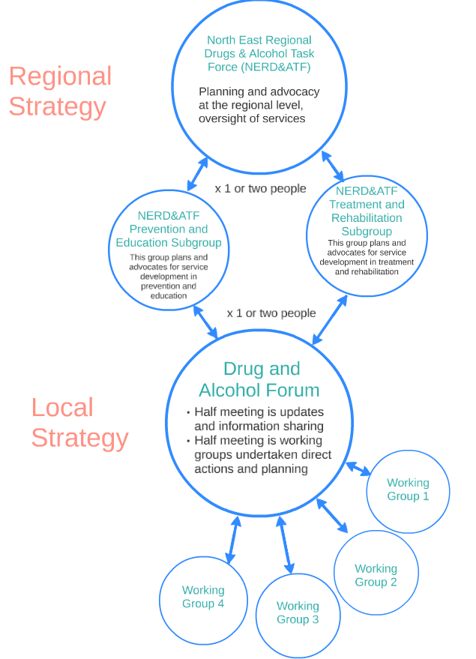

Draft Terms of Reference for the Cavan Alcohol and Drugs Forum

Aim
To support the interagency sharing of information, co-ordination of services and implementation of solutions to problem substance use in County Cavan. Specifically this involves:

- Sourcing, contextualising and disseminating information on existing relevant services
- Sharing good practice, policy development and research findings in order to develop and implement local responses
- To work together to implement a work plan to achieve strategic goals in relation to local service development
- Source funding opportunities where appropriate to support achievement of strategic goals
- Identify needs and advocate for responses at the local, regional or national levels.

Values
The work of the forum is underpinned by the following values:
- Our work is evidence based, meaning we will review evidence before making decisions
- Our approach is inclusive, meaning we welcome new members including those from diverse backgrounds
- Our members are committed, which means attending quarterly meetings and undertaking agreed actions
- Action orientated, meaning that we will focus our attention on getting a small number of meaningful actions done and will work on things we have the power to change, while advocating in relation to factors outside our immediate control.

Membership

Becoming a member / induction of new members
Any organisation with an interest in the area can request through the chair to join the group, so long as they can commit to the terms of reference. Induction will include being sent the past three meeting minutes, the strategic plan of the group and the terms of reference of the group. Requests for new membership will be considered by the Forum and communicated to the applicant organisation after the meeting.
The Forum can co-opt new members if they have relevant expertise.

Member responsibilities
- Members need to commit to attendance at meetings. Where two meetings are missed, the chair will contact them to see if they wish to remain a member. If a substitute attends the meeting the member of the group should ensure they are briefed sufficiently to allow them to undertake tasks that may be assigned to them.
- Members have a responsibility to undertake assigned tasks in the agreed time or to ensure that these are done.
- Non Forum members may be invited to join a working group
- Two service user representatives will be invited to become members.

How the Forum runs

Frequency of meetings
Meetings are held every quarter with dates agreed at the last meeting of the year for the year ahead. Working groups may agree to meet more regularly to progress specific actions.

Working group structure
Working groups will elect a chair whose role is to support assigning of tasks and follow up on these, as well as ensuring engagement of people within the subgroup.

Decision making
As long as actions are in line with the strategic plan working groups may progress actions on behalf of the forum, any queries in relation to the best approach for any actions with political ramifications should be discussed between the chair of the committee and the chair of the working group.

Strategic planning
Every two years the committee will develop a brief but clear plan, which outlines the strategic actions to be progressed. This will form the work plan for the next two years. Working groups will develop their own plans to progress strategic actions for which they are responsible.

Representation on other structures
One or two people will be nominated from the committee to attend the NE-RD&ATF subgroup structure. This involves sharing actions with other areas and advocating for issues and needs as identified by the group.

Length of time for the group
The group will be established for an initial period of two years, after this time it will be reviewed.

Key roles

Chair
The chair is responsible for:
- Managing the meetings with the goal of keeping to a tight agenda and meeting structure which allows for working groups to undertake their work
- Supporting, if necessary the chairs of the working groups
- Speak publicly on behalf of the forum
- Determining how the review of the forum at year two will be undertaken
- At the first meeting a Chair will be appointed from within the members.

Vice chair
The vice chair will undertake chairing duties in the case that the Chair is not available

Chairs of Working Groups
The role of the Chair is to manage the meeting. S/he will the support division of tasks, ensure people have a chance to be heard, and follow up with people in relation to tasks. If working groups chairs have queries in relation to what work and decisions are within the brief of their group they should discuss this with the chair of the forum.
The Chair of each working group will be the spokesperson for the working group.

Secretariat duties
These duties will be managed by the Cavan County Council, and will specifically include:
- Sending out notification of meetings
- Writing and maintaining a file of minutes
- Providing a venue

Other considerations

Speaking on behalf of the forum
In general any public statements made on behalf of the forum will be done by the chair, however if a member with a specialist interest is best placed to speak, this will be agreed with the chair.

Policy context
The policy context is extensive and some of same is listed below:-
- National Drugs Strategy (interim) 2009-2016
- Better Outcomes, Brighter Futures
- HSE National Service Plan
- Niall Watters “Drug Treatment: An Assessment of needs in the north east region NERDTF”. 2008
- Report of the Working Group on Drugs Rehabilitation 2007
- NACD - "An overview of the nature and extent of illicit drug use among the Traveller community: an exploratory study" 2006
- North East Workshop Report “Responding to Drug Issues in the Traveller Community: A regional workshop for the North East” ( Need year)
- Draft Dublin NE HSE Cavan Children’s Services, Social Work Department and Family Support and Child Welfare Services (Need Year)
- Social Housing Strategy 2020

Strategic Goals

Transport
- To develop a plan to expand existing rural transport services (looking at a range of service provision models) to include prioritised community needs, namely health, and mental health, disability and youth. To undertake this in consultation with the Drug and Alcohol Forum.
- To develop LEADER proposals to support development of additional transport projects

Housing
- To liaise with CCC regarding accommodation supports, including emergency accommodation

Residential
- To examine transitional and step down housing options, which provide short term accommodation to homeless and at risk people with complex needs. This would then need to be supported by professional and funded resettlement supports.
- To explore with Tusla, HSE and other statutory agencies the development of a residential short term intervention programme, looking at examples such as the Cavan Centre and/or other successful evidence based programmes.
- To conduct a needs analysis for the regions (cross border, North East region, North Midlands) in relation to Detox, stabilisation and tier four residential services.

Service mapping
- To establish clear referral pathways between existing services in relation to a range of interventions, scenarios and target groups, including: housing, education, mental health services, Probation and justice services, transport, Gardai, addition services, A&E, youth, GPs and on call medical services and other relevant social services. As part of this process to clarify gaps and blocks within the existing system. Following this to establish a process for: 1) responding to existing barriers by making changes to referral criteria and interagency practices, 2) recording when these referral pathways fail in order to garner evidence for future development and/or further resourcing of services.
- To ensure that this information is available and useful to organisations and potentially the public through printed or online resources.
- To ensure that all services are trained in screening using a consistent approach i.e. SAOR to promote effective referrals.
- To use the regional approach of the standard reporting mechanism for gaps and blocks

16 – 25 age group out of education and employment
- To bring together local educational services alongside CCC and the Department of Social Protection to identify the range of work supports for this age group, to identify their strengths and weaknesses in engaging at risk youth and their success in supporting transition into employment.
- To review whether there was need to attain funding for an access officer to support at risk individuals in this age group to; 1) select appropriate programmes to their skills and interests, 2) to attend and complete programmes and 3) benefit from these programmes and then transition into work which is likely to mean engagement with employers and internships etc.

Supports to parents
- To review existing programmes, run in Ireland or internationally, that are successful in developing parenting skills. To run these using an interagency model and to secure funding to support outreach and engagement of the families of at risk youth (see attached resources for a review of evidence based programmes).
- To review existing programme, run in Ireland or internationally, that are successful in developing self-esteem and social skills in the 10 to 13 age group, e.g. roots of empathy, strengthening families.

Activities for youth (10 – 16 age group)
- Develop a out of hours drop in centre / youth café within Cavan town
- To establish more youth facilitates and activities involving sports as well as non sport focused activities, to do this through a co-ordinated youth response involving services such as; Foroige, 365, CE, GAA, national governing body of sport, and relevant statutory agencies.

Access to crisis supports
- To establish clear referral pathways between existing services in relation to interagency crisis intervention for a range of scenarios and target groups, including: housing, mental health services, Gardai, addiction services, GPs and on call medical services. As part of this process to clarify gaps and blocks within the existing system. Following this to establish a process for: 1) adapting existing barriers by making changes to referral criteria and interagency practices, 2) recording when these referral pathways fail in order to garner evidence for future development and/or further resourcing of services.
- Look at supporting an evaluation of the SOSAD model of out of hours service, and if positive to explore possibilities of extending this model.
- To implement a case management approach in relation to follow-up and support of services users post crisis, i.e. Meithal, NDR framework.
- To support the capacity within services to respond to key issues such as dual diagnosis and suicide through training and education.
- 5.9 Alternatives to incarceration/fines in isolation
To review programmes that have been successful in other jurisdictions at moving people with addiction issues into rehabilitation and treatment programmes as an alternative to incarceration (for example, arrest referral). To apply for funds or support to pilot a similar programme in the region.
- To review alcohol related court presentations to assess the need for an alcohol education programme in conjunction with a reduction in fine amounts. Review similar programmes in other jurisdictions to establish best practice models and support the development of a pilot project in Cavan.

Appendix: Resources to Support Research

Summary Findings from the Drug and Alcohol Evidence Review in Relation to Prevention Programmes

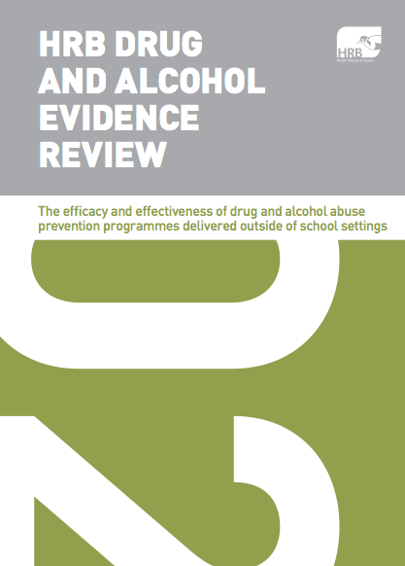
http://www.hrb.ie/publications/hrb-publication/publications//664/

Introduction
This paper reports the results of an evidence review on the efficacy and effectiveness of drug and alcohol abuse prevention programmes delivered outside of school settings. We limited our searches to papers published since 2008. From 1,430 papers and articles identified using our search terms we selected a total of 64 papers as being relevant, on the basis of having read the abstracts only. We were able to retrieve full copies of 55 of those papers. When we read the full texts, we excluded another 22 papers, leaving us with a total of 33 for our evidence review. Of those 33 papers, 12 described primary research studies, and 21 were reviews of research.

Key Messages for Practitioner Groups

Community-based organisations
While there has not been enough good quality evaluation research conducted to provide unequivocal evidence for the effectiveness of community prevention initiatives, the evidence looks promising.
- The most promising interventions address multiple domains: individual and peer, family, school and community.
- Multi-domain programmes targeted at early adolescents (aged 10–13 years) appear to achieve better results compared with other approaches.
- Community-based interventions that work with families to improve parenting can be effective in preventing substance misuse.
- Programmes that help parents to get involved with developing their children’s skills in areas of social competence and self-regulation can be effective.
- Community groups are likely to be most effective when they have access to adequate training and financial resources, are well organised and sustainable, and provide interventions that are culturally appropriate.

Executives, senior managers, commissioners and budget holders
- Evidence-based community intervention policy to prevent drug and alcohol use among young people needs to be developed.
- Community organisations need support to develop the capacity to deliver effective interventions with young people.
- Effective evaluation of community-based interventions needs to be incentivised.
- Policies need to strengthen the community programmes that focus on how well young people will be prepared or how fully they will be engaged in positive activities outside the formal education system.
- Longer-term funding, contingent on evidence of effectiveness, would promote sustainability and improve impact.

Service providers
- Prevention interventions are likely to be more effective when they reflect the broad context of young people’s lives (social skills, education, family, peer groups).
- Interventions tailored to take account of individual needs tend to be more successful.
- The most at-risk young people often come from families that are the most difficult to engage with.
- Providing families with a choice of programmes with distinct formats can help to facilitate engagement.
- The positive effects of interventions tend to be proportionate to the time and energy involved in the intervention.
- Active participation in training and professional development can make real improvements to the delivery of interventions.

Academics, planners and evaluators of drug/ alcohol prevention projects
- Community groups could benefit from support in developing theory-based drug and alcohol interventions.
- Measures such as the ‘capacity assessment survey’ would help to evaluate the capacity of community groups to deliver prevention programmes and show funders where additional support would be most effective. Developing standardised outcome measures would help to establish the relative merits of different programmes for different groups of young people.
- Cost-benefit analysis of prevention programmes is very limited. Community groups would benefit from support in this area.

UN report on evidence based family interventions
This report provides an excellent review of the evidence base for various family intervention programmes, and will assist in determining potential family support programmes for use in Cavan.
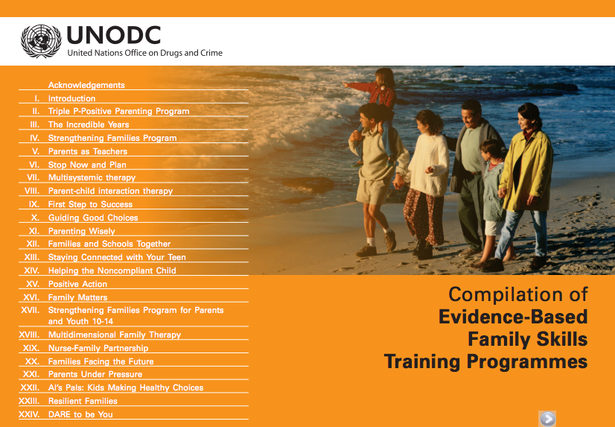

https://www.unodc.org/documents/prevention/family-compilation.pdf

Appendix II List of groups that attended the facilitated session

An Garda Siochana
Breffni Integrated Limited
Cavan County Council
Cavan GAA
Cavan General Hospital
CDA Trust
Extern
Focus FRC
Focus Housing
HSE Primary Care
Irish Society for the Prevention of Cruelty to Children
Monaghan County Council
North East Regional Drug and Alcohol Task Force
Probation Service
School Completion Programme
SOSAD
The Cavan Centre
TUSLA Child and Family Agency
Youthreach (Cavan)

i.e. under 18 is suicidal afterhours, adult is homeless over the weekend, adult of prison is homeless, mother with children at home has both alcohol/drugs and mental heath issues.
i.e. under 18 is suicidal afterhours, adult is homeless over the weekend, adult of prison is homeless, mother with children at home has both alcohol/drugs and mental health issues.

