Cavan County Council

Noise Action Plan

November 2019

Danny McGovern, B.Eng.

Executive Summary

This Noise Action Plan has been prepared as required by the European Communities Environmental Noise Regulations 2018 (S.I. No. 549/2018). These Regulations give effect to the EU Directive 2002/49/EC relating to the assessment and management of environmental noise (END Directive). This Noise Action Plan is aimed at strategic long term management of environmental noise.

Environmental noise is unwanted or harmful outdoor sound created by human activities including noise emitted by means of transport, primarily noise emitted by road traffic. This plan primarily addresses environmental noise from major roads in County Cavan with more than 3 million vehicle journeys per year.

This plan is prepared by Cavan County Council for major roads within their functional area. The actions detailed in this plan have been drawn up to assess noise exposure in priority areas, as indicated by strategic noise mapping.

This Action Plan gives an overview of the main requirements of the Environmental Noise Regulations 2018 and the authorities responsible. The methods used in production of strategic noise maps are outlined and summary results are presented. These results are analysed and several recommendations are made as to the best way to limit population exposure to environmental noise pollution.

This plan may be reviewed annually, and a new Noise Action Plan is revised every 5 years as per the END Directive and Regulations.

County Cavan Noise Action Plan Policy Statement

Cavan County Council will seek to address environmental noise from major roads in the county and will endeavor to maintain a satisfactory noise environment where it currently exists. Cavan County Council will have regard to noise in the planning process to ensure that future developments include provisions to protect the population from the effects of environmental noise, in the interests of residential amenity and public health.

Table of Contents
1 Introduction 5
1.1 Background 5
1.2 Purpose and Scope of the END Directive 5
1.3 Purpose and Scope of the Regulations 6
1.4 Roles and Responsibilities of designated bodies 6
1.4.1 Environmental Protection Agency 6
1.4.2 Noise Mapping Body 6
1.4.3 Action Planning Authority 7
1.5 Key Phases 7
1.5.1 Identification of areas required to be mapped. 7
1.5.2 Preparation of strategic noise maps 7
1.5.3 Development of the noise action plans. 8
1.5.4 Public participation and their role 8
1.5.5 Implementation of the plans 8
2 Existing noise management legislation and guidance 9
2.1 National Legislation or Guidance 9
2.1.1 EPA Act 1992 9
2.1.2 TII Guidance 9
2.1.3 IPPC/ Waste Licensing 9
2.1.4 Wind Energy Planning Guidelines 10
2.1.5 Quarry and Ancillary Activities 10
2.1.6 Building Regulations 10
2.1.7 Project Ireland 2040 - National Planning Framework (February 2018) 10
2.2 Regional or Local Legislation or Guidance 12
3 Description of the Action Planning Area 16
3.1 County Cavan topography and geographical location. 16
3.2 County Cavan Population 16
3.3 Location of noise sensitive groups 16
3.4 Description of the main infrastructure/services. 16
3.5 Extent of the Noise Action Plan area 17
4 The Responsible Authority for Action Planning 18
4.1 Name and contact details for the Responsible Authority 18
4.2 Description of other bodies of relevance 18
4.3 Noise-reduction measures already in force within County Cavan & projects in preparation 2012 - 2019 18
4.3.1 N3 Butlersbridge to Belturbet Road Improvement Scheme 18
4.3.2 N55 Corduff to South of Killydoon Realignment Scheme, Section A 19
4.3.3 N55 Corduff to South of Killydoon Realignment Scheme, Section B 19
4.3.4 Virginia, Main Street, HD15, Safety Scheme 19
4.3.5 Cycling 19
4.3.6 Buses 19
5 Summary of the results of the noise mapping 20
5.1 Cavan Results 20
5.2 Overview of the preparation of the noise map 20
5.3 Presentation of results 21
5.4 Limitations of the maps/results 23

6 Identification of areas to be subjected to noise management activities 24
6.1 Description of the criteria/ decision matrix to be used for the identification of areas qualifying for action 24
6.2 Quiet Areas 25
6.3 Application of the criteria/matrix. 26
6.4 Results of the analyses 26
7 Mitigation and protection measures 27
7.1 Review of Possible Mitigation Measures 27
7.2 Assessing Areas above Onset of Assessment Criteria 27
7.3 Preservation of Areas Below & Between Protection Threshold 27
7.4 Confirming the Extent of Noise Impact 27
7.5 Assessing Effectiveness of Potential Measures 29
7.6 Budget and Cost Benefit Analysis 29
7.7 Outcome 29
8 Public Participation 30
8.1 Public Submissions and Response 31
8.1.1 Submissions Received 31
8.1.2 Response 31
9 Implementation Plan 32
9.1 Roles and Responsibilities. 32
9.2 Targets and Objectives 32
9.3 Programme of Works 32
9.3.1 Year 1 - 2019 32
9.3.2 Year 2 – 2020 32
9.3.3 Year 3 - 2021 33
9.3.4 Year 4 – 2022 33
9.3.5 Year 5 - 2023 33
9.4 Evaluation, Review and Corrective Action Programmes 33
10 Summary and Conclusions 34

List of Tables
Table 1: Roads, Railways, Agglomerations & Airports falling under the scope of the Environmental Noise Regulations 6
Table 2: Environmental Objectives, Indicatiors & Targets (Population and Human Health) 15
Table 3: National Routes Noise Mapping Results 20
Table 4: Regional & Local Routes Noise Mapping Results 20
Table 5. Data input into Noise Model 21
Table 6: L_{den} – Population Exposure Statistics for National Major Roads in Co. Cavan 22
Table 7: L_{den} - Area, Houses and Population Exposure Statistics for National Major Roads 22
Table 8: L_{night} – Population Exposure Statistics for National Major Roads in Co. Cavan 22
Table 9: L_{night} - Area, Houses and Population Exposure Statistics for National Major Roads 23
Table 10: Onset Levels for Assessment of Noise 24
Table 11: Sample Decision Support Matrix to Identify and Prioritise Noisy Areas 25
Table 12: Noise Sensitive Locations – Schools, along N3 & N55 26
Table 13: Sample Decision Support Matrix to Identify and Prioritise Noisy Areas 47
Table 14: Decision Support Matrix to Identify and Prioritise Noisy Areas 48

List of Appendices
Appendix 1: Glossary of Acoustic and Technical Terms 35
Appendix 2: Bibliography and References 37
Appendix 3: Strategic Noise Maps 38
Appendix 4: Overview / Flow diagram of process for action planning decision making 46
Appendix 6: Final/Completed Decision/Selection Matrix 47
Appendix 7: Noise Control on N55 Corduff to South of Killydoon Realignment Scheme, Section A 49
Appendix 8: Public Consultation 52

List of Maps
Map 1: C1. Overview of L_{den} for National Roads in Co. Cavan 38
Map 2: C2. Overview of L_{den} for N3 – Butlers Bridge to Lavey & N55 Cavan to Ballinagh 39
Map 3: C3. Overview of L_{den} for N3 – Poles to Lisgrey 40
Map 4: C4. Overview of L_{den} for N3 – Billis Bridge to Meath border at Whitegate Crossroads 41
Map 5: C5. Overview of L_{night} for National Roads in Co. Cavan 42
Map 6: C6. Overview of L_{night} for N3 – Butlersbridge to Lavey & N55 Cavan to Ballinagh 43
Map 7: C7. Overview of L_{night} for N3 – Poles to Lisgrey 44
Map 8: C8. Overview of L_{night} for N3 – Billis Bridge to Cavan/Meath border at Whitegate Crossroads 45

Introduction

Background
Noise pollution is a major environmental health problem in Europe, with road traffic being the biggest source of Noise pollution. There are an estimated 100 million Europeans affected by harmful noise levels. This Noise Action Plan has been prepared for Cavan County Council, to meet the requirements of the statutory Noise Regulations currently in force, namely the;
- Environmental Noise Directive (END) 2002/49/EC and
- Environmental Noise Regulations, S.I. No. 140 of 2006
- European Communities Environmental Noise Regulations, S.I. No. 549/2018

Under this directive member states are required to:
- Undertake strategic noise mapping to determine exposure to environmental noise.
- Ensure information on environmental noise and its effects is made available to the public.
- Adopt action plans, based upon noise mapping results with a view to preventing and reducing environmental noise where necessary and particularly where exposure levels can induce harmful effects on human health, and to preserve environmental noise quality, where appropriate.

The Noise Action Plan was undertaken in line with the EPA “Guidance Note for Noise Action Planning”, July 2009 and EPA Noise Guidance Notes 2011 & 2016. This Noise Action Plan, in line with the Regulations and Guidelines identifies the population exposed to excessive road noise (along part of the N3 and part of the N55), it informs the public about the relevant noise data and provides an action plan to avoid, prevent or reduce, on a priortised basis, environmental noise exposure along the main roads within the County. This is a 5-year plan, but will be reviewed if necessary, if noise conditions change within this period.

A glossary of acoustic and technical terms used throughout this report is provided in Appendix 1.

Purpose and Scope of the END Directive
In 2002 the European Union issued Directive 2002/49/EC relating to the assessment and management of environmental noise pollution, which is commonly referred to as the Environmental Noise Directive (END) and last updated European Communities Environmental Noise Regulations, S.I. No. 549/2018

The Directive aims to “define a common approach intended to avoid, prevent or reduce on a prioritised basis the harmful effects, including annoyance, due to exposure to environmental noise.”

The Directive requires that Member States:
- Undertake strategic noise mapping to determine exposure to environmental noise.
- Ensure information on environmental noise and its effects is made available to the public and
- Adopt action plans, based upon the noise-mapping results, with a view to preventing and reducing environmental noise where necessary and particularly where exposure levels can induce harmful effects on human health and to preserving environmental noise quality where it is good.

Purpose and Scope of the Regulations
The END was transposed into Irish Law by the Environmental Noise Regulations, S.I. No. 140 of 2006 and last updated European Communities Environmental Noise Regulations, S.I. No. 549/2018. The Regulations define “environmental noise” as unwanted or harmful outdoor sound created by human activities, including noise emitted by means of transport, road traffic, rail traffic, air traffic and from sites of industrial activity.

The Regulations apply to environmental noise to which people are exposed, in built up areas, in public parks or other quiet areas in an agglomeration, in quiet areas in open country, near schools, near hospitals, and near other noise-sensitive buildings and areas. Types of noise not included within these Regulations are noise that is caused by the exposed person, noise from domestic activities, noise created by neighbours, noise at workplaces or noise inside means of transport or due to military activities in military areas.

The Regulations set out a two-stage process for addressing environmental noise from large agglomerations, major roads, railways and airports, as detailed in Table 1.

Table 1: Roads, Railways, Agglomerations & Airports falling under the scope of the Environmental Noise Regulations
Area | First Phase (2007-2008) | Second Phase (2012-2013)
Major Roads | >6 million vehicles/annum | >3 million vehicles/annum
Major Railways | >60,000 trains/ annum | >30,000 trains/annum
Agglomerations | >250,000 inhabitants | >100,000 inhabitants
Airports | >50,000 movements/annum

There were no areas in Cavan that fell within the scope of first phase, so no action was required at this time. In the second phase, some of the Major Roads within the county fall within the scope of the Regulations, so it is these that this Noise Action Plan has been devised for. The second phase thresholds will be used on an on-going basis at 5 yearly intervals, or when a review is undertaken.

Roles and Responsibilities of designated bodies
There are three main designated bodies under the Regulations for the purposes of the County Cavan Noise Action Plan, covering Major Roads.

Environmental Protection Agency
The Regulations designate the Environmental Protection Agency (EPA) as the national authority responsible for overseeing the implementation of the Regulations. The EPA is required to provide advice and guidance on the requirements of the Regulations and to report on Strategic Noise Mapping and Action Planning to the European Commission.

Noise Mapping Body

Under the Environmental Noise Regulations (S.I. No. 549 of 2018) the Environmental Protection Agency (EPA) is the designated national authority for the purposes of the Regulations. The EPA exercise general supervision over the functions and actions of noise-mapping bodies and action planning authorities, and provide guidance or advice to such bodies and authorities, where necessary.

Under the Environmental Noise Regulations (S.I. No. 549 of 2018) Transport Infrastructure Ireland (TII) are the designated noise mapping body for national roads classified as Major Roads, outside of the agglomerations, whilst Cavan County Council are the designated noise mapping body for non-national roads classified as Major Roads in County Cavan. TII are responsible for mapping national ‘Major Roads’ only in County Cavan.

Action Planning Authority
The action planning authorities are the local authorities within the area where any major road, airport or agglomerations are situated. Therefore, Cavan County Council, is the action planning authority for this Noise Action Plan.

Key Phases

Identification of areas required to be mapped.
In County Cavan, strategic noise maps and action plans are prepared for major roads with >3 million vehicles per annum. The requirement for major railways, major airports or agglomerations >100,000 people do not apply to Co. Cavan.

Road traffic volumes were obtained using the Transport Infrastructure Ireland’s (TII) traffic counting system and Cavan County Council’s in house counts, under the Regulations, which identified the roads detailed in Section 5.1, tables 3 & 4.

Preparation of strategic noise maps
In 2016 a centralised approach to the noise mapping of major roads outside agglomerations was adopted. TII, being designated the Noise Mapping Body for all major national roads, and on behalf of Local Authorities responsible for non-national roads, prepared strategic noise maps to meet the requirements of the Regulations. These noise maps were submitted to the Environmental Protection Agency in January 2018. Producing the strategic noise map for the County was done following the EPA Guidance Note for Strategic Noise Mapping for the Environmental Noise Regulations 2006, Version 2, August 2011.

A strategic noise map is a graphical representation of the predicted noise level in a given area. A noise map has different colour coded bands, which represent the predicted decibels (dB(A)) within a certain range, also detailed on the maps in Appendix 3, pages 37 - 44.

A noise map is produced using a computer software package. To develop a noise map a number of variables must be determined in order to correctly represent the amount of noise generated at the source i.e. by traffic driving on the road. For road traffic noise, the noise level at the source is primarily influenced by;
- the speed at which traffic is travelling at,
- the overall quantity of vehicles in the traffic flow,
- the proportion of heavy commercial vehicles (HCVs) in the flow
- the type of road surface used in the construction.

The manner in which the noise propagates away from the source must then be calculated which involves determining the reduction in noise level as it propagates from the source. Distance, ground cover and the presence of barriers such as walls, noise barriers etc. will all influence the level of noise attenuation.

Noise maps for County Cavan are presented in terms of two noise indicators; L_{den} and L_{night}. L_{den} is the day-evening-night noise indicator and it represents the noise indicator for overall annoyance. It is based on day (07:00-19:00), evening (19:00-23:00) and night (23:00-07:00) time periods and it is weighted to account for extra annoyance in the evening and night periods. L_{night} is the night time noise indicator and is used in the assessment of sleep disturbance. It is based on night (23:00-07:00) time period. Both of these indicators are based on year long averages of the day, evening and night time periods and each are plotted separately for the required roads in the County. Each map presents the noise levels in 5dB contour bands.

Development of the noise action plans.
Under the Environmental Noise Regulations (S.I. No. 549 of 2018) Transport Infrastructure Ireland (TII) are the designated noise mapping body for national roads classified as Major Roads, outside of the agglomerations, whilst Cavan County Council are the designated noise mapping body for non-national roads classified as Major Roads in County Cavan. TII are responsible for mapping national ‘Major Roads’ only in County Cavan. The development of the plan is based on the strategic noise maps which provide the baseline predicted noise levels from major roads within the County. The noise action plan details the current situation regarding road traffic noise on major roads within the County and it forms the basis of developing a long term environmental noise strategy.

Public participation and their role
As required under the Regulations, the Public are invited to participate in the development of the County Cavan Noise Action Plan. This allows the general public and relevant stakeholders an opportunity to review and participate in the formulation of strategic noise policy, with a view to preventing and reducing, where necessary, exposure to environmental noise. Relevant stakeholders are detailed on page 30 and are sent a draft copy of the plan for comment.

Following the consultation with the public and stakeholders, there is a review and possible amendments to the final plan. The plan is then to be approved by the Council or SPC and then published.

Implementation of the plans
Noise action plans are to be implemented within a 5-year timeframe, so this Action Plan covers the period 2019 - 2024. The plan may be revised sooner, if a material change in environmental noise occurs.

Existing noise management legislation and guidance

National Legislation or Guidance
A number of legal requirements and guidance documents have guidance levels in relation to noise, depending on the type of development e.g. road, quarry, wind turbine etc. The following list of national legislation and guidelines make reference to environmental noise.

EPA Act 1992
Environmental Noise Regulations in Ireland have come about on foot of the Environmental Protection Agency Act of 1992. Three Sections of the Act are of direct relevance to noise, as follows:
- Section 106 gives the relevant Minister certain powers to regulate noise that may give rise to a nuisance or be harmful to health or property.
- Section 107 gives powers to local authorities and the EPA to serve notice to take steps to control noise.
- Section 108 sets out a process whereby noise issues may be taken to the District Court, which may make an order requiring that the person or body responsible for the noise takes steps to eliminate or ameliorate the noise in question.
There have been various amendments and updates to the Regulations in 1994, 1996, 2004, 2006, 2011, 2012 & 2015.

TII Guidance
The National Roads Authority (NRA) now Transport Infrastructure Ireland (TII) published the document “Guidelines for the Treatment of Noise and Vibration in National Road Schemes” (2004), Good Practice Guidance for the Treatment of Noise during the Planning of National Road Schemes’ in 2014 which sets out the procedure to be followed in respect of the planning and design of national road schemes. These guidelines set out limits for noise related to both the construction and traffic flow on new road schemes. The TII Guidelines for the design of new national roads indicates that mitigation measures should be considered above a level of 60dB L_{den} (free-field). The guidelines put forward measures for mitigating the adverse effects of road construction in so far as possible through the use of measures such as alignment changes, barrier construction and the use of low noise road surfaces.

IPPC/ Waste Licensing
Certain activities that fall under the requirements for an Integrated Pollution Prevention Control (IPPC) Licence or Waste Licence from the EPA may be subject to noise conditions. The EPA Guidance Note for Noise: Licence Applications, Surveys and Assessments in Relation to Scheduled Activities (NG4) (2012) sets out the requirements for noise assessments and sets the typical limit values for noise from licensed sites as;
- Daytime (07:00 to 19:00hrs) – 55dB L_{Ar,T};
- Evening (19:00 to 23:00hrs) – 50dB L_{Ar,T};
- Night-time (23:00 to 07:00hrs) – 45dB L_{Aeq,T}.

Noise limits are generally set at nearby noise sensitive locations to the development and an annual noise survey is typically required by the licence holder.

Wind Energy Planning Guidelines
The Department of the Environment, Heritage and Local Government has produced Planning Guidelines for Wind Energy Developments (2006), which includes noise guidelines.

These guidelines state that in general, a lower fixed limit of 45dB(A) or a maximum increase of 5dB(A) above background noise at nearby noise sensitive locations is considered appropriate to provide protection to wind energy development neighbours. However, in very quiet areas, the use of a margin of 5dB(A) above background noise at nearby noise sensitive properties is not necessary to offer a reasonable degree of protection and may unduly restrict wind energy developments which should be recognised as having wider national and global benefits. Instead, in low noise environments where background noise is less than 30 dB(A), it is recommended that the daytime level of the L_{A90},10min of the wind energy development noise be limited to an absolute level within the range of 35-40 dB(A).

Separate noise limits should apply for day-time and for nighttime. During the night the protection of external amenity becomes less important and the emphasis should be on preventing sleep disturbance. A fixed limit of 43dB(A) will protect sleep inside properties during the night. In general, noise is unlikely to be a significant problem where the distance from the nearest turbine to any noise sensitive property is more than 500 metres. Planning authorities may seek evidence that the type(s) of turbines proposed will use best current engineering practice in terms of noise creation and suppression. The EPA guidelines are under revision and may change during the 5 year period to which this plan refers. The EPA and County Development Plan should be consulted for up to date Wind Energy Guidelines.

The EPA has also produced a Guidance Note on Noise Assessment of Wind Turbine Operations at EPA Licensed Sites (NG3) (2011), which proposes the following Cumulative Site and Turbine Noise Limits
- Daytime 55 dB L_{Ar,T}
- Night-time 45 dB L_{Aeq}
- Wind turbine noise not to exceed 45 dB L_{Aeq} at any time, or to contain any significant tonal components

Quarry and Ancillary Activities
The Department of the Environment, Heritage and Local Government has published Guidelines for Planning Authorities on Quarries and Ancillary Activities (2004). This publication contains a discussion of the primary sources of noise associated with quarrying and offers guidance in relation to the correct approach to be followed in respect of assessment and mitigation.

Suggested noise limit values are 55dB L_{Aeq}, 1hr and 45dB L_{Aeq} 15min for daytime and night time respectively, although more onerous values may be appropriate in areas with low levels of pre-existing background noise.

Building Regulations
The Irish Building Regulations (2008 - 2014) call for certain constructions to offer “reasonable resistance” to both airborne and impact sound. The accompanying Technical Guidance Document E of the Building Regulations sets objective sound insulation values and recommended pre-completion testing requirements.

Project Ireland 2040 - National Planning Framework (February 2018)
This Planning Framework was devised by the Government of Ireland and lists National Policy Objective 65, which will;
“Promote the pro-active management of noise where it is likely to have significant adverse impacts on health and quality of life and support the aims of the Environmental Noise Regulations through national planning guidance and Noise Action Plans.”

In addressing these issues, the National Planning Framework will support:

- Noise Management and Action Planning
Measures to avoid, mitigate, and minimise or promote the pro-active management of noise, where it is likely to have significant adverse impacts on health and quality of life, through strategic noise mapping, noise action plans and suitable planning conditions.

- Noise, Amenity and Privacy
This includes but is not limited to, good acoustic design in new developments, in particular residential development, through a variety of measures such as setbacks and separation between noise sources and receptors, good acoustic design of buildings, building orientation, layout, building materials and noise barriers and buffer zones between various uses and thoroughfares.

- Quiet Areas
The further enjoyment of natural resources, such as our green spaces, through the preservation of low sound levels or a reduction in undesirably high sound levels, is particularly important for providing respite from high levels of urban noise. As part of noise action plans, an extra value placed on these areas, in terms of environmental quality and the consequential positive impact on quality of life and health, due to low sound levels and the absence of noise, can assist in achieving this.

- Transport Initiatives
National and regional transport initiatives that may arise from implementation of the National Planning Framework (NPF) and the Regional Spatial and Economic Strategy (RSES) for the Northern and Western Region have the potential to result in adverse health effects that will need to be mitigated and/or beneficial effects with regard to preserving environmental noise quality. Such issues will be considered during the implementation of the NPF and RSES, including as part of the environmental assessments, where required, for individual transport initiatives.

The National Planning Framework lists noise management as one of its Environment and Sustainability Goals for creating a clean environment for a healthy society.

Regional or Local Legislation or Guidance

The Cavan County Development Plan 2014 - 2020 has noise conservation listed in a number of areas.

Chapter 1: Introduction and context, Section 1.6 Strategic Environmental Assessment (SEA), Environmental Protection Objectives (EPO’s), Population and Human Health, lists the following EPO specifically regarding noise:
“EPO6 Minimise noise, vibration and emissions from traffic, industrial processes and extractive industry.”

Chapter 3: Economic Development, Section 3.7 E-Working and Home-Based Economic Activity in Rural Areas outlines in EDO18 that applications for developments involving working from home will include details on the:
“The effects on the amenities of adjoining occupiers, particularly in relation to hours of work, noise and general disturbance.”

Chapter 4: Physical Infrastructure, Section 4.1.4 Roads Infrastructure lists the following objective regarding noise:
“PIO13 To ensure that all new developments within the zone of influence of existing public roads or new public roads provide suitable protection against traffic noise in accordance with the requirements of S.I. No. 140 (2006) ‘Environmental Noise Regulations.’ The costs of implementing any additional noise mitigation measures shall be borne by the developer.”

Chapter 4: Physical Infrastructure, Section 4.7.3 Renewable Energy, Wind Energy outlines that:
“Wind turbines can have adverse environmental impacts in the form of visual intrusion, noise generation effects, and electro-magnetic interference. Regard will be given to the ‘European Best Practice Guidelines for Wind Farm Development’ (European Wind Energy Association). The Wind Energy Strategy, Planning Guidelines’, DECLG, 2006, is the most relevant guidance document to be used in the preparation and assessment of wind energy proposals.”

This section also states that:
“Noise is generated as the mechanical noise from the turbine and the aerodynamic noise from the blades, these can be considerably reduced by appropriate engineering practice.”

And lists the following objective regarding noise:
“PIO117 The following issues will be considered in the assessment of a wind energy development
Planning applications for new wind energy development and extensions to existing developments shall include details of full compliance with the DECLG ‘Wind Energy Development,’ 2006 guidelines or any future amendments. This shall include but is not limited to details of; ground conditions/ a geology assessment, archaeology, architectural heritage, noise, safety aspects, proximity to roads and power lines, interference with communications systems, aircraft safety, shadow flicker and windtake. An assessment of siting and design impacts shall also be submitted, as well as a layout.”

Chapter 8: Natural Heritage & Environment, Section 8.13.2 Air Quality Monitoring states that:
“The increase in the use of catalytic converters and cleaner fuels etc. has generally contributed to a reduction in pollution from motor vehicles. However, there has also been an increase in the number of cars circulating on the county’s roads. This and increases in the volume and incidences of traffic congestion may lead to an increase in air (and noise) pollution.”

This section also states that:
“Extractive industries and intensive industries contribute to air pollution and noise.”
Chapter 8: Natural Heritage & Environment, Section 8.13.3 Noise outlines the following in relation to Noise:
“It is a Mandatory objective of the ‘Planning and Development Act,’ 2000, as amended that the Development Plan should contain objectives for securing the reduction or prevention of noise emissions or vibrations. The Environmental Noise Regulations (S.I. 140 of 2006) are the relevant legislative mechanism for the monitoring and the EPA is the responsible authority for noise monitoring of larger developments. In County Cavan, the Environment Section has a system for logging complaints on noise. Developments which currently are subject to noise monitoring typically include: quarries; wind farms and industrial land uses.”

This section also lists the following objective regarding noise:
“NHEP34 Ensure that all planning applications for developments which potentially cause noise pollution are subject to appropriate noise monitoring programmes. Potential noise-generating land uses and developments which are subject to the planning process will be assessed in terms of the ‘Environmental Noise Regulations’ (S.I. 140 of 2006).”

Chapter 10: Development Management Standard, Section 10.9 Fast Food Outlets/Takeaways
“The cumulative impact of a number of take-away restaurants in any particular area will be considered in the assessment of any application. Impacts such as noise, litter, disturbance, residential amenities, proximity to residential dwellings and traffic, will also be taken into consideration. The Planning Authority will control the opening hours of takeaways.”

The Cavan Town and Environs Development Plan 2014 - 2020 has the following references relating to Noise

Chapter 4: Physical Infrastructure, Section 4.6 Road Infrastructure lists the following objective:
“RI-O12 To ensure that all new developments within the zone of influence of existing public roads or new public roads provide suitable protection against traffic noise in accordance with the requirements of S.I. No. 140 (2006) Environmental Noise Regulations. The costs of implementing any additional noise mitigation measures shall be borne by the developer.”

Chapter 9: Development Management Standards, Section 9.1.14 Home Based Economic Activity outlines that;
“In determining applications for developments involving working from home, the Planning Authority will have regard to the following considerations:
- The nature and extent of the work
- The effects on the amenities of adjoining occupiers, particularly in relation to hours of work, noise and general disturbance
- Anticipated levels of traffic generated by the proposed development
- Arrangements for the storage of refuse and collection of waste”

Chapter 9: Development Management Standards, Section 9.4.2 Fast Food Outlets/Takeaways states that:
“Impacts such as noise, litter, disturbance, residential amenities, proximity to residential dwellings and traffic, will also be taken into consideration. The Planning Authority will control the opening hours of take aways. Proposals for take-aways are generally permitted in appropriate locations as per the Zoning Descriptions except where
- Development would likely to prove detrimental to the amenities of nearby residential properties, to the visual amenity and to parking, traffic and litter problems which could not reasonably be controlled by use of planning conditions.
- The application has failed to demonstrate that a satisfactory ventilation flue could be provided that would not cause problems of noise and fumes for the occupiers of nearby properties and it would not be detrimental to the visual amenity or
- A further change of use would seriously affect the retail vitality and viability of the defined retail centre due to existing concentration of takeaway premises in an area.”

The Strategic Environmental Assessment (SEA) Statement for the County Development Plan 2014 - 2020 has the following references regarding noise;

Section 2.10 Summary of how environmental considerations and the Environmental Report were factored into the plan lists the following Environmental Protection Objectives (EPOs) lists the EPO below a number of times with regard to Population and Human Health :
“Minimise noise, vibration and emissions from traffic, industrial processes and extractive industry”

Table 2 on the next page, outlining targets & indicators with regard to Population and Human Health, is also included in Appendix 1: Environmental Objectives, Indicators & Targets:

Table 2: Environmental Objectives, Indicatiors & Targets (Population and Human Health)
Environmental Receptor  (SEA Directive  Annex I) Population and Human Health | Objective  (An objective is a statement of what is intended) | Target  (A target is a more detailed plan specific intended achievement) | Indicator  (An indicator is a measure of variables over time, used to measure achievements of targets and objectives) | Indicator Information Source  or  Authority Responsible for Monitoring | Potential Problems (PP)/  Remedial Action (RA)/  Positive Action (PA)  (If the indicators show potential environmental issues, PPs, RAs or PAs have been identified below) | Format for presentation of results
H1:  Emissions | Minimise noise, vibration and emissions from traffic, industrial processes and extractive industry | Good air quality | Number of Notices served under Noise Regulations  Type of Noise Complaints received | Cavan County Council Environment Department | (RA): Investigate source of problems and remedy if possible | Available Traffic Counts  Number of Noise Notices served and solutions/ mitigation used
 |  |  | Air Quality Monitoring (based on nearest stations in Zone D - Kilkitt, Co. Monaghan, Navan, Co. Meath and Drogheda North, Co. Louth)  Monitoring of Solvents Regulations Section 4 Licensing  EIS Monitoring Compliance  Traffic Counts (Annual Average Daily Traffic)  Number of home-working applications granted over the lifetime of the Development Plan  National Allocation Plan 2008-2012 (emissions) | EPA  Cavan County Council Environment Department  Cavan County Council Roads Department  CSO  Enterprise Ireland | (RA): Investigate EIAs monitoring if mitigation not effective and any breaches in Solvent Regulations etc. | Statistics and fines imposed – solutions found etc.
 |  | No deterioration in levels of Drinking Water Quality Standards | Drinking Water Quality Monitoring as per 2007 Regulations or as amended | EPA  Cavan County Council | (RA): Investigate source - remedy based on normal procedures and River Basin Management Plans | Figures, stats – maps of pressure areas
 |  | Implement Transportation Study recommendations for towns | Number of transportation studies operational in Plan period | Cavan County Council Roads Department | (PA): Successfulness of Transport Studies and Implementation of suggestions/ recommendations  (PA): Ensure objectives of the Draft Development Plan are implemented | Quantitative and Qualitative in terms of outstanding areas suffering from traffic congestion

Description of the Action Planning Area

County Cavan topography and geographical location.
County Cavan contains 1937km² or 477,160 acres of land area. It is part of the Border Region and is located in the province of Ulster. Cavan is a land-locked county, which borders six counties, one in Northern Ireland and five in Southern Ireland; Leitrim to the west, Fermanagh and Monaghan to the north, Meath to the south-east, Longford to the south-west and Westmeath to the south. Cavan shares a 70 km border with County Fermanagh in Northern Ireland. The county is characterised by drumlin countryside dotted with many lakes and hills. The north-western area of the county is sparsely populated and mountainous.Cavan is the source of many rivers in Ireland, including the Shannon and the Erne. Cavan is known as 'The Lakeland County' and is reputed to contain 365 lakes. It has a mainly hilly (drumlin) landscape and contains just under 17,000 acres of forested area.

County Cavan Population
County Cavan has a population of 76,176 (2016 census). Cavan town has the highest population with 10,914 persons. Four towns have populations in excess of 2,000 persons; Virginia, Kingscourt, Ballyjamesduff and Bailieborough. Four towns have populations in excess of 1,000 persons; Cootehill, Mullagh, Belturbet and Ballyconnell.

The housing units in the county are predominantly single dwelling with multi-unit development generally confined to larger towns and some villages. Within the Noise Action Plan area, single unit dwellings predominate, comprising once off rural housing. There are some areas of ribbon development adjacent to sections of national road near built up areas and a number of rural houses adjacent to the road, which are continually exposed to environmental noise from road traffic. Developments such as the N3 bypass of Cavan had noise mitigation measures included within the design process. More recent road developments included Noise Assessments in their planning procedure.

Location of noise sensitive groups
A noise sensitive location is any dwelling house, hotel or hostel, health building, educational establishment, place of worship or entertainment, or any other facility or other area of high amenity which for its proper enjoyment requires the absence of noise at nuisance levels. For the purposes of this Noise Action Plan, the following locations are considered noise sensitive within the action plan area detailed in Section 3.5.
- All residential properties up to 500m of the centreline of the major road
- In a built-up area, only residential properties in the immediate vicinity of major roads
- Schools located along the routes that have traffic greater than 3 million vehicle journeys per year as per Section 5, Tables 3 & 4.

Description of the main infrastructure/services.
Two national primary routes pass through the county, The N3 road and the N16 road. The N3 is the longest route in Cavan, crossing the county for 60 km from the Meath border at Whitegate near Virginia and through Belturbet into Fermanagh. This route links Dublin to Enniskillen in Northern Ireland via the A32 and A4. The N16 begins in Sligo and ends at Blacklion in the far northwestern tip of Cavan, it crosses the county for roughly 7km.

Three national secondary routes pass through the county. The N87 road begins in Belturbet and passes through Ballyconnell and Swanlinbar before crossing into County Fermanagh where it becomes the A32. The N54 route from Monaghan and Clones joins the N3 at Butlers Bridge. The N55 links Cavan to the large town of Athlone via Ballinagh and Granard.

There are no airports or rail lines in Cavan relevant to this Noise Action Plan.

Extent of the Noise Action Plan area
In County Cavan, the primary noise source to be considered by the Action Planning Authority relates to major roads carrying >3 million vehicles per year, as defined in the Regulations. There are two national primary roads within the county; the N3 & N16 and two national secondary roads; N54 and N55. The N3, N55 and the R212-4 and R935-0 have been included in the strategic noise map undertaken by the National Roads Authority.

An overview map of all areas modeled within the County is provided in Appendix 3.

Once all required areas to be included in the strategic noise map was determined, the TII noise model looked at receivers in the region of major roads, within approximately 1km each side of the centreline of the road. The Regulations require the Action Plan covers places near major roads affected by noise from the major sources. Noise from major sources is regarded as affecting an area if it causes either an L_{den} value of 55dB(A) or greater or an L_{night} value of 50dB(A) or greater anywhere within the area. For noise modelling purposes, the TII took this to be within about 1km of the centreline of the major road as beyond this road traffic noise will not be a significant contributor in the background noise of an area. In practice, from examination of the noise maps produced in Appendix 3, the L_{den} 55dBA zone and the L_{night} 50dBA zone extends up to 500m from the centre line of the major road and in some instances, much less than this. Therefore, for the purposes of noise action planning, all lands within 500m of the centreline of the major road are considered ‘near’ a major road. Properties within this band will be seen as eligible for inclusion in the assessment stage of noise action planning.

This definition of proximity will not hold for sections of major road passing through developed areas as factors such as reduced vehicle speed and more complex sound propagation will influence the results in these areas. This can reduce the noise exposure distance significantly. Therefore, it is proposed that, within a built-up area only properties in the immediate vicinity of the road be designated as being ‘near’ the source.

The Responsible Authority for Action Planning

Name and contact details for the Responsible Authority
In County Cavan, the primary noise source to be considered by the Action Planning Authorities relates to major roads in excess of 3 million vehicles per year, as required under the Regulations. The functional area of Cavan County Council is affected by road traffic noise under this Noise Action Plan. Therefore, the local authority is considered the designated action planning authority.

The contact details are;

Lead Authority: Cavan County Council
Courthouse Farnham Street Cavan Town County Cavan Tel: 049 437 8300
Email: info@cavancoco.ie

The Roads Department of Cavan County Council is responsible for this Noise Action Plan
Telephone: 049-4378341
Email: roads@cavancoco.ie

Description of other bodies of relevance
The Environmental Protection Agency (EPA) is the designated national authority responsible for overseeing the implementation of the Regulations. The EPA is required to provide advice and guidance to the relevant noise mapping bodies and action planning authorities and is responsible for reporting information to the European Commission. Further details can be found at http://www.epa.ie/downloads/advice/noisemapping/

The TII is the designated noise mapping body for National Roads identified as major roads within the County and Cavan County Council is the designated noise mapping body for non-National major roads. However, the TII undertook the mapping of both National and non-National roads, so they are the Noise Mapping Body for the purposes of this Noise Action Plan. The TII prepared the noise maps for the major road with >3million passenger vehicles for County Cavan. Up to date noise maps can be accessed at https://www.tii.ie/technical-services/environment/noise-maps/

The TII has overall responsibility for the national road network and provides funding to the Council for the maintenance and improvement of the national roads within the county. Cavan County Council Roads Department is responsible for the planning, design, improvement and upkeep of the road network within the county. Non-national roads are funded through the Department of Transport and from the Council’s own resources.

Noise-reduction measures already in force within County Cavan & projects in preparation 2012 - 2019

N3 Butlersbridge to Belturbet Road Improvement Scheme
This Scheme opened in 2017 and included approximately 200 metres of bund walls and 400 metres of sound barriers

N55 Corduff to South of Killydoon Realignment Scheme, Section A
The above scheme was substantially complete in November 2018. The Scheme comprised construction of a total of approximately 3.2km of Type 2 Single Carriageway, typically with 8m wide paved carriageway and 3m wide verges, at two locations on the N55 in County Cavan. Phase 1 of the Works, located south of Ballinagh between the townlands of Garrymore and Pottahee, was approximately 1.1km long, involving online realignment and new alignment construction, predominantly in cutting. Phase 2 of the Works, located south of Ballinagh in the townlands of Corduff, Oghill and Ballytrust was approximately 2.1km long, involving online realignment and new alignment construction. Phases 1 and 2 of this Scheme are complete. Noise control required by contractors during construction of the project is detailed in Appendix 6.

N55 Corduff to South of Killydoon Realignment Scheme, Section B
The above scheme is a 3.7 km long realignment scheme immediately south of Section A, commencing in the townland of Ballytrust and finishing in the townland of Mullaghoran and including the bypass of Killydoon. The Scheme includes on-line and off-line sections and 3 no. new single-span bridge structures over the River Erne. This Scheme has been approved for development by An Bord Pleanála.

Virginia, Main Street, HD15, Safety Scheme
Works involving reconstruction of a bridge and junction in Virginia. These works involved night works and noise monitoring of same.

Cycling
A number of cycling tracks have been constructed in the Cavan Town Area. It is hoped that these will encourage the use of bicycles with a subsequent reduction in traffic noise and pollution.

There are a number of Greenway Proposals which are currently under development.

Buses
New bus routes north, to Ballyhaise and Butlersbridge and South to Ballinagh, introduced since 2016 has increased use of public transport with some reduction in traffic and noise.

Summary of the results of the noise mapping

Cavan Results

Table 3: National Routes Noise Mapping Results
National Routes
Road_No | ADT | Location/Description | AADT*2 | {AADT*2}*365days
N3 | 12253 | Poles | 24506 | 8,944,690
N3 | 12814 | N03 Between R188 Jn and Dublin Road Roundabout, Cavan Bypass | 25628 | 9,354,220
N55 | 3911 | Dublin Road to Kilcolgan < 3 million | 7822 | 2,855,030
N87 | 7119 | N87 Between Ballyconnell and NI Border, North of Swanlinbar | 14238 | 5,196,870

Table 4: Regional & Local Routes Noise Mapping Results
Regional & Local Routes
Road_No | Location/Description | Townland | X | Y | ADT | %_HGV | AADT*2 | {AADT*2}  *365days
R212-4 | At Crystal Hotel |  |  |  | 17,474 |  | 34,948 | 12,756,020
R194 | Virginia Ballyjamesduff (near N3) |  |  |  | 5,706 |  | 11,412 | 4,165,380
L6630 | East of Conaty's Shop |  | 247272 | 309526 | 5,488 |  | 10,976 | 4,006,240
R178 | Virginia Bailieborough (near N3) |  |  |  | 4,852 |  | 9,704 | 3,541,960
R162 | Kingscourt Main St | Dunaree | 278512 | 295965 | 4,826 | 1.5 | 9,652 | 3,522,980
R188 | Cavan Cootehill (Corick) |  |  |  | 4,551 |  | 9,102 | 3,322,230
R205 | Ballyconnell Derrylin |  |  |  | 4,467 |  | 8,934 | 3,260,910
R188 | Cavan - Cootehill | Fartan Lower | 245152 | 308194 | 4,295 | 5.23 | 8,590 | 3,135,350
R188 | R188 Cavan to Cootehill | Corravahan | 248652 | 310112 | 4,196 | 19 | 8,392 | 3,063,080
R935-0 | Moynehall to Cavan Town |  |  |  | 4,547 |  | 9094 | 3,319,310

It is planned to obtain noise impact data on these roads over the life of the current plan as they have exceeded the 3 million vehicle journeys criteria.

Overview of the preparation of the noise map
A noise map is a graphical representation of the various noise levels in a particular area with different colours representing different noise levels in dB(A). In County Cavan roads with >3million vehicle passages per year were identified for noise mapping under the Regulations. These included the R935 (Moynehall to Cavan) and the R212 (Old N55) Dublin Road Roundabout to Cavan Town.

A noise map is produced using computer software and the TII used Predictor Version 8.11 Noise Model. To conduct noise modeling using the software and to produce the noise map a number of variables are determined in order to correctly represent the amount of noise generated at the source, in the case of roads, by traffic driving on the roads. The following information was obtained and input into the noise model. Additional information used for presentation of results is also provided in the table.

Table 5. Data input into Noise Model
Data | Details | Source | Additional Details
Traffic | Volume of traffic, proportion of heavy commercial vehicles (HCVs) | TII Traffic Model was used to determine traffic quantities and composition | The UK Method “Calculation of Road Traffic Noise” (CRTN) methodology was used for the assessment of road traffic noise levels, with reference to supplemental reports specified in the EPA Guidance Note for Strategic Noise Mapping.
Contours & Buildings | Contour heights on / near the road, presence of embankments, Building heights and location | Aerial LiDAR survey completed in 2011 with 1m contours of all national roads, building height information and a digital terrain model was used in the model. | GeoDirectory datasets provide a definitive address database for the country and were used to calculation the population exposed to the various noise bands. CSO (2011) ‘small area’ data was also used for population statistics.
Roads | Width, surface, speed limit, noise barriers | TII Roads Database provides information on carriageway types, road widths, noise barriers, surface types, texture depths and speed limits. | As built drawings for roads kept by the TII provide details on the position, type and height of noise barriers.

Presentation of results
Noise maps were produced by the TII and EPA for the County’s major roads; one showing the L_{den} (dB) and one showing the L_{night} (dB) noise contour bands, with additional details of area, buildings and population exposed. The noise maps are provided in Appendix 3, with different colour coded bands showing the noise level in 5dB bands and can be located at the following websites:

https://gis.epa.ie/EPAMaps/ and https://www.tii.ie

The L_{den} map shows the loudest noise is the road itself (70-74dB – lilac), while moving out from the road the noise level decreases. The lowest noise band shown is 55-59dB (orange) and beyond this the noise level from the road (L_{den}) is not reported under the regulations i.e. <55dB.

The L_{night} map similarly shows noise contours in 5dB bands. The highest noise on the road itself at night is generally in the 60-64dB range (red), with a small number of areas on the road having a noise level of 65-69dB (wine). There is no L_{night} noise >70dB for any of the major roads. Moving out from the road, the noise level decreases with distance with the lowest noise band shown as 45-49dB (yellow) and beyond this the noise level from the road (L_{night}) is not reported under the regulations i.e. <45dB.
As detailed in Section 3.1 noise from major sources is regarded as affecting an area if it causes either an L_{den} value of 55dB(A) or greater or an L_{night} value of 50dB(A) or greater anywhere within the area. Therefore, the extent of the orange band (55-59dB) in the L_{den} map and the pale yellow (ochre) band (50-54dB) in the L_{night} map is the extent of the area eligible for inclusion in the assessment stage of this Noise Action Plan. This area extends less than 500m from the centre line of the main road.

Based on data supplied from the TII regarding the noise modeling, the following table shows the exposure statistics over an average 24hour period on National roads.

Table 6: L_{den} – Population Exposure Statistics for National Major Roads in Co. Cavan
Noise Level Band dB | Approximate No. of People
<55 | 4,276*
55-59 | 820
60-64 | 581
65-69 | 400
70-74 | 163
>75 | 0

* This figure is taken from the population living within 1km either side of the major road.

Table 7: L_{den} - Area, Houses and Population Exposure Statistics for National Major Roads
Noise Level  Band dB | Approximate Area  km² | Approximate No. of  Dwellings | Approximate No. of  People Exposed
>55 | 19 | 1,006 | 1,964
>65 | 4 | 304 | 563
>75 | 0.02 | 0 | 0

Table 8: L_{night} – Population Exposure Statistics for National Major Roads in Co. Cavan
Noise Level Band dB | Approximate No. of People
<50 | 4,915*
50-54 | 675
55-59 | 439
60-64 | 207
65-69 | 3
>70 | 0
* This figure is taken from the population living within 1km either side of the major road.

Table 9: L_{night} - Area, Houses and Population Exposure Statistics for National Major Roads
Noise Level  Band dB | Approximate Area  km² | Approximate No. of  Dwellings | Approximate No. of  People Exposed
>50 | 10 | 650 | 1,325
>60 | 2 | 125 | 210
>70 | 0 | 0 | 0

Limitations of the maps/results
The strategic noise maps produced for this Noise Action Plan provide a best estimate, rather than a complete and wholly accurate account of noise in a given area. There are no actual noise measurements included in this model to verify results. Therefore, it will be necessary to confirm that the noise levels indicated by the strategic noise maps are being experienced by the population within a certain area, prior to the review of potential noise mitigation measures and any subsequent commitment of budget.

Under the Regulations it is required to delimit quiet areas in the open countryside. This is an area that is “undisturbed by noise from traffic, industry or recreational activities.” The strategic noise mapping undertaken did not delimit quiet area in open countryside. This is due to the nature of the assessed noise source i.e. traffic noise and due to the area of coverage of the strategic noise mapping, which is near to major sources and therefore no locations which will be undisturbed by them.

The EPA guidelines on Noise Action Plans requires that the onset level for assessment of noise mitigation is L_{den} 70dBA and L_{night} 57dBA. The strategic noise maps produced do delimit the L_{night} >57dB noise band.

Identification of areas to be subjected to noise management activities

Description of the criteria/ decision matrix to be used for the identification of areas qualifying for action
The results of the strategic noise maps provide an indication of the extent of noise exposure near major roads. For assessment purposes, the EPA Guidelines propose onset levels for assessment of noise mitigation measures and onset levels for assessment of noise level preservation where they are good, as detailed in Table 10. The noise levels in Table 10 represent and annual average 24hour period.

Table 10: Onset Levels for Assessment of Noise
Onset Level for | L_{den} dB | Lnight dB
Noise Mitigation | 70 | 57
Assessment of Noise Level Preservation where they are good | 55 | 45

From examination of the Noise Maps it is estimated that approximately 163 people or 86 dwellings are affected by an L_{den} noise >70dB. A greater number of people and dwellings are affected by L_{night} noise >57dB, as this limit is lower so extends out a greater distance from the road.

Because a number of locations on major roads within the county exceed the EPA onset level for noise mitigation, an approach to establish locations where noise mitigation measures are necessary, feasible and cost effective has been recommended in the Guidelines, in the form of a decision support matrix.

A decision support matrix is a table which takes into account factors such as noise exposure level, type of noise receptor and type of noise source, to facilitate the assessment of the relative importance of each. Table 11 shows the matrix used for this Noise Action Plan. This matrix is conducted for each noise sensitive location or group of noise sensitive locations within an area. It contains a score rating under three different categories, based on the information specific to each location. The total score is calculated and a score of 17 or above indicates locations that should be shortlisted for further assessment.

From examination of the matrix provided, the only type of noise source in Cavan relevant to this Noise Action Plan is road noise. The type of location along the major roads in Cavan is primarily one-off houses i.e. residential. Around towns the location is classified as commercial and other areas e.g. schools are classified as Noise Sensitive Locations. As schools are not functional at night, they are not considered noise sensitive locations during this time. Therefore, L_{night} readings are not applicable in the decision support matrix for schools.

Table 11: Sample Decision Support Matrix to Identify and Prioritise Noisy Areas
Location:
Decision Selection Criteria |  | Score Range  Lden | Score Range  Lnight | Subtotal
Noise Band | <45 | 5 | 6
 | 45-49 | 4 | 5
 | 50-54 | 3 | 4
 | 55-59 | 2 | 2
 | 60-64 | 1 | 3
 | 65-69 | 2 | 4
 | 70-74 | 3 | 5
 | 75-79 | 4 | 6
 | >80 | 5 | 7
Type of Location | City Centre | 1 | 1
 | Commercial | 1 | 2
 | Residential | 2 | 3
 | Noise Sensitive Location | 3 | 3
 | Quiet Area | 3 | 3
 | Recreational Open Space | 2 | 2
Type of Noise Source | Air | 3 | 4
 | Industry | 2 | 3
 | Rail | 2 | 3
 | Road | 3 | 4
Total Score

Quiet Areas
A Quiet Area is an area where environmental noise levels are deemed to be good. As detailed in Table 10, the onset level for noise preservation where they are good is L_{den} 55dBA and L_{night} 45dBA.

Under the Regulations there is a requirement to delimit Quiet Areas within agglomerations. However, as there are no agglomerations (population >100,000) with County Cavan, this is not relevant. The Regulations also require to delimit quiet areas in the open country. The requirement for such an area is that it is “undisturbed by noise from traffic, industry or recreational activities”. The strategic noise mapping undertaken by the TII for this Noise Action Plan is not suitable to delimit quiet area in open countryside as it did not take into account industrial noise or noise from recreational activities and it was undertaken near major noise sources (major roads) and not at location which will be undisturbed by them.

The EPA Guidance Note for Noise: Licence Applications, Surveys and Assessments in Relation to Scheduled Activities (NG4) outline how to undertake Quiet Area Screening of a Development Location, according to the Agency publication Environmental Quality Objectives - Noise in Quiet Areas. This Guidance Note only applies to Scheduled Activities that require a licence with the EPA and not to other potential noise sources which could impact upon a currently quiet area in open countryside. However, it can be used as a guideline for this purpose, in the absence of other Guidelines on this issue.

Parks, scenic routes, scenic viewpoints and walking routes can be used as a starting point to designate quiet areas in open countryside, as they provide a list of known important areas, for which the preservation of noise would be important to maintain the character of the areas.

Application of the criteria/matrix.
Table 10 provides the threshold noise levels for onset of assessment for noise mitigation and onset levels for preservation of noise levels where they are good.

Table 11 provides the Co. Cavan decision support matrix, which can be used to provide a rating scheme which would initially help to identify locations beyond to assessment thresholds, but also provide the process of ranking the locations to help develop an initial prioritisation for further investigation.

The decision support matrix will be used to draw up a short list of potential areas for consideration for further action for noise mitigation, which takes into account any area with a score of approximately 17 or above. Further action for noise mitigation is subject to availability of funding over the lifetime of the plan.

Results of the analyses
An assessment of all noise sensitive locations along the National roads mapped, above the onset level of L_{den} >70dBA and L_{night} >57dBA will be undertaken using the decision support matrix. It is planned to assess all houses within this area will be examined to determine if they fall into the above criteria.

An assessment of all schools near the National roads was examined to determine of any fell within the above bands. As schools do not operate at night (23:00-07:00), the L_{night} levels were not taken into account as the building ceases to be a noise sensitive location at night. Six primary schools were found along the route and none of these fell into the L_{den} >70dBA category. No secondary schools are located close to the route. The list of primary schools assessed is provided in Table 12.

Table 12: Noise Sensitive Locations – Schools, along N3 & N55
Name | Address | Road | Lden | Lnight
Scoil Naisiunta Carraig A Bruis | Maghera, Virginia Co. Cavan | N3 | 55-59 | 45-49
Virginia Mixed National School | Baileborough Road, Virginia | N3 | <55 | <45
Billis National School | New Inn, Ballyjamesduff | N3 | 55-59 | 45-49
Knocknagilla National School | Stradone, County Cavan | N3 | 60-64 (building)  65-69 (yard) | 55-59
Killgarry National School | Killygarry, Co. Cavan | N3 | 60-64 | 50-54
Scoil Naisiunta Corr Lorgan | Corlurgan, Cavan | N55 | 55-59 (yard) | 45-49

Mitigation and protection measures

Review of Possible Mitigation Measures
Where the decision support matrix analysis identifies locations for which noise mitigation measures may be considered appropriate, a review of available measures will then be undertaken. For this process, a balanced approach needs to be taken to help sustainably manage the interests of the residents, the aims of the Noise Action Plan and the Development Plan.

Mitigation and protection measures to date in County Cavan include bund walls and screening on sections of roads as detailed in Section 4.3

Assessing Areas above Onset of Assessment Criteria
Any areas identified as being priority for further action will be further assessed to confirm that the noise levels stipulated in the strategic noise mapping are experienced by the properties and population within the areas being addressed. This will include the roads identified in Section 5.1 Cavan Results.

This will be done by reviewing and refining the strategic noise model and by undertaking field survey work to measure noise levels. Once the extent of the noise impact has been confirmed for the locations under review, the potential noise mitigation measures will be investigated, and a cost benefit analysis undertaken for each, with the aim of developing a selection matrix which leads towards a recommendation for action.

Preservation of Areas Below & Between Protection Threshold
The current Planning and Licensing system manages potential development within the County area, where noise impact of developments are required to be assessed before planning is granted.

Any potential noise impacts from increased traffic on major roads can be addressed by reviewing and revising this Noise Action Plan every 5 years, or sooner, where a material change in environmental noise occurs in an area.

Confirming the Extent of Noise Impact
The extent of the noise impact from major roads will be confirmed by reviewing and refining the noise models if appropriate and by undertaking field survey work to measure noise levels. The field survey work should ascertain whether the property being assessed has noise sensitive rooms on the most exposed facades or whether noise mitigation measures were already present which may not have been taken into account by the noise mapping model.

There are a wide range of potential noise mitigation measures, some of which may act at a national or regional level, others which may be purely localised. Likewise, there are a number of levels of authority which may be capable of making actions. Some examples of measures which may be considered include:

- At EU level, vehicle noise emissions and tyre noise regulations would be set.
- At national level, national planning guidance or noise regulations would be set.
- At regional level transport policy objectives may be set such as;
  - Improved public transport;
  - Getting people out of cars; and
  - Increasing bus, train, bicycle journeys.
- At local authority level there are powers to
  - Replace diesel vehicles with compressed natural gas / electric;
  - Designate truck routes;
  - Restrict night time delivery or limits;
  - Control noise emitting and noise sensitive development;
  - Set speed limits;
  - Introduce road closures / traffic routing;
  - Resurface roads
  - Smooth broken surfaces;
  - Use low noise road surfaces on higher speed routes;
  - Define planning zones:
  - Locate noise sources and population with consideration to potential for noise impact;
  - Require façade insulation:
  - Require secondary or triple glazing as a mitigation measure;
  - Specify building construction details for new developments exposed to environmental noise;
  - Specify noise barriers;
  - Liaise with the public groups; and
  - Set long term targets
- Roads authorities could undertake the following:
  - Traffic management – routes and HGVs;
  - New road construction (bypass);
  - Re-surfacing of roads;
  - Vehicle speed management;
  - Noise screening measures; and
  - Façade insulation measures.

From the above list it is apparent that the Authorities only have powers to act within a number of the possible mitigation scenarios. For others Cavan County Council will seek to engage with the relevant authority and encourage actions to be undertaken to benefit noise reduction for all residents and sensitive locations within the County.

Research has been undertaken within EC funded projects looking into the design of noise mitigation measures and estimates of the extent of costs and benefits. The conclusion is often that there is no single solution which provides the optimal solution, rather a range of measures, each of which may provide an incremental improvement in the situation.

These actions against noise will be considered during the assessment of possible noise mitigation for sites identified through the decision support matrix. The Noise Action Plan will be considered within local and regional development plans, road maintenance proposals and the planning process.

Assessing Effectiveness of Potential Measures
Once the list of areas for potential mitigation are drawn up and prioritised, the potential measures to reduce noise will be examined on a case by case basis. This will then be subject to a cost benefit analysis, in order to develop a prioritised list of actions to be undertaken. This is necessary in order to maximise value for money and deliver benefit from investment.

Budget and Cost Benefit Analysis
In 2017 the Conference of European Directors of Roads (CEDR) published a report entitled “State of the art in managing road traffic noise: cost benefit analysis and cost effective analysis (Technical Report 2017-03)”. This report is used when preparing any cost benefit analysis as part of the Cavan County Council Draft Noise Action Plan.

The cost-benefit analysis should address lifetime construction and maintenance costs against noise reduction benefit i.e. reduction in sound level achieved and the number of people it benefits. The cost benefit analysis will be done in consultation with the TII and EPA and CEDR recommendations above.

Outcome
Areas with predicted noise levels above the onset of assessment criteria will be prioritised using a standardised decision support matrix. This follows a review to confirm that the predicted noise levels are accurate. Mitigation measures will be assessed for each area and following a cost-benefit analysis a list of achievable actions for noise mitigation will be agreed with the TII and EPA.

Public Participation

The Regulations require that Action Planning Authorities consult with the public when drawing up and revising Action Plans. Therefore, submissions or observations on this Draft Plan are invited from the public.

The draft Action Plan will be put on public display for 6 weeks, during which written invitations are invited. A notice will be placed in the local paper, the Anglo Celt in advance advising the public of the locations where and when the plan is on display. A copy of the Draft Action Plan will be put in the following public buildings:

- Cavan / Belturbet Municipal District, Courthouse, Ballyconnell, Co. Cavan.
049 - 9526121

- Ballyjamesduff Municipal District Office, Courthouse, Virginia, Co. Cavan.
049 - 8547013

- Bailieborough / Cootehill Municipal District Office, Courthouse, Cootehill, Co. Cavan.
049 - 4378477

- Johnston Central Library, Farnham Centre, Farnham St, Cavan, Co. Cavan.
049 - 4378500

- Bailieborough Library, Market House, Bailieborough, Co Cavan.
042 - 9665779

A copy of the Draft Noise Action Plan is also available to download on the Cavan County Council website www.cavancoco.ie

Please submit any observations, comments or suggestions in relation to the plan in writing by post or email to the following address:

By email to: roads@cavancoco.ie
Please use the heading “Noise Action Plan” in your email.

By post to: Noise Action Plan
The Roads Department, Cavan County Council, Courthouse, Farnham Street Cavan

In addition to seeking submissions from the general public, the following stakeholders have been asked to comment on this Noise Action Plan.
- Environmental Protection Agency
- Transport Infrastructure Ireland
- Department of Communications, Climate Action and Environment
- Department of Housing, Planning and Local Government
- Department of Transport, Tourism and Sport
- An Taisce
- Meath County Council
- Monaghan County Council
- Longford County Council
- Sligo County Council
- Fermanagh & Omagh District Council

Public Submissions and Response

Submissions Received

  - Transport Infrastructure Ireland - Stephen Byrne, Senior Engineer (Environment), Environmental Policy and Compliance Section
  - Dr. Eamon McDwyer, Swarra House, Drumbo, Cootehill Road, Cavan
  - Eamon McDwyer, Drumbo House, Drumbo, Cootehill Road, Cavan

Response

TII submissions and suggestions have been included and amendments made accordingly

The council is undertaking to get detailed measurements of noise levels at the McDwyer residences and will propose remedial actions where required.

Implementation Plan

This Noise Action Plan covers the period 2019 - 2024.

Roles and Responsibilities.
Cavan County Council are the designated Action Planning Authority for this Noise Action Plan and will ensure that the plan is implemented as set out in this section over the 5-year period.

The implementation of the Planning and licensing regulations is a matter for the appropriate statutory body including Cavan County Council the EPA and An Bord Pleanala.

The TII is the key external stakeholder to the Council during the implementation of this Action Plan. They developed and retain the strategic noise mapping. Review of the strategic noise maps will be carried out in consultation with the TII and the EPA. The TII is also responsible for planning and upkeep of the National roads in the county on which this plan is based. The TII is also in charge of funding for all issues relating to the National and Non National Roads.

Targets and Objectives
The aim of this 5-year Noise Action Plan is to manage environmental noise from major roads, to protect satisfactory noise environments where they exist and to protect the quality of the future noise environment by acoustical planning.

Programme of Works
All measures identified in the programme of works shall be subject to funding and resources.

Year 1 - 2019
- Finish and Publish Noise Action Plan
- Apply the Matrix assessment method described in Section 6.1 to identify from the TII strategic noise maps, specific areas for which further assessment may be warranted (i.e. monitoring). Prioritise these areas.
- Ensure that accurate traffic data is being collected from major roads for future requirements.
- Start assessing roads identified in Section 5.1, Cavan Results.

Year 2 - 2020
- Continue assessing roads identified in Section 5.1, Cavan Results.
- Identify the budget for external noise consultants and begin verification process on the areas of most of concern regarding noise exposure. This will entail re-checking the noise model and verification of the model by on-site noise measurements.
- Consult with the EPA on the process of delimiting Quiet Areas in line with their guidelines and the Landscape Categorisation for Co. Cavan.
- Conduct a feasibility study to identify possible mitigation measures.
- Incorporate action planning measures and best practice environmental noise policy into new Development Plan and Local Area Plans.

Year 3 - 2021
- Conduct cost-benefit analysis for noise mitigation and identify funding sources and the potential budget available for these works, including a timetable for implementation.
- Identify areas for noise mitigation, apply for statutory approval where applicable and apply for funding.
- Commence the implementation of relevant noise management actions where budgets permit.

Year 4 - 2022
- Continue with the implementation of relevant noise management actions where budgets permit.
- Evaluate the effectiveness of works, through re-measurement.

Year 5 - 2023
- Review the progress of the 2019 – 2023 action plan
- Develop and publish new Noise Action Plan

Evaluation, Review and Corrective Action Programmes
A review of the progress of this Noise Action Plan will be carried out annually by Cavan County Council to assess progress against any programme of works. An interim summary report will be prepared when deemed necessary. This report will highlight progress in implementation of action plan measures and will also identify areas where corrective action is required or where the proposed measures must be modified for reasons unforeseen at present.

There are a number of risk factors associated with the delivery of this Noise Action Plan, particularly financial risks. Some critical elements of the Action Plan are outside the control of Cavan County Council and will require the approval of other statutory bodies. Also, the financial resources required to deliver the programme has yet to be determined and the delivery of the noise action plan will be contingent on adequate funding being available. In view of these uncertainties, it is important that the programme is subject to an ongoing review so as to alert all relevant parties to any change in circumstances. Cavan County Council will review the programme on an annual basis and advise all relevant bodies on how the key outcomes are being progressed.

In 2023 the Council will carry out a review of the program of works implemented under this action plan. Progress and results will be evaluated using information gathered through local assessment of environmental noise exposure. This will include “before and after” evaluations of any noise mitigation measures. A review of new noise maps will also be carried out, giving an indication of the change in environmental noise levels and the numbers of people exposed.

Summary and Conclusions

The Environmental Noise Regulations (Environmental Noise Directive (END) 2002/49/EC, Environmental Noise Regulations, S.I. No. 140 of 2006 & European Communities Environmental Noise Regulations, S.I. No. 549/2018) which gives effect to the EU Environmental Noise Directive, requires that Noise Action Authorities prepare Noise Action Plans for their functional areas in respect of specified environmental noise sources. Noise Action Plans must be based upon the results of strategic noise mapping carried out by the designated noise mapping bodies.

In County Cavan only traffic noise on major roads in excess of 3 million vehicles per year applies to this Noise Action Plan, as per Section 5.1, Cavan Results. Strategic noise mapping in respect of the current maps is carried out by the TII.

This Noise Action Plan, which is based on the results of these noise maps, was prepared by Cavan County Council. The Noise Action Plan describes the action planning area and the responsible authorities. It discusses existing noise management legislation and guidance. A summary of the results of the strategic noise mapping is included and the areas that are to be subject to noise management activities are identified. Mitigation and protection strategies are set out for these areas and an implementation plan has been drawn up.

The Noise Action Plan covers a five-year period beginning in 2019 and must be reviewed and revised if necessary at least every 5 years. The public was given early and effective opportunities to participate in the preparation of the Plan. This was done by conducting an 6 week public consultation process on the Draft Plan. The results of the public participation were taken into account when preparing the final document and the public will be informed of the decisions taken. Other bodies including the TII, adjacent Local Authorities and other relevant organisations were consulted on the draft document. Guidance and advice was obtained from the designated national authority, the EPA at all stages of the process.

The results of the strategic noise mapping indicate that, in the County as a whole, an estimated a population of 163 (approx. 82 dwellings) have predicted noise levels above the onset levels for assessment of L_{den} noise mitigation measures. No additional noise sensitive locations (schools) have been identified.

The Noise Action Plan has been drawn up with the twin aims of:
- Protecting the future noise climate
- Improving the existing noise climate where necessary

With this in mind the following key actions are proposed;
- The potential noise impact of future development will be managed through the Planning and Licensing processes, including existing provision for Environmental Impact Assessments. Implementation of existing regulations will continue, and guidance will be provided on noise limits in next County Development Plan.
- The potential noise impact from increased traffic on major roads will be adequately addressed by reviewing (and revising, if necessary) the Noise Action Plan every 5 years, or sooner where a material change in environmental noise in the area occurs.
- Carry out an assessment of Quiet Areas in open countryside, following the EPA screening process and from a review of the landscape categories for the County. Identify areas for delimiting and submit proposal to EPA and Minister for approval.
- The accuracy of predicted noise levels will be confirmed, and potential noise mitigation measures identified on a priority basis. A cost-benefit analyses on potential actions will be carried out and a list of beneficial, achievable actions for noise mitigation drawn up.

Appendix 1: Glossary of Acoustic and Technical Terms

Agglomeration Major continuous urban area as set out within the Regulations

Acoustical planning Controlling future noise by planned measures, such as land-use, planning, systems engineering for traffic, traffic planning, abatement by sound-insulation measures and control of noise sources

ADDT Average Annual Daily Traffic

EPA Environmental Protection Agency established under Section 19 of the Environmental Protection Agency Act 1992 (No. 7 of 1992);

CRTN Calculation of Road Traffic Noise 1988. The Road traffic prediction methodology published by the UK Department of Transport

dB Decibels

EC European Commission

END Environmental Noise Directive (2002/49/EC)

Environmental Noise Unwanted or harmful outdoor sound created by human activities, including noise emitted by means of transport, road traffic, rail traffic, air traffic, and from sites of industrial activity including those defined in Annex I to Council Directive 96/61/EC of 24 September 1996 concerning integrated pollution prevent and control (2)

HCV Heavy Commercial Vehicle

IPPC Integrated Pollution Prevention Control Licence

Lday (Ld) Noise indicator for annoyance during the day period
LAeq,12hr (07:00 to 19:00)

Levening (Le) Noise indicator for annoyance during the evening period
LAeq,4hr (19:00 to 23:00)

L_{night} (Ln) Noise indicator for sleep disturbance
LAeq,8hr (23:00 to 07:00)

L_{den} Day-evening-night noise indicator, which is the noise indicator for overall annoyance

Major airport A civil airport which has more than 50,000 movements per year, excluding those movements purely for training purposes on light aircraft; in this context, “a movement” means a single take-off or landing of an aircraft;

Major railway A railway line which has more than 30,000 train passages per year

Major road A national, regional or international road which has more than three million vehicle passages per year

NRA (now TII) National Roads Authority, established under Section 16 of the Roads Act 1993 (No. 14 of 1993);

Noise Action Plan A plan designed for the purpose of managing noise issues and their effects, including noise reduction if necessary

Noise Model All the input data collated and held within a computer program to enable noise levels to be calculated.

OSI Ordnance Survey of Ireland

TII Transport Infrastructure Ireland

Appendix 2: Bibliography and References

EU Directive 2002/49/EC relating to the assessment and management of environmental noise (END Directive).

Environmental Noise Regulations, S.I. No. 140 of 2006

Environmental Protection Agency Act 1992

The Building Regulations (2012 - 2014)

Technical Guidance Document E of the Building Regulations 1997 (S.I. No.497 of 1997)

Environmental Protection Agency “Guidance Note for Noise Action Planning”, July 2009.

Environmental Protection Agency Guidance Note for Strategic Noise Mapping for the Environmental Noise Regulations 2006, Version 2, August 2011.

The Environmental Protection Agency Guidance Note for Noise: Licence Applications, Surveys and Assessments in Relation to Scheduled Activities (NG4) (2012)

The Environmental Protection Agency Guidance Note on Noise Assessment of Wind Turbine Operations at EPA Licensed Sites (NG3) (2011),

The Environmental Protection Agency Environmental Quality Objectives - Noise in Quiet Areas (2000-MS-14-M1), Synthesis Report, SWS Environmental Services, SWS Group (2003)

The TII “Guidelines for the Treatment of Noise and Vibration in National Road Schemes” (2014),

The Department of the Environment, Heritage and Local Government, Planning Guidelines for Wind Energy Developments (2006)

The Department of the Environment, Heritage and Local Government, guidelines for Planning Authorities on Quarries and Ancillary Activities (2004).

The County Cavan Development Plan 2014 – 2020

The SEA Statement for the County Development Plan 2014 - 2020

Cavan Town and Environs Integrated Framework Plan 2020: Transportation Study Cavan County Council and Cavan Town Council, WSP Ireland, July 2007.

Appendix 3: Strategic Noise Maps

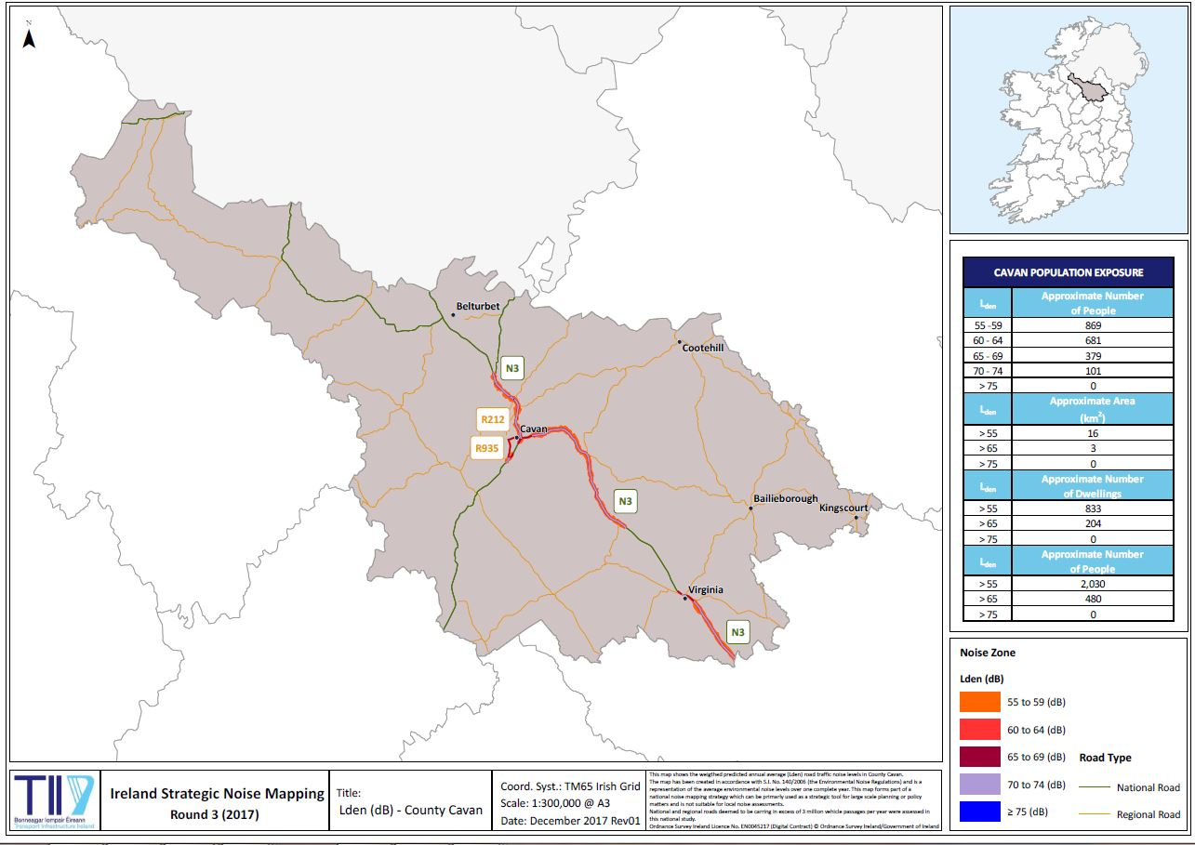
Map 1: C1. Overview of L_{den} for National Roads in Co. Cavan

Map 2: C2. Overview of L_{den} for N3 – Butlers Bridge to Lavey & N55 Cavan to Ballinagh
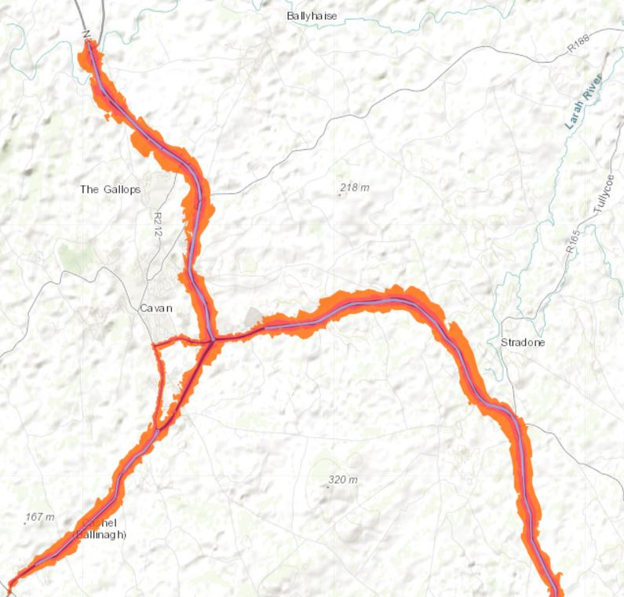

Map 3: C3. Overview of L_{den} for N3 – Poles to Lisgrey
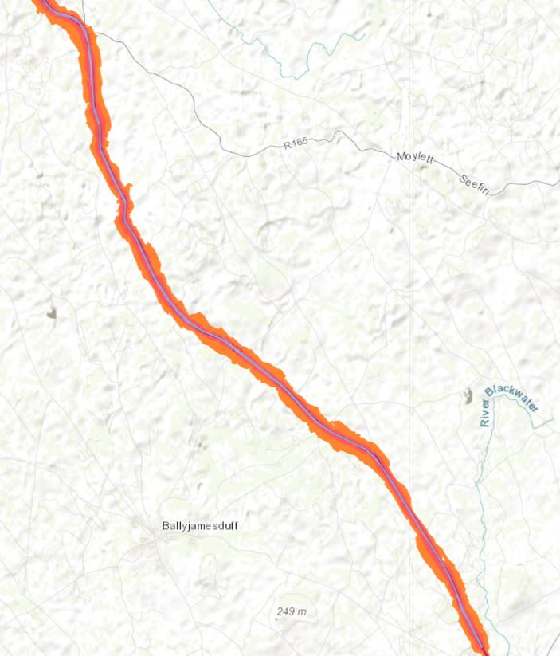

Map 4: C4. Overview of L_{den} for N3 – Billis Bridge to Meath border at Whitegate Crossroads
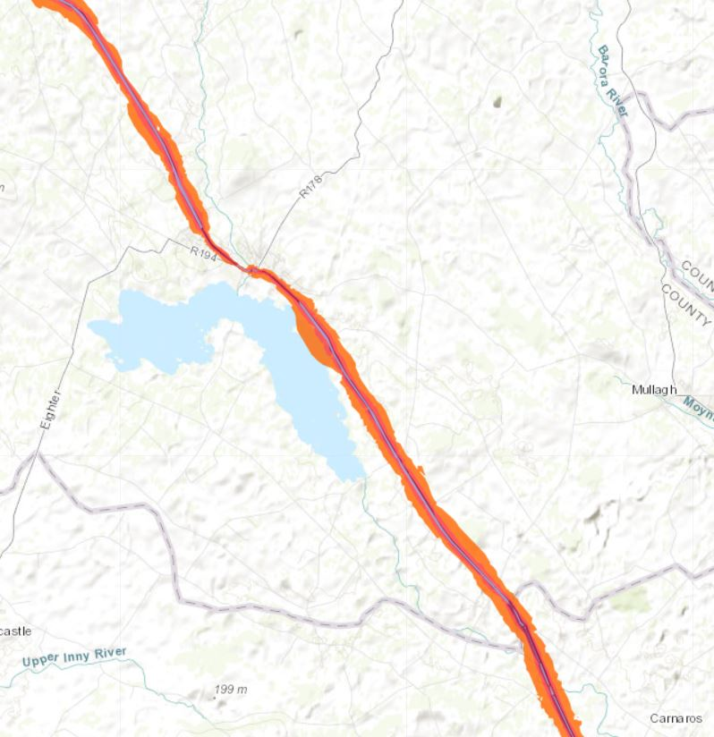

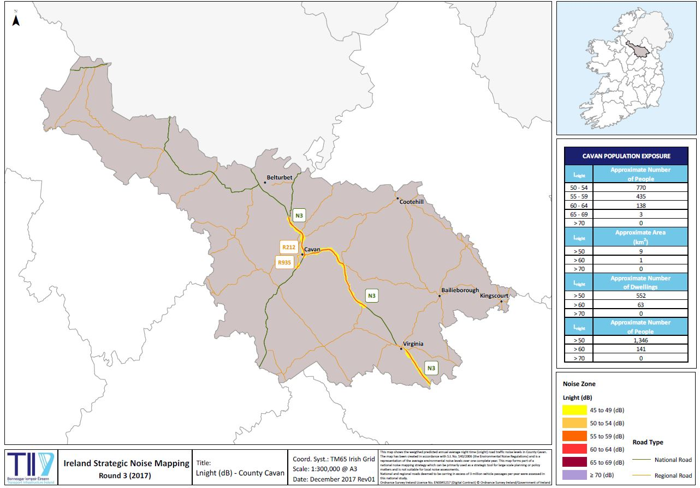
Map 5: C5. Overview of L_{night} for National Roads in Co. Cavan

Map 6: C6. Overview of L_{night} for N3 – Butlersbridge to Lavey & N55 Cavan to Ballinagh

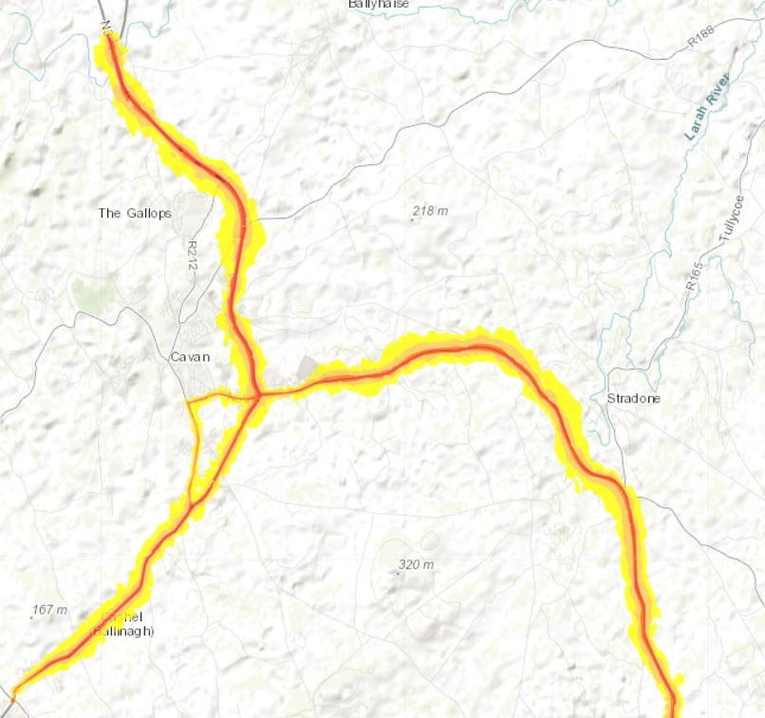

Map 7: C7. Overview of L_{night} for N3 – Poles to Lisgrey

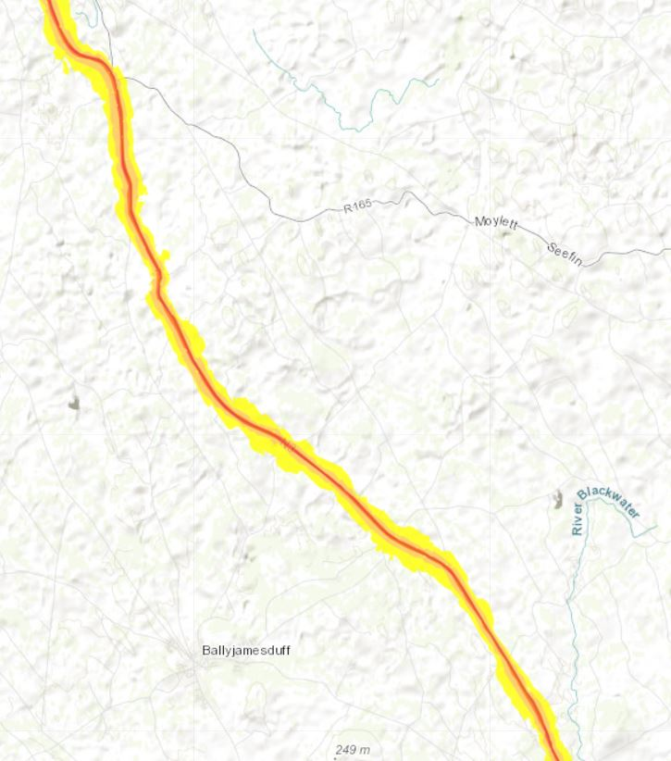
Map 8: C8. Overview of L_{night} for N3 – Billis Bridge to Cavan/Meath border at Whitegate Crossroads
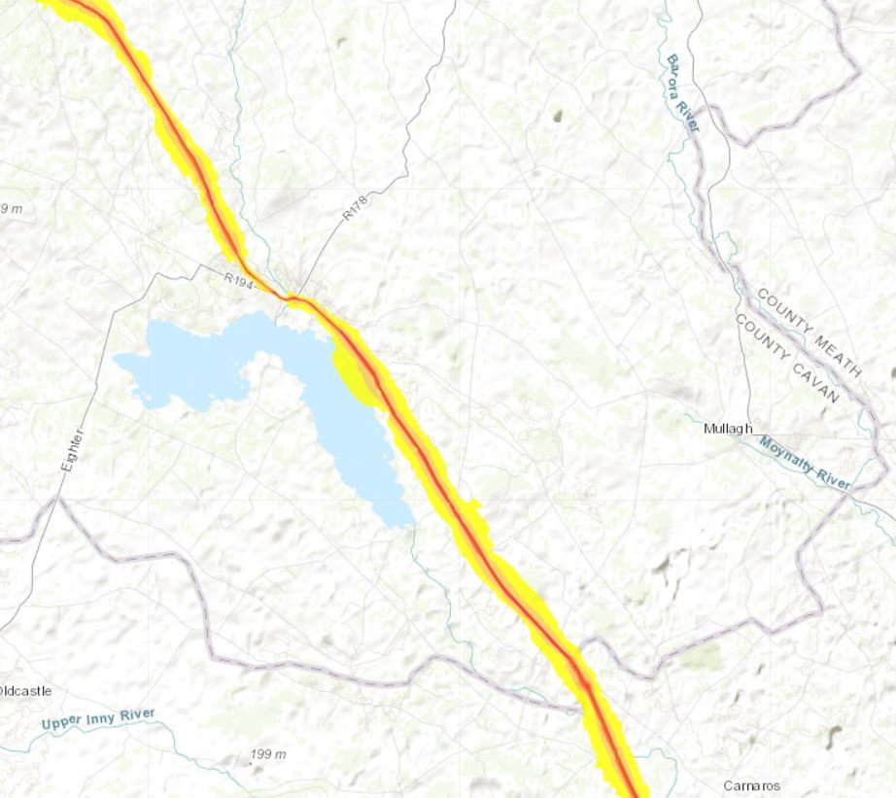

Appendix 4: Overview / Flow diagram of process for action planning decision making
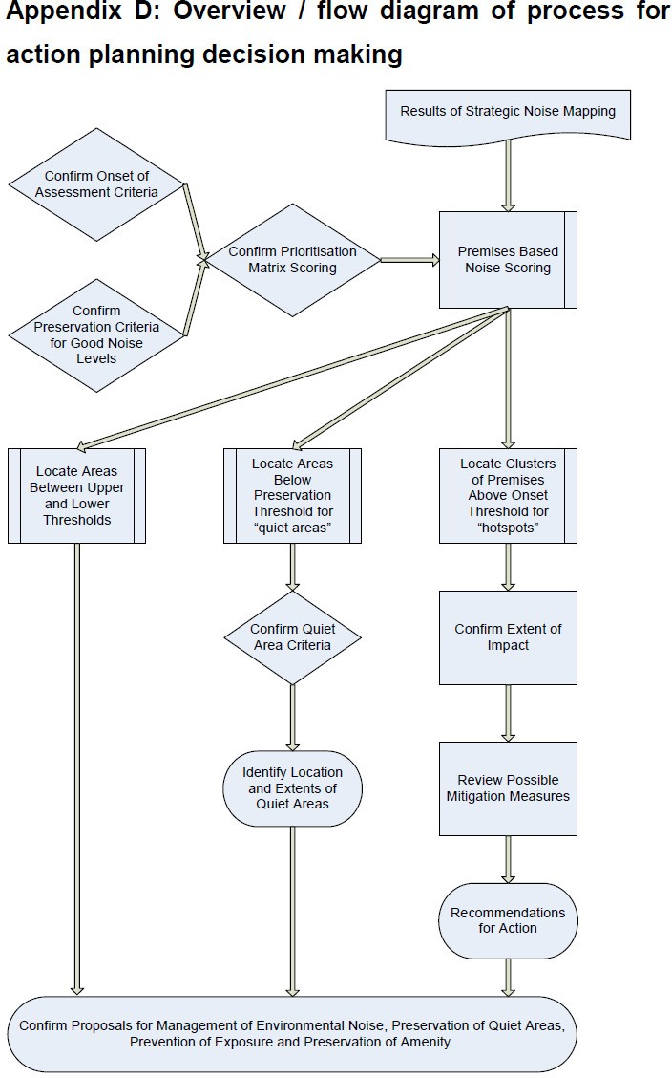

Appendix 5: Final/Completed Decision/Selection Matrix

A decision support matrix is a chart which enables identification, analysis and rating of the strength of relationships between various sets of information. It enables a
number of different factors to be examined and facilitates the assessment of the relative importance of each.

Table 13 presents the prioritisation decision support matrix to be used to support the action planning decision making process.

Table 13: Sample Decision Support Matrix to Identify and Prioritise Noisy Areas
Location:
Decision Selection Criteria |  | Score Range  Lden | Score Range  Lnight | Subtotal
Noise Band | <45 | 5 | 6
 | 45-49 | 4 | 5
 | 50-54 | 3 | 4
 | 55-59 | 2 | 2
 | 60-64 | 1 | 3
 | 65-69 | 2 | 4
 | 70-74 | 3 | 5
 | 75-79 | 4 | 6
 | 80 | 5 | 7
Type of Location | City Centre | 1 | 1
 | Commercial | 1 | 2
 | Residential | 2 | 3
 | Noise Sensitive Location | 3 | 3
 | Quiet Area | 3 | 3
 | Recreational Open Space | 2 | 2
Type of Noise Source | Air | 3 | 4
 | Industry | 2 | 3
 | Rail | 2 | 3
 | Road | 3 | 4
Total Score

Each noise sensitive premises is allocated to one of the “Type of Location” categories, and the noise level at the most exposed façade scored as per the “Noise Band” and the source scored as per the “Type of Noise Source”.

An example of the use of the matrix for a residential property exposed to road traffic noise levels of 73 dB L_{den} and 60 dB L_{night} is shown in Table 14.

Table 14: Decision Support Matrix to Identify and Prioritise Noisy Areas

Location:
Decision Selection Criteria |  | Score Range  Lden | Score Range  Lnight | Subtotal
Noise Band | <45 | 5 | 6
 | 45-49 | 4 | 5
 | 50-54 | 3 | 4
 | 55-59 | 2 | 2
 | 60-64 | 1 | 3 | 3
 | 65-69 | 2 | 4
 | 70-74 | 3 | 5 | 3
 | 75-79 | 4 | 6
 | 80 | 5 | 7
Type of Location | City Centre | 1 | 1
 | Commercial | 1 | 2
 | Residential | 2 | 3 | 5
 | Noise Sensitive Location | 3 | 3
 | Quiet Area | 3 | 3
 | Recreational Open Space | 2 | 2
Type of Noise Source | Air | 3 | 4
 | Industry | 2 | 3
 | Rail | 2 | 3
 | Road | 3 | 4 | 7
Total Score |  |  |  | 18

A score of approximately 17 or above indicates that the threshold levels have been exceeded and the location should be included in the shortlist for further assessment.

Similarly, a location with low noise levels may also score above 17, which then indicates that it should be short listed for consideration as a location where environmental noise levels are currently considered good.

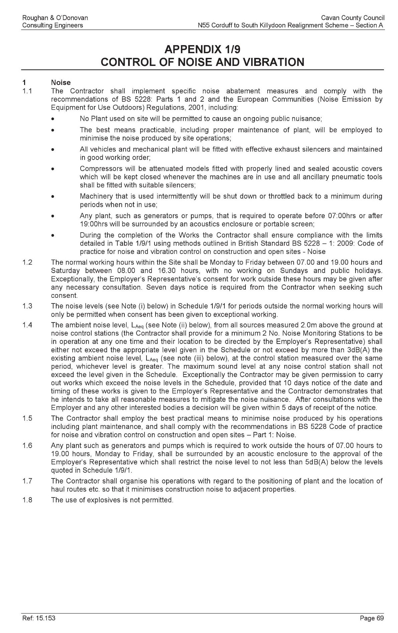
Appendix 6: Noise Control on N55 Corduff to South of Killydoon Realignment Scheme, Section A
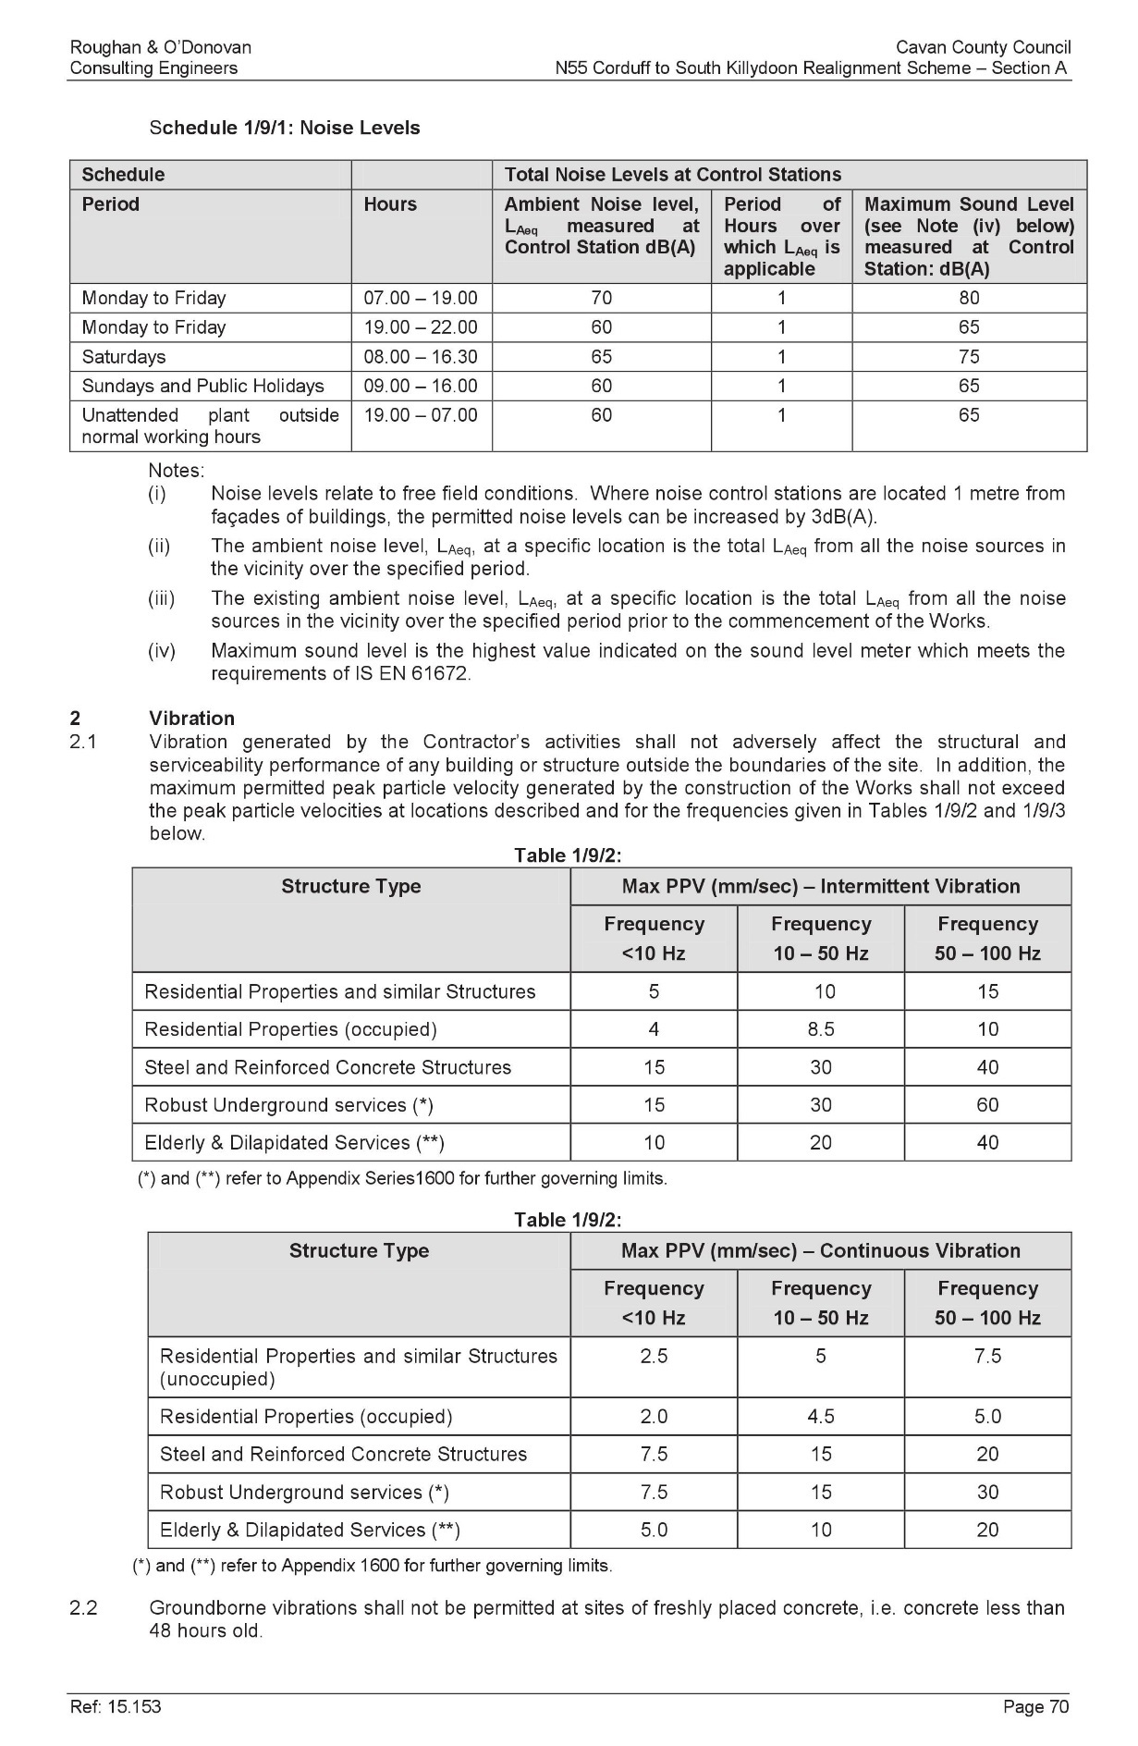
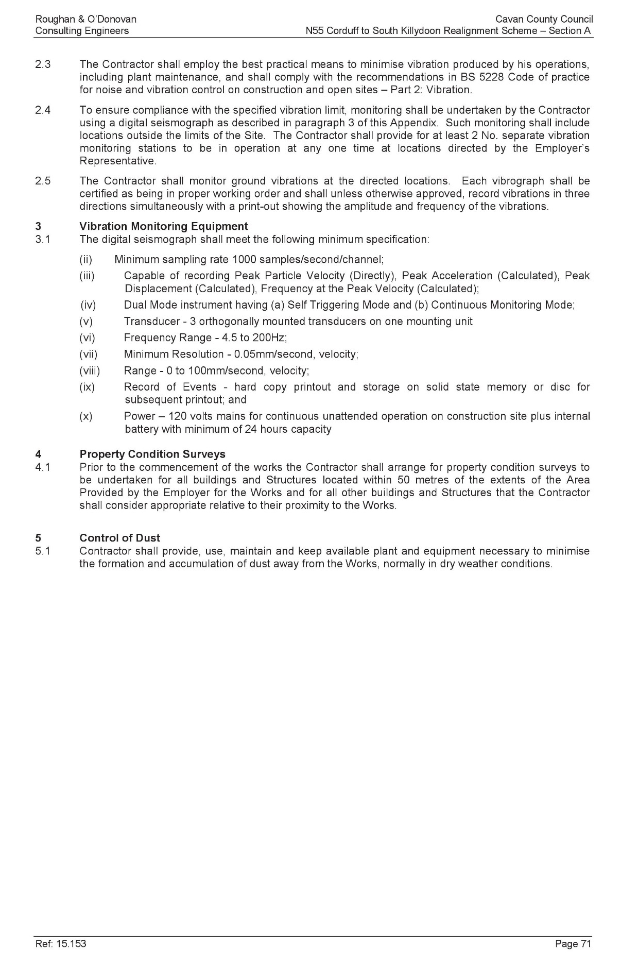
Appendix 7: Public Consultation

Public Consultation - Draft Noise Action Plan 2019

Cavan County Council invites submissions from the public on the Draft Noise Action Plan 2019, prepared under SI No. 140 of 2006, to address noise from major transport sources.

This is a five-year strategic plan to address noise from major roads in Cavan. The plan excludes noise from domestic activities, noise created by neighbours, noise at workplaces or noise inside a means of transport or due to military activities in military areas.

The main purpose of the plan is to inform and consult the public about exposure to noise from major roads and the corrective measures that may be considered to address these issues. The draft plan and associated maps are available for inspection below or at the following locations for a period not less than six weeks beginning on the date of publication of this notice:

  - Cavan / Belturbet Municipal District, Courthouse, Ballyconnell, Co. Cavan.
049 - 9526121

  - Ballyjamesduff Municipal District Office, Courthouse, Virginia, Co. Cavan.
049 - 8547013

  - Bailieborough / Cootehill Municipal District Office, Courthouse, Cootehill, Co. Cavan.
049 - 4378477

  - Johnston Central Library, Farnham Centre, Farnham St, Cavan, Co. Cavan.
049 - 4378500

  - Bailieborough Library, Market House, Bailieborough, Co Cavan.
042 - 9665779

Submissions or observations on the draft plan are invited from the general public. These submissions may be made in writing to:
Administrative Officer, Roads Section, Cavan County Council, Roads Section, The Courthouse, Farnham Street, Cavan, Co. Cavan or by email to roads@cavancoco.ie

Closing Date
12pm, Friday 02 August, 2019

