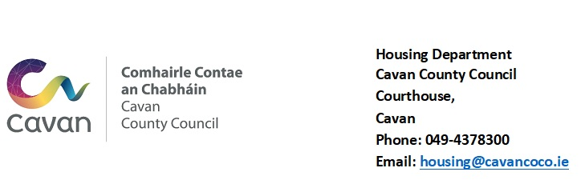

REQUEST FOR STANDING ORDER

NAME & ADDRESS OF BANK ________________________________

________________________________

________________________________

Please charge to my/our Bank Account No. ___________________ and pay to Cavan County Council, Bank of Ireland No. 17684891, Sort Code 90-32-93,
IBAN IE05 BOFI 9032 9317 6848 91, BIC BOFIIE2D.

the sum of €_________ weekly/monthly commencing ______________ , in respect of Cavan County Council Rent Account No. ____________

My/Our Account will contain sufficient funds to enable each payment to be effected in due course.

Signed: ______________________________________

______________________________________

Address: ______________________________________

______________________________________

Date: ______________________________________

N.B. Please submit one copy to your Bank and another copy to the Housing Section, Courthouse, Cavan. If the payment is in respect of Rent, please note that you will need to complete a new form when a Rent Review takes place. Forms are available from the Housing Section @ 049 4378333/ 049 4378322.

*Delete as appropriate.

