Department of Rural and Community Development

COVID-19 Emergency Fund

FOR OFFICE USE ONLY

Date Received:

Reference Number:

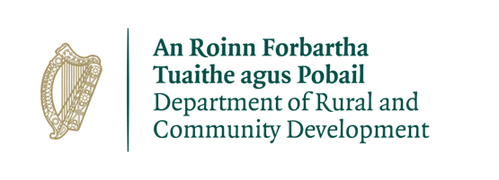
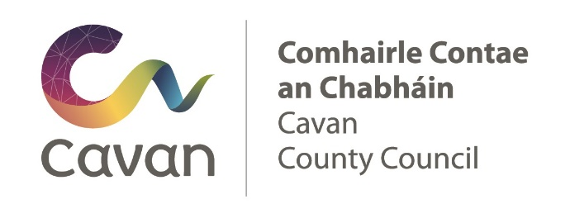

ALL APPLICATIONS ARE TO BE RETURNED BY EMAIL To :

ttierney@cavancoco.ie

By 5pm Friday 24th April 2020
GROUP /ORGANISATION NAME:

Please read the Application Guidelines before completing this form.

Department of Rural and Community Development:
COVID-19 Emergency Fund

In 2020, this grant programme is providing grants to groups that are directly involved in the Community Call response to the COVID-19 pandemic.

It is intended that the majority of the funding allocated to each Local Authority area will be ring-fenced for grants of €1,000 or less for exceptional, once-off costs incurred by community and voluntary groups associated with the Community Call initiative

Local Authorities should distribute grants on a discretionary basis to those groups/organisations involved in the Community Call COVID-19 response locally.

Local Authorities can devolve this task to the LCDC if they deem it appropriate.

TERMS AND CONDITIONS

- Grants will provide funding to groups that are directly involved in the Community Call response to the COVID-19 pandemic.
- The information supplied by the applicant group /organisation must be accurate and complete.
- Misinformation may lead to disqualification and/or the repayment of any grant made.
- All information provided in respect of the application for a grant will be held electronically. The Department reserves the right to publish a list of all grants awarded on its website.
- The Freedom of Information Act applies to all records held by the Department and Local Authorities.
- The application must be signed by the Chairperson, Secretary or Treasurer of the organisation making the submission.
- It is the responsibility of each organisation to ensure that it has proper procedures and policies in place including appropriate insurance where relevant.
- Applications must be on the 2020 application form for the COVID-19 emergency fund.
- Evidence of expenditure, receipts /invoices must be retained and provided to the Local Authority or their representative if requested.
- Grant monies must be expended and drawn down from the Local Authority by end of year 2020. Photographic evidence may be required to facilitate draw down of grants.
- The Department’s contribution must be publicly acknowledged in all materials associated with the purpose of the grant.
- Generally, no third party or intermediary applications will be considered.
- Late applications will not be considered.
- Breaches of the terms and conditions of the grants scheme may result in sanctions including disbarment from future grant applications.
- Please ensure the application form is completed in full. Incomplete applications will not be considered for funding.
- In order to process your application, it may be necessary for Cavan County Council to collect personal data from you. Such information will be processed in line with the Local Authority’s privacy statement which is available to view on www.cavancoco.ie

All questions on this form must be answered. Please write your answers clearly in block letters.

SECTION 1 – YOUR ORGANISATION

Name of Group / Organisation

Address

Eircode

Contact name

Role in Group/Organisation

Telephone number

E-mail

Website

Alternative Contact name

Alternative Telephone number

Alternative E-mail

Year established
What is the purpose of group / organisation

What work is being undertaken by the group/organisation as part of the COVID-19 Community Call?

Successful applications for funding under this programme will only be paid to the applicant organisation’s Bank Account. Please ensure you have your Bank Account details to hand if your application is successful.

Charitable Status Number (if applicable)

Tax Reference Number (if applicable)

Tax Clearance Access Number (if applicable)

SECTION 2 – Project Details

How much funding are you applying for? | €

PURPOSE OF GRANT

What will the funding be used for?

FUNDING

Amount being applied for under the COVID-19 Emergency fund | €

Important note: Please email ttierney@cavancoco.ie for information on the required supporting documentation.

SECTION 3 - DECLARATION

- I declare that the information given in this form is correct.

- I confirm I have read and fully understand the Terms and Conditions of the Programme (see page 2 of this form).

- I confirm that I have read the Guidelines prior to completing this form.

- I confirm that this grant application is submitted in acceptance of and compliance with the Terms and Conditions.

- I confirm that the applicant group/organisation does not have the funding to undertake the work/project without this grant aid or alternatively that the grant will facilitate more work which they would otherwise be unable to afford.
- I confirm that the applicant group/organisation is tax compliant (if tax registered).

Name in block capitals (on behalf of group / organisation):

Signature:

Position held in group / organisation (block capitals):
Date:

