Comhairle Contae An Chabháin
Cavan County Council

Application Form

Cavan County Council
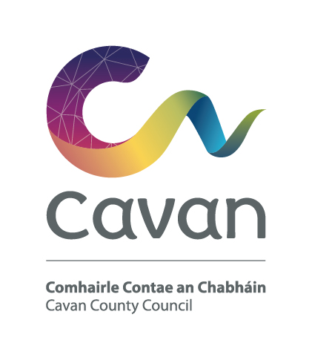
Cavan County Council is an equal opportunities employer

Please return 4 no. signed hard copies of this application form together with 4 no. copies of any additional documentation to the Human Resources Section, Cavan County Council, Farnham Centre, Farnham St., Cavan, so as to arrive not later than 4.00 p.m on Friday, 20th July, 2018

Position: Environmental Senior Executive Technician

1. Name in full (Block Letters)

2. Postal Address (Block Letters)

3. Telephone No. Work

Home

Mobile

E-Mail Address
4. Do you hold a current full driving licence Yes No

5. Do you require a work visa/work permit Yes No

6. Education

General Eduction
Period | School or College Attended | Examinations Taken (with dates) | Results

Where applicable, please submit copy of Leaving Certificate results with application

Academic, Professional Or Technical Qualifications (if any)

Period | Name of College/ University | Part/Full Time | Course & Qualification | Grade & YearObtained

Where applicable, please submit copy of qualification with application.

Other Relevant Training (if any)

Date | Other Relevant Training (course name) | Qualification received

NOTE:- Certification & qualifications will be subject to verification post interview and prior to appointment. If you are forwarding any additional documentation, please submit 4 copies.

7. Career History

Particulars of present appointment

Employer:
Position Title:
Address:
Perm/Temp:
Start Date:
Describe briefly your present position, outlining your main responsibilities
and activities, to whom you are responsible and who, if anyone, is responsible to you.

8. Previous Employment Record

Give below, in date order, full particulars of all employment starting with your position immediately preceding your present position to date of leaving school or college.No period between these dates should be left unaccounted.

From | To | Name and Addressof Employer | Job Title  Description of duties/main responsibilities

9. Having regard to the requirements set out in the briefing document, please indicate below any particular work or personal skills/experience which you have acquired and which you wish the interview board to be aware of. You may support your answer by examples from your work experience to date (not more than 300 words)

10. Supporting Information
Please use this space to outline any other information not already included which you feel may support your application (eg leisure interests, hobbies, membership of clubs etc) (this section is optional)

11. References:
Give names and addresses of two responsible persons to whom you are
well known, but not related. The Council will assume permission to contact
referees unless the Applicant has stated otherwise.
(1)
Name

Address

Occupation

(2)
Name

Address

Occupation

12. Are you now, or have you been within the past 12 months a member of a
Local Authority?

Yes No

13. Are you in receipt of a superannuation allowance in respect of an office under
a Local Authority? Is so, give particulars of pension,
office of employment, grounds and date upon which is was granted.
Yes No

14. Do you require any special facilities/arrangements for the interview
(e.g. wheelchair access etc)

Yes No

15. Please advise where you heard of this vacancy:

Tick as appropriate

Local Paper: National Paper: Council Website:

Social Media: Face Book: Twitter: LinkedIn:

Before signing this form, please ensure that you have replied fully to all questions
asked. You should also satisfy yourself that you are eligible under the qualifications.

I, the undersigned, hereby declare all the foregoing particulars to be true.

Signature of Applicant

Date

Communications relating to your application will be by email to the address provided.

N.B. Canvassing by or on behalf of the applicant will disqualify

