Cavan LCDC Peace IV Partnership

PEACE IV

EU Programme for Peace and Reconciliation 2014-2020

Building Positive Relations: Action 4.1 “Local Authority Action Plans”

Application Form

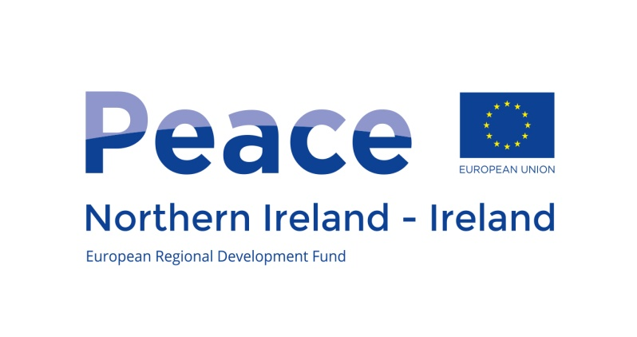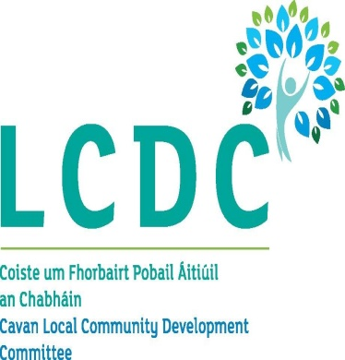

This project/initiative is supported by the EU’s PEACE IV Programme, managed by the Special EU Programmes Body.

GENERAL POINTS TO NOTE
- Before submitting an application, applicants should satisfy themselves that the project meets the selection criteria outlined in the Guidance Note.

- An application form must be returned for each project proposal.

- The information on this form may be made available to other departments and/or agencies for the purposes of audit, research, meeting statutory obligations and preventing or detecting crime.

- Full programme rules are available at http://www.seupb.eu/Libraries/PEACE_IV_Programme_Guidance/PIV_ProgammeRules_Version3_27January2017.sflb.ashx

Your Application Form should be submitted by email to jcrudden@cavancoco.ie
or posted to:

Peace IV Programme Manager
Community & Enterprise
Cavan County Council
Library Building
Farnham Street
Cavan
H12 C9K1
Tel: 049 4378300

There will be a rolling call for submission of applications between October 2017 and February 2018
- Opening Date: 21 September 2017
- Closing Date(s): 27 October 2017 (15:00); 15 December 2017 (15:00) and 16 February 2018 (15:00)

Please enclose the following documents:

- Annual/Audited accounts
- Recent bank statement
- Legal Status – Copy of governing document (signed constitution, or memorandum and articles of association)
- Job descriptions (if applicable)
- Organisational Chart including list of board members and sub-committee managing this project.
- Declaration of participation / agreement with partner organisations . Necessary if a partnership has been established. (as appropriate)
- Current Tax Clearance Certificate (original)
- Details on VAT information
- Signed minutes of board meeting authorising submission of this application.
- Child Protection Policy (If your project will be working with children and young people)
- Details of organisations financial procedures
- Garda Clearance (If your project is working with children or vulnerable adults)
- Insurance cover with indemnification for Cavan Co Council (Or commitment to obtain)

1. CONTACT INFORMATION OF APPLICANT

Name of Organisation: ____________________________________________

Address: ____________________________________________
(cont’d) ____________________________________________
City/Town/Townland: ____________________________________________
County: ____________________________________________
Postcode: ____________________________________________

Telephone: ___________________

Email: ____________________________

Enter name of person to be contacted regarding the expression of Interest below

Title: (Mr/Mrs/Miss/Ms) ___________________________

Forename: _____________________________________________________

Surname: _____________________________________________________

Position e.g. Chairperson: _________________________________________

2. PARTNER DETAILS
This section of the form asks about the organisations who will be potential project partners (if appropriate)

Name and Address of Organisation | Nature of Organisation
1.

2.

3.

3. PROJECT DESCRIPTION – Please provide an outline of the project, including a summary of the proposed actions/activities and proposed timeframe. Where appropriate please indicate the status of all statutory approvals and permissions that are required for the project to progress. NB: Projects must be a minimum of 12 months duration

4. OBJECTIVES OF THE PROJECT – What are the main objectives and what are the expected results and outputs of the project? (including participant numbers).

5. Quality of project proposal: Please demonstrate how your project will create opportunities for sustained, meaningful and purposeful contact between people and groups of different backgrounds

6. Quality of Cross Community/Cross Border cooperation. Project implementation must involve demonstrable cross-community and/or cross border partnerships and activities. Please include cross community/border targets for each activity (as applicable)

7. Quality of the project team and implementation arrangements. Groups will have to demonstrate that those involved have the right skills and experience to deliver on the Peace programme outputs. Groups should also outline the implementation arrangements for the project.

8. Contribution to Sustainable Development.

9. Contribution to Equality.

FINANCING

10. PROJECT COSTS

Expenditure Item | Total Cost
Staff Costs

Office and Administrative Costs (15% of staff costs where applicable)

Travel and Accommodation Costs

External Expertise and Services Costs

Equipment Costs

Capital (Investment) Costs

TOTAL

11. Please provide a detailed breakdown of what is included within the figures:

13. DECLARATION

  - I certify that the information contained in this application is correct and confirm that this project will be carried out as described in the application.

  - I certify that no bad debts or judgements have been made against us over the past five years, (please give details below where relevant).

  - I understand that providing wrong or misleading information is an offence and such information may be used against us in any subsequent criminal investigation.

  - I understand that information contained in this form may be released under the Freedom of Information Act, 2014.

Signed: _________________________________

Name of Applicant (in capitals): _________________________________

Position in organisation/group: _________________________________

Date: _________________________________

