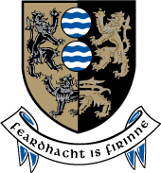
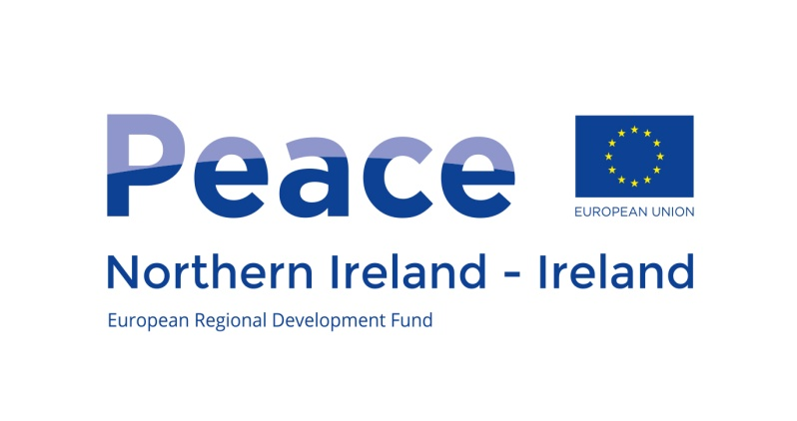
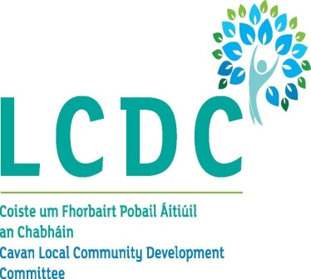

GUIDANCE NOTES

PEACE IV
EU Programme for Peace and Reconciliation 2014-2020,
Cavan County Council

Cavan County Council is seeking applications for funding from the Peace IV Programme under the following measure:

Building Positive Relations - Action 4.1 Local Authority Action Plans

This project/initiative is supported by the EU’s PEACE IV Programme, managed by the Special EU Programmes Body.
INTRODUCTION

The Special EU Programmes Body (SEUPB) is a North/South Implementation Body sponsored by the Department of Finance in Northern Ireland and the Department of Public Expenditure and Reform in Ireland. It is responsible for managing two EU Structural and Investment Funds Programmes – PEACE IV and INTERREG VA - which are designed to enhance cross-border co-operation, promote reconciliation and create a more peaceful, social and economic prosperous society.

PEACE IV
Through the PEACE IV Programme Cavan County Council wish to support projects that promote social inclusion, combat poverty and discrimination and make a lasting difference in building greater cohesion between communities. In particular, projects should be able to demonstrate how they will foster enhanced peace and reconciliation in Co Cavan and in some instances in our bordering northern counties.

PEACE IV will place a strong emphasis on promoting cross-community relations and understanding. All projects will be required to identify how they will contribute towards the achievement of the result indicators of the Programme in order to promote a greater level of reconciliation and understanding in Co Cavan and in some instances in our Bordering Northern Counties

Summary of Call
Cavan County Council is seeking applications from formally constituted organisations such as;

- Community development groups;
- Cultural organisations;
- Minority ethnic groups;
- Women’s Groups;
- Intercommunity networks;
- Projects for young adults;
- Youth Groups;
- Older People Groups;
- Sports Governing Bodies;
- Faith-based groups; and
- Other organisations involved in community relations, reconciliation and cultural diversity, including state and public agencies.

Organisations are invited to submit project proposals with the following specific objective:

The promotion of positive relations characterisd by respect, where cultural diversity is celebrated and people can live, learn and socialise together, free from prejudice, hate and intolerance.

A total of €526,580 (subject to funding being approved) may be allocated to this measure. The minimum level of funding available per project will be €5,000 and maximum €50,000. In exceptional circumstances a maximum small grant allocation @ €125,000.00 could be considered.

This document offers guidance on how to apply for funding to Cavan County Council PEACE IV Programme – Building Positive Relations Measure

The Programmes are open to any organisation(s)/group(s) that can contribute to the results and outputs of the Programme with the capacity to implement an EU funded project. The assessment process will assess both of these aspects.

The grants are aimed at key target groups within Peace IV such as:
- victims of the conflict
- displaced people, who have moved because of violence, sectarianism or racism
- people who have been excluded or marginalised from economic, social and civil networks as a result of problems related to sectarianism, racism and the conflict
- young people, women, older people, minority communities.
- former members of the security and ancillary services
- ex-prisoners and their families
- public, private and voluntary sector organisations and their staff who have a contribution to make towards developing a shared society

There will be a rolling call for submission of applications between October 2017 and February 2018
- Opening Date: 21 September 2017
- Closing Date(s): 27 October 2017 (15.00); 15 December 2017 (15.00) and 16 February 2018 (15.00)
- Application forms and guidelines are available on www.cavancoco.ie or by e-mailing jcrudden@cavancoco.ie or request for posting by calling Jane Crudden on 0494378300

Result indicators: The promotion of positive relations characterised by respect, where cultural diversity is celebrated and people can live, learn and socialise together, free from prejudice, hate and intolerance that will contribute to the result indicators listed below:

- An increase in the percentage of people who think relations between Protestants and Catholics are better than they were 5 years ago by 7%.
- An increase in the percentage of people who think relations between Protestants and Catholics will be better in 5 years’ time by 4%.
- An increase in the percentage of people who know quite a bit about the culture of some minority ethnic communities by 8%.

Building Positive Relations: it is anticipated that the programme will fund actions contributing to:

- Conflict resolution and mediation at a local level;
- Events linked to the decade of commemorations that explore history in a sensitive manner and build mutual understanding;
- Sport, arts, culture (including Irish and Ulster Scots language) and environment projects that promote positive relations through addressing issues of trust, prejudice and intolerance;
- Projects to facilitate personal interaction between residents and groups from divided neighbourhoods.

Successful projects will also demonstrate that they:
- Will not duplicate or compete with existing projects and services locally; and
- Can be delivered within the programme timeframe, and have the necessary permission in place in order to progress

Financial Information
Applications should include a detailed breakdown of all costs involved in delivering the project. The budget proposed will be robustly tested as part of the assessment of your project.

Budget should be broken down into the following categories;

- Staff Costs
- Office and Administrative Costs (Office rent, insurances and taxes, utilities, office supplies, general accounting, archives, maintenance, cleaning and repairs, security, IT systems, communication, bank charges for administration, charges for transnational financial transactions
- Travel and Accommodation Costs
- External Expertise and Services Costs (Programme costs)
- Equipment Costs

Where a project has eligible staff costs, SEUPB have set a 15% flat rate for office and administrative costs.

Application assessment Criteria
Applications must demonstrate relevance to the seven criteria, each with a weighting listed below, against which applications will be appraised and scored (0 to 5).

In order to be successful, a minimum score of 3 for each criterion is required.

 | Criterion | Weighting
1. | Contribution of the project to the defined results and outputs of the programme | 20%
2. | Quality of project proposal | 20%
3. | Quality of cross community/border co-operation with demonstrable added value | 20%
4. | Quality of the project team and implementation arrangements | 10%
5. | Is the budget realistic and offer Value for money | 20%
6. | Contribution towards sustainable development | 5%
7. | Contribution towards equality | 5%

All projects which meet the required threshold will be ranked in order of score. Cavan LCDC Peace IV Partnership Board will make the final decision on which applications are successful and submit to SEUPB for approval prior to a letter of offer being issued.

Unsuccessful applications will be formally rejected with clear reasons for rejection. Applicants rejected at this Stage will have the right to a review.

The fund is limited and even if the application meets all the conditions, funding cannot be guaranteed.

Completed applications should be submitted to jcrudden@cavancoco.ie or Jane Crudden, Peace Programme Manager, Community & Enterprise, Cavan County Council, Library Building, Farnham street, Cavan H12 C9K1.

To note:
Applicants should specify if match funding is available. Match funding from other EU funding streams would be deemed ineligible.

Applicants can only receive one grant in each objective.

Contact Us
For enquiries about this funding call please contact Cavan County Council

Contact Name: Jane Crudden
Peace Programme Manager
Community & Enterprise
Cavan County Council
Library Building
Farnham Street
Cavan H12 C9K1
jcrudden@cavancoco.ie
0494378300

Please remember to enclose the following documentation:

Item required | Enclosed
Annual/Audited accounts
Recent bank statement
Legal Status – Copy of governing document (signed constitution, or memorandum and articles of association)
Job descriptions (if applicable)
Organisational Chart including list of board members and sub-committee managing this project.
Declaration of participation / agreement with partner organisations. Necessary if a partnership has been established. (as appropriate)
Current Tax Clearance Certificate (original)
Details on VAT information
Signed minutes of board meeting authorising submission of this application.
Child Protection Policy (If your project will be working with children and young people)
Details of organisations financial procedures
Garda Clearance (If your project is working with children or vulnerable adults)
Insurance cover with indemnification for Cavan Co Council (Or commitment to obtain)

