Very Disadvantaged and Disadvantaged Urban Areas in County Cavan based on the Haase 2016 Index.
Legend
Very Disadvantaged
Disadvantaged

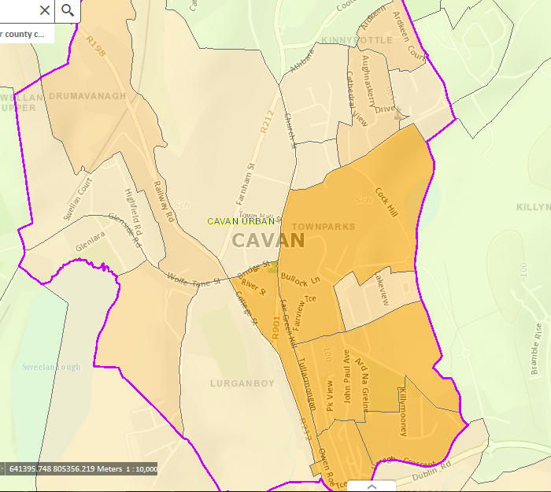
Cavan

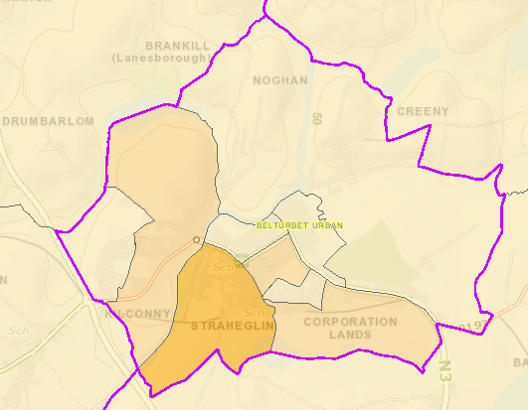
Belturbet
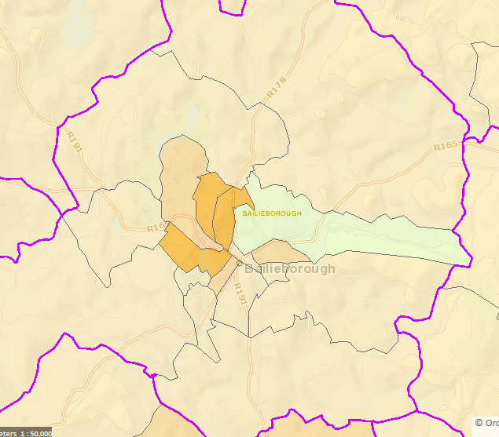
Bailieborough

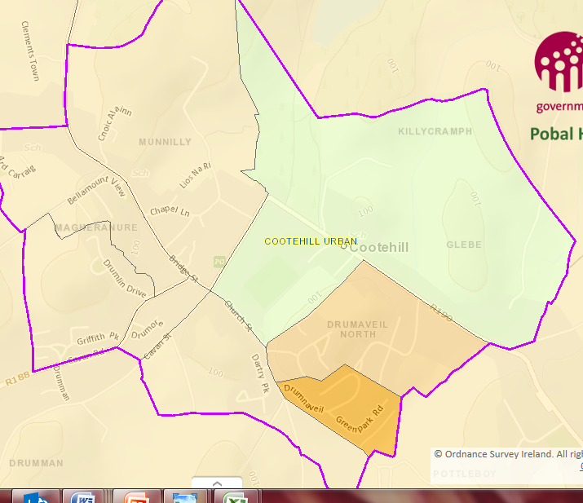
Cootehill
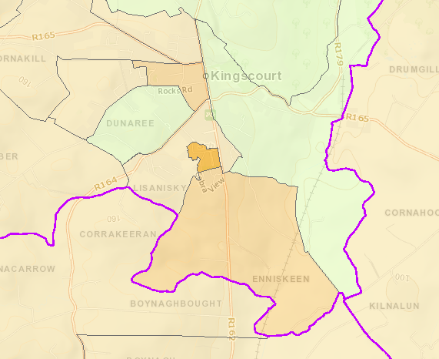
Kingscourt

Disadvantaged Areas Urban Areas and Provincial Towns in County Cavan

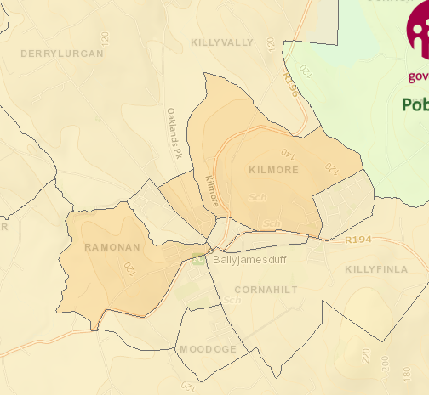
Ballyjamesduff

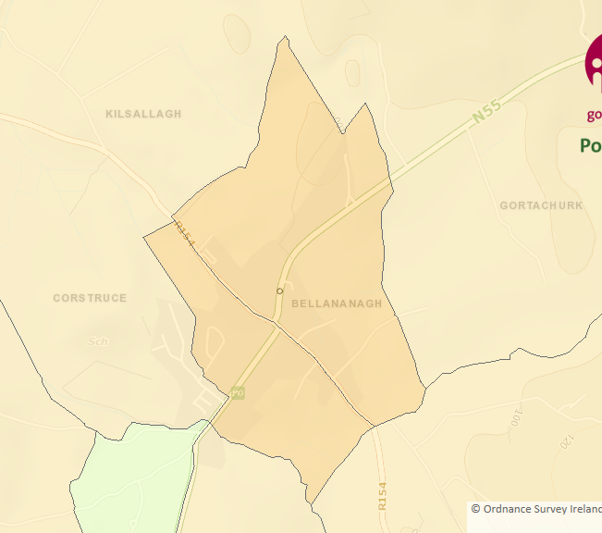
Ballinagh
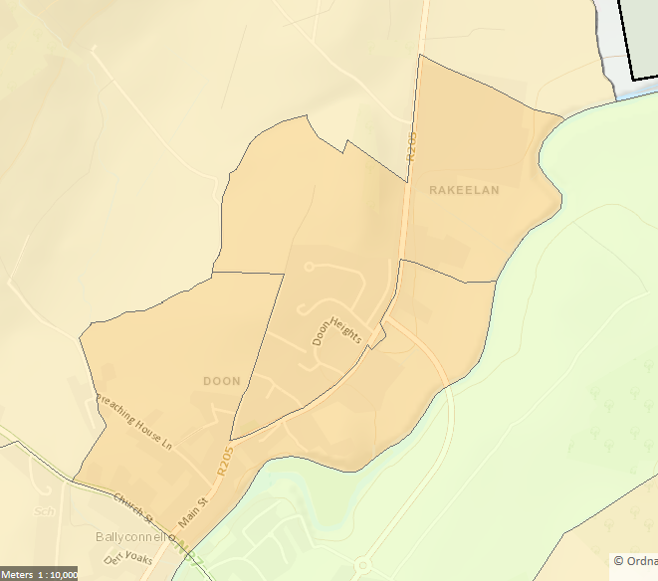
Ballyconnell
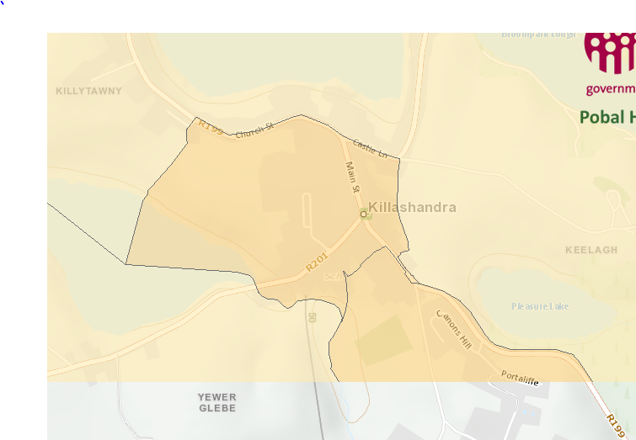
Killeshandra

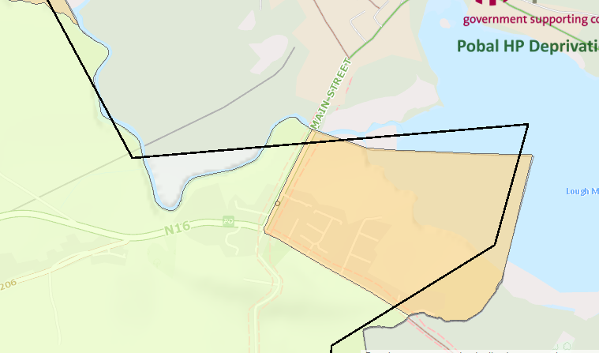
Blacklion
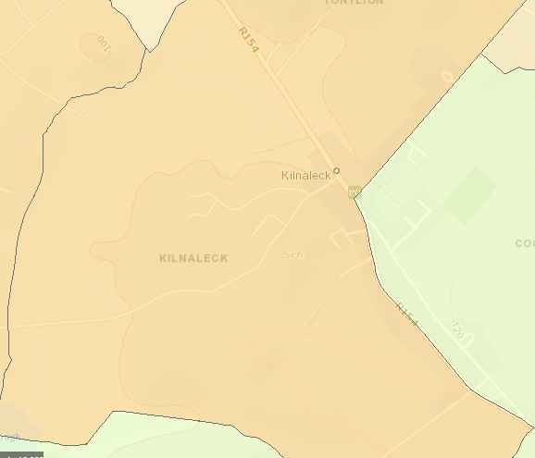
Kilnaleck

