Comhairle Contae an Chabháín
Cavan County Council
Proposed Playground Ballyhaise

Background: This scheme is funded under the Community Recognition Fund (CRF).
The CRF aims to support the development of community infrastructure and facilities in recognition of the contribution being made by communities across the country in welcoming and hosting significant numbers of arrivals from Ukraine and other countries.
Proposed Playground: Location Map
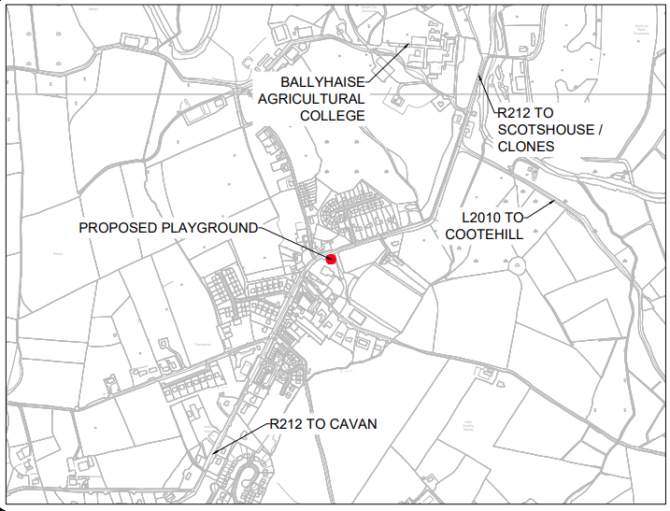
Under CRF it is proposed to provide a new playground totalling 4 - 5 number of pieces of play equipment. This proposal will be of significant benefit to the local community and provide an amenity in the area where there has been none to date.
The proposed playground will be on community grounds to the front of the existing community centre, in the heart of Ballyhaise Village, close to the R212 and entrance to the local GAA grounds providing the playground with excellent passive surveillance.

Proposed Playground Description
The proposed playground will include play equipment pieces that will challenge children of all abilities, while ensuring accessibility. Proposed equipment will include,
- A multi-use play area for older children
- A multi-use play area for younger children
- A universal Carousel
- And Interactive Play Panels
Proposed Works
Proposed works shall consist of the following:
- Site clearance, regrading of slopes and alteration to drainage
- Construction of retaining walls on steep banks
- Reduce width of existing car park
- Install 2.4m high secure perimeter fencing on play area
- Install play equipment.
- Install safety surfacing.
- Provide associated footpaths, kerbing, surfacing and landscaping

