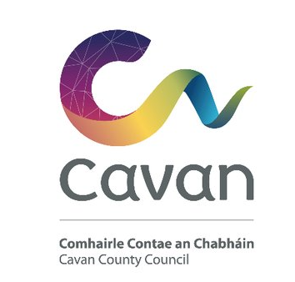
CAVAN COUNTY COUNCIL
Comhairle Chontae an Cabháin
Planning Notice – Part 8
Notice under Planning & Development Regulations 2001 as amended – Part 8
Bridge Widening of the existing bridge at Derrylea Bridge, in Derrylea, Ballyjamesduff, County Cavan
In accordance with the above Regulation, Cavan County Council proposes to provide enhanced facilities for vehicular traffic by constructing a bridge widening of the existing bridge at Derrylea Bridge, in Derrylea, Ballyjamesduff, County Cavan.
Derrylea Bridge is a two span masonry arch structure which carries the R194 over the Claddagh River. The river feeds into Lough Sheelin approximately, which is 7.5 km downstream to the south-west. The bridge is situated c. 2km south-west of Ballyjamesduff, Co. Cavan on a dangerous bend on the R194 road and close to the junctions of three minor roads with the R194.

The proposed development, which is the subject of this Part 8, include
- the realignment of the R194 on the approaches to the bridge
- the widening of the bridge on both sides using reinforced concrete arches, matching the existing profile and faced in masonry to match the existing.
- There will be some minor repairs to the existing bridge also.

The carriageway of the realigned section of the regional road will be 6.5m wide and a 2.5m wide footpath will be provided on the north side of the road. The realignment extends over a length of 237m including 60m transitions at either end and a 510m radius curve over a 117m length. The maximum superelevation on the curve is 5%.
An Appropriate Assessment Screening Report including a Bat and Otter Survey, of the proposed development has been completed and are available for inspection with this application.
Drawings and particulars of the proposed development will be available for inspection or purchase at a fee not exceeding the reasonable cost of making a copy, during normal office hours 9.00am to 1pm and 2pm to 5pm, Monday to Friday (excluding public holidays), at:
a. Cavan County Council, Planning Section, The Johnston Library, Farnham Street, Cavan, Co. Cavan
b. Cavan County Council, Ballyjamesduff Municipal District Area, Main Street, Virginia, Co. Cavan.

during the period from Thursday 11th November 2021 to Thursday 9th December 2021, both dates inclusive.

Submissions or observations with respect to the proposed development, dealing with the proper planning and sustainable development of the area in which the proposed development would be situated, may be made in writing or email to derrylea@cavancoco.ie , to Cavan County Council, addressed to the undersigned, on or before 4 p.m. on Thursday 23rd December 2021.

In accordance with the requirements of the European Union (Planning and Development) (Environmental Impact Assessment) Regulations 2018 (S.I. No. 296 of 2018), the Planning Authority has concluded that the proposed development does not require an Environmental Impact Assessment and will not be likely to have a significant effect on the environment. Any person may, within 4 weeks from the date of this notice apply to An Bord Pleanala for a screening determination as to whether the development would be likely to have significant effects on the environment.
Mr Paddy Connaughton, Director of Services, Roads and Infrastructure, Cavan County Council

