Comhairle Contae an Chabháín
Cavan County Council
Proposed Natural Playground & Access Track
Dun a Rí Forest Park, Kingscourt, Co. Cavan

Background: This project is funded under the Outdoor Recreation Infrastructure Scheme (ORIS).
The ORIS provides funding for the development of new outdoor recreational infrastructure. It also provides support for the necessary repair, maintenance, enhancement or promotion of existing outdoor recreational infrastructure in rural areas across Ireland.
The scheme supports outdoor recreation activities such as walking, trekking, cycling, kayaking and hiking. It helps to make use of the resources of the countryside that contribute to healthy active lifestyles. It supports the economic and tourism potential of the area for both local communities and tourist visitors alike.
Proposed Playground: Location Map
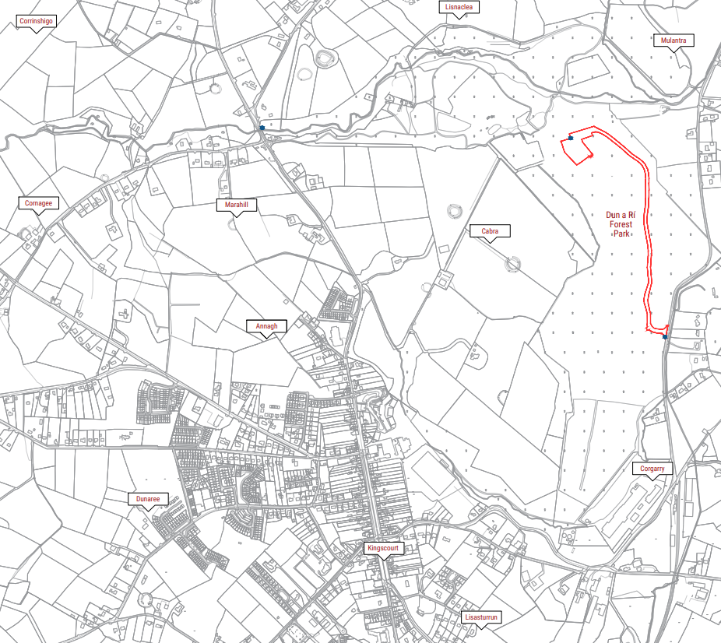
Under ORIS it is proposed to provide enhanced accessible/off-road access from Kingscourt to Dún a Rí Forest Park and the creation of a natural woodlands play area in the park.
The trail that is being proposed is designed to improve access to the Forest Park particularly for people with disabilities and will be designed based on best practice for all access trails.
The natural play area will also be designed with accessibility for all abilities to the forefront and this will be an integral part of the design. This will open this natural woodland environment to individuals with a physical disability in a way that was not previously possible.
There is also strong evidence that natural play areas have a much more calming influence over traditional playgrounds which often include vivid colours and can over stimulate children. Natural play areas are also shown to offer much more development potential to children of all abilities. In addition, by encouraging children to engage with nature in the play area, it will inspire the next generation to respect and care for biodiversity and the natural environment.

Proposed Works
Provision of a new natural playground and additional works comprising of new access path at Dun a Rí Forest Park adjacent to the existing car park within the forest park.

