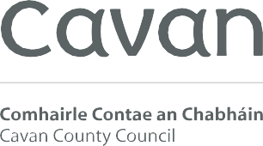

FIXED CHARGE PARKING FINE APPEAL FORM

Cavan County Council operate restricted parking areas (as defined in Article 9(2) of the County of Cavan Traffic and Parking Bye-Laws, 2016) which includes Pay & Display Parking in Cavan Town where motorists must display a paid parking disc and obey the time limits for each respective parking area.

Cavan County Council also operate 2-hour restricted parking in the following towns: Belturbet, Ballyconnell, Cootehill, Bailieborough, Virginia.

If you receive a Fixed Charge Parking Fine and you consider that this action was unjustified, you may lodge a written appeal.

All appeals must be submitted in writing and should be sent to:

Email to: parking@cavancoco.ie
Or
By post to: Parking Section, Cavan County Council, Courthouse,
Farnham Street, Cavan.

Only an appeal received by the Parking Section within 14 days of the issue date of the Fixed Charge Parking Fine will be accepted. Please note that if your appeal is unsuccessful, you will be liable for any increase in the penalty irrespective of any delay occurring during the processing of this appeal and you will be open to prosecution.

ALL FINES WILL INCREASE BY 50% AFTER 28 CALENDAR DAYS FROM THE DATE THE FIXED CHARGE PARKING FINE WAS ISSUED NOTWITHSTANDING AN APPEAL APPLICATION.

We can only accept appeals from the Registered Owner of the Vehicle.

An appeal should include the following information:
- Name, address, email address of appellant, vehicle registration number and Fixed Charge Parking Fine Number.
- Reason for appeal.

Appeals will not be considered on the following grounds:

- Pay and Display disc not clearly visible on vehicle dashboard due to ticket falling on the ground or otherwise misplaced (warden photos used to confirm this).
- Disabled Persons Badge not clearly displayed on vehicle dashboard or out of date (warden photos used to confirm this).
- Residents Parking Permit not clearly displayed on dashboard or out of date (warden photos used to confirm this).

If you are no longer the owner of the vehicle and wish to appeal on these grounds, please submit proof of sale.

When we receive your appeal:
- We will, on receipt of your written appeal, immediately begin processing it through our appeals processing procedure.
- We will consider your appeal in conjunction with evidence supplied by Traffic Wardens in relation to the issuing of this Fixed Charge Parking Fine.
- We will notify you in writing of our decision.

Cavan County Council
Courthouse Farnham Street Cavan H12 R6V2

T : 049 437 8300

E: parking@cavancoco.ie

Comhairle Contae an Chabháin
E: eolas@cavancoco.ie

W: www.cavancoco.ie

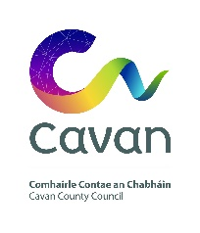
Cavan County Council
Comhairle Contae on Chabháin
Fixed Charge Parking Fine Appeal Form

Date of Appeal: Fixed Charge Parking Fine Number:

Vehicle Reg No:

* Name and Address of Registered Car Owner: Date Fine was Issued:

Contact No: Email:
Reason(s) for Appeal:

*Signed:

To be returned to Parking Section by email to parking@cavancoco.ie or by post to Parking Section, Cavan County Council, Courthouse, Farnham Street, Cavan. Please attach any supporting documentation.

The personal information (data) collected on this form, including any attachments, (which may include the collection of sensitive data) is collected for the purpose of processing this application and any data collected is subject to Cavan County Council’s privacy statement which can be viewed online at https://www.cavancoco.ie/privacy-statement/.

