ANNUAL FINANCIAL STATEMENT

Cavan County Council

For the year ended 31st December 2015

CONTENTS

UNAUDITED

Page

Financial Review

Certificate of Chief Executive/Head of Finance Audit Opinion
Statement of Accounting Policies

Financial Accounts

Statement of Comprehensive Income (Income & Expenditure Account) Statement of Financial Position (Balance Sheet)
Statement of Funds Flow (Funds Flow Statement) Notes on and forming part of the Accounts

Appendices

- Analysis of Expenditure
- Expenditure and Income by Division
- Analysis of Income from Grants and Subsidies 4 Analysis of Income from Goods and Services 5 Summary of Capital Expenditure and Income 6 Capital Expenditure and Income by Division
- Major Revenue Collections
- Interest of Local Authorities in Companies 9 Summary of Local Property Tax Allocated
3

4

5

6

11

12
13
14
15-25

26

27
28-31
32
33
34
35
36
37
38

Cavan County Council

Financial Review

Annual Financial Statement for Financial Year ended 31st December 2015

Income & Expenditure Account Statement

Revenue Expenditure for 2015 amounts to €54,403,612 net transfers to reserves amounts to 0,769,186 giving total expenditure of €58, 172,798. Revenue income amounts to 05,189,242, income from rates amounts to €13, 536,702, pension related deduction income amounts to €988, 545, income from Local Government Fund/Local Property Tax allocation amounts to €8,458,415 resulting in total income of
€58, 172,904. The net position on Revenue account for 2015 is a surplus of €107 increasing general reserve at 31/12/2015 to €1,742,864. This represents a satisfactory outcome for 2015 on revenue account and reflects the ongoing prudent management of Councils finances in difficult economic conditions.
The Council acknowledges the following grants from the Arts Council in 2015, the sum of €43, 750 to Ramor Theatre Virginia and the sum of €45,400 contribution to Arts programme for 2015. The Council also wishes to acknowledge funding of €21,000 for Comhairle na Nog from Pobal and the sum of €77, 788 from the Department of Transport Tourism and Sport under the Sports Capital Programme for Bowling Green in

Balance Sheet

The balance sheet incorporates fixed assets, work in progress, long term debtors, current assets, current liabilities and creditors greater than one year. Net assets amount to €1,535,990,782 and details of how same are funded is also identified.

Capital Account

Capital Account expenditure for 2015 amounts to €20,842,935 whilst capital account income amounts to
€18,454, 107, net transfers from revenue account amount to €2,926,822 giving total capital income of
€21,380,929. This has resulted in a surplus of €537,995 for year and reflects movement in opening balance of €10,791,702 credit to closing balance of €11,329,697 credit.

Debtors

Gross debtor figure amounts to €9, 172,995, a decrease of €12,868, 106 on the 2014 figure ,mainly as a result of the payment of €5,726,544.81 redemption amount in respect of Water Services HFA oans by the Department and the recoupment of €5,937,000 in respect of Water Services unfunded capital balances at 31/12/2013 and non domestic water charges debtors at 31/12/2013 by Irish Water. Provision for doubtful debts amounts to €4,757, 028 and prepayments amount to €248,426.

Cavan County Council

Certificate of Chief Executive & Head of Finance for the year ended 31 December 2015

  - We the Chief Executive and Head of Finance are responsible for preparing an annual financial statement in accordance with the accounting code of practice issued by the Minister under section 107 of the Local Government Act, 2001

  - We are responsible for maintaining proper books of account that disclose with reasonable accuracy the financial position of the local authority and enable it to ensure that financial statements prepared comply with the statutory requirements.

  - We are responsible for the safeguarding of assets of the local authority and for taking reasonable steps for the prevention and detection of fraud and other irregularities.

  - When preparing financial statements we have:
    - stated that the financial statements have been prepared in accordance with the Accounting Code of Practice and the accountinq policies have been applied consistently; and,
    - made judgments and estimates that are reasonable and prudent;

  - We certify that the financial statements of Cavan County Council
for the year ended 31 December 2015, as set out on pages 6 to 25, are in agreement with the books of account and have been prepared in accordance with the accounting requirements as directed by the Minister for the Environment, Community and Local Government.

CV n
Head of Finance

Date Date

Independent Auditor's Opinion to the Members of Cavan County Council

Ihave audited the annual financial statement of Cavan County Council for the year ended 31 December 2015 as set out on pages 6 to 25, which comprises the Statement of Accounting Policies, Statement of Comprehensive Income, Statement of Financial Position, Statement of Funds Flow and Notes on and forming part of the Accounts. The financial reporting framework that has been applied in its preparation is the Code of Practice and Accounting regulations as prescribed by the Minister for the Environment, Community and Local Government.

Responsibilities of the Council and the Local Government Auditor

The Council, in accordance with Section 107 of the Local Government Act, 2001, is responsible for the maintenance of all accounting records including the preparation of the Annual Financial Statement. It is my responsibility, based on my audit, to form an independent opinion on the statement and to report my opinion to you.

Scope of the audit of the financial statement

I conducted my audit in accordance with the Code of Audit Practice, as prescribed under Section 117 of the Local Government Act, 2001. An audit includes examination, on a test basis, of evidence relevant to the amounts and disclosures in the annual financial statement. It also includes an assessment of the significant estimates and judgements made in the preparation of the financial statement, and of whether the accounting policies are appropriate to the Council's circumstances, consistently applied and adequately disclosed.

I planned and performed my audit so as to obtain all the information and explanations which I considered necessary in order to provide sufficient evidence to give reasonable assurance that the annual financial statement is free from material misstatement, whether caused by fraud or error.

Opinion on the financial statement

In my opinion the annual financial statement, which has been prepared in accordance with the Code of Practice and Accounting Regulations for local authorities, presents fairly the financial position of Cavan County Council at 31 December 2015 and its income and expenditure for the year then ended.

Statutory Audit Report

I have also prepared an associated audit report as provided for in Section 120(1)(c) of the Local Government Act, 2001.
1W U.
Patrick McCabe
Local GoAnment Auditor
Date: O l fu

STATEMENT OF ACCOUNTING POLICIES

- General

The accounts have been prepared in accordance with the Accounting Code of Practice ACoP on local authority accounting, as revised by the Department of Environment, Community and Local Government (DECLG) at 31st December 2015.

- Statement of Funds Flow (Funds Flow Statement)

A Statement of Funds Flow was introduced as part of AFS 2011. While the guidance of International Accounting Standard 7 Statement of Cash Flows has been followed, the business of local authorities is substantially different to most private sector organisations and therefore some minor changes to the format have been agreed to ensure the data displayed is meaningful and useful within the local government sector. For this reason the statement is being referred to as a 'Statement of Funds Flow'. The financial accounts now include a Statement of Funds Flow shown after the Statement of Financial Position (Balance Sheet). Notes 17 - 22 relate to the Statement of Funds Flow and are shown in the Notes on and forming part of the Accounts section of the AFS. Note 19 details Project/Non Project/Affordable/Voluntary balances, which can be either a debit or a credit balance. The funds flow assumes that these are debit balances and bases the (lncrease)/Decrease description on this.

- Accruals

The revenue and capital accounts have been prepared on an accrual basis in accordance with the Code of Practice. In relation to development contributions income has been accrued on basis of development completed to roof level in respect of commencement notices received prior to 3/7/2009, for commencement notices received from 3/7/2009 income has been accrued on receipt of commencement notice.

- Interest Charges

Loans payable can be divided into the following two categories: Mortgage related loans
Non- mortgage related loans

  - Mortgage Related Loans

Mortgage related loans have a corresponding stream of income from long term advances (i.e. monies lent by the local authorities to borrowers), for the purchase of houses. Only the interest element is charged or credited to the Statement of Comprehensive Income (Income and Expenditure Statement).

  - Non Mortgage Related Loans

Note 7 to the accounts sets out the types of borrowing under this heading. Loans relating to assets/grants, revenue funding will not have a corresponding stream of income. Bridging finance will eventually become part of permanent funding. Loans in respect of the other headings will have a corresponding value in Note 3.

- Pensions

Payments in respect of pensions and gratuities are charged to the revenue account in the accounting period in which the payments are made. The cost of salaries and wages in the accounts includes deductions in respect of pension contributions (including Widows and Orphans) benefits. Such deductions are credited as receipts to the Statement of Comprehensive Income (Income & Expenditure Statement). The requirements of current accounting standards relating to pensions and their application to local authority accounting remains under consideration.

- Agency and Other Services

Expenditure on services provided or carried out on behalf of other local authorities is recouped at cost or in accordance with specific agreements.

- Insurance

The Local Authority operates an insurance excess of €6,300 in respect of Public Liability

- Provision for Bad & Doubtful Debts

Provision has been made in the relevant accounts for bad & doubtful debts.

- Fixed Assets

  - Classification of Assets

Fixed assets are classified into categories as set out in the Statement of Financial Position (Balance Sheet). A further breakdown by asset type is set out in note 1 to the accounts.

  - Recognition

All expenditure on the acquisition or construction of fixed assets is capitalised on an accrual basis.

  - Measurement

A Statement of Financial Position (Balance Sheet) incorporating all of the assets of the local authority was included for the first time in the Annual Financial Statement for 2003. The assets were valued based on the 'Valuation Guideline' issued by the DECLG. All assets purchased or constructed as from 1/1/2004 have been included at historical cost. Accounting policies relating to leases are currently being developed and will be reflected in the financial statements at a future date.

Page 7

------------------- - ----- - --

  - Revaluation

As set out in a revision to the Accounting Code of Practice it is policy to show fixed assets at cost. Maintenance and enhancement costs associated with Infrastructure assets are not currently included in fixed assets but will be reviewed at a future date. Due to their physical nature the vast majority of assets are unique to local authorities and are not subject to disposal. Any loss or gain associated with the net realisable value of the remaining general assets subject to disposal, are accounted for at time of disposal.

  - Disposals

In respect of disposable assets, income is credited to a specific reserve and is generally applied in the purchase of new assets. Proceeds of the sale of local authority houses are to be applied as directed by the DECLG.

  - Depreciation

Under the current method of accounting, the charge for depreciation is offset by the amortisation of the source of funding the asset. This method has a neutral impact on Income & Expenditure and consequently the charge for depreciation and the corresponding credit from amortisation is excluded from the Statement of Comprehensive Income (Income & Expenditure Statement).

The policies applied to assets subject to depreciation are as follows:

Asset Type | Bases | Depreciation Rate
Plant & Machinerv
- Long life | S/L | 10%
- Short life | S/L | 20%
Eauioment | S/L | 20%
Furniture | SIL | 20%
Heritaoe Assets |  | Nil
Library Books |  | Nil
Plavorounds | SIL | 20%
Parks | S/L | 2%
Landfill sites (*See note)
Water Assets
- Water schemes | SIL | Asset life over 70 vears
- Drainage schemes | S/L | Asset life over 50 years

The Council does not charge deprec1at1on in the year of disposal and will charge a full year's depreciation in the year of acquisition.
* The value of landfill sites has been included in note 1 under land. Depreciation represents the depletion of the landfill asset.

- Government Grants

Government grants are accounted for on an accrual basis. Grants received to cover day-to-day operations are credited to the Statement of Comprehensive Income (Income & Expenditure Statement). Grants received, relating to the construction of assets, are shown as part of the income of work-in-progress. On completion of the project the income is transferred to a capitalisation account.

- Development Debtors & Income

All development debtors are now included in notes 3 & 5. Income from development contributions not due to be paid within the current year is deferred and shown under long term creditors in the balance sheet.
Development Levies disclosed include the long term element relating to Irish Water.

Debt Redemption

The proceeds from the early redemption of loans by borrowers, are applied to the redemption of mortgage related borrowings from the HFA and OPW.

Lease Schemes

Rental payments under operating leases are charged to the Statement of Comprehensive Income (Income & Expenditure Statement). Assets acquired under a finance lease are included in fixed assets. The amount due on outstanding balances is shown under current liabilities and long-term creditors.

Stock

Stocks are valued on an average cost basis.

Work-in-Progress & Preliminary Expenditure

Work-in progress and preliminary expenditure is the accumulated historical cost of various capital related projects. The income accrued in respect of these projects is shown in the Statement of Financial Position (Balance Sheet) as 'Income WIP'.

Debtors and Creditors

  - Debtors

At the close of the financial year, debtors represent income due but not yet received.

Creditors

At the close of the financial year, creditors represent payments due in respect of goods received and services rendered but not yet paid.

- Interest in Local Authority Companies

The interest of Cavan County Council in companies is listed in Appendix 8.

- Transfer of Responsibility for the Delivery of Water Services

The Water Services Act 2013 and the Water Services (No. 2) Act 2013 provided for the establishment of Irish Water as an independent subsidiary within the Bord Gais Eireann Group. From January 2014, the legislation provided for:
- The transfer of Local Authority water services assets and liabilities to Irish Water.
- All functions of a Local Authority relating to water services to transfer to Irish Water other than those related to rural water services, notably group water schemes and individual domestic wastewater treatment systems.
- Local authorities to deliver services on behalf of Irish Water through service level agreements for an agreed payment. It is provided that these agreements will run for an initial 12 year period with reviews after two years and seven years and began in 2014.

The transfer for the delivery of water services took effect from 1 January 2014 and does not affect the going concern capacity of Local Authorities.

FINANCIAL ACCOUNTS

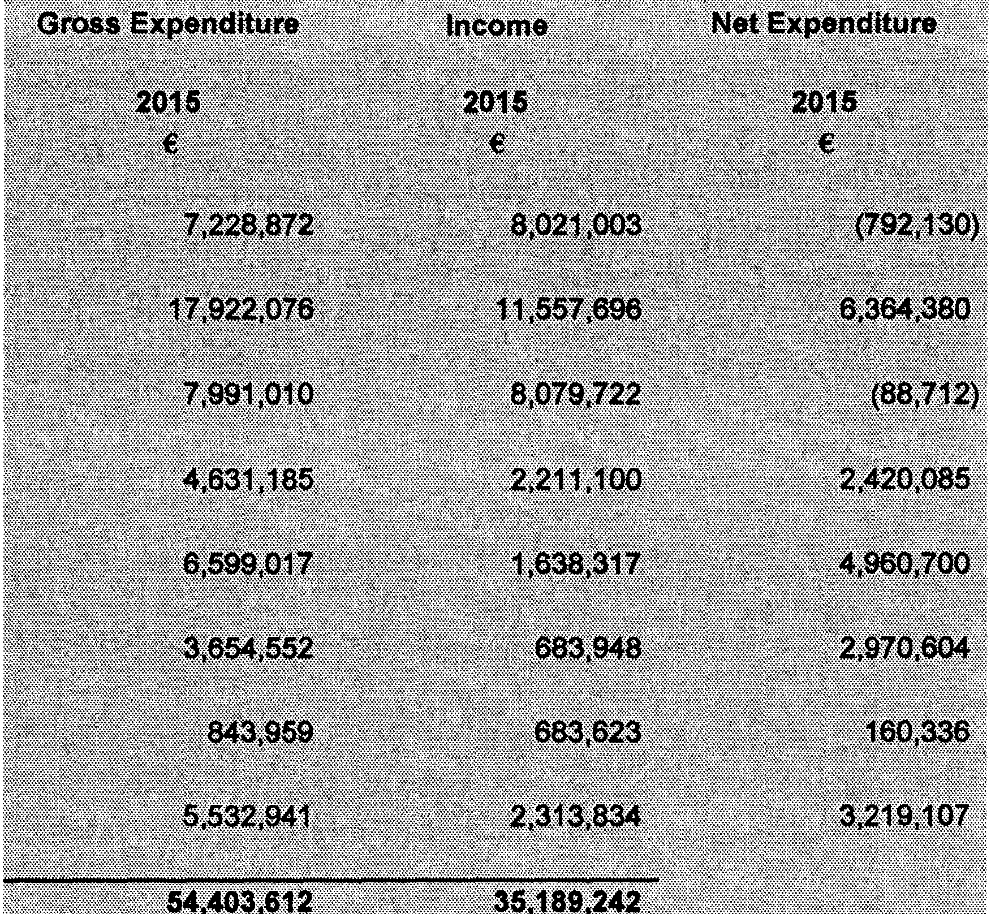
STATEMENT OF COMPREHENSIVE INCOME (INCOME & EXPENDITURE ACCOUNT STATEMENT) FOR YEAR ENDING 31st DECEMBER 2015

The Income and Expenditure Account Statement brings together all the revenue related income and expenditure.
It shows the surplus/(deficit) for the year. Transfers to/from reserves are shown separately and not allocated by service division. Note 16 allocates transfers by service division in the same format as Table A of the adopted Local Authority budget.
Expenditure by Division | Net Expenditure
 | 2014
Notes | €
Housing & Building | (1,007,330)
Roads Transportation & Safety | 6,060,730
Water Services | 163,173
Development Management | 2,230,531
Environmental Services | 5,444,657
Recreation & Amenity | 2,957,311
Agriculture, Education, Health & Welfare | 303,028
Miscellaneous Services | 3,169,664
Total Expenditure/Income 15
Net cost of Divisions to be funded from | 19,321,763
Rates & Local Property Tax
Rates | 13,336,756
Local Property Tax | 8,458,415
Pension Related Deduction | 1,022,086
Surplus/(Deficit) for Year before Transfers 16 | 3,495,493
Transfers from/(to) Reserves 14 | (3,495,365)
Overall Surplus/(Deficit) for Year | 129
General Reserve @ 1st January 2015 | 1,742,628
General Reserve @ 31st December 2015 | 1,742,757

STATEMENT OF FINANCIAL POSITION (BALANCE SHEET) AT 31st DECEMBER 2015

 | Notes | 2014  €
Fixed Assets
Operational |  | 265,831,071
Infrastructural |  | 1,217,777,627
Community |  | 540,792
Non-Operational |  | 32 098 725
 |  | 1 516 248 215
Work in Progress and Preliminary Expenses | 2 | 6,924,980
Long Term Debtors | 3 | 17,017,670
Current Assets
Stocks | 4 | 185,750
Trade Debtors & Prepayments | 5 | 15,030,760
Bank Investments |  | 13,477,118
Cash at Bank |  | 1,183,622
Cash in Transit |  | 151 070
 |  | 30 028 320
Current Liabilities (Amounts falling due within one year)
Bank Overdraft Creditors & Accruals | 6 | 16,266,802
Finance Leases
 |  | 16 266 802

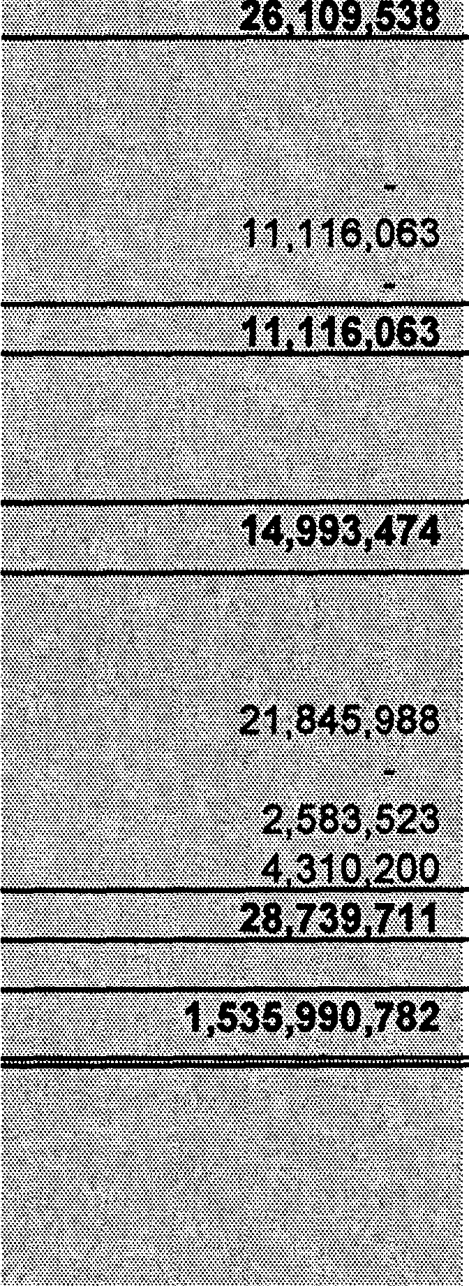Net Current Assets / (Liabilities)
13,761,518
1,528,137,342

Creditors (Amounts falling due after more than one year)  Loans Payable | 7 | 18,592,834
Finance Leases Refundable deposits | 8 | 2,790,433
Other |  | 4 431 773
 |  | 25 815 041
Net Assets

Represented by  Capitalisation Account | 9 | 1,516,248,213
lncome WIP | 2 | 6,874,724
Specific Revenue Reserve |  | 1,108,139
General Revenue Reserve |  | 1,742,757
Other Balances | 10 | 2,163,509

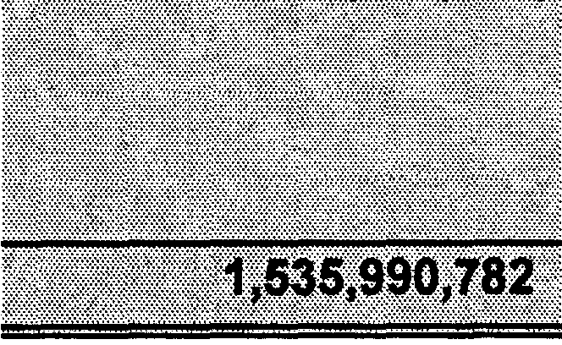Total Reserves
1,528,137,342

STATEMENT OF FUNDS FLOW (FUNDS FLOW STATEMENT) AS AT 31ST DECEMBER 2015

 | Note | 2015  € | 2015  €
REVENUE ACTIVITIES
Net lnflow/(outflow) from operating activities | 17 |  | 5,103,308
CAPITAL ACTIVITIES
Returns on Investment & Servicing of Finance
lncrease/(Decrease) in Fixed Asset Capitalisation Funding |  | 11,907,851
lncrease/(Decrease) in WIP/Preliminary Funding |  | (1,272,775)
lncrease/(Decrease) in Reserves Balances | 18 | 514,425
Net lnflow/(Outflow) from Returns on Investment and Servicing of Finance |  |  | 11,149,502
Capital Expenditure & Financial Investment
(lncrease)/Decrease in Fixed Assets |  | (11,907,851)
(lncrease)/Decrease in WIP/Preliminary Funding |  | 1,414,160
(lncrease)/Decrease in Agent Works Recoupable
(lncrease)/Decrease in Other Capital Balances | 19 | (117,815)
Net lnflow/(Outflow) from Capital Expenditure and Financial Investment |  |  | (10,611,507)
Financing
lncrease/(Decrease) in Loan Financing | 20 | 4,079,118
(lncrease)/Decrease in Reserve Financing | 21 | (3,178,354)
Net lnflow/(Outflow) from Financing Activities |  |  | 900,764
Third Party Holdings
lncrease/(Decrease) in Refundable Deposits |  |  | (206,910)
Net lncrease/(Decrease) in Cash and Cash Equivalents | 22 |  | 6,335,157

NOTES TO AND FORMING PART OF THE ACCOUNTS

- Fixed Assets

Costs

Plant & Computers, Water &
Land Parks Housing Buildings Machinery Furniture & Heritage Roads & Sewerage Total
(Long & Short Equipment Infrastructure Network Lifel
€ € € € € € € € € €

Accumulated Costs @ 1/1/2015 50,723,837 |  | 836,642 | 193,143,134 | 59,709,795 | 9,659,503 | 2,024,380 | 203,792 | 1,223,501,168 |  | 1,539,802,251
Additions  - Purchased 60,594 |  | 181,399 | 2,739,023 | 8,077,997 | 139,489 |  |  | 167,754 |  | 11,366,256
- Transfers WIP |  |  |  | 1,011,333 |  |  |  |  |  | 1,011,333
Disposals\Statutory Transfers |  |  | (172,321) |  |  |  |  |  |  | (172,321)
Revaluations  Historical Cost Adjustments |  |  |  | (17,045) |  |  |  |  |  | (17,045)
Accumulated Costs @ 31/12/2015 50,784,431 |  | 1,018,041 | 195,709,836 | 68,782,079 | 9,798,992 | 2,024,380 | 203,792 | 1,223,668,922 |  | 1,551,990.473
_ru-eciatLoJ1  Depreciation @ 1/1/2015 | 12,876,356 | 513,035 |  |  | 8,293,577 | 1,871,068 |  |  |  | 23,554,037
Provision for Year |  | 50,047 |  |  | 176,517 | 53,807 |  |  |  | 280,371
Disposals\Statutory Transfers
Accumulated Depreciation @ 31/12/2015 | 12,876,356 | 563,082 |  | _- _ _ _ _ | M70,!!_94 | 1,924,875 |  | --- -- - |  | 23,834,407
Net Book Value @ 31/12/2015 | 37,908,075 | 454,959 | 195,709,836 | 68,782,079 | 1,328,898 | 99,505 | 203,792 | 1,223,668,922 |  | 1,528,156,066

Net Book Value @ 31/12/2014 37,847.480 _323 6Q7 _j93 143 134 59 709 795 1 365 926 153 312 203 792 1 223 501 168 1 51§,_ll_,215

Net Book Value bl£ Catego!:)l  Operational | 5,514,350 | 454,959 | 195,709,836 | 56,215,364 | 1,328,898 | 57,505 |  | 18,307,301 | 277,588,213
Infrastructural |  | (0) |  | 12,566,716 |  |  |  | 1,205,361,621 | 1,217,928,337
Community | 295,000 |  |  |  |  | 42,000 | 203,792 |  | 540,792
Non-Operational | 32,098,725 |  |  |  |  |  |  |  | 32,098,725
Net Book Value @ 31/12/2015 | 37,908,075 | 454,959 | 195,709,836 | 68,782,079 | 1,328,898 | 99,505 | 203,792 | 1,223,668,922 | 1,528,156,066

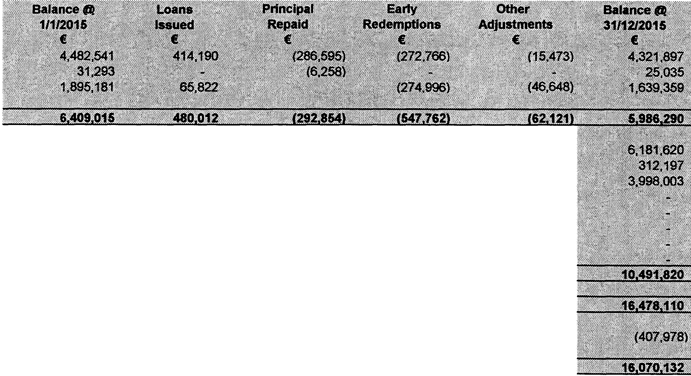

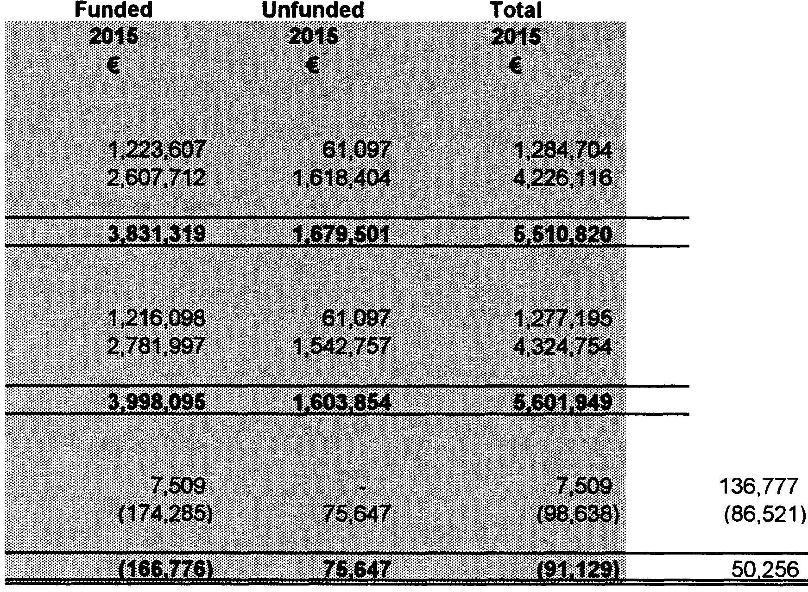
NOTES TO AND FORMING PART OF THE ACCOUNTS

2. Work in Progress and Preliminary Expenses  A summary of work in proqress and preliminary expenditure by asset cateqory is as follows: | Total
 | 2014
 | €
Expenditure
Work in Proqress | 1,800,320
Preliminary Expenses | 5,124,660
 | 6,924,_!)_80
Income
Work in Proqress | 1,663,543
Preliminary Expenses | 5,211,181
 | 6.eZ4.72_4
Net Expended
Work in Proqress
Preliminary Expenses
Net Over/(Under) Expenditure
3. Long Term Debtors
A breakdown of the lonq-term debtors is as follows:
 |  |  | Balance (li1
 |  |  | 31/12/2014
 |  |  | €
Lonq Term Mortqaqe Advances* |  |  | 4,482,541
Tenant Purchases Advances |  |  | 31,293
Shared Ownership Rented Equity |  |  | 1,895,181
 |  |  | 6.409,_Q15
Voluntary Housinq & Water Loans recoupable Capital Advance Leasinq Facility |  |  | 6,584,860
Development Levy Debtors |  |  | 4,431,773
Inter Local Authority Loans
Lonq-term Investments Cash
Interest in associated companies Other
 | 'IJ.Q16,633
 | 17,425,648
Less: Amounts fallinq due within one year (Note 5) | (407,978)
Total Amounts fallinq due after more than one vear | 17,917,670
* Includes HFA AQencv Loans

NOTES TO AND FORMING PART OF THE ACCOUNTS

Stocks

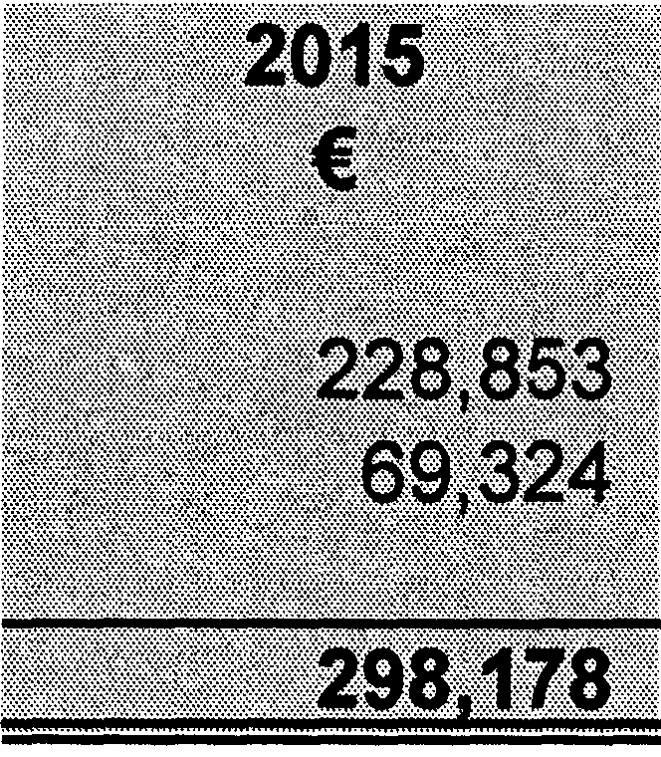A summary of stock is as follows:
2014
€
101,166
84,584
185 750

Central Stores Other Depots

Total

Trade Debtors & Prepayments

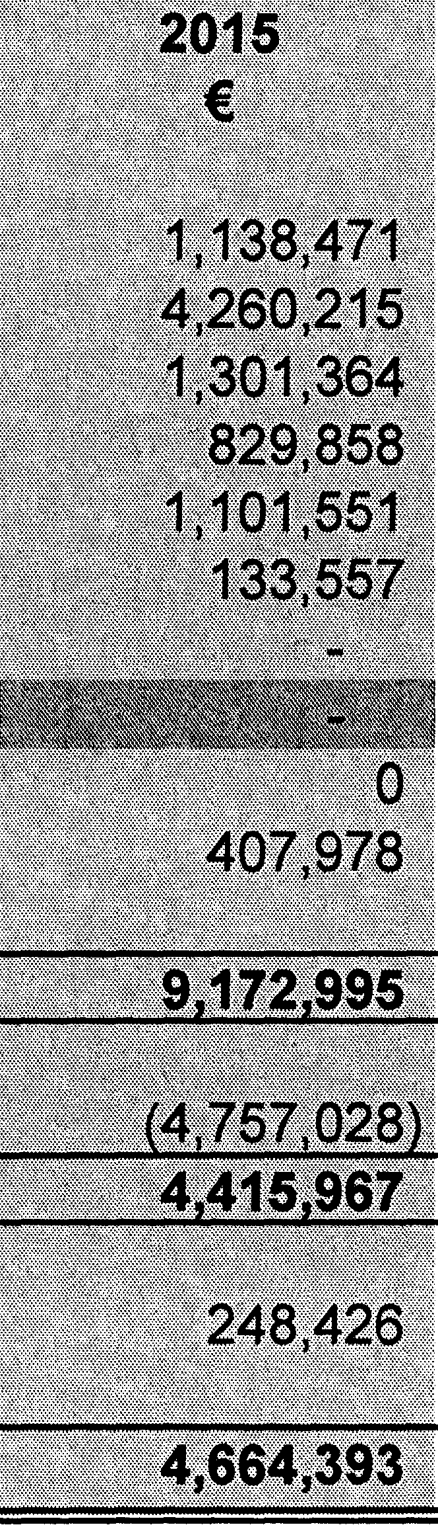A breakdown of debtors and prepayments is as follows:
2014
€
7,723,340
4,808,363
1,343,124
547,616
7,112,457
98,223
0
407,978
22,041,101
7,225,623
14,815,478
215,282
15,030,760

Government Debtors Commercial Debtors
Non-Commercial Debtors Development Levy Debtors Other Services
Other Local Authorities Agent Works Recoupable Revenue Commissioners Other
Add: Amounts falling due within one year (Note 3)

Total Gross Debtors

Less: Provision for Doubtful Debts

Total Trade Debtors

Prepayments

Page 17

NOTES TO AND FORMING PART OF THE ACCOUNTS

6. Creditors and Accruals

A breakdown of creditors and accruals is as follows:
2014
€
Trade creditors | 1,728,282
Grants | 28,609
Revenue Commissioners | 1,000,017
Other Local Authorities | 410,791
Other Creditors | 121 208
 | 3 288 907
Accruals | 1,977,948
Deferred Income | 2,986,077
Add: Amounts falling due within one year (Note 7) | 8,013,869
 | 16,266,802

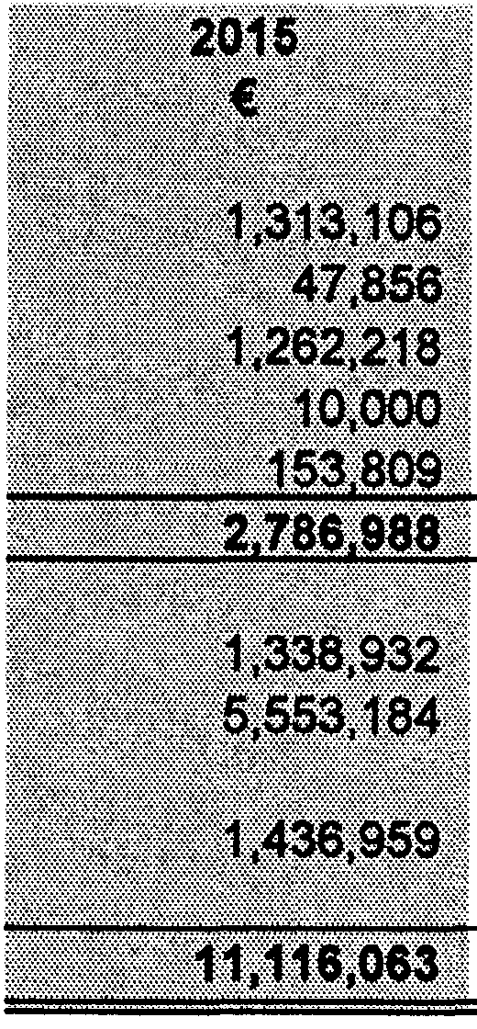
7. Loans Payable
- 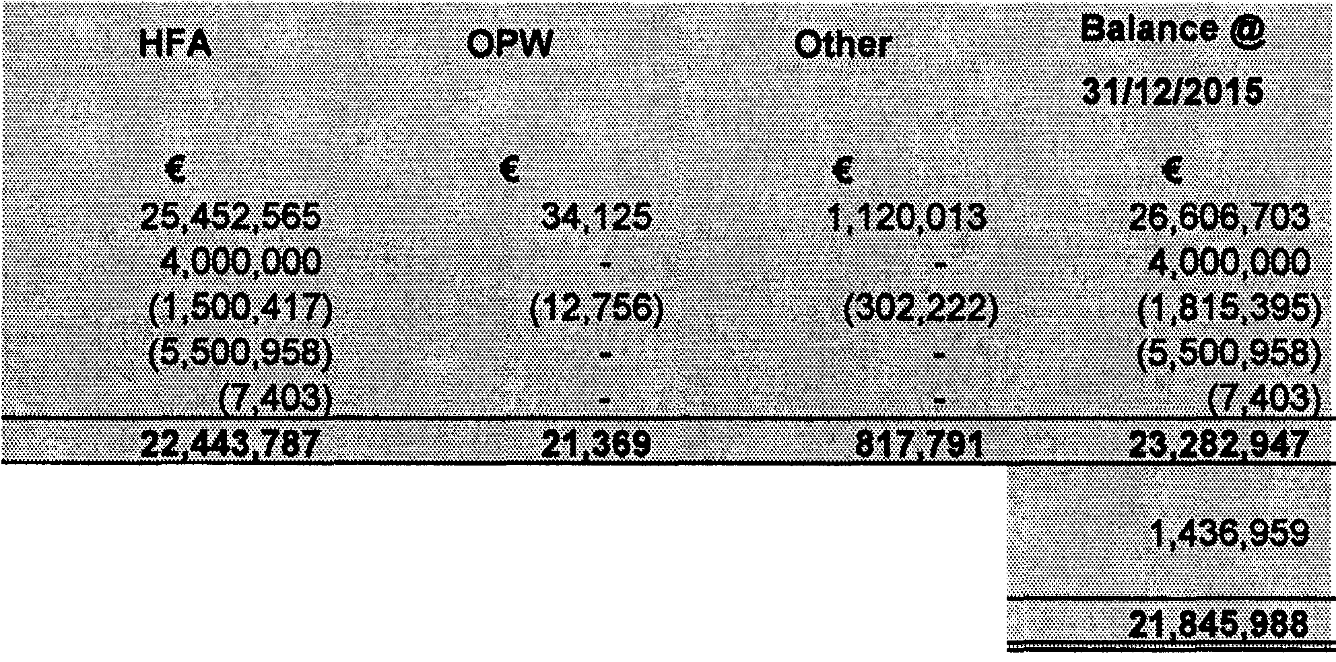Movement In Loans Payable
Balance @
31/12/2014

€ 27,996,330
500,000
(1,889,627)
26 606 703

8,013,869

18 592 834

Balance @ 1/1/2015
Borrowings
Repayment of Principal Early Redemptions Other Adjustments Balance @ 31/12/2015

Less: Amounts falling due within one year (Note 6)

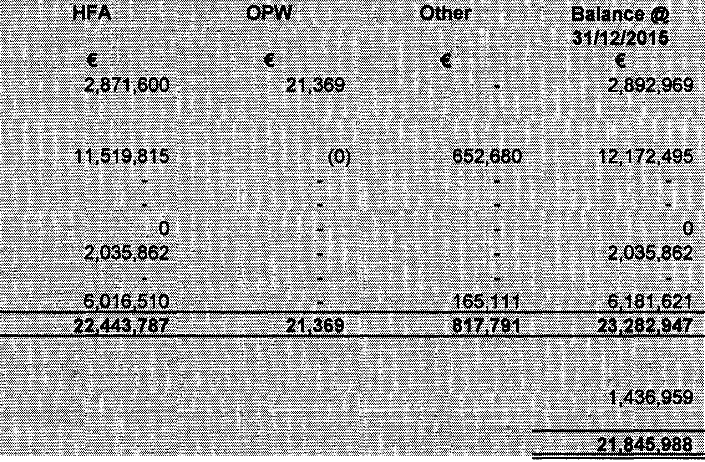
Total Amounts falling due after more than one year

(bl Application of Loans  An analysis of loans payable is as follows: | Balance @ 31/12/2014
 | €
Mortgage loans• | 3,141,317
Non-Mo_ng_age loans
Asset/Grants Revenue Funding | 8,966,079
Bridging Finance
Recoupable | 5,813,869
Shared Ownership - Rented Equity | 2,100,578
Inter-Local Authority
Voluntary Housing & Water Loans recoupable | 6 584 860
 | 26 606 703
Less: Amounts falling due within one year (Note 6) | 8,013,869
Total Amounts falling due after more than one year | 18 592 834
- Includes HFA Agency Loans

Page 18

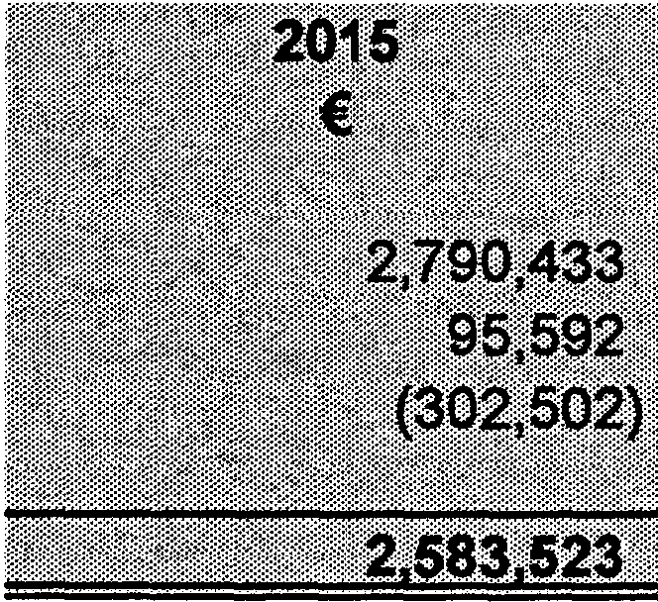
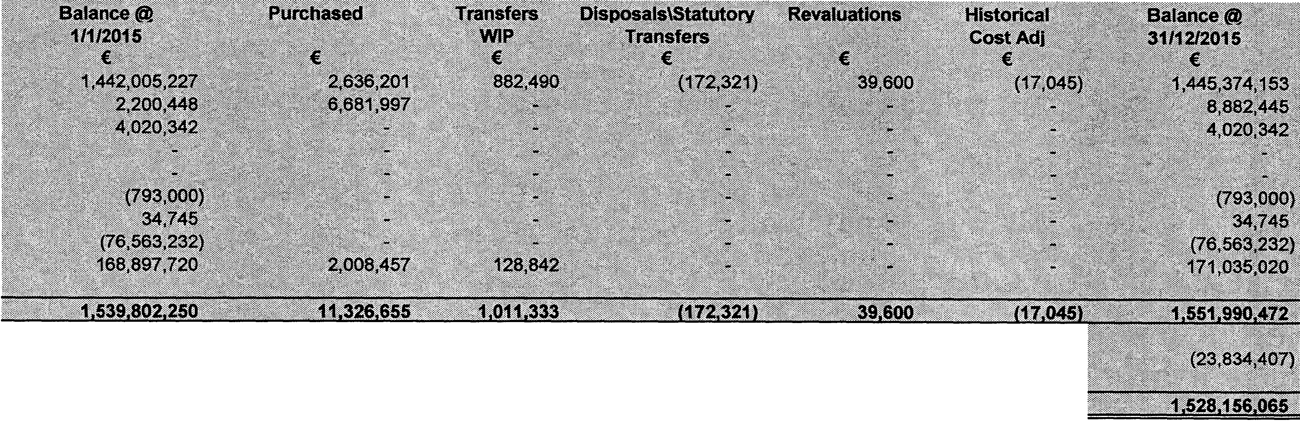

8. Refundable Deposits | NOTES TO AND FORMING PART OF THE ACCOUNTS
The movement in refundable deposits is as follows:
 | 2014
 | €
Opening Balance at 1 January | 2,976,729
Deposits received | 36,462
Deposits repaid | (222,758)
Closing Balance at 31 December | 2,790,433
Note: Short Term Refundable Deposits are included as part of Cash Investments on the Balance sheet
9. Capitalisation Account
The capitalisation account shows the funding of the assets as follows:
 |  | Balance @
 |  | 31/12/2014
Grants |  | €  1,442,005,227
Loans |  | 2,200,448
Revenue funded |  | 4,020,342
Leases
Development Levies
Tenant Purchase Annuities |  | (793,000)
Unfunded |  | 34,745
Historical |  | (76,563,232)
Other |  | 168,897,720
Total Gross Funding |  | 1,539,802,250
Less: Amortised |  | (23,554,037)
Total * |  | 1,516,248,213
* Must agree with note 1

NOTES TO AND FORMING PART OF THE ACCOUNTS

- Other Balances

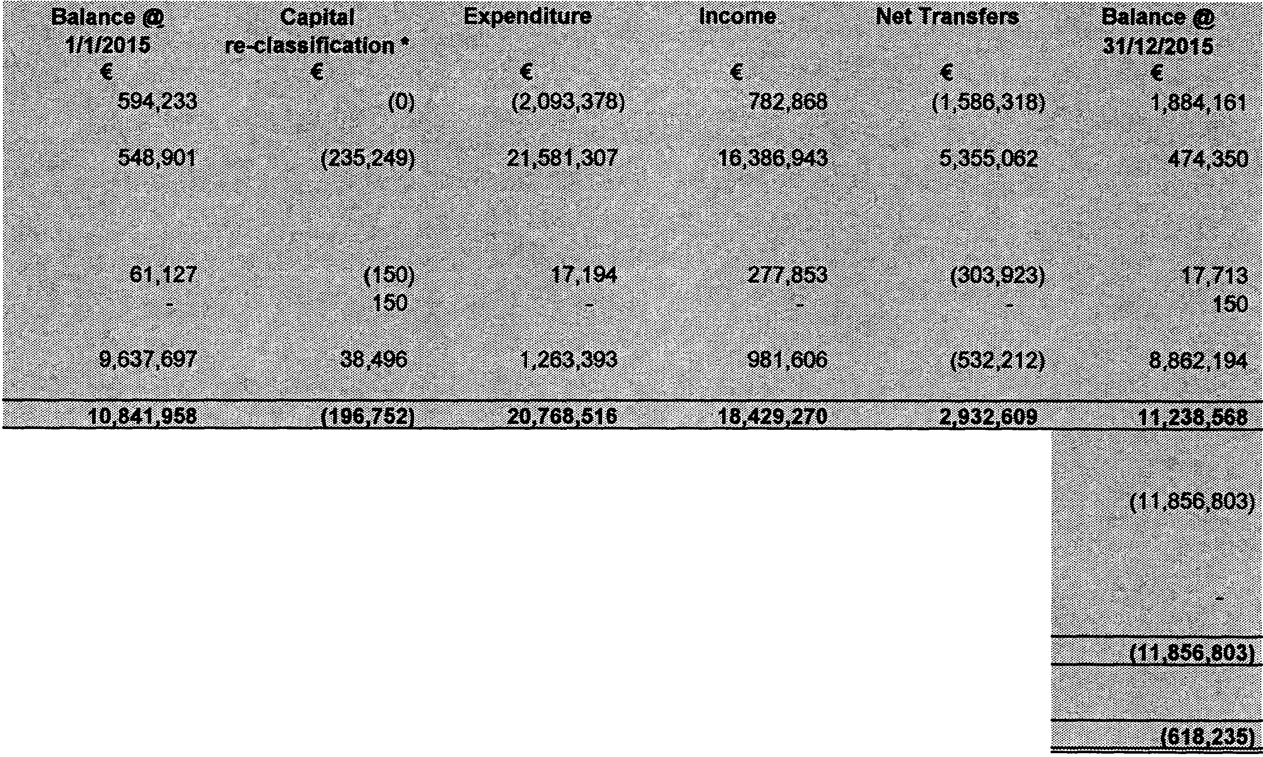A breakdown of other balances is as follows:
Balance @
31/12/2014
€
594,233

548,901
61,127
9,637,697

10,841,958
(8,678,449)
8,678,449
2,163,509

Development Levies balances

Capital account balances including asset formation and enhancement

(al (b)

Voluntary & Affordable Housing Balances
- Voluntary Housing
- Affordable Housing

Reserves created for specific purposes

(cl

(dl

- Net Capital Balances

Balance Sheet accounts relating the loan principal outstanding (including Unrealised TP Annuities)
(e)

Interest in Associated Companies (fl

- Non Capital Balances

Total Other Balances
*() Denotes Debit Balances

(al This represents the cumulative balance of development levies i.e. income less expenditure and transfers to date.
- This represents the cumulative position on funded and unfunded capital jobs consisting of project (completed assets) and non-project (enhancment of assets) balances. Debit balances will require sources of funding to clear.
(cl This represents the cumulative position on voluntary and affordable housing projects.
- Relates to reserves and advance funding for future Local Authority assets, insurance liabilities, other purposes and includes realised tenant purchase annuities.
- Loan related balances including outstanding principal on leases and non-mortgage loans remaining to be funded, historical mortgage funding gap, unrealised principal on tenant purchase annuities to be repaid in the future and shared ownership rented equity.
(fl Represents the local authority's interest in associated companies.

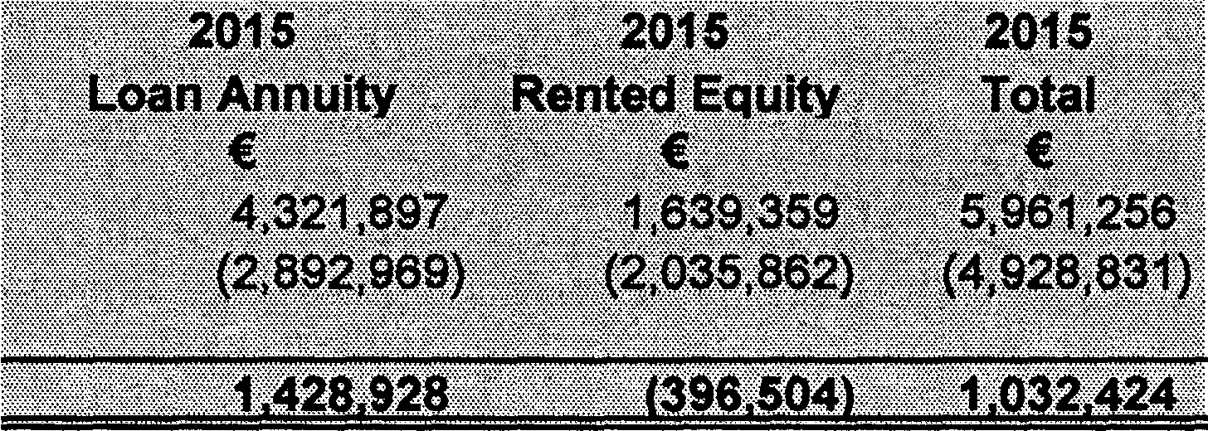
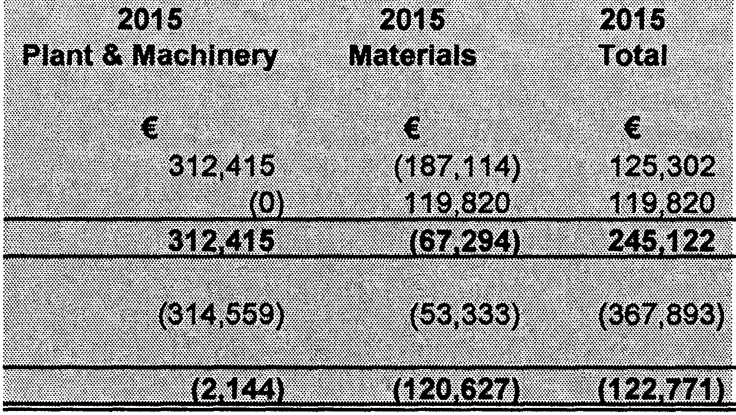
NOTES TO AND FORMING PART OF THE ACCOUNTS

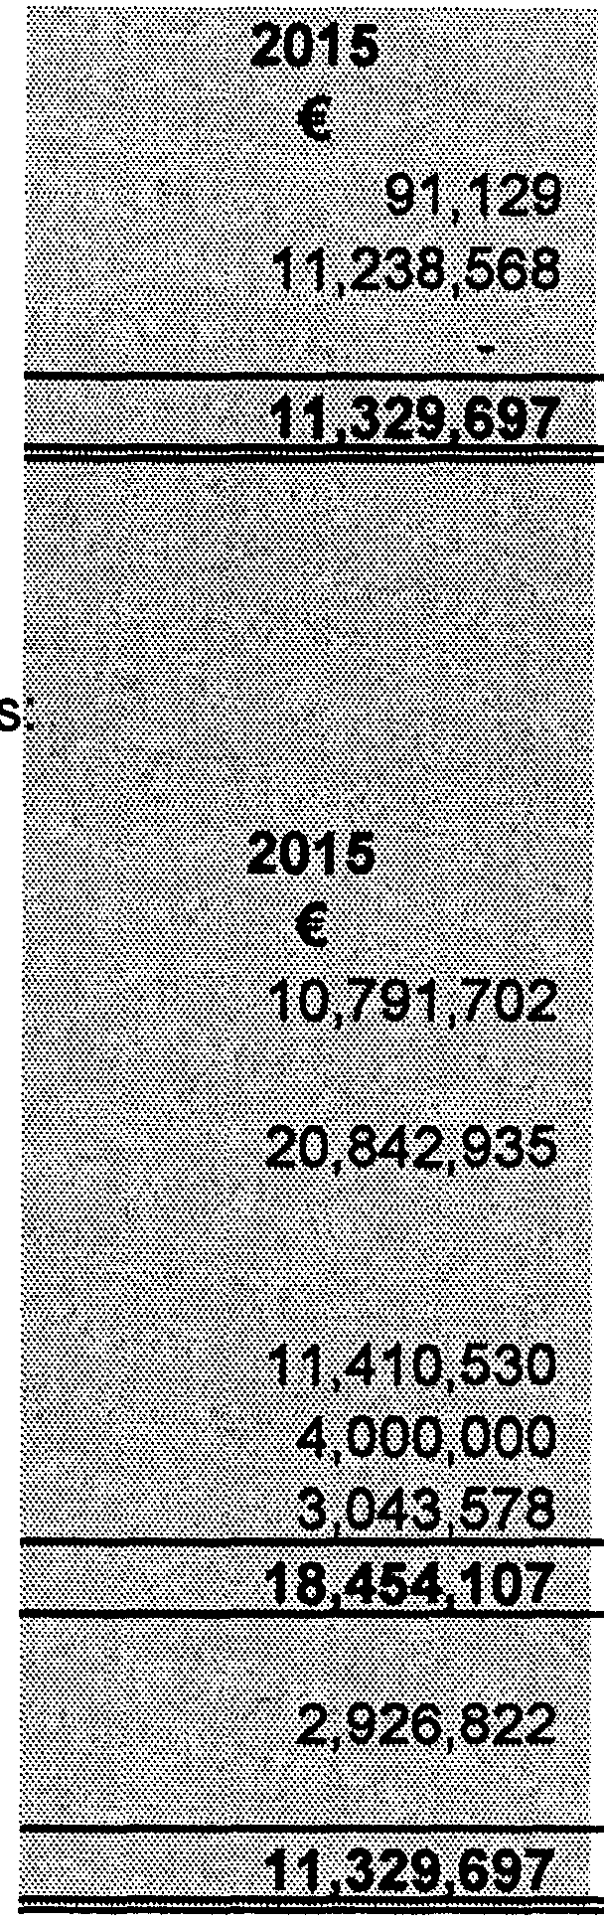
- Capital Account Analysis

The capital account has been de-aggregated and is comprised of the following accounts in the balance sheet:
 | 2014
 | €
Net WIP & Preliminary Expenses (Note 2) | (50,256)
Net Capital Balances (Note 10) | 10,841,959
Agent Works Recoupable (Note 5)
Capital Balance Surplus/(Deficit) @ 31 December | 10 791 703
A summary of the changes in the Capital account (see Appendix 6) is as follow
 | 2014
 | €
Opening Balance @ 1 January | 8,712,798
Expenditure | 17,571,407
Income
- Grants | 9,783,661
- Loans | 505,142
- Other | 6 658 964
Total Income | 16 947 767
Net Revenue Transfers | 2,702,545
Closing Balance @ 31 December | 10 791 702
12. Mortgage Loan Funding Surplus/(Deficit)
The mortgage loan funding position on the balance sheet is as follows:
 |  |  | 2014
 |  |  | Total
 |  |  | €
Mortgage Loans/Equity Receivable (LT Mortgage Shared Own Note 3) |  |  | 6,377,722
Mortgage Loans/Equity Payable (Mort Loans Shared Own Note 7) |  |  | (5,241,895)
Surplus/(Deficit) in Funding @ 31st December |  |  | 1 135 827
NOTE: Cash on Hand relating to Redemptions and Relending
13. Summary of Plant & Materials Account
A summary of the operations of the Plant & Machinery account is as follows:
2014
Total
 |  |  | €
Expenditure |  |  | (154,978)
Charged to Jobs |  |  | 276 412
 |  |  | 121 434
Transfers from/(to) Reserves |  |  | (173,937)
Surplus/(Deficit) for the Year |  |  | 52 503

Page 21

NOTES TO AND FORMING PART OF THE ACCOUNTS

Transfers from/(to) Reserves

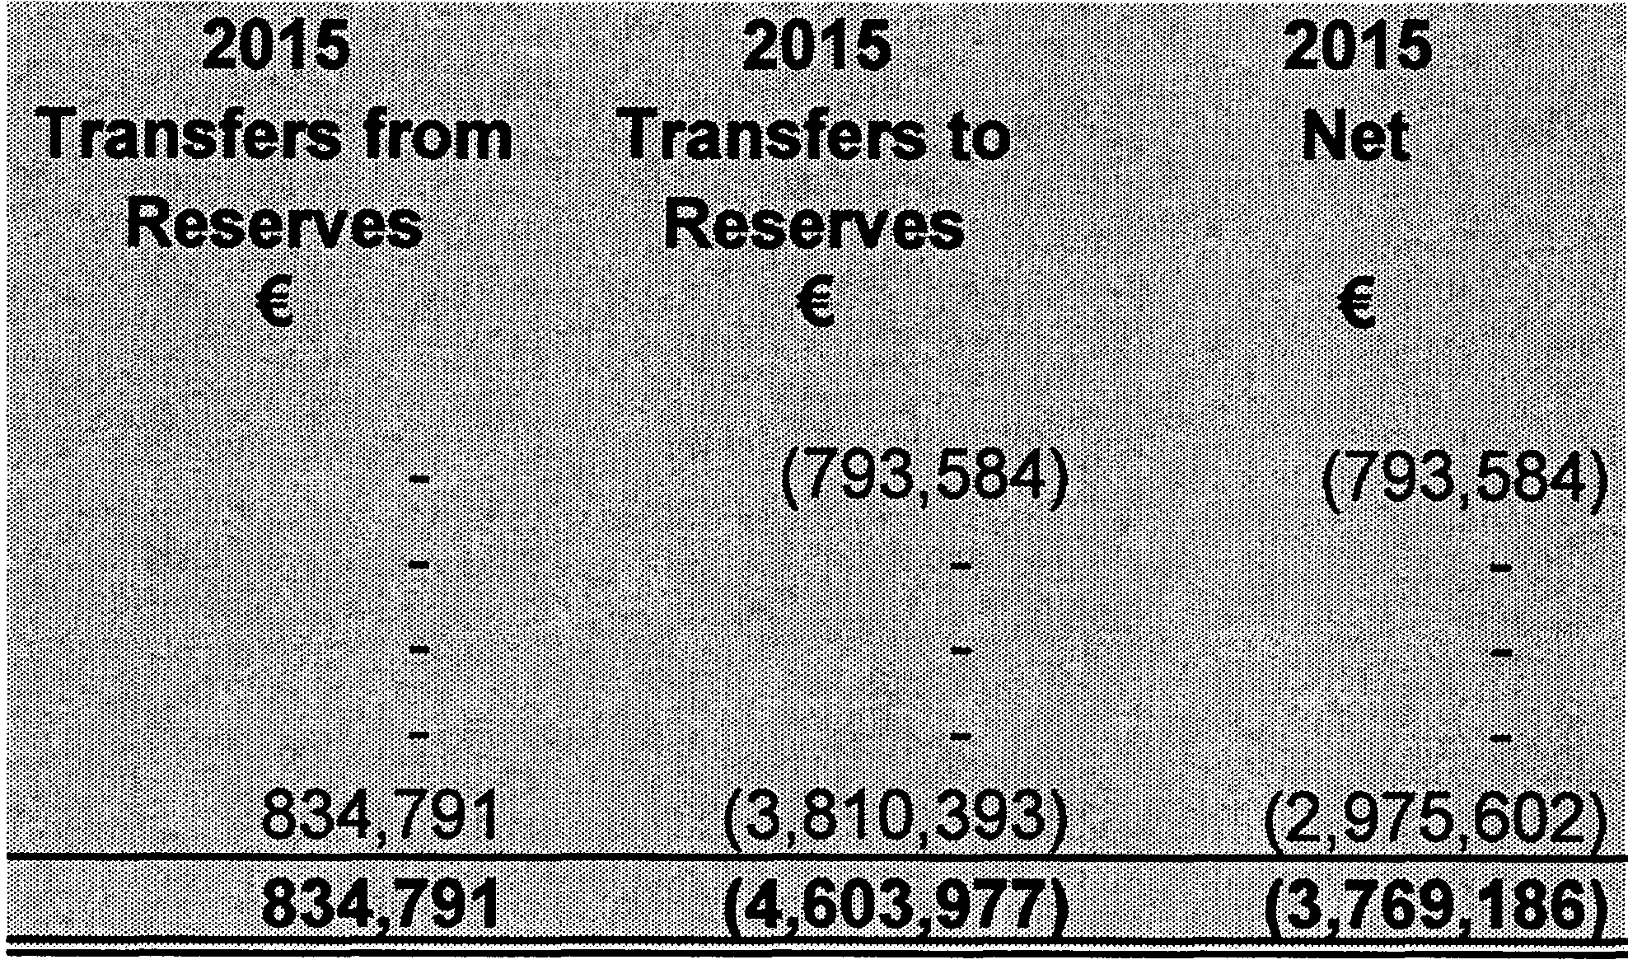A summary of transfers to/from Reserves is as follows:
2014
€
(764,339)
2,731,026
3,495,365

Loan Repayment Reserve Lease Repayment Reserve
Historical Mortgage Funding Write-off Development Levies
Other
Surplus/(Deficit) for Year

- Analysis of Revenue Income

A summary of the major sources of revenue income is as follows:

Grants & Subsidies
Appendix No
2014
3
€
21,615,073
337,994
%
34%
1%
4 18,164,684 29%
Contributions from other local authorities Goods & Services
 |  |  | 40,117,751 | 64%
Local Property Tax |  |  | 8,458,415 | 13%
Pension Related Deduction |  |  | 1,022,086 | 2%
Rates |  |  | 13,336,756 | 21%
Total Income |  |  | 62,935,008 | 100%

Page 22

NOTES TO AND FORMING PART OF THE ACCOUNTS

- Over/Under Expenditure

The following table shows the difference between the adopted estimates and the actual outtum in respect of both expenditure and income:
 | EXPENDITURE
 | Excluding  Transfers  2015  € | Transfers  2015  € | Including  Transfers  2015  € | Budget  2015  € | (Over)/Under Budget  2015  €
Housing & Building  Roads Transportation & Safety Water Services  Development Management Environmental Services Recreation & Amenity  Agriculture, Education, Health & Welfare  Miscellaneous Services | 7,228,872  17,922,076  7,991,010  4,631,185  6,599,017  3,654,552  843,959  5 532 941 | 354,671  332,024  90,877  83,536  632,794  383,808  89,204  2 637 063 | 7,583,543  18,254,099  8,081,888  4,714,721  7,231,811  4,038,360  933,163  8 170 004 | 6,965,804  17,479,994  8,291,165  3,780,517  7,144,599  4,003,291  909,624  5 790 761 | (617,739)  (774,106)  209,277  (934,204)  (87,212)  (35,069)  (23,538)  12 379 2431
Total Divisions | 54 403 612 | 4 603 977 | 59 007 589 | 54 365 753 | 14 641 835)
Local Property Tax Pension Related Deduction Rates  Dr/Cr Balance |  | -
Deficitl/Sunolus for Year | 54403 612 | 4603 977 | 59 007 589 | 54 365 753 | 14 641 8351

INCOME
Excluding Transfers  2015  € | Transfers  2015  € | Including Transfers  2015  € | Budget  2015  € | Over/(Under) Budget  2015  €
8,021,003 | 400,000 | 8,421,003 | 7,746,145 | 674,857
11,557,696 | 422,437 | 11,980,133 | 11,509,650 | 470,483
8,079,722 |  | 8,079,722 | 8,081,309 | (1,587)
2,211,100 | 11,325 | 2,222,425 | 1,274,050 | 948,375
1,638,317 |  | 1,638,317 | 1,000,692 | 637,625
683,948 | 1,029 | 684,977 | 602,944 | 82,033
683,623 |  | 683,623 | 585,265 | 98,358
2 313 834 |  | 2 313 834 | 748 476 | 1 565 358
35 189 242 | 834 791 | 36 024033 | 31 548 531 | 4 475 502
8,458,415 |  | 8,458,415 | 8,458,415 | (0)
988,545 |  | 988,545 | 1,048,560 | (60,015)
13,536,702 |  | 13,536,702 | 13,310,247 | 226,455
58 172 905 | 834 791 | 59 007 696 | 54 365 753 | 4 641 943

NET
(Over)/Under Budget
2015
€
57,118
(303,623)
207,690
14,170
550,413
46,964
74,819
(813 885)
(166,333)
(0)
(60,015)
226,455
108

Page 23

NOTES TO AND FORMING PART OF THE ACCOUNTS | 201 5
 | €
17. Net Cash lnflow/(Outflow) from Operating Activities
Operating Surplus/(Deficit) for Year | 107
(lncrease)/Decrease in Stocks | (112,428)
(lncrease)/Decrease in Trade Debtors | 10,366,368
Non operating activity in Trade Debtors (Agent Works)
lncrease/(Decrease) in Creditors Less than One Year | (5,150,739)
 | 5 103 308

18. lncrease/(Decrease) in Reserve Balances  lncrease/(Decrease) in Development Levies balances | 1,289,928
lncrease/(Decrease) in Reserves created for specific purposes | (775,503)
 | 514 425
19. (lncrease)/Decrease in Other Capital Balances
(lncrease)/Decrease in Capital account balances including asset formation and enhancement | (74,551)
(lncrease)/Decrease in Voluntary Housing Balances | (43,414)
(lncrease)/Decrease in Affordable Housing Balances | 150
 | (117,815)
20. lncrease/(Decrease) in Loan Financing
(lncrease)/Decrease in Long Term Debtors | 947,538
lncrease/(Decrease) in Mortgage Loans | (248,348)
lncrease/(Decrease) in Asset/Grant Loans | 3,206,416
lncrease/(Decrease) in Revenue Funding Loans
lncrease/(Decrease) in Bridging Finance Loans lncrease/(Decrease) in Recoupable Loans | (5,813,869)
lncrease/(Decrease) in Shared Ownership Rented Equity Loans | (64,716)
lncrease/(Decrease) in Inter-Local Authority Loans
lncrease/(Decrease) in Voluntary Housing Loans | (403,239)
lncrease/(Decrease) in Finance Leasing  (lncrease)/Decrease in Portion Transferred to Current Liabilities | 6,576,910
lncrease/(Decrease) in Long Term Creditors - Deferred Income | (121,573)
 | 4 079 118

NOTES TO AND FORMING PART OF THE ACCOUNTS

21. (lncrease)/Decrease in Reserve Financing
(lncrease)/Decrease in Specific Revenue Reserve
(lncrease)/Decrease in Balance Sheet accounts relating the loan principal outstanding (including Unrealised TP Annuities) (lncrease)/Decrease in Reserves in Associated Companies
2015
€

(3,178,354)

(3,178,354)

22. Analysis of Changes in Cash & Cash Equivalents
lncrease/(Decrease) in Bank Investments | 4,037,297
lncrease/(Decrease) in Cash at Bank/Overdraft | 2,258,799
lncrease/(Decrease) in Cash in Transit | 39 062
 | 6 335 157

APPENDICES

Page 26

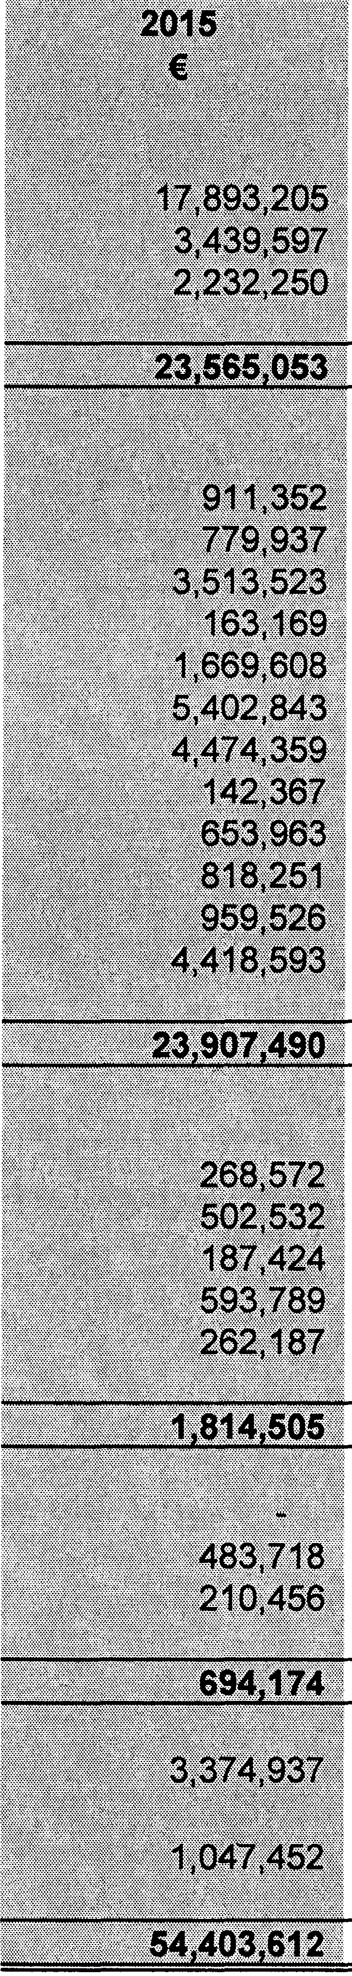
APPENDIX 1
ANALYSIS OF EXPENDITURE
FOR YEAR ENDED 31st DECEMBER 2015
 | 2014
 | €
Payroll Expenses
Salary & Wages | 17,797,211
Pensions (incl Gratuities) | 4,733,803
Other costs | 2,091.415
Total | 24 622,429
Operational Expenses
Purchase of Equipment | 845,057
Repairs & Maintenance | 879,051
Contract Payments | 2,748,110
Agency services | 421,599
Machinery Yard Charges incl Plant Hire | 2,018,708
Purchase of Materials & Issues from Stores | 6,767,774
Payment of Grants | 5,260,085
Members Costs | 166,365
Travelling & Subsistence Allowances | 691,959
Consultancy & Professional Fees Payments | 1,008,109
Energy I Utilities Costs | 897,691
Other | 4,106,619
Total | 25 811,127
Administration Expenses
Communication Expenses | 289,975
Training | 410,318
Printing & Stationery | 238,477
Contributions to other Bodies | 610,076
Other | 276,667
Total | 1 825,512
Establishment Expenses
Rent & Rates | 668,143
Other | 247,579
Total | 915 722
Financial Expenses | 2,974,687
Miscellaneous Expenses | 3,290,036
Total Expenditure | 59 439,514

Page 27

APPENDIX 2 SERVICE DIVISION A
HOUSING and BUILDING

 |  | EXPENDITURE | INCOME
DIVISION |  | TOTAL  € | State Grants & Subsidies  € | Provision of Goods and Services  € | Contributions from other local authorities  € | TOTAL  €
A01 | Maintenance/Improvement of LA Housing | 2,222,123 | 73,058 | 516,684 |  | 589,742
A02 | Housing Assessment, Allocation and Transfer | 353,826 |  | 7,018 |  | 7,018
A03 | Housing Rent and Tenant Purchase Administration | 346,506 |  | 3,894,276 |  | 3,894,276
A04 | Housing Community Development Support | 126,375 |  | 2,365 |  | 2,365
ADS | Administration of Homeless Service | 112,237 | 2,000 | 2,274 | 42,943 | 47,217
A06 | Support to Housing Capital & Affordable Prag. | 359,272 | 144,209 | 8,890 |  | 153,099
A07 | RAS Programme | 3,505,638 | 2,558,503 | 946,901 |  | 3,505,404
AOB | Housing Loans | 412,947 | 72,035 | 146,152 |  | 218,187
A09 | Housing Grants | 141,473 |  | 3,455 |  | 3,455
A11 | Agency & Recoupable Services | 3,147 |  | 240 |  | 240
A12 | HAP Programme
SERVICE DIVISION TOTAL INCLUDING TRANSFERS TO/FROM RESERVES |  | 7,583,543 | 2,849,805 | 5,528,255 | 42,943 | 8,421,003
Less Transfers to/from Reserves |  | 354,671 |  | 400,000 |  | 400,000
SERVICE DIVISION TOTAL EXCLUDING TRANSFERS TO/FROM RESERVES |  | 7,228,872 |  | 5,128,255 |  | 8,021,003

SERVICE DIVISION B
ROAD TRANSPORTATION and SAFETY

 |  | EXPENDITURE | INCOME
DIVISION |  | TOTAL  € | State Grants & Subsidies  € | Provision of Goods and Services  € | Contributions from other local authorities  € | TOTAL  €
801 | NP Road • Maintenance and Improvement | 1,365,307 | 829,181 | 5,815 |  | 834,996
B02 | NS Road - Maintenance and Improvement | 486,942 | 321,438 | 3,266 |  | 324,704
803 | Regional Road - Maintenance and Improvement | 3,387,008 | 8,924,115 | 158,833 |  | 9,082,948
B04 | Local Road - Maintenance and Improvement | 10,049,764 | 413,645 | 403,909 |  | 817,554
BOS | Public Lighting | 602,300 |  | 11,551 |  | 11,551
BOB | Traffic Management Improvement | 300,996 |  | 6,262 |  | 6,262
607 | Road Safety Engineering Improvement | 364,548 | 32,193 | 1,494 |  | 33,687
808 | Road Safety Promotion/Education | 17,037 |  | 1,111 |  | 1,111
809 | Maintenance & Management of Car Parking | 675,602 |  | 624,427 |  | 624,427
610 | Support to Roads Capital Prog. | 268,075 |  | 23,293 |  | 23,293
611 | Agency & Recoupable Services | 736,521 | 20,481 | 185,480 | 13,639 | 219,600
SERVICE DIVISION TOTAL INCLUDING TRANSFERS TO/FROM RESERVES |  | 18,254,099 | 10,541,053 | 1,425,440 | 13,639 | 11,980,133
Less Transfers to/from Reserves |  | 332,024 |  | 422,437 |  | 422,437
SERVICE DIVISION TOTAL EXCLUDING TRANSFERS TO/FROM RESERVES |  | 17,922,076 |  | 1,003,003 |  | 11,557,696

APPENDIX 2 SERVICE DIVISION C WATER SERVICES

 |  | EXPENDITURE | INCOME
DIVISION |  | TOTAL  € | State Grants & Subsidies  € | Provision of Goods and Services  € | Contributions from other local authorities  € | TOTAL  €
C01 | Operation and Maintenance of Water Supply | 2,244,619 | 52,867 | 2,251,336 | 300 | 2,304,503
CO2 | Operation and Maintenance of Waste Water Treatme | 1,678,499 | 13,337 | 1,684,874 |  | 1,698,211
C03 | Collection of Water and Waste Water Charges | 240,743 |  | 241,585 |  | 241,585
C04 | Operation and Maintenance of Public Conveniences | 32,967 |  | 474 |  | 474
cos | Admin of Group and Private Installations | 3,555,862 | 3,498,372 | 6,106 |  | 3,504,478
C06 | Support to Water Capital Programme | 261,771 |  | 262,989 |  | 262,989
C07 | Agency & Recoupable Services | 67,427 |  | 67,483 |  | 67,483
COB | Local Authority Water and Sanitary Services
SERVICE DIVISION TOTAL INCLUDING  TRANSFERS TO/FROM RESERVES |  | 8,0B1,B88 | 3,564,576 | 4,514,845 | 300 | 8,079,722
Less Transfers to/from Reserves |  | 90,877
SERVICE DIVISION TOTAL EXCLUDING TRANSFERS TO/FROM RESERVES |  | 7,991,010 |  | 4,514,845 |  | 8,079,722

SERVICE DIVISION D DEVELOPMENT MANAGEMENT

 |  | EXPENDITURE | INCOME
DIVISION |  | TOTAL  € | State Grants & Subsidies  € | Provision of Goods and  Services  € | Contributions from other local authorities  € | TOTAL  €
D01 | Forward Planning | 207,715 |  | 6,977 |  | 6,977
D02 | Development Management | 791,993 | 1,0B5 | 2B8,206 |  | 289,291
D03 | Enforcement | B9,954 |  | 2,966 |  | 2,966
D04 | Op & Mice of Industrial Sites & Commercial Facilities | 345
DOS | Tourism Development and Promotion | 385,459 | 2,500 | 17,966 |  | 20,466
D06 | Community and Enterprise Function | 1,629,154 | 171,400 | 649,169 |  | 820,569
D07 | Unfinished Housing Estates | 119,359 |  | 2,326 |  | 2,326
DOB | Building Control | 51,209 |  | 845 |  | 845
D09 | Economic Development and Promotion | 1,053,387 | 730,102 | 131,953 |  | 862,055
D10 | Property Management | 22,701 | 250 | 22,014 |  | 22,264
D11 | Heritage and Conservation Services | 154,934 | 3B,OB4 | 2,669 |  | 40,753
D12 | Agency & Recoupable Services | 20B,510 |  | 153,912 |  | 153,912
SERVICE DIVISION TOTAL INCLUDING TRANSFERS TO/FROM RESERVES |  | 4,714,721 | 943,422 | 1,279,003 |  | 2,222,425
Less Transfers to/from Reserves |  | 83,536 |  | 11,325 |  | 11,325
SERVICE DIVISION TOTAL EXCLUDING TRANSFERS TO/FROM RESERVES |  | 4,631,185 |  | 1,267,678 |  | 2,211,100

APPENDIX 2 SERVICE DIVISION E
ENVIRONMENTAL SERVICES

 |  | EXPENDITURE | INCOME
DIVISION |  | TOTAL  € | State Grants & Subsidies  € | Provision of Goods and Services  € | Contributions from other local authorities  € | TOTAL  €
E01 | Operation, Maintenance and Aftercare of Landfill | 1,044.187 |  | 386,813 |  | 386,813
E02 | Op & Mice of Recovery & Recycling Facilities | 231,490 | 78,171 | 85,266 |  | 163,437
E03 | Op & Mtce of Waste to Energy Facilities
E04 | Provision of Waste to Collection Services | 3,048 |  | 59 |  | 59
EOS | Litter Management | 268,807 | 15,322 | 13,279 |  | 28,601
E06 | Street Cleaning | 305,658 |  | 6,453 |  | 6,453
E07 | Waste Regulations, Monitoring and Enforcement | 505,388 | 317,442 | 45,742 |  | 363,184
EOB | Waste Management Planning | 89,884 | 822 | 1,064 |  | 1,886
E09 | Maintenance and Upkeep of Burial Grounds | 15,789 |  | 379 |  | 379
E10 | Safety of Structures and Places | 309,827 | 102,507 | 9,180 |  | 111,688
E11 | Operation of Fire Service | 3,695,956 | 8,788 | 438,879 |  | 447,667
E12 | Fire Prevention | 256,950 |  | 6,771 |  | 6,771
E13 | Water Quality, Air and Noise Pollution | 503,686 | 61,827 | 59,552 |  | 121,380
E14 | Agency & Recoupable Services | 1,140
SERVICE DIVISION TOTAL INCLUDING TRANSFERS TO/FROM RESERVES |  | 7,231,811 | 584,880 | 1,053,437 |  | 1,638,317
Less Transfers to/from Reserves |  | 632,794
SERVICE DIVISION TOTAL EXCLUDING TRANSFERS TO/FROM RESERVES |  | 6,599,017 |  | 1,053,437 |  | 1,638,317

SERVICE DIVISION F RECREATION and AMENITY

 |  | EXPENDITURE | INCOME
DIVISION |  | TOTAL  € | State Grants & Subsidies  € | Provision of Goods and Services  € | Contributions from other local authorities  € | TOTAL  €
F01 | Operation and Maintenance of Leisure FacWties | 265,362 |  | 4,899 |  | 4,899
F02 | Operation of Library and Archival Service | 1,798,740 | 28,132 | 66,829 | 67,474 | 162,435
F03 | Op, Mtce & Imp of Outdoor Leisure Areas | 375,324 |  | 3,373 |  | 3,373
F04 | Community Sport and Recreational Development | 308,919 | 150,011 | 22,366 |  | 172,377
FOS | Operation of Arts Programme | 1,282,692 | 97,183 | 244,710 |  | 341,893
FOG | Agency & Recoupable Services | 7,323
SERVICE DIVISION TOTAL INCLUDING TRANSFERS TO/FROM RESERVES |  | 4,038,360 | 275,326 | 342,177 | 67,474 | 684,977
Less Transfers to/from Reserves |  | 383,808 |  | 1,029 |  | 1,029
SERVICE DIVISION TOTAL EXCLUDING TRANSFERS TO/FROM RESERVES |  | 3,654,552 |  | 341,148 |  | 683,948

APPENDIX 2 SERVICE DIVISION G
AGRICULTURE, EDUCATION, HEALTH and WELFARE

 |  | EXPENDITURE | INCOME
DIVISION |  | TOTAL  € | State Grants & Subsidies  € | Provision of Goods and Services  € | Contributions from other local authorities  € | TOTAL  €
G01 | Land Drainage Costs | 132,166 |  | 36,609 | 276 | 36,885
G02 | Operation and Maintenance of Piers and Harbours
G03 | Coastal Protection
G04 | Veterinary Service | 481,309 | 246,479 | 205,725 |  | 452,203
G05 | Educational Support Services | 319,688 | 188,543 | 5,991 |  | 194,534
G06 | Agency & Recoupable Services
SERVICE DIVISION TOTAL INCLUDING  Tn Dnu DCQCDHCQ |  | 933,163 | 435,022 | 248,325 | 276 | 683,623
Less Transfers to/from Reserves |  | 89,204
SERVICE DIVISION TOTAL EXCLUDING TRANSFERS TO/FROM RESERVES |  | 843,959 |  | 248,325 |  | 683,623

SERVICE DIVISION H MISCELLANEOUS SERVICES
 |  | EXPENDITURE | INCOME
DIVISION |  | TOTAL  € | State Grants & Subsidies  € | Provision of Goods and Services  € | Contributions from other local authorities  € | TOTAL  €
H01 | ProfiULoss Machinery Account | 2,144 |  | (0) |  | (0)
H02 | Profit/Loss Stores Account | 120,627 |  | 0 |  | 0
H03 | Adminstration of Rates | 3,086,663 |  | 67,318 |  | 67,318
H04 | Franchise Costs | 102,637 |  | 2,610 |  | 2,610
H05 | Operation of Morgue and Coroner Expenses | 143,454 |  | 892 |  | 892
H06 | Weighbridges
H07 | Operation of Markets and Casual Trading | 10,225 |  | 7,427 |  | 7,427
H08 | Malicious Damage
H09 | Local Representation/Civic Leadership | 717,305 |  | 23,642 |  | 23,642
H10 | Motor Taxation | 664,758 | 28,899 | 18,946 |  | 47,845
H11 | Agency & Recoupable services | 3,322,190 | 99,966 | 1,999,380 | 64,753 | 2,164,099
SERVICE DIVISIO..N TOTAL INCLUDING  """"""· |  | 8,170,004 | 128,865 | 2,120,215 | 64,753 | 2,313,834
Less Transfers to/from Reserves |  | 2,637,063
SERVICE DIVISION TOTAL EXCLUDING TRANSFERS TO/FROM RESERVES |  | 5,532,941 |  | 2,120,215 |  | 2,313,834
TOTAL ALL DIVISIONS |  | 54,403,612 | 19,322,949 | 15,676,908 | 189,385 | 35,189,242

APPENDIX 3

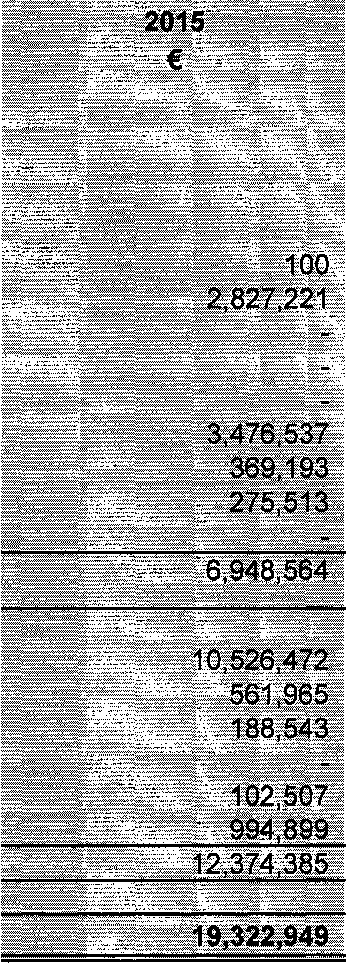ANALYSIS OF INCOME FROM GRANTS AND SUBSIDIES
2014
€
10,217
2,552,083
0
0
0
3,857,842
31,506
1,007,554
0
7,459,201
11,599,863
562,983
716,773
0
92,851
1,183,402
14,155,872
21,615,073

Department of the Environment, Heritage and Local Government
Road Grants
Housing Grants & Subsidies Library Services
Local Improvement Schemes
Urban and Village Renewal Schemes Water Services Group Schemes
Environmental Protection/Conservation Grants Miscellaneous
LPT Self Funding

Other Departments and Bodies
Road Grants
Local Enterprise Office Higher Education Grants
Community Employment Schemes Civil Defence
Miscellaneous

Total

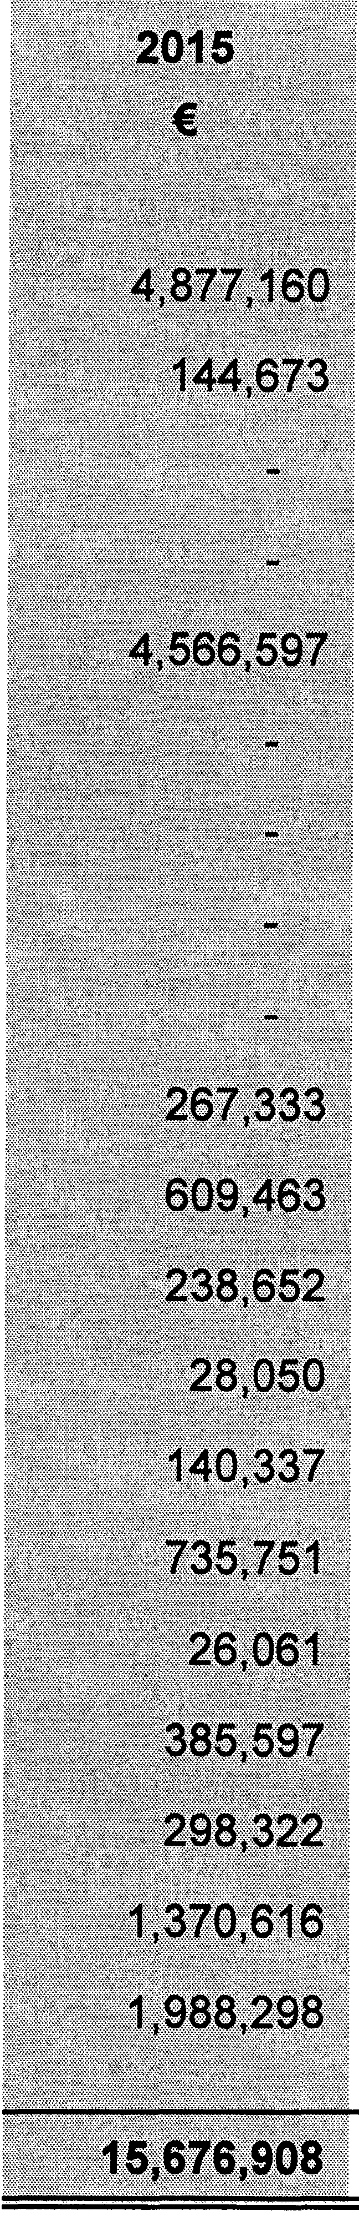
APPENDIX 4
ANALYSIS OF INCOME | FROM GOODS AND SERVICES  2014
 | €
Rents from Houses | 4,737,178
Housing Loans Interest & Charges | 171,867
Domestic Water
Commercial Water
Irish Water | 4,600,699
Domestic Refuse | 91,932
Commercial Refuse
Domestic Sewerage
Commercial Sewerage
Planning Fees | 177,342
Parking Fines/Charges | 583,708
Recreation & Amenity Activities | 229,454
Library Fees/Fines | 26,250
Agency Services | 18,153
Pension Contributions | 730,512
Property Rental & Leasing of Land | 28,397
Landfill Charges
Fire Charges | 282,085
NPPR | 1,870,885
Misc. (Detail) | 4,616,222
 | 18,164,684

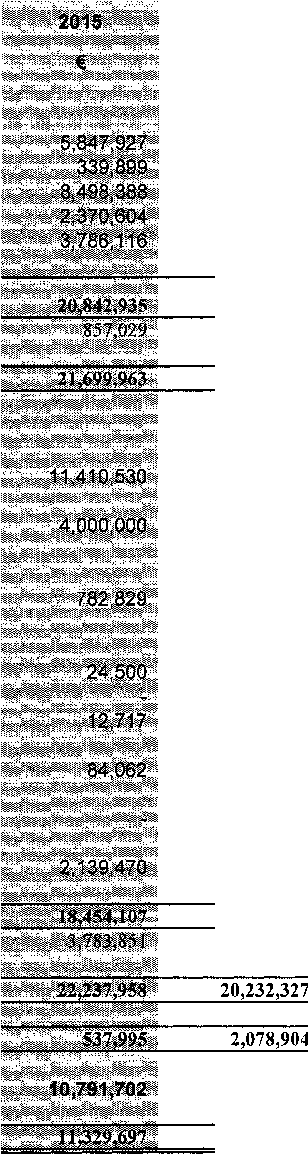
APPENDIX 5
SUMMARY OF CAPITAL EXPENDITURE AND | INCOME | 2014
 |  | €
EXPENDITURE
Payment to Contractors |  | 5,346,331
Puchase of Land |  | 1,286,340
Purchase of Other Assets/Equipment |  | 961,387
Professional & Consultancy Fees |  | 536,880
Other |  | 9,440,469
Total Expenditure (Net of Internal Transfers) |  | 17,571,407
Transfers to Revenue |  | 582,016
Total Expenditure (Incl Transfers) * |  | 18,153,423
INCOME  Grants and LPT |  | 9,783,661
Non - Mortgage Loans ** |  | 505,142
Other Income  (a) Development Contributions |  | 934,902
(b) Property Disposals
- Land |  | 174,850
- LA Housing |  | 2,807,872
- Other property |  | 11,150
(c) Purchase Tenant Annuities |  | 394
(d) Car Parking |  | 0
(e) Other |  | 2,729,796
Total Income (Net of Internal Transfers) |  | 16,947,767
Transfers from Revenue |  | 3,284,560
Total Income (Incl Transfers) *
Surplus\(Deficit) for year
Balance (Debit)\Credit @ 1 January |  | 8,712,798
Balance (Debit)\Credit @ 31 December |  | 10,791,702
* Excludes internal transfers, includes transfers to and from Revenue account

APPEND1X 6
ANALYSIS OF EXPENDITURE AND INCOME ON CAPITAL ACCOUNT

 | BALANCE @ 1/1/2015 | EXPENDITURE | INCOME |  |  |  |  |  |  | TRANSFERS |  |  |  |  | BALANCE @ 31/12/2015
 |  |  | Grants and LPT | Non-Mortgage  Loans* |  | Other |  | Total Income |  | Transfer from  Revenue | Transfer to | Revenue | Internal Transfers
 | € | € | € | € |  | € |  | € |  | € | € |  | € |  | €
Housing & Building | 5,753,566 | 6,298,542 | 3,986,781 |  |  | 274,188 |  | 4,260,969 |  | 309,425 |  | 400,000 | 145,677 3,771,095
Road Transportation & Safety | 2,452,818 | 10,717,083 | 3,669,124 | 4,000,000 |  | 250,153 |  | 7,919,277 |  | 168,041 |  | 30,645 | 1,977,985 1,770,394
Water Services | 269,529 | 2,024,904 | 1,315,711 | - |  | 520,340 |  | 1,836,051 |  | 32,000 |  | - | 112,676
Development Management | (1,095,714) | (754,179) | 862,457 | - |  | 1,092,980 |  | 1,955,437 |  | 46,500 |  | 19,554 | (891,626) 749,222
Environmental Services | 927,018 | 1,554,942 | 1,097,126 | - |  | 41,354 |  | 1,138,480 |  | 374,064 |  | - | 536,608 1,421,229
Recreation & Amenity | 53,403 | 560,663 | 479,330 | - |  | 16 |  | 479,346 |  | 58,861 |  | - | 547,202 578,149
Agriculture, Education, Health & Welfare | 637 |  | - |  |  | - |  | - |  | 85,614 |  | - | - 86,251
Miscellaneous Services | 2,430,446 | 440,980 | - |  |  | 864,546 |  | 864,546 |  | 2,709,345 |  | 406,830 | (2,315,846) 2,840,682
TOTAL | 10,791,702 | 20,842,935 | 11.410.530 i |  | 4.aaa.aaa i |  | 3,043,578 i |  | 18,454,107 | 3,783,851 |  | 857.029 i |  | - 11,329,697
Note: Mortgage-related transactions are excluded

Page 35

APPENDIX 7
Summary of Major Revenue Collections for 2015

A  Debtor type | 8  Incoming arrears @ 1/1/2015 | C  Accrued - current year debit (Gross) | D  Vacant property adjustments | E  Write offs | F  Waivers |  | G  Total for collection  =(B+C-D-E-F) | H  Amount collected | I  Closing  arrears @ 31/12/2015  = (G-H) | J  Specific doubtful arrears* | K  % Collected  = (H)/(G-J)
 | € | € | € | € | € |  | € | € | € | €
Rates | 4,874,587 | 13,536,702 | 1,727,641 | 876,682 |  | - | 15,806,967 | 11,943,256 | 3,863,711 | 1,301,809 | 82%
Rents & Annuities | 981,818 | 4,909,806 | - | 11,390 |  | - | 5,880,235 | 4,927,936 | 952,298 | - | 84%
Housing Loans | 221,892 | 383,803 | - | 15,118 |  | - | 590,578 | 431,090 | 159,488 | - | 73%
Domestic Refuse | (0) | - | - | - |  | - | (0) | - | (0) | - | 0%
Commercial Refuse | - | - | - | - |  | - | - | - | - | - | 0%

*Specific doubtful arrears = (i) Vacancy applications pending/criteria not met & (ii) Accounts in examinership/receivership/liquidation and no communication regarding likely outcome

APPENDIX 8

INTEREST OF LOCAL AUTHORITY IN COMPANIES AND JOINT VENTURES

Where a local authority as a corporate body or its members or officers, by virtue of their office, have an interest in a company (controlled, jointly controlled and associated), the following disclosures should be made for each entity:

Name of Company or Entity | Voting Power % | Classification: Subsidiary I Associate I Joint Venture | Total Assets | Total Liabilities | Revenue Income | Revenue Expenditure | Cumulative Surplus/Deficit | Currently Consolidated Y I N | Date of Financial Statements
Cavan Regional Health Sports and Leisure Co Ltd | 85.71% | Subsidary | 1,180,573 | 1,215,467 | 918,461 | 882,179 |  |  | 30/06/2014
 |  |  |  |  |  |  | -34,894 N
Glassell Ltd | 100.00% | Subsidary | 150,061 | 118,922 | 584,018 | 550,244 | 31,139 | N | 31/12/2014
Bridge Street Resource and Community Centre Ltd | 83.33% | Subsidary | 41,100 | 10,412 | 56,565 | 49,974 | 30,688 | N | 31/12/2014

APPENDIX 9
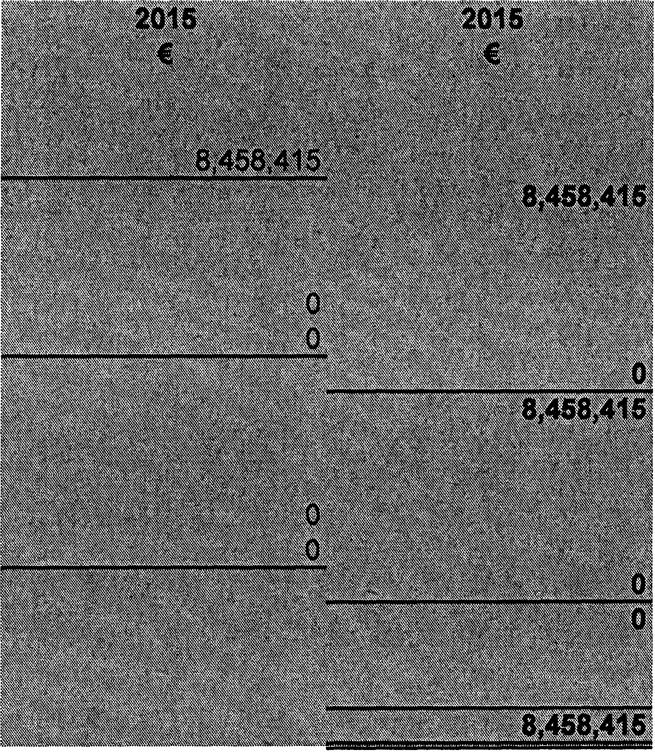
SUMMARY OF LOCAL PROPERTY TAX ALLOCATED

Discretionary
Discretionary Local Property Tax

Self Funding - Revenue
Housing & Building
Roads Transportation & Safety
Total Local Property Tax - Revenue Self Funding - Capital
Housing & Building
Roads Transportation & Safety

Total Local Property Tax - Capital

Total Local Property Tax - Allocated

Page 38

