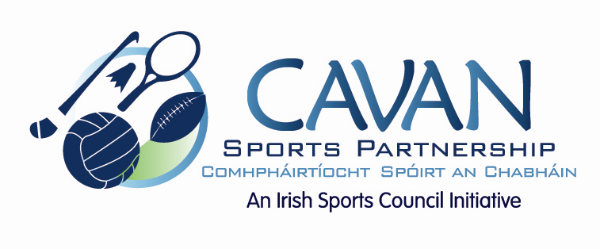

Cavan Sports Partnership Board Meeting
Monday 7th November 2016
10.00 am
Breffni Integrated Offices, Corlurgan Business Park, Cavan

Agenda

- Welcome

- Matters arising and adoption of minutes from previous board meeting 26th September 2016

- Sport Ireland funding application 2017

- Sport Ireland performance evaluation of Cavan Sports Partnership

- Date of next meeting

