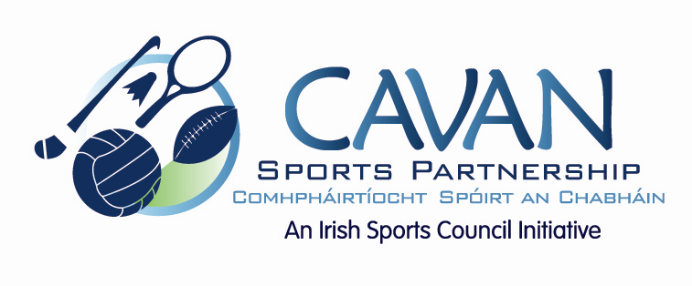

Cavan Sports Partnership Board Meeting
Friday December 2nd 2016
9.00 am
Breffni Integrated Offices, Corlurgan Business Park, Cavan

Agenda

- Welcome

- Matters arising and adoption of minutes from previous board meeting 7th November 2016

- Sport Ireland performance evaluation of Cavan Sports Partnership

  - Overview of the SI performance review process
  - KPMG Audit recommendations; document review and sign off.
  - Cavan Co. Co. Internal audit report

- Date of next meeting

