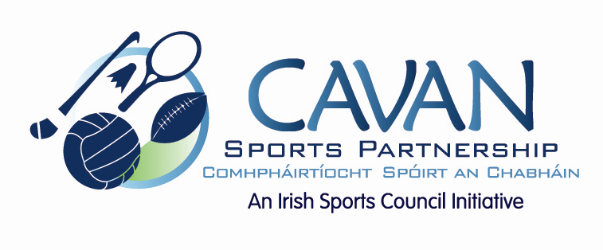

Cavan Sports Partnership Board Meeting
Tuesday February 14th 2017
9.30 am
Breffni Integrated Offices, Corlurgan Business Park, Cavan

Agenda

- Welcome

- Matters arising and adoption of minutes from previous board meeting 2nd December 2016

- CSP Workplan 2017

- Non attending board members of CSP

- Cavan Sports Partnership Strategic Plan 2017-2021

- Date of next meeting

