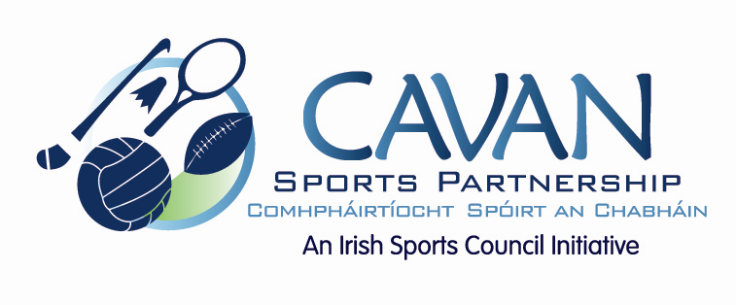

Cavan Sports Partnership Board Meeting
Thursday 8th June 2017
9.30 am
Cavan Council Chamber, Courthouse, Cavan

Agenda

- Welcome

- Formal adoption of new board members
  - James Sherry; Secondary Schools representative
  - David Cahill; Disability representative.

- Matters arising and adoption of minutes from previous board meeting 14th February 2017.
- CSP workplan; mid-year review
- Budget: Sport Ireland 25% return drawdown
- CSP Strategic Plan 2017-2021
- Board member review meeting; feedback
- A.O.B.
- Date of next meeting

