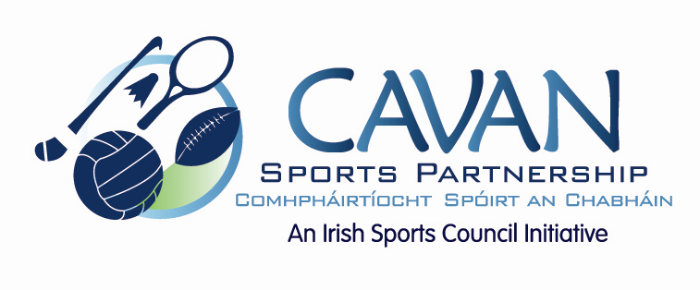

Cavan Sports Partnership Board Meeting
Tuesday 26th September 2017
9.30 am
Cavan Council Chamber, Courthouse, Cavan

Agenda

- Welcome
- Matters arising and adoption of minutes from previous board meeting 8th June 2017.
- CSP workplan update
- CSP small grant scheme 2017-2018
- CSP Strategic Plan 2017-2021
- Board member review meeting; feedback
- A.O.B.
- Date of next meeting

