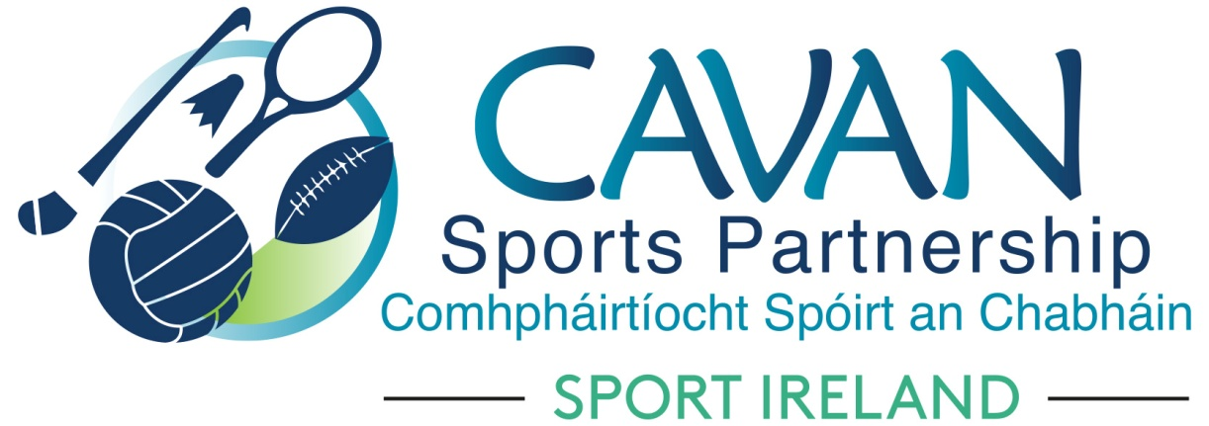

Cavan Sports Partnership Board Meeting
Tuesday 27th March 9.30am
Council Chamber, Cavan County Council

Agenda

- Welcome

- Election of Chairperson and Vice Chairperson 2018 - 2020

- Matters arising and adoption of minutes from previous board meeting 26th September 2017

- Filling of vacant positions – Cavan sports partnership board

- Sport Ireland 2018 budget allocation

- Cavan Sports Partnership Annual Implementation plan 2018

- A.O.B.

- Date of next meeting

