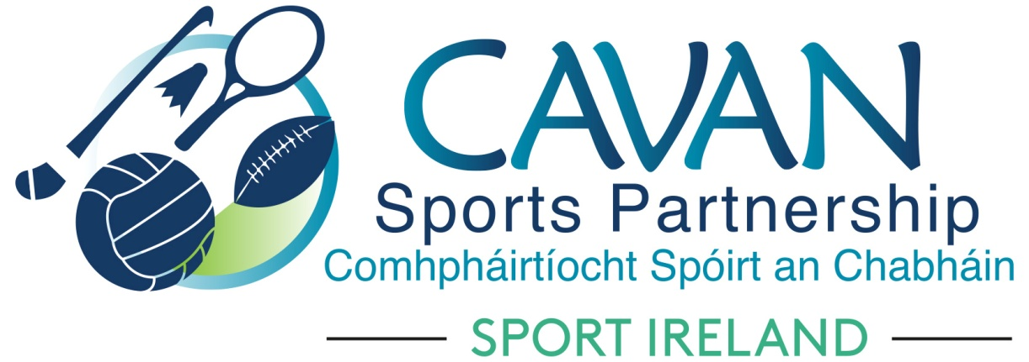

Cavan Sports Partnership Board Meeting
Thursday 21st June, 9.30am
Old Reference Library, Cavan County Council

Agenda

- Welcome

- Matters arising and adoption of minutes from previous board meeting 27th March 2018

- Measuring success – SPEAK Report 2017

- Mid term review - Cavan Sports Partnership Annual Implementation plan 2018

- Sport Ireland 2017 financial report and 25% draw down

- Dormant Accounts – expression’s of interest received

- A.O.B.

- Date of next meeting

