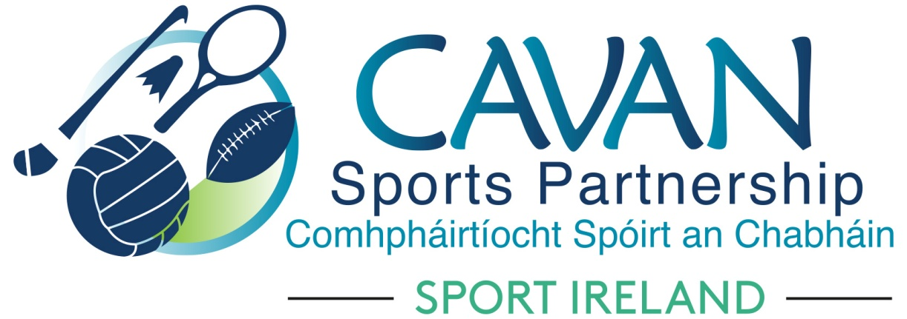

Cavan Sports Partnership Board Meeting
Tuesday 18th September 2018
Council Chamber, Cavan County Council

Agenda

- Welcome

- Matters arising and adoption of minutes from previous board meeting 21st June 2018

- Cavan Sports Partnership Annual Report

- Cavan Sports Partnership – financial review 2008-2017

- Sport Ireland 2019 application process

- Dormant accounts 2019 application process

- Cavan sports partnership sports club grant scheme 2018/2019

- A.O.B.

- Date of next meeting

