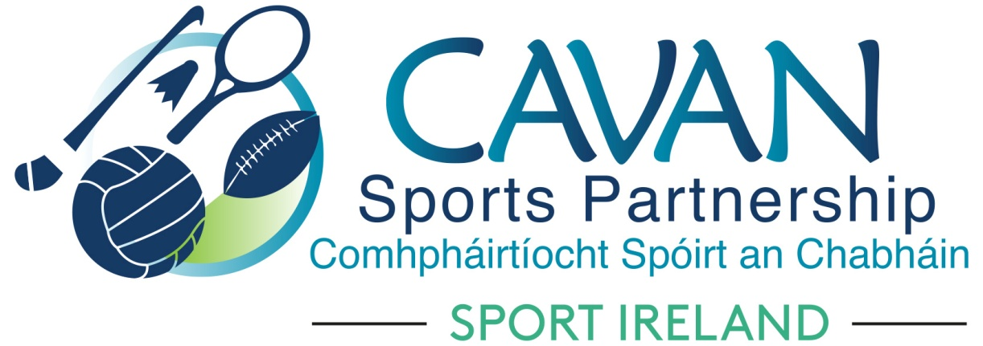

Cavan Sports Partnership Board Meeting
Tuesday 16th October 2018
Council Chamber, Cavan County Council

Agenda

- Welcome

- Matters arising and adoption of minutes from previous board meeting 21st June 2018

- Adoption of Cavan Sports Partnership Annual Report 2017

- Sport Ireland 2019 Funding Application

- Dormant Accounts Fund 2019 Application

- A.O.B.

- Date of next meeting

