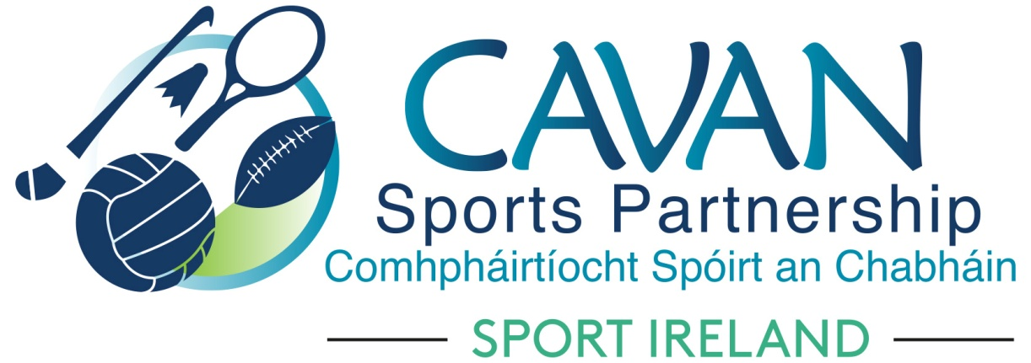

Cavan Sports Partnership Board Meeting
Tuesday 12th February 2019
Council Chamber, Cavan County Council

Agenda

- Welcome
- Matters arising and adoption of minutes from previous board meeting 16th October 2018
- CSP finance 2018
- CSP dormant accounts funding allocation 2018/2019
- CSP funding allocation 2019
- CSP Workplan Q1 2019
- A.O.B.
  - Discretionary funding application – Cavan Town Park Run
  - Sport Ireland
- Date of next meeting

