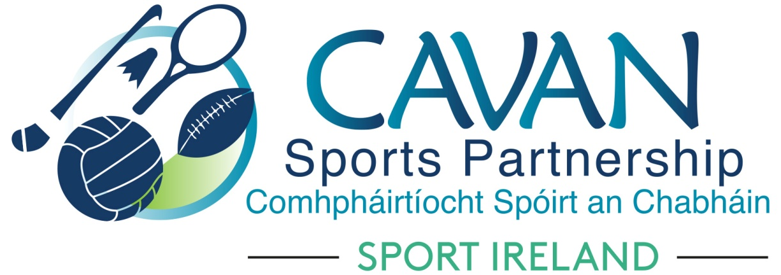

Cavan Sports Partnership Board Meeting
Friday 21st June 2019 at 9.30am
Bridge Street Centre, Bridge Street, Cavan Town

Agenda

- Welcome
- Matters arising and adoption of minutes from previous board meeting 12th February 2019
- CSP finance update
- CSP Workplan Q2 2019 update
- Dormant Accounts Funding
- Senior Sports Development Officer / SIDO update
- A.O.B.
  - Discretionary funding application – Knocktemple National School
  - Correspondence
  - Sport Ireland Visit 26th June 2019
- Date of next meeting

