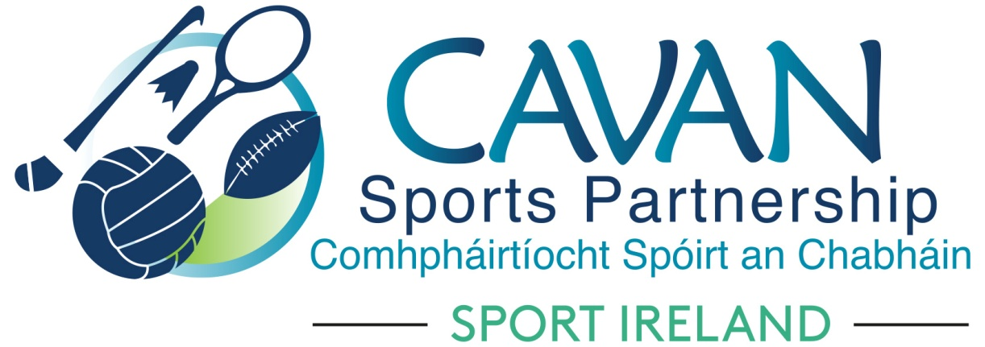

Cavan Sports Partnership Board Meeting
Tuesday 24th September 2019 at 10am
Bridge Street Centre, Bridge Street, Cavan Town

Agenda

- Welcome
- Matters arising and adoption of minutes from previous board meeting 21st June 2019
- Follow up and discussion on CSP audit 2017; Benny Cullen, Partnership & Governance Manager Sport Ireland
- CSP annual report 2018 (draft)
  - CSP Risk assessment document (draft)
- CSP Core mid year reporting 2019
- CSP Finance
- Dormant accounts projects
  - Reporting 2018/2019
  - Application submission 2019/2020
- Sport Ireland core funding application 2020
- A.O.B.
- Date of next meeting

