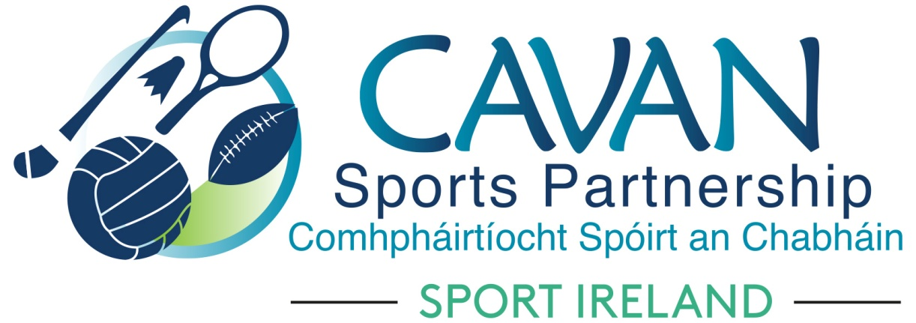

Cavan Sports Partnership Board Meeting
Tuesday 19th November 2019 at 11am
Hotel Kilmore, Cavan

Agenda

- Welcome
- Matters arising and adoption of minutes from previous board meeting 24th September 2019
- Governance:
  - CSP Board Member Handbook
  - Sport Ireland Terms & Conditions of Grants 2020 update
  - CSP Internal audit report by Cavan Co.Co. 2019.
- CSP board
  - Skills audit and identify areas for development
- CSP Finance update
- CSP Club Grant Scheme
- CSP staff presentation and Q&A
- A.O.B.
- Date of next meeting

