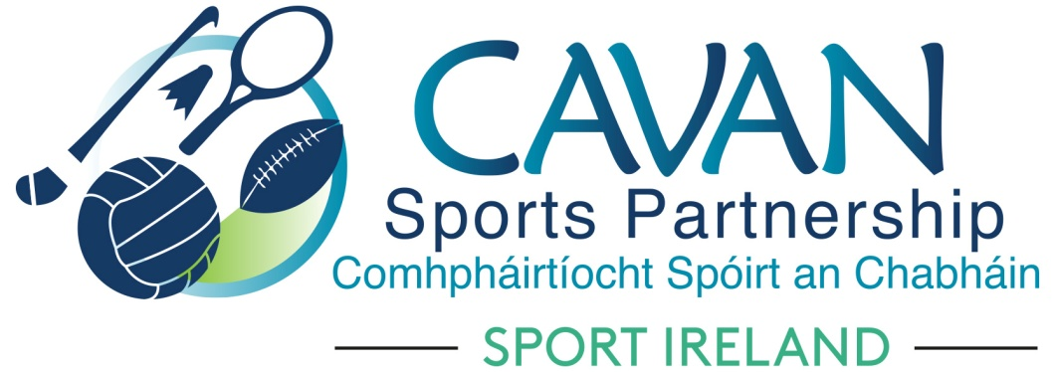
Date of Meeting: 27th March 2018 |  | Venue: Council Chamber
Present: John Kearney, Cllr Madeline Argue, Cllr Paddy McDonald, Brendan O’ Reilly , John Donohoe, David Cahill, Cllr. Philip Brady
Apologies: Terry Hyland, Liam Mc Cabe, Carol Kiernan
In Attendance: Nadine McCormilla, Aine O Reilly.
Agenda Item | Discussion / Action
1. Welcome
J. Kearney welcomed everyone to the meeting.
2. Election of Chairperson and Vice Chairperson 2018 – 2020
Nomination of Chairperson: John Kearney
Proposed: M. Argue Seconded: P. Brady

Nomination of Vice Chairperson: Terry Hyland
Proposed: P. Brady Seconded: M. Argue

N. Mc Cormilla thanked John Kearney for his work as chairperson for the previous three years.
J. Kearney thanked the board members and staff of the sports partnership for their work and support in his term as Chairperson.

3. Minutes of previous Board Meeting
The minutes of the previous board meeting were adopted.
Proposed: J. Donohoe Seconded: D. Cahill
4. Filling of vacant positions – Cavan sports partnership board | N McCormilla outlined the current vacant seats on the CSP board  - Community Rep / PPN : J. Donohoe to follow up with PPN  - Primary and Secondary School Reps: N. Mc Cormilla to invite nominations from both sectors via letter to all school principals.  - Cavan Institute: N. Mc Cormilla to issue a letter of invitation Cavan Institute director for a nomination to the board.  - A discussion took place on the quorum for meetings of the board. Current quorum (as per board member handbook March 2018) stands at one-half plus one of the membership to be in attendance for a board meeting to proceed. A decision was made to reduce the quorum to one-third plus one of the membership.  Proposed: M. Argue Seconded: D. Cahill.  - D. Cahill highlighted the importance of a gender balance within the board membership.  - J.Kearney addressed the issue of non attendance of board members. It was agreed that the following procedure would be implemented:  - If a board member misses two meetings (regardless of apologies) a phone call is to be made to the board member and if a further meeting is missed a letter to the board member outlining non attendance is to follow.  Proposed: P. Mc Donald Seconded: M. Argue  N Mc Cormilla to make the relevant changes to the board member handbook in relation to the quorum and non attendance of board members.
5. Sport Ireland 2018 budget allocation | N McCormilla discussed the Sport Ireland Budget allocation 2018 and a hand out detailing the allocation was given to board members. N. Mc Cormilla discussed the upcoming Dormant Accounts funding stream and it was decided that an expression of interest was to be publicly advertised and discussed at the next board meeting.  N. Mc Cormilla requested €2,500 allocation from CSP reserves to the contingency fund.  Proposed: D. Cahill Seconded: P. Brady  N. Mc Cormilla requested €1,000 allocation from CSP reserves to the Cavan Walking Festival.  Proposed: M. Argue Seconded: P. M Donald
6. Cavan Sports Partnership Annual Implementation plan 2018 | N. Mc Cormilla presented the DRAFT CSP annual implementation plan for 2018. All board members received a copy of the plan. N. Mc Cormilla discussed the sport Ireland evaluation system SPEAK. J. Kearney reflected on the SI 2016 performance review audit and suggested that 2 - 3 successful programmes are presented to the board at each meeting to highlight the ongoing work. N. Mc Cormilla to review methods on measuring impacts and highlighting success.
7. A.O.B. | N McCormilla spoke to the board about a phone call received from local lady, Marieta Sharkey who was a wheelchair user and who is training towards competing in the next Paralympics and was requesting supports ( monetary or ‘in kind’ ) from the sports partnership. Calls from athletes / parents of athletes achieving at a high level are becoming more prevalent. Should this be the sports partnerships role? N. Mc Cormilla to research other LSP’s to see if there are programmes supporting emerging talent in other counties.
8. Date of next meeting | The timing of board meetings was discussed. N. MC Cormilla to send a survey to all board members for preferred time of board meetings.  - Board development session – 22nd May  - Tuesday 5th June  - Tuesday 18th September  - Tuesday 4th December

