Comhairle Contae An Chabháin
Cavan County Council

Application Form

Cavan County Council
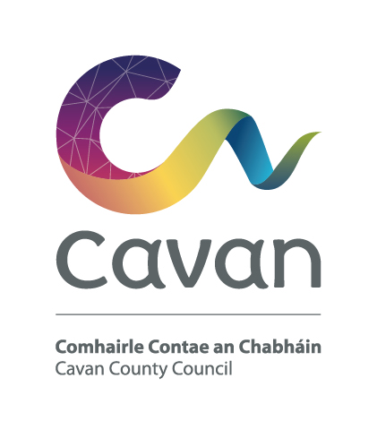
Cavan County Council is an equal opportunities employer

The latest date for the receipt of completed Application Forms is 5.00 p.m. on Monday 3rd April, 2023.
Completed application forms should be emailed to jobs@cavancoco.ie

Position: Senior Staff Officer – Grade VI

Please indicate which panel(s) you wish to apply for,
(please refer to Candidate Information Booklet for Qualifying Criteria)

Panel A (Existing Local Authority Sector Staff Only)

Panel B (Open Competition)

Panel C (Existing Cavan County Council Staff Only)
----------------------------------------------------------------------------------------------------

1. Name in full (Block Letters)

2. Postal Address (Block Letters)

3.
Contact Details:
Work Phone: |  | Extn Number:
Home Phone: |  | Mobile Number:
Email Address:

4. Do you hold a current full driving licence Yes No

5. Do you require a work visa/work permit Yes No

6. Education

General Education
Period | School or College Attended | Examinations Taken (with dates) | Results

Where applicable, please submit copy of Leaving Certificate results with application

Academic, Professional Or Technical Qualifications (if any)

Period | Name of College/ University | Part/Full Time | Course & Qualification | Grade & Year Obtained

Where applicable, please submit copy of qualification with application.

Other Relevant Training (if any)

Date | Other Relevant Training (course name) | Qualification received

NOTE:- Certification & qualifications will be subject to verification post interview and prior to appointment.

7. Career History

Particulars of present appointment

Employer:
Position Title:
Address:
Perm/Temp:
Start Date:
Describe briefly your present position, outlining your main responsibilities
and activities, to whom you are responsible and who, if anyone, is responsible to you.

8. Previous Employment Record

Give below, in date order, full particulars of all employment starting with your position immediately preceding your present position to date of leaving school or college. No period between these dates should be left unaccounted.

From | To | Name and Address of Employer | Job Title  Description of duties/main responsibilities

9. Supplementary Questions Section for the post of Senior Staff Officer

In each of the competency areas below briefly detail two examples which you feel best demonstrates your capacity in the competency area described. You may use the same example across more than one competency area should you so wish. Your examples should show clearly how you have demonstrated the particular competency. You should be mindful that the scale and scope of the examples given demonstrate the competency in question and are appropriate to a post at Senior Staff Officer/Grade VI level. (See Candidates Information Booklet)

NB: Examples should not exceed 300 words under each heading.

- Management and Change

Total No of Words (Max 300):

- Delivering Results & Communicating Effectively
Total No of Words (Max 300):

- Leading and Motivating and Managing Performance

Total No of Words (Max 300):

D Personal Effectiveness
Total No of Words (Max 300):

Please include below a brief statement (no longer than 300 words) outlining why you wish to be considered for the position and where you feel your knowledge, experience and skills meet the requirements of the position

Total No of Words (Max 300):

11. References:
Give names and addresses of two responsible persons to whom you are
well known, but not related. The Council will assume permission to contact
referees unless the Applicant has stated otherwise.
(1)
Name

Address

Occupation

(2)
Name

Address

Occupation

12. Are you now, or have you been within the past 12 months a member of a
Local Authority?

Yes No

13. Are you in receipt of a superannuation allowance in respect of an office under
a Local Authority? Is so, give particulars of pension,
office of employment, grounds and date upon which is was granted.
Yes No

14. Do you require any special facilities/arrangements for the interview
(e.g. wheelchair access etc)

Yes No

Before signing this form, please ensure that you have replied fully to all questions
asked. You should also satisfy yourself that you are eligible under the qualifications.

I, the undersigned, hereby declare all the foregoing particulars to be true.

Signature of Applicant

Date

Communications relating to your application will be by email to the address provided.
N.B. Canvassing by or on behalf of the applicant will disqualify

Notes

Applicants should read these notes and the Candidates Information Booklet carefully before completing the application form.

Completion of the Application Form

Before you return your application form, please ensure that you have completed all sections and that you have signed the application form. It is the responsibility of candidates to establish their eligibility for the post through the information provided in the application form.

Please do not submit a CV with this application. Only information contained in the application form will be considered when assessing an applicant’s suitability for the post.

Candidates may be short-listed on the basis of information supplied on this application form.

Please ensure that you have certified copies of all qualifications, as indicated on this application form, available for inspection, if requested.

Submission of Application Form

Completed application forms should be returned as an attachment in either Word or PDF format by email only to jobs@cavancoco.ie.

Please include “Senior Staff Officer” as a reference in the subject line when emailing the application.

Completed applications must be received not later than 5.00 pm on Monday 3rd April 2023.

Late applications will not be accepted.

Proof of receipt of Application Form

Applications submitted by email will be acknowledged automatically. Please keep this acknowledgement as proof of delivery and receipt of your application.

If you do not receive an acknowledgement within 24 hours, please contact the Human Resources Department immediately at 049 4378600. It is the responsibility of candidates to ensure the proper delivery and receipt their applications.

Further Queries

By email: jobs@cavancoco.ie

By telephone: 049 4378600

Important!

Canvassing by or on behalf of the applicant will automatically disqualify.

Cavan County Council is an Equal Opportunities Employer

