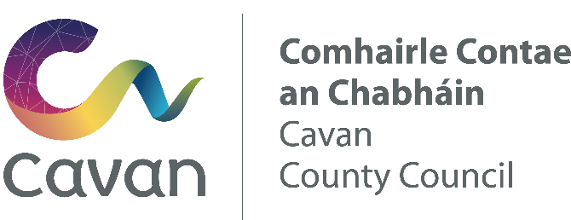

Comhairle Contae an Chabháin
Ceantar Bardasach An Cabhán - Béal Tairbirt

A Chathaoirligh agus gach baill den Ceantar Bardasach.

27/02/26

A Chomhairleoir,

Beidh an chéad cruinniú Ceantar Bardasach An Cabhán - Béal Tairbirt ar siúl sa Seomra na Comhairle, Teach Cúirte, An Cabhán.
- Dé Luain, 9 ú Márta, 2026 ag 9.15 r.n.

Tá an clár ar an thaobh eile den laethanach.

Is mise le meas,

Rosaleen Higgins
Riarthóir cruinnithe.

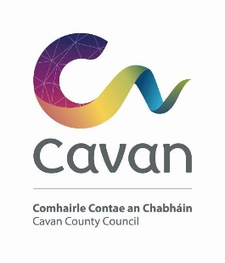

Cavan County Council

Cavan Belturbet Municipal District

27/02/26

To Cathaoirleach and Each Member of The Cavan Belturbet Municipal District

Dear Councillor,
The next meeting of Cavan Belturbet Municipal District will be held in the Council Chamber in the Courthouse Cavan
- On Monday 9th March at 9.15 am
.

The agenda is overleaf.

Yours sincerely

__________________
Meetings Administrator

A G E N D A/ CLÁR
- Confirmation of Minutes
- To confirm Minutes of Monthly Meeting held on Tuesday the 13th of January

- Disclosure of Interests (Section 177 Local Government Act 2001)

- Correspondence-
Email from Uisce Éireann in response to Cllr Smith’s motion in September.

Business prescribed by Statute, Standing Orders or Resolutions of the Council

- Executive Items-

4.1 Municipal Districts 2026 grant applications: John Donohoe SEO, Community Enterprise and Tourism.
4.2 Part 8 Planning Report for Morrisey Park, Corporation Land, Belturbet, Co.Cavan: Martin Quigley, SEE, Community Enterprise and Tourism.

5. Road Works Programme update and 2026 RI Programme Paul Mulligan
6. Members Items
6.1 Councillor Á Smith
Safety measures at Cootehill rd turn off and at John Sullivan home, Cavan town.

6.2 Councillor D Brady

Public Toilets in Cavan Town

6.3 Councillor D Brady

Traffic calming at playground in Sean Lee drive, Belturbet
6.4 Councillor Fay
Safety measures on Railway Road, Belturbet and surrounding areas. With 3 schools and happy days play school, this includes speed. Footpaths and manholes grave concern, from the community at large.

6.5 Councillor Fay

Some roads been used as rat runs, namely Kinnagha Beg / Kinnagha Mór, Belturbet.

6.6 Councillor Feeley

Update on traffic calming and pedestrian safety on the Crossdoney Road, Cavan Town

6.7 Councillor Feeley
That this MD request that Christopher O’Sullivan TD, Minister of State, include Cavan Burren Park in state owned lands designated for Biodiversity.

6.8 Councillor N Brady
Provision and upkeep of public lighting in our towns and villages.

6.9 Councillor Walsh
Drains and Gullies full.

6.10 Councillor Walsh
Update on Tractamotors Junction.

AOB
Date of next meeting.

