.
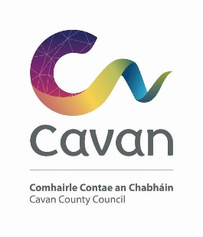

Cavan County Council

Cavan Belturbet Municipal District

08 July 2024

To Cathaoirleach and Each Member of The Cavan Belturbet Municipal District

Dear Councillor
The next meeting of Cavan Belturbet Municipal District will be held in the Events Space in Johnston Central Library-
- On Monday 15th July 2024 at 9.30
.

The agenda is overleaf.

Yours sincerely

__________________
Meetings Administrator

A G E N D A/ CLÁR
- Confirmation of Minutes

To confirm Minutes of Monthly Meetings held on the 22^{nd of} April 2024.

- Disclosure of Interests (Section 177 Local Government Act 2001)

- Correspondence- None
Business prescribed by Statute, Standing Orders or Resolutions of the Council

- Executive Items- None.

- Road Works Programme update Paul Mulligan

Members Items
- Sewerage in Milltown Cllr Smith
- Parking bays and parking meters in Cavan town. Cllr Smith

- Signage at Derrygoss, Butlersbridge Cllr Walsh

- Safety Measures on the N87 at Cranaghan Cllr D Brady

- Traffic calming on the Derrylin Road, Ballyconnell Cllr Feeley

- Traffic calming Moynehall, Cavan Cllr Feeley

